|  |  |
| --- | --- |
|  | CASES21 Restrictions/Risk tab Quick Guide |

The enhanced **Restrictions/Risk** tab can be accessed via the *Enter or Modify Student Enrolment Details – Daisychain Version [ST11001]* or *Tab Version [ST11001T]*. The fields on this tab are to be checked and updated for all students **before** transferring to their new school. The example below provides a summary of what information should be entered for each field on the tab. For further information, refer to Chapter 2 of the [CASES21 Administration User Guide](https://edugate.eduweb.vic.gov.au/Services/bussys/cases21/Pages/C21-User-Guides.aspx?RootFolder=%2FServices%2Fbussys%2Fcases21%2FUser%20Guides%2FAdministration%20User%20Guide&FolderCTID=0x0120004C9E15E0B526674E861484BC0480850D&View=%7B31E75C2F%2DBBFF%2D4EF3%252).

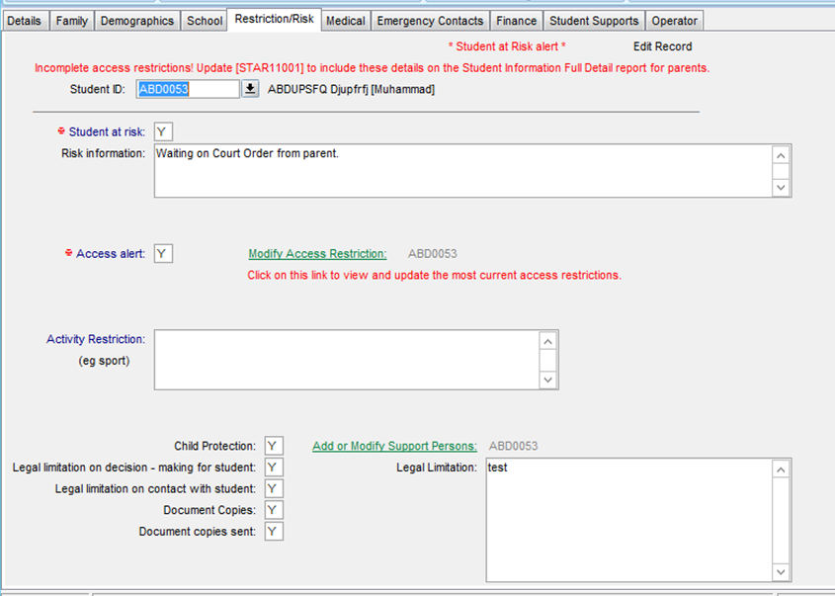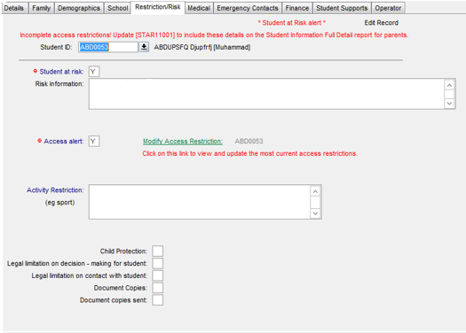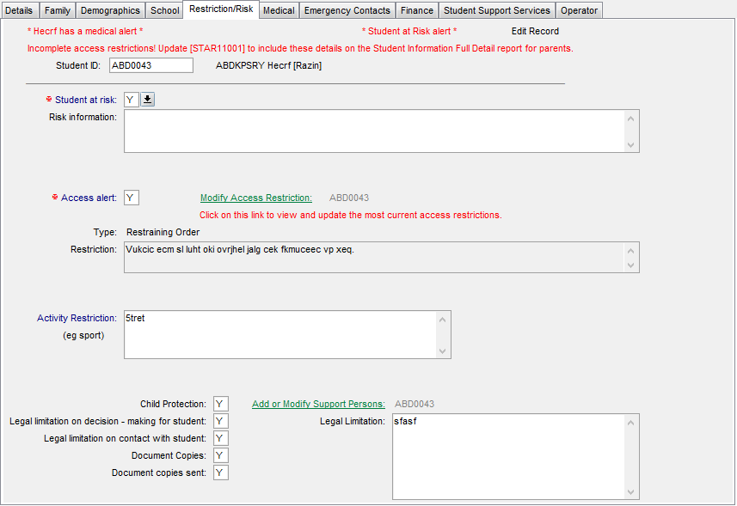

Does the student have any risks, reported by the parent/carer, **NOT** related to access restrictions/alerts? If yes, enter details in the *Risk Information* box. **Note**: **This field is VISIBLE on the student’s record when printed.**

Are there any **court orders or related documents** for the student and/or family circumstances? If yes, click on the *Modify Access Restriction* link to enter details. Note that information in this field is included in the Current Student Details form.

What is the type/category of **access restriction** for this student? Enter details of the access restriction (see page 2).

Are there any **activity restrictions** that apply to the student, such as sport and excursions?

Is the **Department of Health and Human Services** currently involved with the child and/or their family? If yes, click on the *Add or Modify Support Persons* link to enter details of the child protection worker.

Are there any limitations on who can **make decisions** on behalf of the student? If yes, enter details in the *Legal Limitation* box.

Are there any limitations on who can **contact the student**? If yes, enter details in the *Legal Limitations* box.

Are there any **documents** associated with the student’s restrictions/risk profile? If yes, are arrangements in place for these documents to be forwarded to the receiving school? N.B. as per the privacy legislation student information can be transferred to the receiving school after an offer of placement has been made.

|  |  |  |
| --- | --- | --- |
| When you click on the Add or Modify Support Persons daisy chain link the following screen appears. The First Name, Surname and Support Role fields are mandatory. |  | When you click on the Modify Access Restrictions daisy chain link, the following screen appears.  When entering a **new Access Type**, a drop down list appears. The list includes the following access restriction types to select from – Parenting Order, Parenting Plan, Intervention Order, Protection Order, Informal Carer Stat Dec, DHHS Authorisation, Witness Protection Program, and Other.  cid:image002.png@01D1CBCA.6557A4D0  **Access Restriction text box**  Where there is an Access Alert relating to a student, the school must record the access type and details in CASES21. Access alert data previously entered must be re-entered in the new format.   Until this is completed, a red alert will appear at the top of the student’s record as a reminder to update the restrictions. This update is also required for access restriction details to appear on the new ***Student Enrolment Information Form (ST21090)***.  The ***Student Access Restrictions Clean-up (STAR21002)*** report can be used to identify students whose access type(s) and restriction(s) haven’t been entered into *Add or Modify Access Restriction (STAR11001)* via the **Modify Access Restrictions link** on the Risk/Restrictions tab of *Student Information (ST11001/T)*.  **Schools must exercise extreme caution when viewing the access restrictions, to ensure they are referring to the most current information.** |
|  |  |  |