VicSRC
Victorian Student Representative Council

The Victorian Student Representative Council (VicSRC)
Transitions Project | Final Report
August 2015
Prepared by: Linda Randall (on behalf of the VicSRC)

About the Victorian Student Representative Council (VicSRC)
The Victorian Student Representative Council (VicSRC) is the peak body representing students in Victoria. The VicSRC’s vision is a world where all children and young people have access to education that is student-led, student driven and student focussed. The organisation exists to empower all student voices to be valued in every aspect of education. The VicSRC is auspiced by the Youth Affairs Council Victoria, and funded through the Victorian Department of Education and Training (DET).

EXECUTIVE SUMMARY
Background, introduction and consultation aims
In March 2015, the Victorian Auditor-General’s Office conducted an audit into education transitions. The audit found that there is no consistent approach to middle-years transitions (Grade 6 - Year 7) in government schools and linked this to an overall decline in both engagement and academic outcomes in Year 7 and 8. The audit recommends that the DET develop a comprehensive framework to support a consistent approach to middle-years transitions across Victoria. The VicSRC Transitions project contributes to this work by providing a student perspective on transitions.
Consultation methodology
One hundred and fifty five students (104 Grade 6 students; 51 Year 7 students) participated in activity based workshops to generate the findings outlined in this report. Consultations focused on two localities, one in a regional area and one in a metropolitan area. In each locality one secondary school and two of its feeder primary schools were invited to nominate one class to participate.
Consultation findings
Challenges faced by students in middle-years transitions
The most substantial challenges that students face in making the transition from primary school to secondary school are managing the increased workload and navigating peer relationships. Students also reported concerns about finding their way around in a large and unfamiliar environment however, these concerns appear to be quickly resolved once students get to know the school.
Improving middle-years transitions: A student perspective
There are many ways in which both primary schools and secondary schools can support students to make smooth transitions from Grade 6 to Year 7. These include:
- Ensuring students have access to strong support networks before, during and after transition. These networks may include peers, family and teachers.
- Aligning students’ workloads so that the increase in academic expectations post-transition is manageable.
- Providing formal and informal opportunities that foster collegiality and friendship among students.
- Reducing the “unknown” for students prior to transition wherever possible.
- Providing clear avenues for students to access information about their new school.
- Employing effective strategies to address bullying.
Conclusion and recommendations
The report presents six recommended areas around which the DET can work with schools to better support middle-years transitions. The recommendations themselves are derived from the consultation findings and are complemented by practical suggestions for implementation that were developed using the ideas of both consultation participants and members of the VicSRC Student Executive.

SUMMARY OF RECOMMENDATIONS
Recommendation #1 Ensure students have access to strong support networks before, during and after transition. These networks may include peers, family and teachers.
Implementation ideas:
- Peers:
  - Provide workshops or similar opportunities that allow students (primary and secondary) to talk about their hopes and fears relating to transition.
  - Group primary students according to their destination secondary school and get them to undertake a small research project looking at what to expect at their new school.
  - Match primary school students with secondary school mentors. If possible, these matches should be made prior to transition and the younger student should have access to their mentor throughout Grade 6.
  - Create “class team groups” in Year 7 (several per class) to foster strong relationships between smaller groups of students.
- Family:
  - Communicate openly with parents of Grade 6 students about what to expect before, during and after transition.
  - Provide ideas to parents about ways to support their child to adapt to secondary school (e.g. letting them know about extra-curricular activities on offer; making sure they know who to go to if they are having trouble).
  - Work with older students on ideas to support younger siblings throughout the transition period.
- Teachers:
  - Ensure that students are aware of all the different ways various members of the teaching staff can be of support.
  - Dedicate time for all teachers to get to know students in a fun way through transition days and at the beginning of Year 7.
Recommendation #2 Align students’ workloads so that the increase in academic expectations post-transition is manageable.
Implementation ideas:
- Provide opportunities for Grade 6 students to “trial” Year 7 style work, including homework. It is important that expectations and grading are still consistent with Grade 6 standards and that this does not simply result in increasing pressure on students earlier.
- Provide ‘study skills’ workshops throughout Year 7 that support students to gradually learn the skills they need for secondary school.
- Encourage collaboration between teaching staff to ensure that student workloads (particularly homework) are manageable, taking into account time for extra-curricular activities and general recreation.
- Ensure students have access to support and know who to talk to if they do become overwhelmed by the workload.
- Provide formal and informal opportunities for students to work together on homework assignments.
Recommendation #3 Provide formal and informal opportunities that foster collegiality and friendship among students.
Implementation ideas:
- Hold Year 7 camp early in term 1.
- Promote and encourage extra-curricular activities such as drama, dance, art and sport.
- Run activities in class that encourage students to socialise with a broad range of their peers.
Recommendation #4 Reduce the “unknown” for students prior to transition wherever possible.
Implementation ideas:
- Organise representatives from Year 7 and/or 8 to come and talk about their experience of secondary school to Grade 6 classes.
- Hold “Practice Year 7 days” in primary school where students move between the Grade 6 classrooms for different lessons throughout the day.
- Provide at least two orientation days.
- Ensure that orientation days include at least some experience of ‘a typical day’ in Year 7.
Recommendation #5 Provide clear avenues for students to access information about their new school.
Implementation ideas:
- Ensure that introductory information is provided in a format that students (not just parents) can easily engage with.
- Have Year 7 and/or 8 students make creative videos for Grade 6s dealing with common transition concerns.
- Provide both digital and face-to-face forums for Grade 6 students to access information and ask questions about their new school.
Recommendation #6 Employ effective strategies to address bullying.
Implementation ideas:
- Avoid barriers between groups by creating as many opportunities as possible for students to mix from the beginning.
- Promote greater collaboration between school clusters to ensure that strategies employed by primary schools to address bullying may continue to be effective in Year 7 and beyond.

Table of Contents
EXECUTIVE SUMMARY iii
SUMMARY OF RECOMMENDATIONS iv
BACKGROUND, INTRODUCTION AND CONSULTATION AIMS 2
CONSULTATION METHODOLOGY 3
CONSULTATION FINDINGS 4
Challenges faced by students in middle-years transitions 5
Improving middle-years transitions: A student perspective 10
CONCLUSION AND RECOMMENDATIONS 16
APPENDIX I – PRIMARY SCHOOL WORKSHOP 20
APPENDIX II – SECONDARY SCHOOL WORKSHOP 24

BACKGROUND, INTRODUCTION AND CONSULTATION AIMS
In March 2015, the Victorian Auditor-General’s Office conducted an audit into education transitions. The audit assessed the effectiveness of the Department of Education and Training (DET), government schools and early childhood education and care providers in supporting children to transition into Prep and from primary to secondary school.
The audit found that the comprehensive, well-researched framework developed by DET to support early-years transitions has contributed to improved student outcomes. In contrast, student outcomes following the transition from primary to secondary school were found to be much more mixed. Despite evidence of some schools taking innovative approaches to middle-years transitions, state-wide data showed an overall decline in both engagement and academic outcomes in Year 7 and 8. In response to this, the audit recommends that the DET develop a comprehensive framework to support a consistent approach to middle-years transitions across Victoria.
The DET has accepted the recommendations of the audit and is currently in the process of developing policies and guidelines to support a more consistent approach to middle-years transitions. The VicSRC Transitions project contributes to this work by providing a student perspective on transitions. The report draws on the ideas and experiences of Grade 6 (n = 104) and Year 7 (n =51) students to address two key questions:
What are the key challenges faced by students in the transition from primary school to secondary school?
How can schools better support students to make smooth transitions from primary school to secondary school?
Based on the findings of the consultation, the report makes six recommendations designed to inform the DET’s work on middle-years transitions. Practical strategies through which these recommendations may be implemented have also been developed in partnership with members of the VicSRC Student Executive.

CONSULTATION METHODOLOGY
The consultation took place in term 2, 2015. It targeted two localities, one in a regional area and one in a metropolitan area. In each locality, one secondary school and two of its feeder primary schools were invited to nominate one class to participate. This recruitment method resulted in a total of 155 students (104 Grade 6 students; 51 Year 7 students) participating in the consultation. This model, including the specific aims of each part of the consultation, is shown in Figure 1.
Figure 1: Consultation model
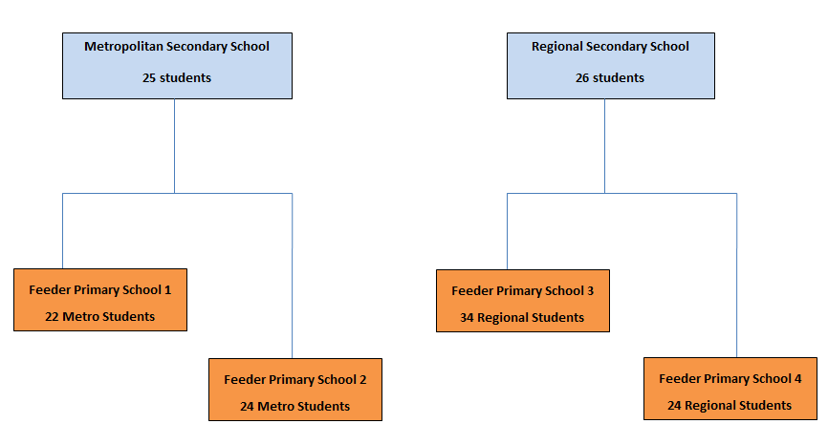

As Figure 1 explains, data was collected using activity based workshops. Each activity encouraged interaction between students and employed strategies through which to document ideas. The workshop design included a combination of activities where students worked together and activities where students came up with ideas on their own before sharing them with other students. The aim of this was to ensure that students shared their own feelings as opposed to “borrowing” ideas from other participants. Despite these efforts, it is important to acknowledge that participant’s responses may still have been affected by the presence of their peers.
Including entire class groups in a single workshop made it easy for schools to participate in the project. It is important to recognise however that the fast-paced approach necessary to keep the workshops engaging and fun for such large groups of students was not ideal for exploring individual ideas in great depth. As a result, this report is best understood as a broad snap-shot of students’ ideas and experiences and is designed to complement other work on transitions currently being undertaken by DET.
The findings of the consultation and a series of draft recommendations were presented to members of the VicSRC Student Executive. Twelve of the group’s 15 members provided input. This feedback shed further light on the results and formed a basis for the development of practical strategies through which each recommendation could be implemented.

CONSULTATION FINDINGS
This section focuses on the challenges participants reported facing in making the transition from primary school to secondary school and participants’ ideas for how schools can work to reduce or overcome these challenges. Consultation findings are reported in two sections.
The first section responds to the question: What are the key challenges faced by students in the transition from primary school to secondary school? It explores the concerns primary school participants reported experiencing as they approach transition and the actual challenges secondary school participants reported experiencing during transition. It also considers the relationship between the anticipated challenges reported by primary school participants and the actual challenges reported by secondary school participants.
The second section builds on the first, responding to the question: How can schools better support students to make smooth transitions from primary school to secondary school? It draws on primary school participants’ experiences preparing to make the transition and secondary school participants’ experiences both before and after transition. It also presents participants’ general ideas about how transition can be better supported.

Challenges faced by students in middle-years transitions
Key finding:
The most substantial challenges students face in making the transition from primary school to secondary school are managing the increased workload and navigating peer relationships. Students also reported concerns about finding their way around in a large and unfamiliar environment however, these concerns appear to be quickly resolved once students get to know the school.

This section responds to the question: What are the key challenges faced by students in the transition from primary school to secondary school? It explores the concerns primary school participants reported experiencing as they approach transition and the actual challenges secondary school participants reported experiencing during transition. It also considers the relationship between the anticipated challenges reported by primary school participants and the actual challenges reported by secondary school participants.
Both primary and secondary school participants were asked to indicate their level of agreement with a series of basic statements related to transition. For primary school participants, the statements related to feelings about their upcoming transition. For secondary school participants, the statements related to their actual experiences of transition. Responses from primary school participants are shown in Figure 2.
Figure 2: Primary School participants’ responses to statements about transition
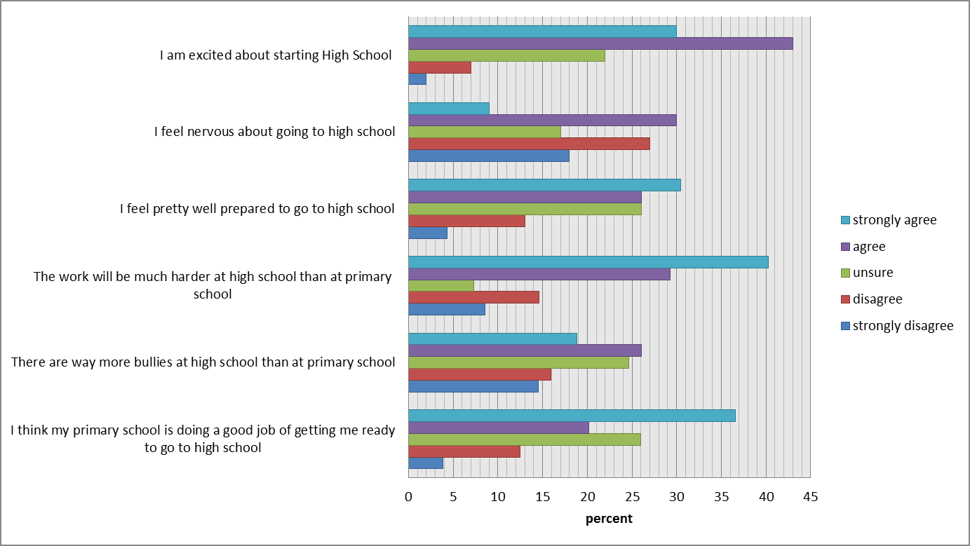
As can be seen in Figure 2, primary school participants were, for the most part, feeling both excited and well prepared for Secondary School. Amongst this excitement however, participants also reported feeling some nervousness. Two areas of particular concern were bullying and the workload.
Bullying – Fears about bullying were mostly based on the assumption that a bigger school would naturally have more bullies and that as the youngest members of the school community they would be the most vulnerable. There were also several students who described older siblings or friends experiencing bullying in secondary school.
There are bullies everywhere - and the high schools are bigger so won't there be more bullies.
(Grade 6 participant)
I think there will be heaps more, because right now my brother is being bullied and he's in high school. Yeah there will be heaps because they are a lot older than you and they can bully you about many different things.
(Grade 6 participant)
Workload – Both the difficulty and volume of work participants expected to receive was consistently raised as a concern, with homework a particular source of apprehension. It is worth noting that, although all participants expected the work to be more difficult, not everyone saw this as a bad thing. Some students looked forward to this challenge or at least accepted it as a reasonable part of their progression through school.
Of course it’s going to be harder - if it doesn't get harder how are we going to learn?
(Grade 6 participant)
As noted above, secondary school participants were also asked to respond to a range of statements about transition. These statements differed slightly from those given to the primary school participants and reflected common concerns of primary school students prior to transition derived from literature reporting on work with student action teams in schools.
Participants were asked to rank the statements based on the degree to which the concerns they described were actually challenging for them in practice. Their responses are shown in Figure 3.
Figure 3: Degree to which secondary school participants experienced challenges
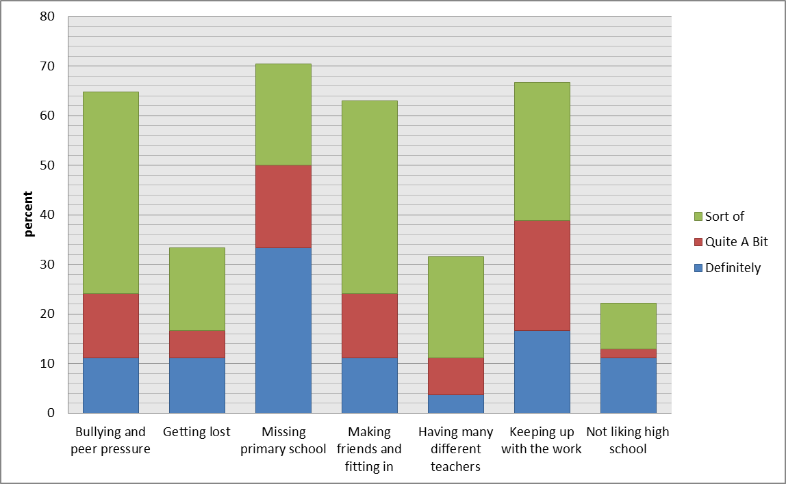
As Figure 3 demonstrates, the things most commonly reported by secondary school participants as challenging to at least some degree were “missing primary school”; “keeping up with the work”; “bullying and peer pressure” and “making friends and fitting in”. Several of these challenges are consistent with the things that primary school participants reported being most nervous about.
In a separate activity, both primary and secondary school participants were given an opportunity to respond to open ended questions about what they felt nervous about (Grade 6 participants) and about the challenges they faced (Year 7 participants) in transition. These responses were subject to thematic analysis, the results of which are shown in Figure 4.
Figure 4: Comparison between concerns reported by primary school participants and challenges reported by secondary school participants
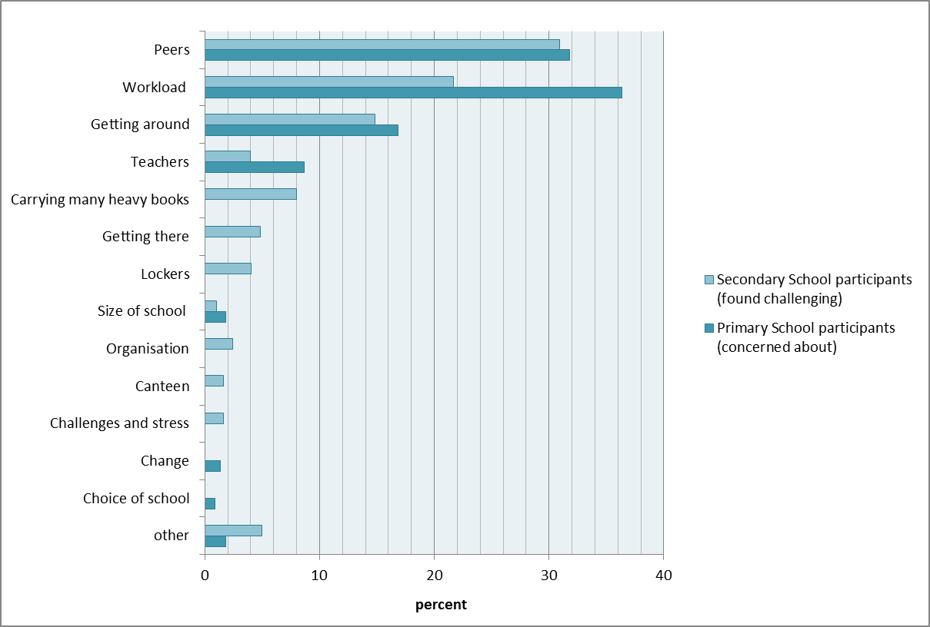
As Figure 4 demonstrates, there was again marked consistency in the things primary school participants reported feeling nervous about prior to starting Year 7 and the things secondary school participants reported being the most challenging once they were actually there. The three most common themes to emerge were ‘getting around’, ‘workload’, and ‘peers’.
Getting around – Primary school participants were concerned that moving to a bigger and unfamiliar school would result in them getting lost. Many were also afraid that this would result in being late and subsequent punishment. Secondary school participants reported that, yes – they did get lost, but only at first. They found their way around eventually and teachers were patient while this learning occurred.
Workload – As discussed above, primary school participants were concerned with both the difficulty level and the volume of the work, particularly the homework. Responses from secondary school students suggest that this apprehension may be well-founded though they reported this as a challenge to a somewhat lesser extent than the primary school participants reported it as a fear. A particular source of worry for both year levels was homework due the following day.
Peers – This was both the largest and the most complex of the top three concerns/challenges. The extent to which concerns/challenges relating to peers were raised was similar among primary school and secondary school participants. As Figure 5 shows however, applying sub-themes to this category revealed some quite substantial differences between the anticipation and the reality.

Figure 5: Thematic breakdown of concerns/challenges relating to “peers”

As noted above, bullying was a major concern for primary school participants. Bullying was also raised by secondary school participants as a challenge but to a much lesser degree. In practice, a far greater challenge was losing or being separated from their primary school friends. In some cases this separation was physical when friends were put in a different class or even went to an entirely different school. In other cases the move to secondary school changed the nature of friendships. This was a challenge for students in-and-of-itself and also led to further challenges associated with making new friends.
Overall the consultation found that the most substantial challenges that students face in making the transition from primary school to secondary school are the increased workload and navigating changes to peer groups. Students also reported concerns about navigating their way around in a large and unfamiliar environment however these concerns appear to be quickly resolved once students get to know the school.

Improving middle-years transitions: A student perspective
Key finding:
There are many ways in which both primary schools and secondary schools can support students to make smooth transitions from Grade 6 to Year 7. These include:
- Ensuring students have access to strong support networks before during and after transition. These networks may include peers, family and teachers.
- Aligning students’ workloads so that the increase in academic expectations post-transition is manageable.
- Providing formal and informal opportunities that foster collegiality and friendship among students.
- Reducing the “unknown” for students prior to transition wherever possible.
- Providing clear avenues for students to access information about their new school.
- Employing effective strategies to address bullying.
This section seeks to address the question: How can schools better support students to make smooth transitions from primary school to secondary school? It draws on primary school participants’ experiences preparing to make the transition and secondary school participants’ experiences both before and after transition. It also presents participants’ general ideas about how transition can be better supported. Many of the ideas presented in this section were developed in direct response to the transition concerns/challenges reported by participants. As a result these findings both draw from and build on the previous section.
Throughout the course of the activities described in the previous section, primary school participants came up with hypothetical ideas designed to reduce the concerns experienced by themselves and their peers. They also gave concrete examples of things that were helping them feel more confident in the lead up to transition. Strategies relating to the key challenges raised in the previous section, as well as things that helped in a general way, are discussed below in turn.
Getting around – Primary school participants who had already paid a visit to their prospective secondary school generally reported less anxiety about getting lost at their new school. Other suggestions to help with this challenge included carrying a map and asking for help from teachers or other students if you don’t know where to go.
Workload – Primary school participants who were already being given more difficult work were more likely to report that, although the work would be harder, they felt prepared for it.
I reckon all the teachers at [my school] have been trying to prepare us for high school for years. I remember in Year 5 my teacher was telling us that we need to knuckle down if we are going to get to high school. And all the teachers in Grade 6 are helping us out heaps - giving us Year 7 work to get us prepared for high school. So I reckon everything is fine.
(Grade 6 participant)
Other suggestions to deal with the workload included: getting all the work done in class to minimise homework; getting help/support when you need it from teachers, parents, peers and tutors; and using diaries and other tools to stay organised.
Bullying – Suggestions for dealing with bullying included avoiding bullies; standing up for yourself; and getting support from peers and teachers. At one school, many participants suggested using the 5 Finger Rule, a strategy they had been taught in class, if you were bullied.
General - Students with older siblings or friends who were already attending secondary school reported less uncertainty than those who did not have access to a peer who could provide practical guidance. Students who had attended more than one primary school also reported being less anxious. Making the transition with friends was cited by many as a reason for feeling excited about the transition.
Secondary school participants were put into groups and asked to brainstorm things that were helpful to them in moving from primary to secondary school, including pre and post-transition interventions. They were then asked to rank these interventions from ‘most helpful’ to ‘least helpful’. These responses were analysed thematically, the results of which are shown in Figure 6. The number in brackets beside each theme shows its weighting, with lower numbers representing interventions that were the most helpful to participants.
Figure 6: Secondary school participants’ reports of things that supported transition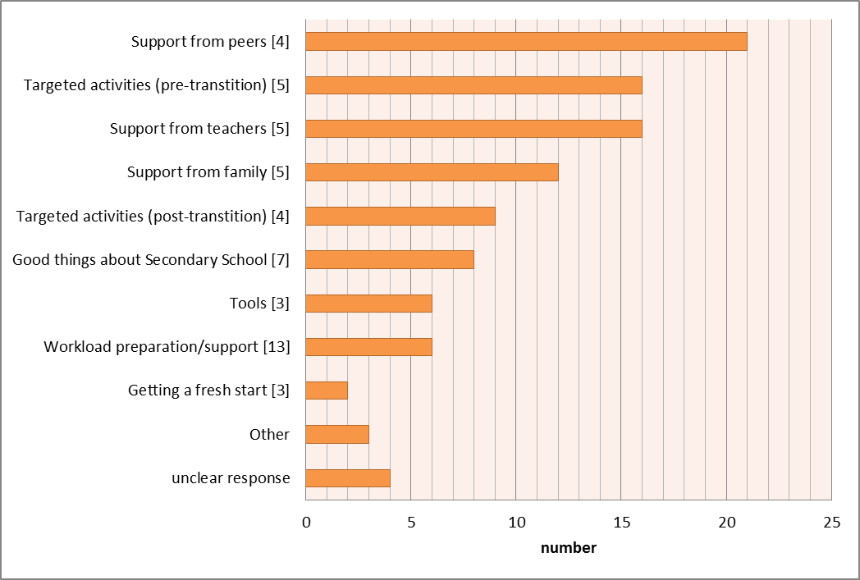

As can be seen in Figure 6, the factors most important to a smooth transition were support from others, including peers, teachers and family members, and targeted activities, both pre and post-transition.
Support from peers, teachers and family – Consistent with primary school participants’ reports in the previous section, knowing someone who already went to their new school was a great help to many secondary school participants. Knowing people in their class was also an important source of support as were teachers and family members. Older siblings were particularly helpful as they were able to provide insight into the road ahead as well as more general support.
Targeted activities – Pre-transition activities that were deemed helpful included: orientation days; information nights; and students and teachers from secondary school coming to speak at primary school. Post-transition activities that were deemed helpful included: events and activities that encourage mixing between students; and structured support from older students (e.g. buddy systems). Camps held early on in the school year were mentioned by several groups as particularly useful.
Both primary school and secondary school participants were asked to brainstorm ideas about things that schools can do to make transition easier for students. The 97 students who took part in this activity came up with a total of 234 ideas. These ideas were subject to thematic analysis, the results of which are shown in Figure 7.

Figure 7: Participants’ ideas about things schools can do to support transition (all participants)
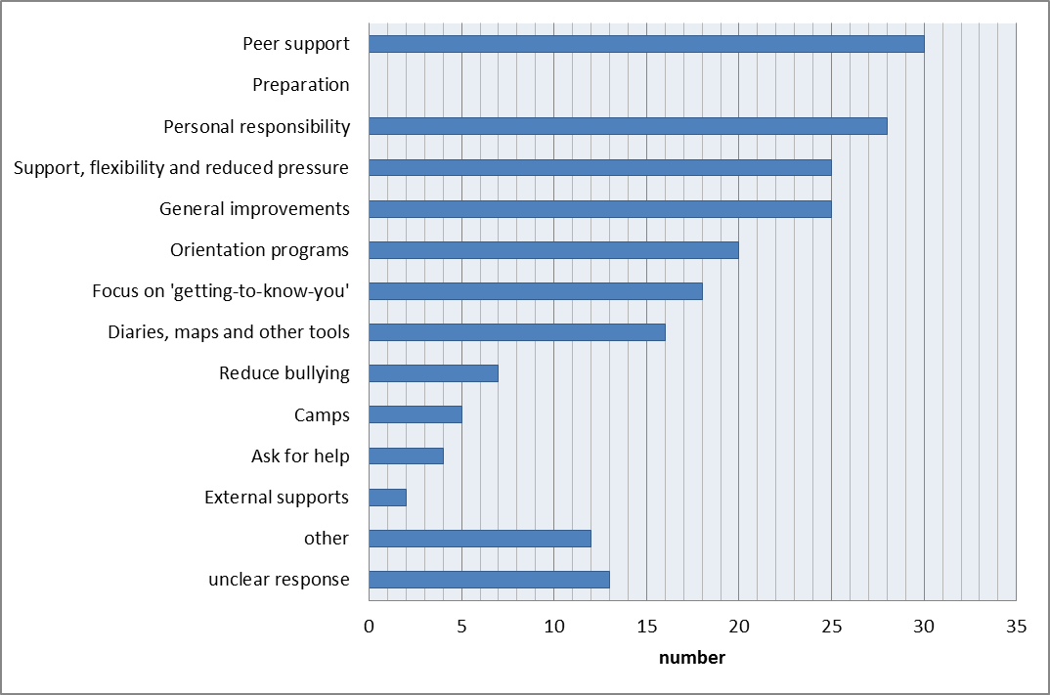
The remainder of this section is focused on providing context for each of the themes listed in Figure 7 using excerpts from the brainstorming sessions.
Peer support – Included students supporting one another within the year level in a general way as well as structured approaches to peer support both within and between year levels. Ideas for between-year-level support included buddy programs and having Year 7 or Year 8 students come and talk to Grade 6 students about what to expect.
Surround yourself with good people.
(Grade 6 participant)
Have more than 2 people from a primary school per class.
(Year 7 participant)
Get students from your high school to come and tell you what it’s like.
(Grade 6 participant)
Preparation – Participants suggested that primary schools could prepare students better for secondary school by showing them what to expect. These responses were mostly centred around the work, however participants also suggested opportunities to practise the format of high school and more workshops such as this to promote open discussion about hopes and fears.
More homework this year so we get used to the feeling of having a lot in high school.
(Grade 6 participant)
Having a day at primary school where we have schedules and we move around between the Grade 6 classes to get used to having different teachers and moving around.
(Grade 6 participant)
Personal responsibility – This category included suggestions about ways for students themselves to make their transition experience positive.
Don’t save your homework until the last minute.
(Grade 6 participant)
Listen and pay attention.
(Grade 6 participant)
Be excited and think positive.
(Grade 6 participant)
Support, flexibility and reduced pressure – This category included suggestions about how secondary schools could make Year 7 less stressful for students. Suggestions mostly related to the workload.
Extra one on one teaching.
(Year 7 participant)
Personal learning time.
(Year 7 participant)
Teachers shouldn’t give children more work than they can deal with because they might feel distressed and upset.
(Grade 6 participant)
Letting kids choose what specialists they want.
(Grade 6 participant)
General improvements – This category included suggestions about general things that students wanted at their school, such as more sports programs or bigger lockers. Suggestions made in this category did not appear to be specific to transition.
Orientation programs – This category included recommendations for structured visits by primary school students to the secondary school they will attend. Participants suggested that these visits include simulated experience of what secondary school is actually like and that they occur over two or more days.
One week where we go to high school and work with the Year 7s.
(Grade 6 participant)
Focus on “getting to know you” – This category included recommendations for structured activities, both in and out of class time, aimed at making students feel welcome in the school, supporting them to make new friends and get to know their class mates and teachers.
Interactive/team building for first few days
(Year 7 participant)
Night to meet people and make friends
(Year 7 participant)
Diaries, maps and other tools – These were seen as useful for keeping organised and avoiding getting lost. Several students suggested that these supports should be digital. The regional secondary school that took part in this research is currently using a virtual student platform that provides a nice example of how this may work in practice.
This consultation found a range of ways in which both primary schools and secondary schools can support students to make smooth transitions. These include:
- Ensuring students have access to strong support networks before, during and after transition. These networks may include peers, family and teachers.
- Aligning student’s workloads so that the increase in academic expectations post-transition is manageable.
- Providing formal and informal opportunities that foster collegiality and friendship among students.
- Reducing the “unknown” for students prior to transition wherever possible.
- Providing clear avenues for students to access information about their new school.
- Employing effective strategies to address bullying.
The next section will explore each of these areas in more depth, providing recommendations about specific strategies that may be employed by schools.

CONCLUSION
This report drew on the ideas and experiences of Grade 6 (n = 104) and Year 7 (n =51) students to address two key questions:
What are the key challenges faced by students in the transition from primary school to secondary school?
How can schools better support students to make smooth transitions from primary school to secondary school?
It found that the two most substantial challenges students face in middle years transitions are managing the increased workload and navigating peer relationships. It also identified a range of ways in which schools can support students with these challenges and others. The final section of the report incorporates the advice of VicSRC Student Executive (Exec) members to provide further insight into these findings and develop recommendations for the DET about how schools can best support middle-years transitions.
Exec members mostly agreed that managing the increased workload (78%) and navigating peer relationships (70%) are key challenges for students in the transition from primary school to secondary school. With respect to the workload, Exec members suggested that both the actual increase in the amount of work and students perceptions about the increase in the quantity and difficulty of work were sources of stress.
a) Many students are brought up being told that year 7 is a massive jump and thus in their mind the entire time during year 7 they think they are getting heaps more work thus they get worried and then stress.
b) The workload does increase especially with the larger number of subjects that students have to face and with the sudden tests, exams and assignments that were unknown in primary school. This change does bring about fear in many students.
(VicSRC Student Executive member)
Several Exec members suggested the increase in workload is manageable provided students are given some preparation in primary school and that secondary schools are flexible with students in the beginning. This is consistent with the finding of the primary school consultations that students who were already being given secondary school style work were feeling more prepared for the change.
With respect to navigating peer relationships, Exec members agreed that trying to fit in, in a new environment is a big challenge for students. Consistent with the consultation findings, several Exec members suggested that this was particularly challenging when students were separated from their primary school friends.
This is possibly one of the biggest challenges I've witnessed. Those who come from much smaller primary schools in particular have the problem with fitting in I believe as they are not used to being around so many people. Another thing for Year 7’s coming from a very small primary school is dealing with bullying as they are now around so many different people.
(VicSRC Student Executive member)
Because you are thrown into a new environment where you have to suddenly make new friends, meet new people and do things that you've never done before. Of course this is difficult especially if you have entered a school without any of your old friends (e.g. myself), it is a scary thing because of the unknown. Before Year 7s even start high school, they are doubting whether they can even make friends.
(VicSRC Student Executive member)
Those who suggested navigating peer relationships was not a big challenge explained that they were talking from their own experience and conceded that things may not be so easy in other schools. Examples of why this challenge wasn’t a problem in their school included having the camp in the first two weeks of Year 7 and going to a school that is ‘largely bully free and very open’.
In addition to the two key challenges identified through the consultation, Exec members also suggested managing the schedule, adapting to different teaching styles, making and maintaining relationships with so many teachers at once and the distance travelled to get to school as further challenges. These challenges were all raised at some point throughout the consultation but to a lesser degree than the two that became the focus of this report. Given the relatively small number of students who took part in this consultation, it may be worth exploring these ideas in future research into middle-years transitions.

Strategies and recommendations
The remainder of this section presents recommendations for the DET about strategies through which schools can better support students to make smooth transitions from primary school to secondary school. The recommendations themselves are derived from the consultation findings discussed in the previous section. These recommendations are complemented by practical suggestions for implementation that were developed using the ideas of both consultation participants and Exec members.
Recommendation #1 Ensure students have access to strong support networks before during and after transition. These networks may include peers, family and teachers.
Implementation ideas:
- Peers:
  - Provide workshops or similar opportunities that allow students to talk about their hopes and fears relating to transition.
  - Group primary students according to their destination secondary school and get them to undertake a small research project looking at what to expect at their new school.
  - Match primary school students with secondary school mentors. If possible, these matches should be made prior to transition and the younger student should have access to their mentor throughout Grade 6.
  - Create “class team groups” in Year 7 (several per class) to foster strong relationships between smaller groups of students.
- Family:
  - Communicate openly with parents of Grade 6 students about what to expect before during and after transition.
  - Provide ideas to parents about ways to support their child to adapt to secondary school (e.g. letting them know about extra-curricular activities on offer; making sure they know who to go to if they are having trouble).
  - Work with older students on ideas to support younger siblings throughout the transition period.

- Teachers:
  - Ensure that students are aware of all the different ways various members of the teaching staff can be of support.
  - Dedicate time for all teachers to get to know students in a fun way through transition days and at the beginning of Year 7.
Recommendation #2 Align students’ workloads so that the increase in academic expectations post-transition is manageable.
Implementation ideas:
- Provide opportunities for Grade 6 students to “trial” Year 7 style work, including homework. It is important that expectations and grading are still consistent with Grade 6 standards and that this does not simply result in increasing pressure on students earlier.
- Provide ‘study skills’ workshops throughout Year 7 that support students to gradually learn the skills they need for secondary school.
- Encourage collaboration between teaching staff to ensure that student workloads (particularly homework) are manageable, taking into account time for extra-curricular activities and general recreation.
- Ensure students have access to support and know who to talk to if they do become overwhelmed by the workload.
- Provide formal and informal opportunities for students to work together on homework assignments.
Recommendation #3 Provide formal and informal opportunities that foster collegiality and friendship among students.
Implementation ideas:
- Hold Year 7 camp early in term 1.
- Promote and encourage extra-curricular activities such as drama, dance, art and sport.
- Run activities in class that encourage students to socialise with a broad range of their peers.
Recommendation #4 Reduce the “unknown” for students prior to transition wherever possible.
Implementation ideas:
- Organise representatives from Year 7 and/or 8 to come and talk about their experience of secondary school to Grade 6 classes.
- Hold “Practice Year 7 days” in primary school where students move between the Grade 6 classrooms for different lessons throughout the day.
- Provide at least two orientation days.
- Ensure that orientation days include at least some experience of ‘a typical day’ in Year 7.
Recommendation #5 Provide clear avenues for students to access information about their new school.
Implementation ideas:
- Ensure that introductory information is provided in a format that students (not just parents) can easily engage with.
- Have Year 7 and/or 8 students make creative videos for Grade 6s dealing with common transition concerns.
- Provide both digital and face-to-face forums for Grade 6 students to access information and ask questions about their new school.
Recommendation #6 Employ effective strategies to address bullying.
Implementation ideas:
- Avoid barriers between groups by creating as many opportunities as possible for students to mix from the beginning.
- Promote greater collaboration between school clusters to ensure that strategies employed by primary schools to address bullying may continue to be effective in Year 7 and beyond.

APPENDIX I – PRIMARY SCHOOL WORKSHOP
Key aims:
- Identify hopes and fears relating to transition
- Identify what (if any) preparation students have had for transition and how effective they feel these strategies have been
- Get ideas from students about ways schools can better support transitions

What? | How? | Time and tools
Introduction  Purpose: Students understand: who we are; the format and purpose of the consultation; how their information will be used. | Who knows what an SRC does?  (Brief discussion with students about the purpose of an SRC. If it doesn’t come up organically be sure to mention that another purpose of an SRC is to make sure there is a way for students to give ideas about how the school is run)  I am from the Victorian Student Representative Council – or VicSRC for short. Our job is to work in a similar way that SRCs do within schools but for the whole state. So sometimes decisions need to get made that will affect all schools in Victoria.  Who do you think should get to have input on these decisions?  (Brief discussion of these ideas. If it doesn’t come up organically be sure to ask: What about students?)  At the VicSRC we believe that students have really good ideas about what’s going to work best in schools and we work really hard to make sure these ideas get through to the people who make the decisions.  That brings me to why I’m here today. At the Department of Education and Training they are doing some work to try and make the move from primary school to high school easier for students. So they have asked us to go out and talk to students about what they think.  We are going to do a few activities that will involve talking about how you are feeling about going into Year 7. There will be a little bit of writing but mostly we will be just talking. I am going to have this little tape recorder going the whole time so that we don’t forget anything. And <insert name of exec member> will be taking some notes. But only the staff at the VicSRC will see and hear these and we will destroy them when the project is done. If I ask you any questions that you don’t want to answer just tell me and we can move on.  The advice and ideas that we give to the Department of Education Training will be used to inform policies that will affect many students so there are two things that are super important. 1) Be honest! There are no wrong answers to any of the questions we are going to ask today – we just want to hear about what you think. 2) Respect one another! If we are going to come up with some really great and creative ideas today we need to make a space where everyone feels free to say their thoughts out loud – no matter how crazy they might seem at first!  You ready?! | 5-10 mins  Lollies for participation  Name tags
Take a stand  Purpose of activity:  Break the ice  Identify what (if any) preparation students have had for transition and how effective they feel these strategies have been. | (Explanation) See the markers around the room (strongly agree, agree, unsure, disagree, strongly disagree)? In a minute, am going to get you all to close your eyes while I read out a question. With your eyes still closed, I want you to think about which of the markers best matches your response to the question. Then, I want you to open your eyes and go and stand by that marker. I will then ask a few people to explain why they are standing where they are. If anyone (including me) says anything that makes you change your mind you can move (quietly!) to a different marker at any time. Once we are finished chatting I will get you to close your eyes again and I’ll ask another question.  Questions (can use in any order – skip questions that have already been covered through other discussion):  - I am excited about starting High school.  - I feel nervous about going to High school.  - The work will be much harder at High school than primary school.  - I feel pretty well prepared to go to High school.  - I think I will get lost at High school and I feel worried about this. (if they think they will get lost but are not worried about this they should disagree)  - There are way more bullies at High school than primary school.  - I think <name of primary School> is doing a good job of getting me ready to go to High school.  If it doesn’t happen organically, be sure to provide reassurance and real world examples to “myth-bust” unrealistic fears. | 20-30 minutes  A3 markers (strongly agree, agree, unsure, disagree, strongly disagree)  List of questions  Lollies for participation
Bursting the nerves  Purpose of activity:  Identify hopes and fears relating to transition  Get ideas from students about things they think would help support their upcoming transition | (Explanation) In this activity we are going to have a go at bursting some of the nerves that we talked about in the first activity. And we are actually going to physically burst them so I hope no one is afraid of balloons!! (check in with teachers before-hand to make sure there are no students for whom this activity may be traumatic and no latex allergies. If so the balloons can be replaced with another mechanism for concealing the excitement). I am going to give you each a small piece of paper, a texta, a balloon, and a piece of glad wrap. I want you to write on the piece of paper one or two things that you are excited about when you think of starting Year 7 next year. Then, I want you to fold it up tight, wrap it up in the glad wrap, put it in the balloon and blow it up.  Allow time for students to do first part of the activity.  (Explanation) Now, I want you to write on the outside of the balloon one or two things that you feel nervous about, or that you think will be difficult, in Year 7.  Allow time for students to continue the activity (hand out the detective worksheets while they are working).  (Explanation) Now comes the tricky part!! I want you all to imagine that you are detectives. Your mission is to find someone in the class and find out what they are excited about when they think about starting Year 7. BUT, there is only one way to burst the balloon. You have to come up with something to make your partner feel better about their worry that is written on their balloon.  Once you have burst the balloon you can fill in your detective worksheet. If there are any of the balloons that are really tough to burst we might have to come all back together and work as a team.  Allow time for students to compete the activity.  Bring everyone back together.  Burst any stubborn balloons that were left over and facilitate a brief discussion about the ideas that they used to pop the balloons. | 25-30 minutes  Small pieces of coloured paper  Balloons  Textas  Glad wrap  Detective worksheets  Lollies for everyone
Making transition easier  Purpose of activity:  Get ideas from students about things they think would help support their upcoming transition | Put the students into groups of approximately 5 and give them some textas and butchers paper.  (Explanation) So remember that the purpose of today is to find out what schools can do to make going from primary school to high school easier for students. I want you to think about all the things that we have talked about already today. Then, together in your group, I want you to do your best to fill your butcher’s paper with new ideas about things that schools can do to make the move from primary school to high school easier for students. Go!!  If there is time get each group to share 1 or 2 of their ideas with the group.  Address any remaining nerves/myths (e.g. any concerns about transition that are still unresolved and may play on student’s minds following the session).  Finish up with each person reading out one of the things that they feel excited about when they think of going into Year 7.  Collect all butchers paper. | Remainder of the time  Textas  Butchers paper  Lollies for participation
Where to from here? | Thanks so much for sharing your ideas with us today. We will make a summary version of the report that we send to the Education Department and send copies to your teacher to give to you.  In the meantime, if you have any questions about the project, or have some more ideas that you want to tell us about, you can email my boss at manager@vicsrc.org.au. You can also find out more about the VicSRC at www.vicsrc.org.au (write both on the board)  Thanks again!! | 5 mins

APPENDIX II – SECONDARY SCHOOL WORKSHOP
Key aims:
- Identify main transition challenges
- Identify positive strategies used by schools to support transitions
- Get ideas from students about ways schools can better support transitions

What? | How? | Time and tools
Introduction  Purpose:  Students understand who we are, the format and purpose of the consultation, and how their information will be used. | Who knows what an SRC does?  (Brief discussion with students about the purpose of an SRC. If it doesn’t come up organically be sure to mention that another purpose of an SRC is to make sure there is a way for students to give ideas about how the school is run)  I am from the Victorian Student Representative Council – or VicSRC for short. Our job is to work in a similar way that SRCs do within schools but for the whole state. So sometimes decisions need to get made that will affect all schools in Victoria.  Who do you think should get to have input on these decisions?  (Brief discussion of these ideas. If it doesn’t come up organically be sure to ask: What about students?)  At the VicSRC we believe that students have really good ideas about what’s going to work best in schools and we work really hard to make sure these ideas get through to the people who make the decisions.  That brings me to why I’m here today. At the Department of Education and Training they are doing some work to try and make the move from primary school to high school easier for students. So they have asked us to go out and talk to students about what they think.  We are going to do a few activities that will involve talking about what your experience of changing from primary school to high school was like. There will be a little bit of writing but mostly we will be just talking. I am going to have this little tape recorder going the whole time so that we don’t forget anything. And <insert name of exec member> will be taking some notes. But only the staff at the VicSRC will see and hear these and we will destroy them when the project is done. If I ask you any questions that you don’t want to answer just tell me and we can move on.  The advice and ideas that we give to the Department of Education and Training will be used to inform policies that will affect many students so there are two things that are super important:  1) Be honest! There are no wrong answers to any of the questions we are going to ask today – we just want to hear about what you think and what things were like for you.  2) Respect one another! If we are going to come up with some really great and creative ideas today we need to make a space where everyone feels free to say their thoughts out loud – no matter how crazy they might seem at first!  You ready?! | 5-10 mins  Lollies for participation  Name tags
Reflection  Purpose of the activity:  Break the ice  Get students in a good mind-frame for reflecting on their transition experience | Ask students to close their eyes for a minute and think about their first day of high school. Get them to open their eyes, find a friend or someone they feel comfortable with and share a story from their first day.  Give students a few minutes to reflect and then ask them to find a new partner and share another story.  Ask a few students at random to share their stories with the group. | 10-15 minutes
Taking the temperature on transition  Purpose of activity:  Identify main transition challenges | Give each student some stickers (same as number of thermometer posters)  (Explanation) See the posters around the room? Last week we went and spoke to students at <insert names of primary schools> and we asked them what they were nervous about when they thought about starting Year 7. At the top of each poster is one of their responses. Below the statement is a thermometer that we are going to use to rank how much you agree or disagree with the idea above. I want you to think about what starting High school was actually like. Then I want you to go and stick one of your stickers on each poster to show how much you agree or disagree with each statement based on your actual experience of starting high school (demonstrate). Does that make sense?  Allow time for students to do first part of the activity. (put a bingo card on each student’s desk while they are working)  Facilitate a brief discussion based on the outcomes of the first part of the activity.  (Explanation) You’ll see while you were gone I put a small card on your desk with 5 squares. In each square I want you to write something that was difficult about moving from primary school to high school. You might want to use some of the ideas from the poster that you agreed were challenges or you might have new ideas. You can write a mix of things that were only a little bit challenging (e.g. more books to carry) and things that were really hard (e.g. best friend going to a different high school). (if students are really stuck they can write a colour in each left over square but don’t give them this option straight up)  Allow time for students to continue with the activity.  (Explanation) Now, when I say go, your mission is to find people with the same challenges as you on their BINGO card and find out why this was a challenge for them. Once you have found three matches in a diagonal line you can shout out BINGO. Important: If you haven’t added the info about the reason this was challenging you will be disqualified and we will keep going!!  At the end of the activity get students to rank the challenges on their BINGO card from 1 to 5 with 1 being the most significant challenge.  Collect all BINGO cards. | 20-25 minutes  Thermometer posters with key concerns of primary school students as headings  Sticky dots  Blank bingo cards  Textas  Lollies for participation
What works and what could work in the future?  Purpose of activity:  Identify positive strategies used by schools to support transitions  Get ideas from students about ways schools can better support transitions | Put students into groups of around 7 and give them some coloured card rectangles and textas.  (Explanation) In this activity we are going to look at the things that helped make the move from primary school to high school easier for you. Each person in the group should take a turn to talk about the things that helped them. As new ones come up write them on a separate piece of card (only need to write each strategy once – even if it is raised by several people). Think about things that happened while you were still in Grade 6, and things that happened after you started Year 7. You might want to include things that your school organised. You might also want to include things that just happened like conversations with friends or older siblings or support from parents. You might also want to include programs that were designed to help but didn’t.  Allow time for students to do first part of the activity.  (Explanation) Now, I want you to take a look at all of the cards together and arrange them in order from things that you think are most helpful to things that you think are least helpful. Once you are happy with the order you can glue them on to the butchers paper.  Allow time for students to continue the activity.  Get each group to report back on their top 2.  (Explanation) Last thing! Take a look at the list you have there and think about all of the things we have talked about today. Now take a new sheet of butchers paper and, together in your group, I want you to do your best to fill it with new ideas about things that schools can do to make the move from primary school to high school easier for students. Go!!  If there is time get each group to share 1 or 2 of their ideas with the group.  Collect all butchers paper | 25-30 minutes  Coloured card rectangles  Textas  Butchers paper  Glue  Lollies for everyone
Where to from here? | Thanks so much for sharing your ideas with us today. We will make a summary version of the report that we give to the Education Department and we will send copies to your teacher to give to you.  In the meantime, if you have any questions about the project, or have some more ideas that you want to tell us about, you can email my boss at manager@vicsrc.org.au. You can also find out more about the VicSRC at www.vicsrc.org.au (write both on the board)  Thanks again!! | 5 mins

VAGO 2015, Education Transitions, available at <http://www.audit.vic.gov.au/reports_and_ publications/latest_reports/2014-15/20150318-education-transitions.aspx> accessed 16 July, 2015.
The VicSRC Executive is made up of 15 secondary school students from across Victoria who are elected by their peers to steer the work of the VicSRC.
A detailed account of the format of the workshops can be found in Appendix I and Appendix II.
Holdsworth 2010, 'Student engagement in transition: A student action team approach', Connect, vol. 182, pp. 18-20. Holdsworth 2009, 'Students act to improve transition', Connect, vol. 180, pp. 25-29.
Note: As a result of time constraints, only two of the four primary schools took part in this activity.

