Tool 4: A Transition Data Analysis Tool
This tool is to be used in conjunction with a report of audit/survey findings. It is best used by pairs or a small group who discuss the data findings and draw conclusions about the findings, and then consider the implications of the findings. The sharing of comments and insights within and between groups/pairs helps to build greater clarity about the findings and understanding about their implications.
Conversation | Your Comments
Findings  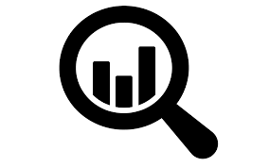  What factual statements can you make based on the data? | We found that:
Implications  Where should improvement efforts be focused? | We need to focus on improving:

