Registered bus operator risk register

School: Vermont South Special School

Supervising teachers/staff: Principal Kathryn Russo

School address: 22-30 Livingstone Road Vermont South 3133

Year Level (if relevant):

Date(s): May 2017

Location(s):

Risk Title & Description | Risk Causes & Consequences | Existing Controls | Current Risk Assessment – with existing controls |  |  |  | Treatment | Target Risk Assessment – after treatments
Define the risk event including a risk title and a short description  What can go wrong? | Describe the risk event cause/s and consequence/s.  What would cause it to go wrong? (causes)  What are the impacts if it does go wrong? (consequences) | Describe any existing policy, procedure, practice or device that acts to minimise the risk  What is in place now that reduces the likelihood of this risk occurring or its impact if it did occur? | Effectiveness of existing controls  How effective are the current controls we have in place?  (choose one) | Current Risk Consequence  How big would the impact of this risk be if it occurred?  (choose one) | Current Risk Likelihood  How likely is this risk to occur?  (choose one) | Current Risk Rating  What is the current risk level based on the risk rating matrix? | Describe the actions to be undertaken for those risks requiring further treatments.  What will be done? Who is accountable? When will it happen? | Target Risk Consequence  (choose one) | Target Risk Likelihood  (choose one) | Target Risk Rating  What is the target risk level based on the risk rating matrix?
Risk Title  Vehicle suitability  Risk description  There is a risk that the school bus is not suitable for use | Causes  - Lack of appropriate regular maintenance  - Lack of seating  - Lack of seatbelts  - Poor vehicle visibility  - Doors that have the potential to trap passengers  - Risk of on-board fires (e.g. gas buses, loose wiring)  Consequences  - Death, injury, trauma event  - Students fail to gain targeted educational outcomes  - Disruption / cancellation of planned activity  - Reputation damage to school / DET | - Appointed School Bus Manager.  - Ongoing vehicle maintenance program.  - Drivers undertake pre-departure checks to ensure the serviceability of vehicle lights, indicators, brakes, steering etc. and anomalies logged for immediate resolution.  - Fire extinguishers are fitted and maintained in accordance with AS2444.  - Bus driver conducts head count prior to departure to ensure capacity demands do not exceed the maximum number of passengers that may safely be carried. | Ineffective  Needs improvement  Acceptable  Effective | Severe  Major  Moderate  Minor  Insignificant | Almost certain  Likely  Possible  Unlikely  Rare | Extreme  High  Medium  Low | - Develop training for staff (including fire extinguisher training).  - Develop a documented procedure that ensures that risks associated with the opening and closing of bus doors are understood (and practised) by drivers i.e. drivers are required to ensure passengers are well clear of doors prior to opening and closing. | Severe  Major  Moderate  Minor  Insignificant | Almost certain  Likely  Possible  Unlikely  Rare | Extreme  High  Medium  Low
Risk Title  Driver fitness / behaviour  Risk description  There is a risk the bus driver puts the safety of passengers at risk | Causes  - Drug and alcohol consumption  - Fatigue (including that resulting from secondary employment)  - Fitness / medical complaints  - Lack of concentration or attention  - No licence, Loss of Licence / Driver Authority  - Dangerous or hazardous driving  - Bus runs out of fuel  Consequences  - Death, injury, trauma event  - Disruption / cancellation of planned activity  - Reputation damage to school / DET | - Implementation of Drug and Alcohol Program including:  - Information and Training  - Testing Procedures  - Remedial Procedures  - Drug and Alcohol Policy.  - Driver contracted to:  - Report any loss / change to their licence / authorisation  - Report any injury or illness (including mental illness) that may affect their fitness to drive  - Renew their licence / authorisation periodically to ensure currency.  - Extra staff allocated for every bus trip so they can provide student supervision.  - Bus(es) are fuelled at the end of each operating day and the fuel level is checked prior to departure for any activity. | Ineffective  Needs improvement  Acceptable  Effective | Severe  Major  Moderate  Minor  Insignificant | Almost certain  Likely  Possible  Unlikely  Rare | Extreme  High  Medium  Low | - Develop monitoring protocol for bus drivers regarding their driver performance.  - Develop fatigue management policy including timetables constructed to ensure drivers are not required to exceed driving hours. | Severe  Major  Moderate  Minor  Insignificant | Almost certain  Likely  Possible  Unlikely  Rare | Extreme  High  Medium  Low
Risk Title  Environmental conditions  Risk description  There is a risk that road conditions change or are not favourable to safe driving | Causes  - Wet weather conditions  - Ice, snow, fog  - Unaware of weather conditions  - Bushfire  - Congested roads  - Steep or windy roads  - Unpaved or narrow roads  - Kangaroos or other animals  Consequences  - Death, injury, trauma event  - Disruption / cancellation of planned activity  - Reputation damage to school / DET | - Driver training on driving to conditions.  - Drivers to reduce speed when driving in early mornings, late afternoons and at night to avoid animal strikes  - Driver to be made aware of / assess environmental conditions prior to departure for any activity.  - Incident management system in place should an ‘incident’ occur whereby Principal notified immediately.  - School ensures drivers have means to communicate with Principal if an ‘incident’ occurs. | Ineffective  Needs improvement  Acceptable  Effective | Severe  Major  Moderate  Minor  Insignificant | Almost certain  Likely  Possible  Unlikely  Rare | Extreme  High  Medium  Low | - Develop training for drivers regarding building their capacity to locate and interpret Bureau of Meteorology data. | Severe  Major  Moderate  Minor  Insignificant | Almost certain  Likely  Possible  Unlikely  Rare | Extreme  High  Medium  Low
Risk Title  Operating environment  Risk description  There is the risk of injury to the bus driver or passengers | Causes  - Bus involved in motor vehicle crash  - Passengers moving about the bus en route  - Road users do not see a child getting on or off the bus  - The bus driver does not see a child approaching or getting off a bus  - Passenger misbehaviour (not wearing seatbelts)  - Road rage  Consequences  - Death, injury, trauma event  - Students fail to gain targeted educational outcomes  - Disruption / cancellation of planned activity  - Reputation damage to school / DET | - Driver training on driving to conditions.  - Deliver an education program for students travelling on the school bus highlighting risky behaviour e.g. not wearing seatbelts.  - Incident management system in place should an ‘incident’ occur whereby Principal notified immediately.  - School ensures drivers have means to communicate with Principal if an ‘incident’ occurs.  - Drivers instructed to document / report all incidents  - A process exists for formal warnings to parents if child misbehaves. | Ineffective  Needs improvement  Acceptable  Effective | Severe  Major  Moderate  Minor  Insignificant | Almost certain  Likely  Possible  Unlikely  Rare | Extreme  High  Medium  Low | - Develop training for drivers in School Student Code of Conduct.  - Develop de-brief procedures for any affected drivers. | Severe  Major  Moderate  Minor  Insignificant | Almost certain  Likely  Possible  Unlikely  Rare | Extreme  High  Medium  Low
Risk Title  Risk description | Causes  - xxx  Consequences  - xxx |  | Ineffective  Needs improvement  Acceptable  Effective | Severe  Major  Moderate  Minor  Insignificant | Almost certain  Likely  Possible  Unlikely  Rare | Extreme  High  Medium  Low |  | Severe  Major  Moderate  Minor  Insignificant | Almost certain  Likely  Possible  Unlikely  Rare | Extreme  High  Medium  Low

Add more rows as required. This is one way of documenting the risk management process and does not preclude other approaches. The list of risks listed here is not exhaustive and should be adapted to suit the circumstances of your activity / school.
DET Risk Process 

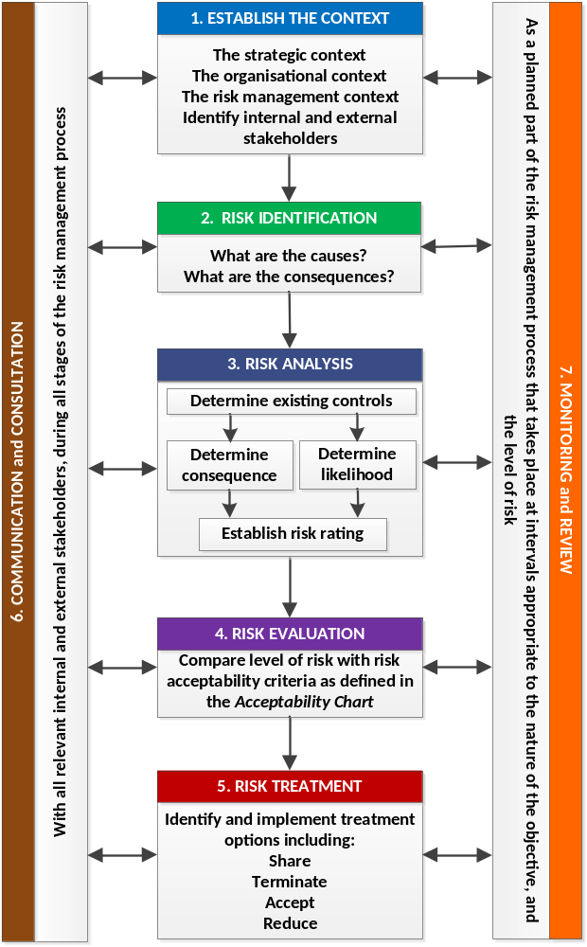

DET Risk Process
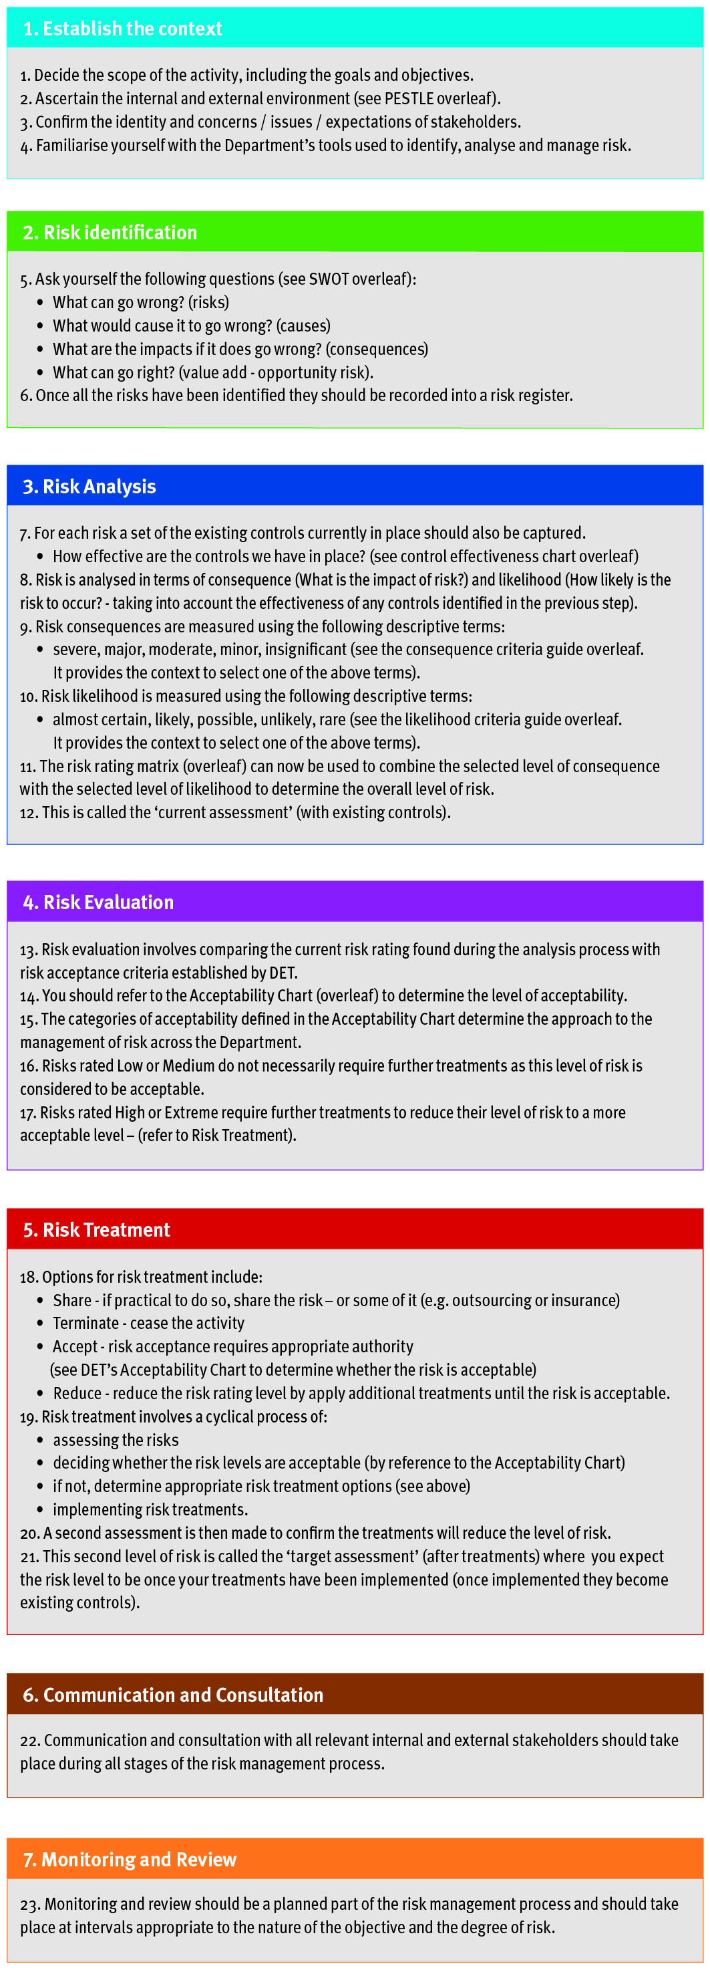
DET Risk Management Framework - Assessment Tools
Consequence Criteria: This guide provides indicative terms against which the significance of risk is evaluated.
Descriptor | Student Outcomes | Wellbeing and Safety | Finance | Reputation | Operations | Strategic
Insignificant | - Educational outcomes, engagement and wellbeing and pathways and transitions can be met with workarounds | - Minor injury requiring no first aid or peer support for stress / trauma event | - Small loss that can be absorbed | - Internal impact (no external impact) | - School operations continue with slight interruptions to normal activities | - Goals, targets and key improvement strategies can be delivered with inconsequential impacts
Minor | - Educational outcomes, engagement and wellbeing and pathways and transitions achieved but below targets | - Injury / ill health requiring first aid  - Peer support for stress / trauma event | - Loss of ‘consumable’ assets,  - < 2% deviation from budget  - Minor fraud possible | - Adverse comments local community media  - Short term stakeholder dissatisfaction / comment | - Some school operations disrupted  - Minor workarounds return school to normal operations | - Minor workaround need to be implemented to deliver the SSP goals, targets and key improvement strategies
Moderate | - Student’s overall levels of Literacy and Numeracy static  - Increasing truancy  - Partial achievement of targeted pathways and transition | - Injury / ill health requiring medical attention  - Stress / trauma event requiring professional support | - Loss of assets  - 2% - 5% deviation from budget  - External audit management letter | - External scrutiny e.g. VAGO  - Adverse state media comment  - Stakeholder relationship impacted | - Key school operations temporarily disrupted  - School leadership team meets to return school to normal operations | - Constant consultation with key stakeholders needs to be maintained to deliver the SSP goals, targets and key improvement strategies
Major | - National targeted improvements not achieved  - Partial achievement of targeted learning outcomes  - Student dissatisfaction with access to pathways/transitions | - Injury / ill health requiring hospital admission  - Stress / trauma event requiring ongoing clinical support | - Loss of significant assets  - 6% - 15% deviation from budget  - External audit qualification on accounts  - High end fraud committed | - External investigation  - Adverse comments national media  - Stakeholder relationship tenuous | - Whole of school operations disrupted  - Assistance sought from Regional Office | - Significant adjustment to resource allocation and service delivery required to deliver SSP goals, targets and key improvement strategies
Severe | - Literacy and Numeracy decline  - Student’s engagement and connectedness to the school and their peers is very poor  - Declining number of student options for pathways and transitions | - Fatality or permanent disability  - Stress / trauma event requiring extensive clinical support for multiple individuals | - Loss of key assets  - >15 % deviation from budget  - Systemic and high value fraud | - Commission of inquiry  - National front page headlines  - Stakeholder relationship irretrievably damaged | - Normal school operations cease  - School evacuated  - Regional Office notified | - SSP goals, targets and key improvement strategies cannot be delivered  - Changes need to be made to the SSP
Likelihood Criteria: This guide provides the indicative terms against which the probability of a risk event occurrence is evaluated.
Descriptor | Description | Indicative % | Indicative Frequency | Note:  - The Likelihood Criteria refers to the likelihood of the consequence descriptor you have selected i.e. the likelihood of a ‘major’ consequence.  - The Indicative Frequency may not be relevant when assessing risks related to repeated activities, or when objectives are to be delivered over discrete periods of time. It should not be the sole basis for assessment.
Almost Certain | Expected to occur | >95% | Multiple times in the next year
Likely | Probably will occur (no surprise) | 66-95% | At least once in the next year
Possible | May occur at some stage | 26-65% | Once in the next 3 years
Unlikely | Would be surprising if it occurred | 5-25% | Once in the next 5 years
Rare | May never occur | <5% | Once in the next 10 years
DET’s Control Effectiveness: Indicates the self-assessment of control effectiveness.
Controls Effectiveness Rating and Criteria
Ineffective | - The design of controls overall, is ineffective in addressing key causes and/or consequences.  - Documentation and/or communication of the controls does not exist (e.g. policies, procedures, etc.).  - The controls are not in operation or have not yet been implemented.
Needs Improvement | - The design of controls only partially addresses key causes and/or consequences.  - Documentation and/or communication of the controls (e.g. policies, procedures, etc.) are incomplete, unclear or inconsistent.  - The controls are not operating consistently and/or effectively and have not been implemented in full.
Acceptable | - The design of controls is largely adequate and effective in addressing key causes and/or consequences.  - The controls (e.g. policies, procedures, etc.) have been formally documented but not proactively communicated to relevant stakeholders.  - The controls are largely operating in a satisfactory manner and are providing some level of assurance.
Effective | - The design of controls is adequate and effective in addressing the key causes and/or consequences.  - The controls (e.g. policies, procedures, etc.) have been formally documented and proactively communicated to relevant stakeholders.  - The controls overall, are operating effectively so as to manage the risk.
DET’s Risk Rating Matrix: Used to combine consequence with likelihood to determine the overall level of risk.
Risk Rating Matrix |  | Consequence
 |  | Insignificant | Minor | Moderate | Major | Severe
Likelihood | Almost Certain | Medium | High | Extreme | Extreme | Extreme
Likelihood | Likely | Medium | Medium | High | Extreme | Extreme
Likelihood | Possible | Low | Medium | Medium | High | Extreme
Likelihood | Unlikely | Low | Low | Medium | Medium | High
Likelihood | Rare | Low | Low | Low | Medium | Medium

DET’s Acceptability Chart: Used to decide whether the risk is acceptable, based on the rating calculated.
Extreme = Unacceptable  (must have Principal / School Council / Regional Office oversight) | Immediately consider whether the activity associated with this risk should cease. Any decision to continue exposure to this level of risk should be made at Principal/School Council/Regional Office level, be subject to the development of detailed treatments, on-going oversight and high level review.
High = Tolerable  (with ongoing Principal Class Officer review) | Risk should be reduced by developing treatments. It should be subject to on-going review to ensure controls remain effective, and the benefits balance against the risk. Escalation of this level of risk to Principal Class Officer level should occur.
Medium = Tolerable  (with frequent risk owner review) | Exposure to the risk may continue, provided it has been appropriately assessed and has been managed to as low as reasonably practicable. It should be subject to frequent review to ensure the risk analysis remains valid and the controls effective. Treatments to reduce the risk can be considered.
Low = Acceptable  (with periodic review) | Exposure to this risk is acceptable, but is subject to periodic review to ensure it does not increase and current control effectiveness does not vary.
Find Risk Management on eduGate
School Cycle - where schools should use risk management
Utilise risk management at all stages of the school cycle, to drive decision making, establish priorities and allocate resources. Risk management should be based on the best information available. Effort expended should be proportionate to the risk and benefits should be balanced against the risk.

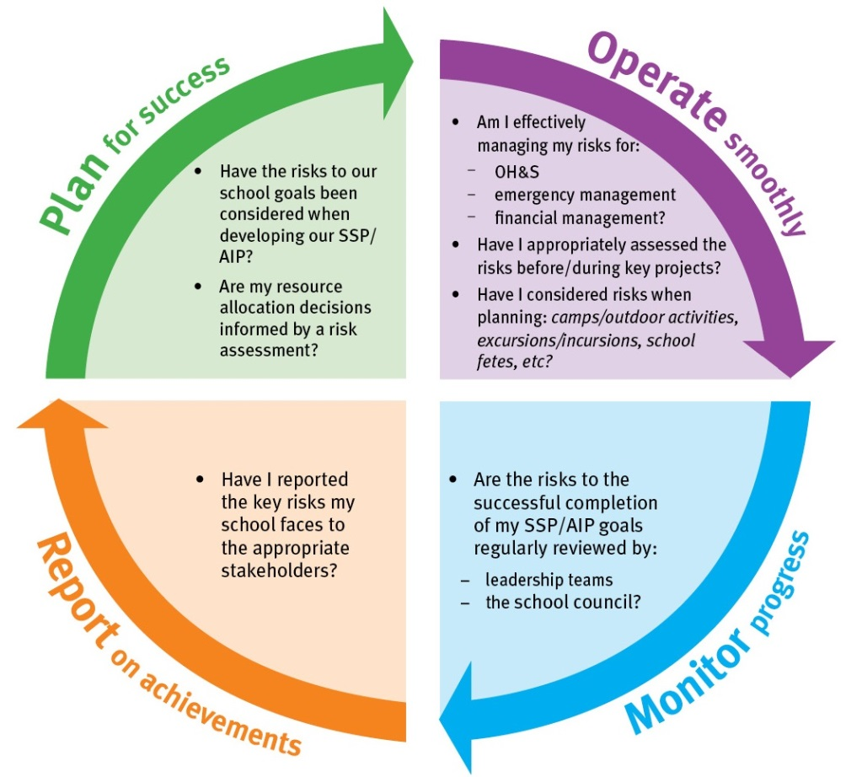

PESTLE Analysis - used to establish the context
PESTLE - (political, economic, social, technological, legal, environmental) is a useful tool to analyse the operating environment and to understand any other factors that contribute to it. It may be beneficial to involve your key stakeholders when conducting this type of analysis.

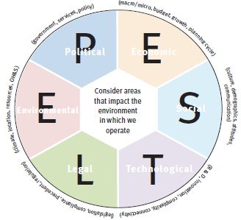

SWOT Matrix - used in risk identification
A SWOT Matrix (strengths, weaknesses, opportunities and threats) is a useful tool to analyse the environment and establish current issues and future risks. It may be beneficial to involve your key stakeholders when conducting this type of analysis.



