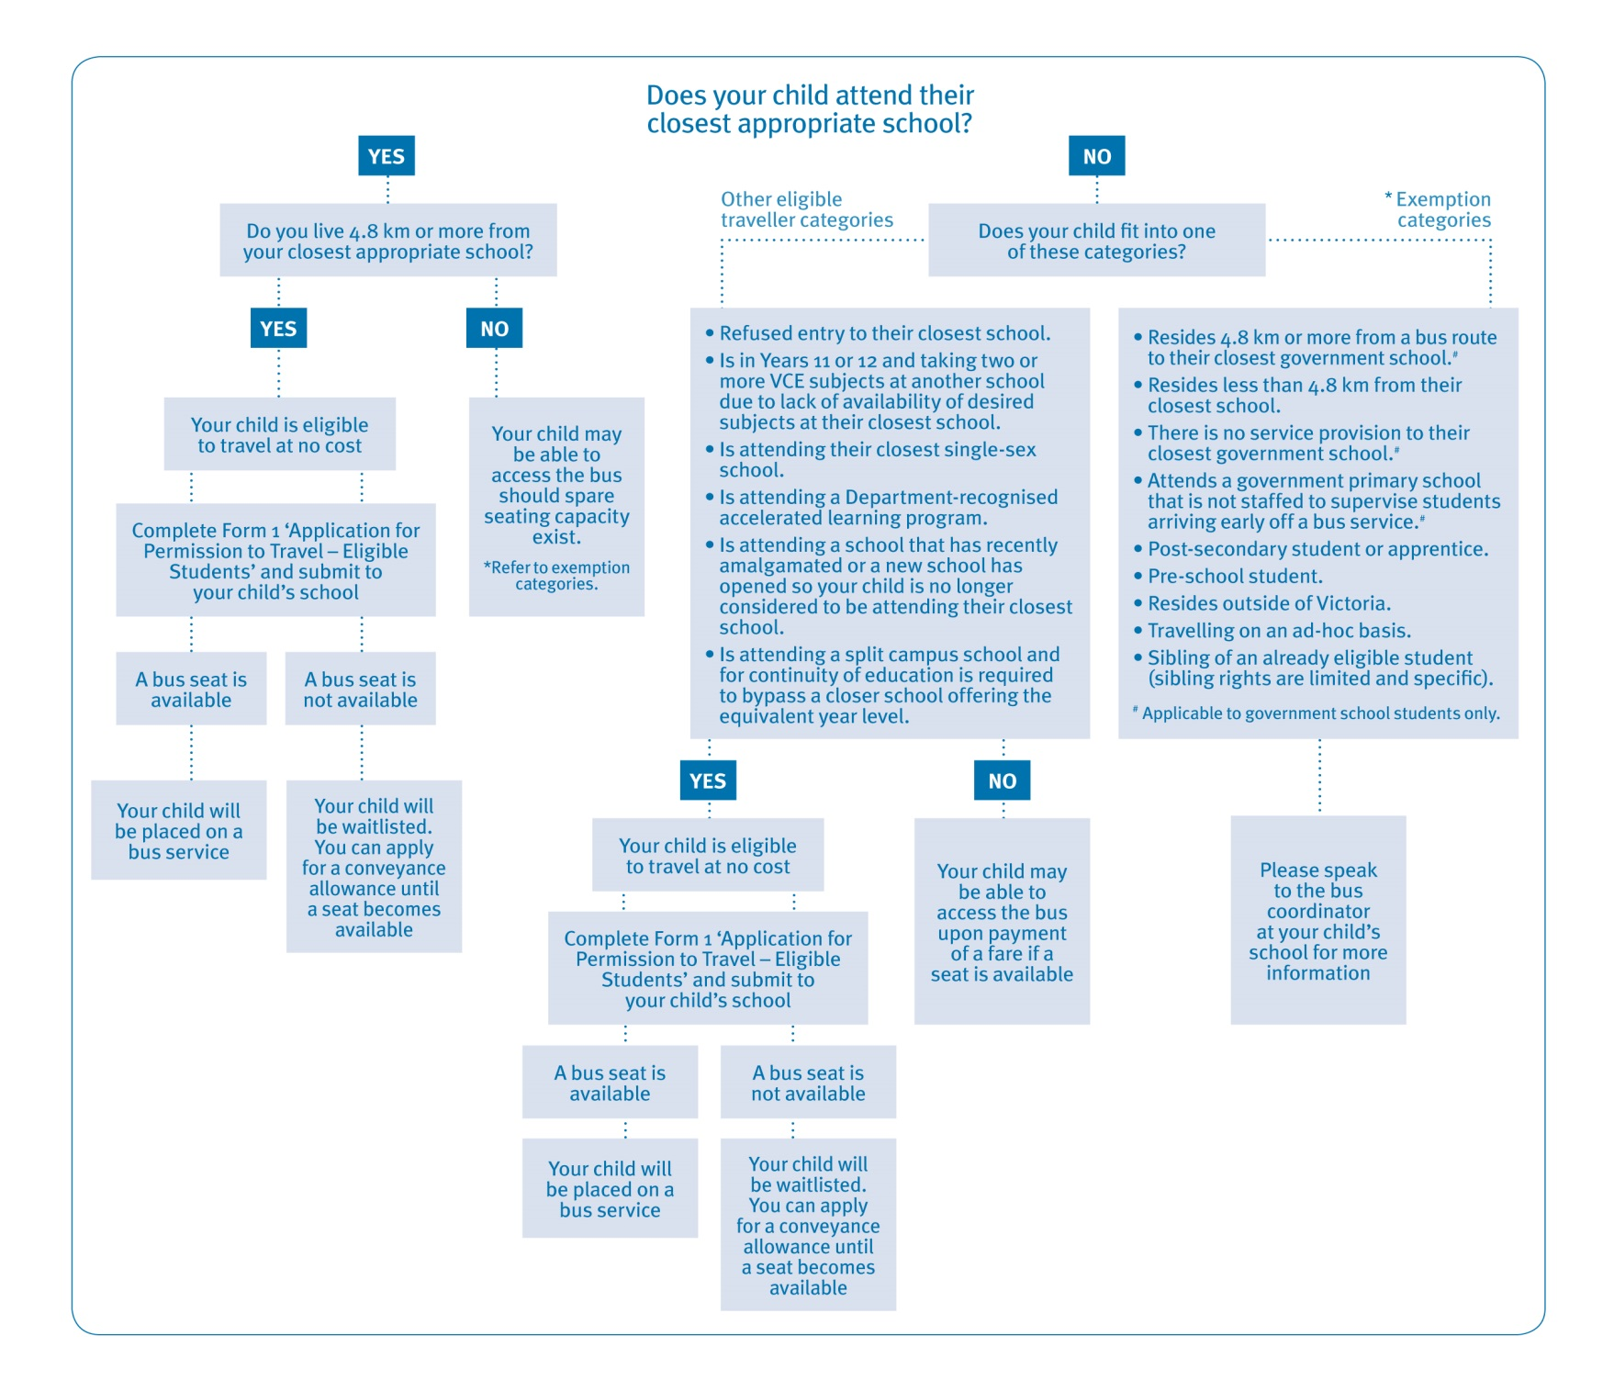
School Bus Program – Eligibility guide for families
This leaflet will help explain the School Bus Program and assist you in determining your child’s eligibility to travel on a school bus. While parents/guardians are primarily responsible for getting their children to and from school, the School Bus Program assists families in rural and regional Victoria by transporting students to school. The School Bus Program services both government and non-government schools.
Categories of eligibility determine whether a student travels at no cost or travels upon the payment of a fare. Students wishing to access a seat on a bus must complete an application form and parents/guardians must agree to the conditions of travel including, if applicable, the payment of a fare.

Public Transport Victoria (PTV) administers the School Bus Program as directed by the policy. The Student Transport Unit of the Department of Education and Early Childhood Development (DEECD) sets the policy and provides general transport advice to regional offices and schools.
To be eligible for a seat on a bus at no cost a student must:
- Attend their closest government school or closest appropriate non-government school, which is determined by the denomination of the school
- Reside 4.8 km or more from the school
- Reside in Victoria.

Students are expected to access public transport if it is within 1.6 km of their home or closer than their nearest school bus service.

Notes
Closest government school or closest appropriate non-government school
- To be eligible for travel on a school bus at no cost, government students must attend their closest school while non-government students must attend their closest appropriate school, which is determined by the denomination of the school.
- Students not attending their closest school may be accommodated on a bus service as long as they pay a fare and seating capacity exists.
- Students must reside 4.8 km or more from the school. The distance is measured by the shortest practicable route from the student’s front gate to the school’s main entrance.
Non-government school students
- Eligible government students have priority over eligible non-government students when being accommodated on services.
- Non-government students may be accommodated where capacity exists.
- Non-government students on their own do not form a case for the establishment of a new school bus service or an extension to a route.

Exemptions
- The policy has some exemptions where a student may be granted access to a bus service at no cost. These exemptions are limited and specific.
- Exemptions are not granted on the basis of financial hardship.
Fare paying
- Government and non-government students not attending their closest appropriate school are required to pay a fare as set by PTV.
- A fare paying student may be required to relinquish their seat if the service is at capacity and an eligible non-fare paying student (government and nongovernment) wishes to access the service. The status of fare paying students is assessed each term.
- Parents/guardians must agree in writing that their child will travel as long as they pay a fare and seating capacity exists.
- Parents/guardians agree to make alternative travel arrangements should their child be required to relinquish their seat.
- Fare paying students do not form a case for service retention.
Conditions of travel and parental responsibilities
- Students and parents/guardians must agree to comply with the conditions of bus travel as stated on the back of all School Bus Program travel application forms.
- Parents/guardians understand that school bus travel is a privilege and not a right.
Special cases
- Families may apply for special consideration in complex and challenging transport circumstances (not including financial hardship). An application for special case consideration can be made through the school and requires DEECD regional endorsement and any documentation that supports the case.
- Speak to your school’s bus coordinator for further information on special case consideration.
Emergency management
- In a forecast emergency school bus services will be cancelled if any part of the route is deemed at risk.
- A rapid onset emergency may result in service cancellations and buses being held at the school or if in transit, the buses returning to the school.
- Parents/guardians should familiarise themselves with the school’s school bus emergency management plans.
Further information
Go to www.education.vic.gov.au/travellingtoschool for travel application forms and the School Bus Program’s policy and procedures. For further assistance with your application, please contact the bus coordinator at the school your child will be attending.

