# School Bus Program – Administration Reform

Pilot**ublished by the Communications Division**

**Authorised by the Department of Education**

**N 978-0-7594-0743-5**

**This document is also available on the internet at**

**www.education.vic.gov.au/studenttransport**

The Department of Education and Early Childhood Development (DEECD) and Public Transport Victoria (PTV) are inviting school bus networks to participate in the pilot of the new administrative arrangements for the School Bus Program (SBP). The administration of the SBP is changing and parents will apply directly to PTV for access to the SBP. The current policy governing the SBP will not change but the new organisational arrangements will streamline processes and significantly reduce the administrative burden on schools. School bus networks involved in the pilot will be supported for the duration of the testing phase by a joint team from PTV and DEECD.

Submitting an Expression of Interest is wholly the decision of each school bus network. The following pages provide further information about the pilot, timelines and expectations.

If you wish to discuss this further, please contact DEECD’s Student

Transport Unit’s reform team –

**Jane Thomson** 9637 2215 (thomson.jane.t@edumail.vic.gov.au) or

**Rebecca Clark** 9637 3322 (clark.rebecca.r2@edumail.vic.gov.au)

# Introduction

Since 1944 the School Bus Program (SBP) has been transporting children in rural and regional Victoria to and from school. The program ensures school-aged children who live remotely and/or travel extended distances have reasonable access to education through the provision of safe and reliable transport services.

Access to the SBP is universal to all government and non-government students living outside metropolitan Melbourne and categories of eligibility determine whether a student travels at no cost or upon payment of a fare. When applied properly, the categories of eligibility ensures the fair and equal treatment of families and schools and the intent of the program is maintained.

Today the SBP transports over 70,000 students on 1,468 bus services, covering 32 million kilometres at an annual cost of $201 million. It is a worthwhile program that has created opportunity, certainty and peace of mind for Victoria’s rural and regional communities, however it is currently not working as effectively, efficiently or as fairly as it should be.

Over the past 18 months, Public Transport Victoria (PTV) and the Department of Education and Early Childhood Development (DEECD), who jointly manage the SBP, have become increasingly aware of the complexities with the administration of the program. With input from schools, they have been looking at short and long-term solutions that will assure the program’s future. This document looks at the long-term solution and the help needed from principals, schools, families and school bus networks to achieve it.

# Issues

As the SBP expanded, DEECD and PTV’s regional offices incrementally gained more autonomy over the program. Decisions affecting schools and school bus networks were increasingly made at a local level and schools took on the bulk of the administrative role with limited support from the central departments. This resulted in the program becoming localised, fragmented and compromised.

With this in mind, DEECD and PTV want to modernise the program with a more streamlined approach to its administrative processes. This move is supported by many schools who DEECD and PTV have met with.

Factors supporting an administrative change include:

* The program’s administrative workload, which falls to schools, distracts from their core business of teaching and learning.
* The size of the administrative workload is exacerbated by a cumbersome paper-based system.
* Increased awareness of the inconsistent application of the eligibility criteria between school bus networks.
* Growing recognition of the challenges schools face when collecting fares.
* Numerous decades old local agreements that no longer meet the needs of the school community or unfairly advantage one school over another.

More and more schools are keen to see change that will reduce their administrative burden while re-establishing consistency and fairness within the program.

# Moving the School Bus Program Online

## New application process

A significant step towards improving the SBP is the transitioning of the application process and some school bus management processes online. This is a logical progression that moves the program into the 21st century and will ensure all applications are treated consistently, fairly, objectively, accurately and quickly.

## How the new SBP administration system will work

The biggest change will see schools no longer processing SBP applications. Parents instead will apply online directly to PTV for access to the program. Fare collection, if applicable, and bus seat allocation will also be managed online between parents and PTV. Updated bus rolls will be sent electronically to schools from PTV. The new arrangements will significantly reduce the administrative burden on schools.

Irrespective of the new administrative arrangements, schools will continue to be integral to the SBP and will be the first point of contact for parents enquiring about the program. Schools will continue to provide information to parents about the various travel options and direct them to the PTV website to apply for the SBP. Schools will retain their roles in emergency management, the management of student behaviour and will continue to provide PTV with local advice on bus routes, bus stops and changes to routes.

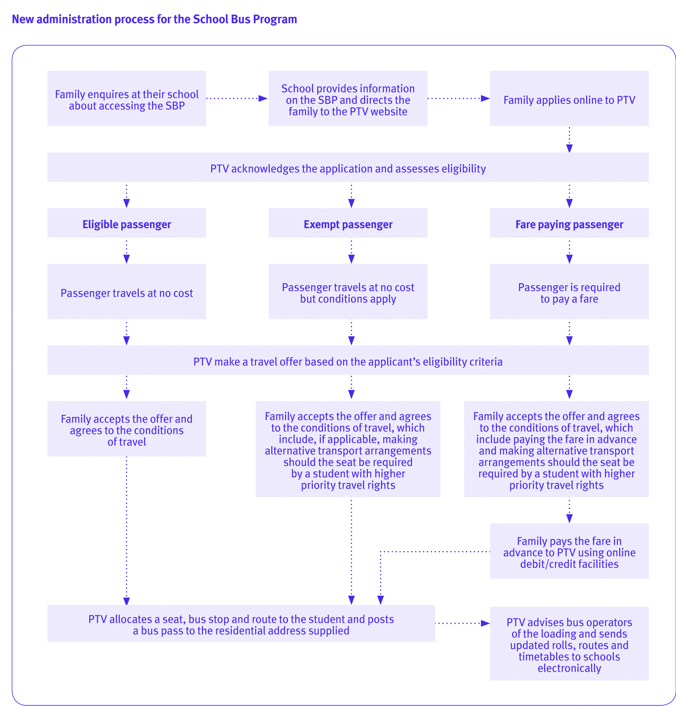

### Passenger eligible to travel at no cost

If accepted and the student is travelling at no cost, a seat, bus stop and route will be allocated once the student and parents have agreed to the conditions of travel. Once agreed to, PTV will post a bus pass to the residential address supplied and notify the school electronically of the details.

### Exempt passenger travelling at no cost

If an applicant has been determined as an exempt rather than an eligible traveller, the parents and student will be required to agree to the same terms and conditions as an eligible traveller. However, they must also agree, if applicable, to make alternative transport arrangements should the seat be required by a student with higher priority travel rights. Once the conditions are agreed to, PTV will allocate a seat, bus stop and route to the student. PTV will then post a bus pass to the residential address supplied and notify the school electronically of the details.

### Fare paying passenger

If the applicant is determined as a fare payer, then the conditions of travel require the fare to be paid in advance each term directly to PTV. Parents and the student also must agree to make alternative transport arrangements should the seat be required by a student with higher priority travel rights. Once the fare is paid and conditions agreed to, PTV will allocate a seat, bus stop and route to the student. PTV will then post a bus pass to the residential address supplied and notify the school electronically of the details.

#### Application process

A child’s eligibility for the SBP can be quickly determined once a parent has electronically submitted an application. Parents will be advised whether their child travels at no cost or upon payment of a fare. PTV will then make a travel offer, which can be accepted or declined by the parent.

Parents can monitor the progress of their child’s application online.

#### Eligible passenger categories (travel at no cost)

* Resides 4.8 km or more from their closest appropriate school.
* Refused entry to their closest school.
* Is in Years 11 or 12 and taking two or more VCE subjects at another school due to lack of availability of desired subjects at their closest school.
* Is attending their closest single-sex school.
* Is attending a Department-recognised accelerated learning program.
* Is attending a school that has recently amalgamated or a new school has opened so they are no longer considered to be attending their closest school.
* Is attending a split campus school and for continuity of education is required to bypass a closer school offering the equivalent year level.

#### Exempt passenger categories (travel at no cost)

* Resides 4.8 km or more from a bus route to their closest government school.*
* Resides less than 4.8 km from their closest school.
* There is no service provision to their closest government school.*
* Attends a government primary school that is not staffed to supervise students arriving early off a bus service.*
* Post-secondary student or apprentice.
* Pre-school student.
* Resides outside of Victoria.
* Travelling on an ad-hoc basis.
* Sibling of an already eligible student (sibling rights are limited and specific).

*Applicable to government school students only.

# Role of school bus networks

## Testing the new administration system

Prior to the new administration system being rolled out statewide, we are seeking expressions of interest from school bus networks of various sizes, complexity and geographical spread to help us test the system.

The testing phase is an opportunity for school bus networks to be at the forefront of change by providing feedback that will contribute towards the refinement of the SBP online administration system to ensure it meets the needs of schools and families now and into the future.

Preferably, all schools within a network should agree to participate and have the capacity to do so for the duration of the 20 month pilot, which commences in April 2015. PTV and DEECD are leaving it to the discretion of each school bus network to determine whether there is enough support to successfully participate in the pilot.

## What it means to be part of the pilot

Once a school bus network has been selected to participate in the pilot, there will be two phases.

**1.** Transition phase

**2.** Pilot testing phase.

### Transition phase – Jul 2014 - Apr 2015

In the lead up to April 2015, selected school bus networks will, with support of PTV and DEECD, have nine months to prepare for the transition to the new administrative arrangements. Support with communicating to families will be offered to ensure school bus networks are ready, prepared and confident when they switch administration systems.

### Pilot testing phase – Apr 2015 - Dec 2016

From April 2015, school bus networks operating as part of the pilot will transition completely to the new administration system. School-based processing of applications and seat and route allocation will cease at all school bus networks participating in the pilot.

Parents and school bus networks will be invited by PTV to provide feedback and suggestions on such things as the ease, navigability, speed, and aesthetics of the new administrative system. PTV will assess, refine and enhance the system based on feedback received. Feedback and suggestions may be collected through online surveys, face-to-face meetings or over the phone.

Towards the end of the pilot an evaluation will be conducted. This evaluation will determine if any enhancements need to be made to the system and the phasing of the roll out of the new SBP administration system statewide.

Please note: that additional school bus networks may join during the pilot and this will be at the discretion of PTV and DEECD.

## Interested?

If your school bus network is interested in participating in the pilot then an Expression of Interest (EOI) must be completed and submitted to the student transport reform team of DEECD by close of business Monday, 23 June 2014. School bus networks must be able to clearly demonstrate in the EOI their capacity, commitment and support towards the pilot.

Either a coordinating or client school can lead the development and submission of an EOI on behalf of their school bus network. EOI information can be found in the back of this booklet. Rebecca Clark ([clark.rebecca.r2@edumail.vic.gov.au](mailto:clark.rebecca.r2@edumail.vic.gov.au)) and Jane Thomson ([thomson.jane.t@edumail.vic.gov.au](mailto:thomson.jane.t@edumail.vic.gov.au)) from the Student Transport Unit’s reform team are able to assist networks wishing to submit an EOI. This support includes attending school council meetings, answering EOI queries and providing communications advice.

EOIs will be assessed by representatives from PTV and DEECD. School bus networks selected to participate will be notified by email on Monday, 14 July 2014 and will be followed by a letter of intent that confirms a network’s participation in the pilot. A school bus network may withdraw from the pilot any time prior to signing and returning the letter of intent.

# Important information principals and school councils need to know

**There is no compulsion or requirement for school bus networks to participate in the pilot of the new administration system. It is up to the schools in each network to decide whether they wish to submit an EOI.**

#### No change to the School Bus Program’s eligibility criteria

The SBP policy will be applied the same way to schools participating in the pilot as those networks continuing to use the paper-based system. The new arrangements affect the administration of the program only and not the policy.

#### Short-term plans for the School Bus Program

Running parallel to the pilot are the information forums on the SBP. The School Bus Program’s Policy and Procedures document (formerly Contract School Bus Guidelines) were reissued to schools in November 2013. While the document was renamed, reformatted, reordered and had ambiguities clarified, no changes were made to the policy. SBP forums designed to educate and re-familiarise schools with the eligibility criteria and fare collection are being held across the state. The forums also briefly touch on the pilot of a new administration system.

As well as the reformatted policy, additional supporting SBP information has been developed including an eligibility guide for parents and FAQs. This information, including the policy can be found at [**www.education.vic.gov.au/studenttransport**](http://www.education.vic.gov.au/studenttransport). Click on the School Bus Program link.

#### Role of school councils

All school councils should be consulted prior to submitting an EOI. If required, during the submission period PTV and/or DEECD can attend meetings to brief school councillors. While an EOI will not require separate motions from each school council, it will require evidence from the school leading the EOI that all school councils have been consulted and there is general support for the network’s participation in the pilot.

#### Consultation between a school bus network

It is desirable that all schools contemplating submitting an EOI have the support of their school bus network. It is important all schools are consulted and it is understood that levels of support may vary between schools. It is important that schools act in good faith and contribute positively towards the pilot if their school bus network is selected to participate.

#### Informing families

Schools may wish to inform families of a school bus network’s intention to submit an EOI through newsletters and school council representatives. Greater emphasis on communicating with families will be required once a school bus network is selected to participate in the pilot. DEECD and PTV will assist networks to communicate with families during the transition phase.

#### Status of student travellers prior to the pilot

The travelling status of students attending schools participating in the pilot and accessing the SBP prior to Monday, 13 April 2015 will remain unchanged for the duration of the pilot. This means current students who are incorrectly travelling at no cost and attending a school participating in the pilot will be grandfathered for the period of the pilot. The status of these travellers may be reviewed at the end of the pilot.

No sibling rights apply. Younger siblings of students grandfathered during the pilot and who are applying for the SBP for the first time from Monday, 13 April 2015 will be considered new applicants. New applicants will be assessed according to the policy using the new SBP administration system, which may assess them as having to pay a fare.

#### Roles of coordinating and client schools during the pilot

Coordinating and client schools will continue to have important roles during the pilot. However, the roles of both schools will be reduced due to the bulk of the SBP administrative processes moving online and to PTV. Nonetheless, coordinating and client schools remain important to the SBP and retain the responsibilities listed below.

##### Coordinating schools

##### Coordinating schools - emergency management

Coordinating schools will retain responsibility for the emergency management of school buses. The **School Bus Program Emergency Management Operational Guidelines** that were issued in 2013 (and updated in February 2014) will continue to apply during the pilot of the new administration system. This supports the emergency management principle that emergencies are best managed locally, where practicable.

**All emergency management procedures and reporting lines remain and are unchanged.**

##### Coordinating schools - student behaviour

Coordinating schools will retain responsibility for the management of their students’ behaviour on bus services. It will continue to be managed at a local level. Refer to the **School Bus Program Policy and Procedures document** for further information on the process for managing student behaviour.

##### Coordinating schools - planning, reviewing and changing of bus stops and routes

Schools’ local knowledge is essential to PTV’s planning. Therefore, coordinating schools participating in the pilot will continue to have input into the planning, reviewing and altering of bus routes, stops and services. Coordinating schools will also continue to be consulted as part of school bus reviews. Refer to the **School Bus Program Policy and Procedures document** for further information on the process for the planning and reviewing of bus routes and stops.

##### Client schools - emergency management

During the pilot of the online administration system, client schools will continue to adhere to **The School Bus Program Emergency Management Operational Guidelines** that were issued in 2013 (and updated in February 2014).

**All emergency management procedures and reporting lines remain and are unchanged.**

##### Client schools - student behaviour

During the pilot coordinating schools will retain responsibility for the management of their students’ behaviour on bus services. Refer to the **School Bus Program Policy and Procedures document** for further information on the process for managing student behaviour.

##### Client schools - planning, reviewing and changing of bus stops and routes

Schools’ local knowledge is essential to PTV’s planning. Therefore, client schools participating in the pilot will have input into the planning, reviewing and altering of bus routes, stops and services. Client schools will also continue to be consulted as part of school bus reviews.

#### Support provided by PTV and DEECD

An experienced project team comprising members from DEECD and PTV has been assigned to support school bus networks from the commencement of the EOI process to the conclusion of the pilot. In the initial stages, school bus networks are likely to have the most contact with the team from DEECD but as the pilot progresses they are likely to have more contact with the operational team from PTV. Support provided by DEECD and PTV will be general, technical, operational and may be conducted through face-to-face meetings, telephone, video conferencing and email.

#### Departmental discretion

It will be at PTV and DEECD’s discretion whether a school bus network is selected to participate in the pilot. PTV and DEECD must have confidence that a school bus network has the capacity, resourcing and the commitment to manage the pilot. PTV and DEECD must also ensure a range of school bus networks are represented in the pilot and that selected networks vary in size, complexity and geography.

# FAQs

#### 1. How long is the pilot for?

The pilot starts in April 2015 and is for up to 20 months. The reasons for the extended period are twofold. Firstly, April is a quieter period as there are fewer SBP applications to process. This will give school bus coordinators and networks time to familiarise themselves with the new administrative arrangements. By the time the busy period starts in Term 4, school bus coordinators will have greater confidence in guiding families in the use of the online system. Secondly, schools operate in calendar years and for practical reasons the pilot must run over a calendar year.

#### 2. Will we receive training?

Yes. All school bus coordinators will be trained in how the new SBP administrative system works. They will also be provided with information to give to families enquiring about the SBP.

#### 3. What happens to students already on the system?

Students already accessing the SBP will be transitioned to the online system in time for April 2015.

#### 4. What if a student turns up at a bus stop without a bus pass?

This procedure remains unchanged and as stated in the School Bus Program Policy and Procedures document; any unauthorised student who presents at a bus stop must be accepted for travel on a bus and reported to the coordinating principal. Under the new administrative arrangements, if the situation is not resolved quickly at a local level, principals should escalate it to PTV.

#### 5. I know my local community and area much better than PTV. How can I make sure the services meet the school’s needs?

The local knowledge of schools is essential to PTV’s planning. Schools participating in the pilot will continue to have input into the planning, reviewing and altering of bus routes, stops and services. Schools will also continue to be consulted as part of the school bus review process.

#### 6. How often will PTV send updated bus roll information to schools?

Schools will be emailed updated rolls on a term-by-term basis or as and when any changes to school bus details occur. The bus rolls will detail each student’s bus stop, timetable and the route allocated to them.

#### 7. What if a family has no internet access?

Families with no internet access can either have their application submitted online by the school or be directed to another facility, such as a library, which is likely to offer free internet access.

#### 8. During the pilot what will happen to local arrangements?

Selection for participation in the pilot will not be affected by whether a school bus network has a local arrangement in place. However, irrespective of the pilot, PTV will continue its school bus reviews, which may include networks participating in the pilot. Any local agreements will be reviewed at this time.

#### 9. Will school bus networks involved in the pilot lose any bus services?

No school bus network will lose bus services because of their participation in the pilot. There will be a transition phase as schools are brought into the new arrangements during which time services are unlikely to change. However, as with current arrangements, services may be altered after that time to ensure supply is meeting demand.

#### 10. Will PTV continue their school bus network reviews?

Yes. School bus reviews will continue across all networks.

#### 11. Will coordinating schools involved in the pilot continue to receive their school bus coordinator payment?

Coordinating schools that currently receive coordinator payments will continue to do so for the duration of the pilot. There will be no additional payments for participation in the pilot and payments will be reviewed post the pilot.

#### 13. What is the relationship between bus operators and schools participating in the pilot?

The relationship between school bus networks and bus operators remains unchanged as bus operators are unaffected by the new administrative arrangements of the SBP. Schools should direct bus operators seeking information on the pilot to PTV. Bus operators will be briefed on the pilot by PTV and DEECD.

# Important dates

## Monday, 23 June 2014

Expressions of Interest close

## Tuesday, 24 June – Friday, 11 July 2014

PTV and DEECD assess EOI submissions

## Monday, 14 July 2014

School bus networks informed of selection by email

## Tuesday, 15 July 2014

Transition phase of the pilot commences

## Monday, 13 April 2015

SBP pilot commences

# Guidance for completing an Expression of Interest

Expressions of Interest (EOIs) must be submitted electronically in Word or PDF by close of business Monday, 23 June 2014 to **Jane Thomson at thomson.jane.t@edumail.vic.gov.au**

The EOI application form can also be found at **www.education.vic.gov.au/studenttransport**. Then click the on the School Bus Program link.

Contact Jane Thomson on 9637 2215 if you have any issues. Only one EOI per school bus network can be submitted.

**Please provide**

1. Contact details including details of the coordinating school if they are not submitting the EOI. Please use the EOI form provided.
2. Complete the school bus network information sheet providing the names of the schools, principals and school bus coordinators. Please also indicate the level of support from each school using the drop downs.
3. Statement of interest

The statement should discuss the four points below. Prompt points have been included to assist you with your statement of interest.

**> Expected benefits from participation in the pilot:**

* Why does the school bus network wish to participate?
* How will it benefit schools and families in the network?

**> Support for participation in the pilot:**

* What is the level of support from schools and school councils within the network?
* What is the level of support from the coordinating school?
* How were principals and school councils consulted?

**> Local issues that might affect success:**

* What issues made schools reticent about participating, if any?
* If there were any issues, how were they resolved and/or how will they be managed so as not to impede the pilot?

**> Readiness to participate in the pilot:**

* Plans the network has to keep schools working together and supportive of the pilot for its duration?
* How schools will work with PTV and DEECD in preparation for the pilot and beyond?
* Are schools willing to provide PTV with constructive feedback and suggestions on the new administration system?
* Are staff available for training on the new online system?

1. A motion from the school leading the EOI that reflects its school council’s support for the pilot and that consultation has been undertaken within the school bus network.