Professional Practice
and Performance for
Improved Learning:
School Accountability
November 2013

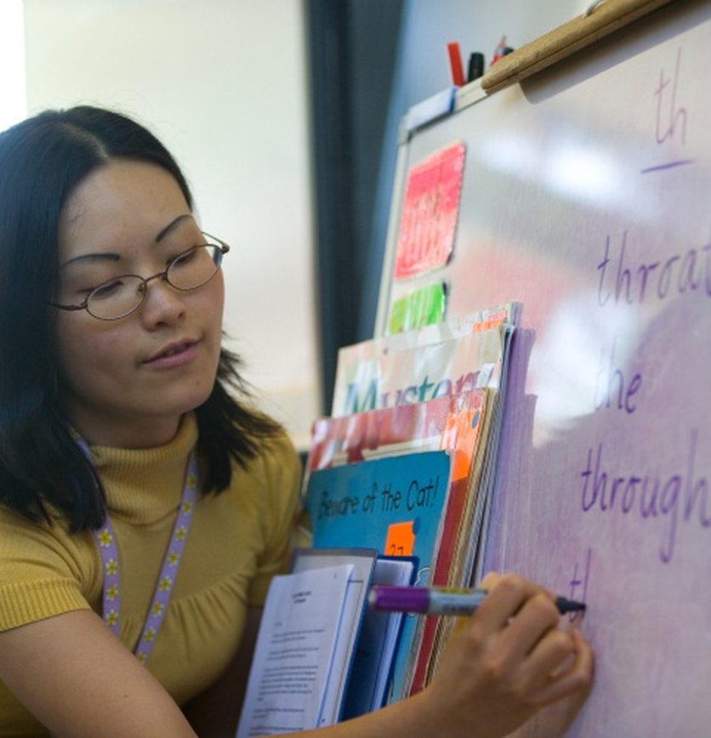
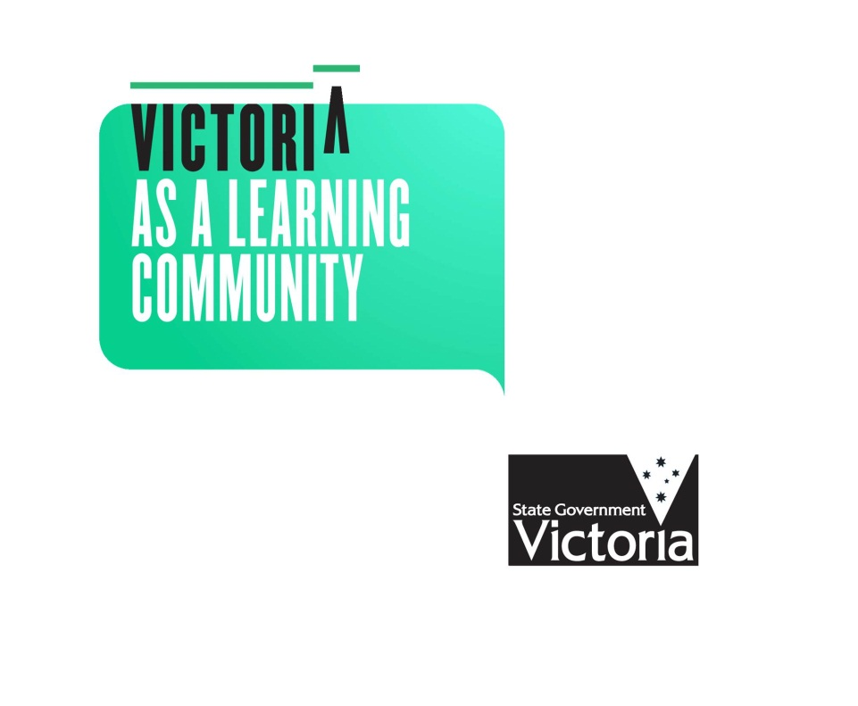
Department of Education and Early Childhood Development

Published by the
Department of Education and Early Childhood Development
Melbourne
November 2013

©State of Victoria (Department of Education and Early Childhood Development) 2013

The copyright in this document is owned by the State of Victoria (Department of Education and Early Childhood Development), or in the case of some materials, by third parties (third party materials). No part may be reproduced by any process except in accordance with the provisions of the Copyright Act 1968, the National Education Access Licence for Schools (NEALS) (see below) or with permission.

An educational institution situated in Australia which is not conducted for profit, or a body responsible for administering such an institution may copy and communicate the materials, other than third party materials, for the educational purposes of the institution.

Authorised by the Department of Education
and Early Childhood Development,
2 Treasury Place, East Melbourne, Victoria, 3002.
ISBN 978-0-7594-0701-5
This document is also available on the internet at
http://www.education.vic.gov.au/
Contents
Overview 4
1. Introduction 5
1.1. Guiding principles 6
2. A new approach to school accountability 7
2.1. Ongoing self-evaluation 7
2.2. School Review 7
2.3. Peer Review 9
2.4. Priority Review 9
2.5. Exemplary Practice Review 10
3. Intervention and support 11
3.1. Monitoring and support 11
3.2. Structured system support 11
3.3. Tailored external support 11
4. Achieving rigour through accreditation and training 12
5. Support for schools 12
6. Next steps 13
Appendix 1……………………………………………………………………………………..14
Appendix 2……………………………………………………………………………………..15

Overview
The Victorian Government is introducing a new approach to professional practice and performance in government schools. The approach is being introduced to help us achieve exceptional learning outcomes for every Victorian student.
This paper is the second in a series of five documents called Professional Practice and Performance for Improved Learning. The series introduces a new approach to measuring, monitoring and improving performance, in Victorian government schools.
This paper describes a new approach to school-based accountability arrangements.
Victorian schools will use the School Performance Framework to improve their performance by engaging their peers in a cycle of performance feedback that includes performance planning, self-evaluation, review, and performance reporting.
Key features of the new approach
- Schools will engage in self-evaluation every year
- At least once every four years schools will undertake one of two types of review: peer review or priority review
- Schools undertaking a peer review will select at least two peers from across the system and an accredited reviewer to conduct the review
- Exemplary practice will be shared across the system
- Schools undertaking a priority review will be supported by an independent review team that will carry out a four-day intensive analysis of the school’s performance
- Following a priority review, intervention and support may be initiated based on the diagnosed needs of the school
- A School Review and Intervention Services Panel has been established through which schools can enlist accredited reviewers and intervention specialists
- All school reviews will include a registration requirements check against relevant regulatory standards.

Performance above
thresholds
Peer Review
At least once every 4 years, either:

Exemplary Practice Review

Prioritisation

Priority Review

Performance below
thresholds, or where there is other evidence of significant risk to student achievement, wellbeing or engagement.
Support and intervention

Phased implementation
Most components of the new arrangements will be implemented from Term 1, 2014. Some schools have selected to undertake a review in Term 4, 2013 and will be supported to do so.
If you would like to provide feedback about this paper please email your comments to schoolaccountability@edumail.vic.gov.au.

Introduction
Over the next twelve months, a number of policies are being implemented in schools. In addition to the Government’s commitments following the 2010 election, Towards Victoria as a Learning Community, the New Directions paper and the Vision for Languages Education set out an ambitious reform agenda for education. Key elements have already commenced and build on Victoria’s strong track record of leading and implementing significant education reform over the past twenty years.
Reform proposals extend across teaching and learning, leadership, governance, accountability, resources and partnerships towards a common goal of seeing Victorian students reach the very highest levels of learning within the next ten years.
At the centre of this vision for Victoria’s education system is student learning, and an understanding that learning is about:
- what students learn (curriculum)
- how students learn and how we help them learn (pedagogy)
- how we know students are learning, where they are up to in their learning (assessment), and
- the feedback we give to students and their families on learning progress and what they need to learn next (reporting).
Improvement in student learning is only possible when this understanding is shared. To ensure students are given the best chance to thrive and succeed in a globalised economy and society, focused, collaborative effort is required to ensure we are:
- Shifting the achievement curve – ensuring that every student is challenged and supported to meet their potential, no matter what their stage on the learning journey, based on a deep understanding of their individual learning profile and the next steps they require
- Facilitating a self-improving system – establishing mechanisms and practices that enable educators to hold themselves and each other to account through their professional interactions, and support transparent accountability to the broader community
- Supporting collaboration and networks – supporting formal and informal arrangements that facilitate exchange of practice, ideas, opportunities and resources across school boundaries, and draw on the broad range of expertise available within the learning community
- Supporting leadership and professional practice – developing the expertise and professional capabilities of principals and teachers to deliver quality education for children and young people, and lead improvement in outcomes
- Maximising access and inclusion - providing quality learning opportunities for all students, with a particular emphasis on ensuring that the most vulnerable and disadvantaged are effectively engaged.
These objectives are clear in Victoria’s school reform agenda.
With this work, Victoria will improve the opportunities for all learners without exception. In doing so, the education system takes the next step in making Victoria a global leader in education, for a vibrant economy and society.

Figure 1: Victoria as a Learning Community Wheel
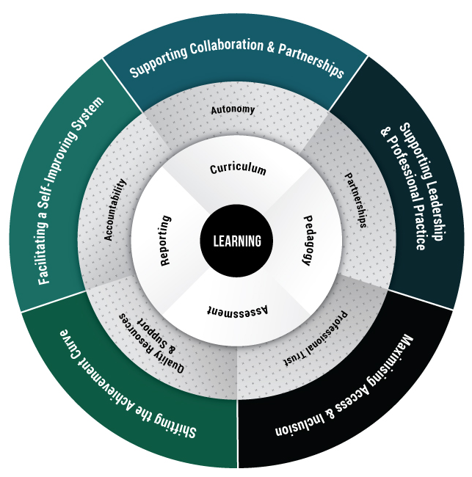

1.1. Guiding principles
The new approach to professional practice and performance builds on the global evidence base about effective accountability in schools. This evidence, and the views expressed by school leaders and stakeholders from across Victorian school communities since the release of Towards Victoria as a Learning Community, informed the development of key principles to guide the new approach. The principles are described in detail in the Overview paper, but repeated here:
- Improving students’ learning is the core of our work
- Ensuring equity and inclusion is paramount
- High expectations are non-negotiable
- The framework should be aligned and integrated to build a self-improving system
- The framework should foster a culture of accountability within local learning communities
- Autonomy is matched by accountability
- Accountability is matched by support.
- The response is swift where underperformance is identified
- Learning should be enabled across our system through providing quality feedback
- Performance expectations should be clear and consistent, with open and transparent assessment.

2. A new approach to school accountability
This paper addresses the commitment in Towards Victoria as a Learning Community to implement a new approach to accountability that helps realise the goal of exceptional learning for every child.
The School Performance Framework, introduced in the Overview paper and repeated in Appendix 1, is supported by a cycle of performance feedback that is integrated and replicated across the school. Under the new approach, the internal accountabilities that schools meet on a day-to-day basis are formalised in a structured cycle of reflection based on rigorous interrogation of evidence, broad engagement in planning for the future, and transparent monitoring of progress.
All accountability arrangements will be underpinned by quantifiable and transparent benchmarks that will be universally known and understood. These benchmarks will give a clear indication of the standards and behaviours expected of schools and professionals within the Victorian education system. They will also signal when intervention and support are necessary.
Appendix 2 comprises detailed process guides to support school planning, self-evaluation, peer validation and review, and school performance reporting. These components focus on professional interactions between peers. The specific intention is to strengthen schools’ internal accountability and build supportive professional relationships between schools.

2.1. Ongoing self-evaluation
Great schools regularly evaluate their progress. They pause to reflect, undertaking a thorough analysis of the available data to reflect on how well the human, financial, physical and information resources of the school have been deployed to achieve the goals and priorities in the school’s strategic plan.
Good self-evaluation is a powerful process of engagement. It empowers the whole school community – students, parents and carers, teachers and the community more broadly – to actively participate in a process of reflective practice. It uses an inquiry model to arrive at a shared view of the school’s strengths, achievements and future needs.
Principals and school governing bodies share responsibility for overseeing the preparation of the school self-evaluation, but this does not mean that principals and council members need to conduct the self-evaluation. Some of the most effective evaluative practice in Victorian schools has been led and conducted by students and staff, including the development of the evaluation methodology that will be used.
The self-evaluation is a significant opportunity for discussion, consultation and feedback across the whole school community, with an opportunity for active contribution and leadership from students, staff and parents.
From 2014, all schools will be expected to engage in self-evaluation annually. The process guide included at Appendix 2 details expectations. It includes the support the Department will provide in the form of templates, school examples and advice.

2.2. School Review
At least once every four years, all schools will engage in one of two types of review: peer review, or priority review. Towards Victoria as a Learning Community states that the type of review a school undertakes will be determined following assessment of the school’s performance against a consistent set of statewide measures about students’ achievement, engagement and wellbeing, and the productivity of their school (see Figure 2). Measures will be drawn from the School Performance Framework. Schools performing above key performance thresholds will engage in a peer review. Schools performing below the thresholds will engage in a priority review.
The thresholds will be determined to a significant extent by the system data available. Our system will continue to define our concept of what a world-leading learning community looks like and how we will know when we’ve achieved success. As our understanding grows we will develop other measures and include them in the thresholds. They are likely to include measures of achievement beyond literacy and numeracy, measures of within-school variance, equity and inclusion, wellbeing and students’ engagement in learning beyond school.
All reviews will
- examine a consistent set of state-wide performance measures and lead indicators
- examine curriculum, assessment, reporting, teaching practices and leadership
- examine the quality of the relationships between the school and the wider community, and any partnerships it has established
- consider how effectively school resources are deployed to achieve school priorities, including consideration of financial, physical and information resources and staffing
- make recommendations for improvement
- deliver findings that are reported to the school community and shared with the Department to increase transparency and facilitate sharing of evidence across the system.
Towards Victoria as a Learning Community

The Department is currently working with the University of Melbourne to develop a set of key performance thresholds that are fair and accurate and reflect our system goals for improvement. A draft version of the thresholds will be released in Term 4, with further consultation and refinement to take place to ensure an agreed set of thresholds are in place for 2014.
The thresholds are being constructed to ensure they:
- privilege growth in student learning outcomes as a key determinant of school performance
- provide indicators of expectations across the four outcome areas of achievement, engagement, wellbeing and productivity
- reflect high standards and expectations for success whilst appropriately accounting for school context, including school size
- are appropriate across a range of school types including specialist schools
- indicate what we are able to measure now and what we intend to measure in the future.
School Reviews and reviewers themselves will play a critical role in monitoring the performance of our system as a whole. Reviewers will collect evidence about the curriculum offered in each school, the instructional models used, the role of student voice in the school, the quality of each school’s governance and the nature of interactions with the community. Reviewers will support whole-of-system learning through conducting thematic reviews that focus on the impact of particular programs or dimensions of professional practice.
Reports from all school reviews will be publicly available.
The process guides included at Appendix 2 detail expectations for peer and priority review. They include the support the Department will provide in the form of templates, school examples and advice.

2.2.1. School review trial
Throughout Term 2, 2013, 18 Victorian government schools worked with their peers to trial the new school review processes. Of the 18 trial schools, 17 undertook a peer review and each was supported by at least two peers and a school reviewer or critical friend. One school undertook a priority review and was supported by a team of reviewers.
The evaluation of the peer review trial sought to identify any barriers to effective peer review, how these could be overcome, and the critical success factors underpinning the peer review process.
The evaluation found:
- a well facilitated, rigorous peer review was considered beneficial to participating schools. It prepared them for developing a new strategic plan and was a valuable professional learning experience for peer principals
- selecting peers with specific expertise and qualities encouraged rigorous, professional discussion at the peer review panel day
- a robust and thorough self-evaluation provided a strong foundation for successful peer review.
2.2.2. Registration requirements check
Under the new approach to school accountability and performance improvement, all school reviews conducted in Victorian government schools will include a registration requirements check, based on the Victorian Registration and Qualifications Authority (VRQA) minimum standards for school registration.
The Education and Training Reform Act 2006 establishes the principles on which school education in Victoria is based and the VRQA was established under the Act. The VRQA is responsible, among other things, for registering all schools that operate in Victoria and for ensuring that registered schools meet the standards required for registration. This includes schools offering senior secondary qualifications.
An accredited external reviewer will conduct the registration requirements check. Findings from registration requirements checks will be reported to the VRQA. Any school found to fall short of the requirements will be notified and given a timeline within which it is expected to meet the requirements. The Department will support all schools to meet the requirements through the provision of exemplars and practical guidance.

2.3. Peer Review
Peer reviews involve leaders from Victorian school communities working together to assess an individual school’s performance and co-developing a set of recommendations for improvement. The scope of peer reviews will be sufficiently flexible to match the learning needs and priorities of each school.
To ensure a high quality standard across the system, all peer reviews will be conducted by a panel of at least two peers and will be facilitated by an externally accredited reviewer. School councils have oversight of school accountability and are expected to play an active leadership role in the review.
The term peers in not intended to be limited to school principals. Schools will determine their peer reviewers following consideration of a range of factors, including local learning partnerships beyond the school and learning and development opportunities for potential future school leaders.
School council members and the community more broadly, including students and parents, will be actively involved in strategic planning, self-evaluation, review and reporting in a manner that suits a school’s local needs and accords with principles of good governance.
The accredited reviewer will support the peer review team to ensure that a high level of challenge, rigour and quality assurance is applied to the process. The accredited reviewer is responsible for documenting all peer review activity.
Peer reviews will provide an opportunity for principals to build their professional knowledge and capacity, foster collegial support, and share knowledge and experience of successful school practices.
Principals will be supported to undertake peer reviews through a combination of funding, training and access to principals identified as having quality-assured system leadership capabilities.

2.4. Priority Review
The Department has an obligation to respond when a school does not demonstrate sufficient progress or where there is other evidence of significant risk to students’ achievement, wellbeing or engagement. In such circumstances, the Department will determine the level of support or intervention required to restore the ability and autonomy of that school to self-improve. The Department will initiate this support through a Priority Review.
An independent review team, accredited and contracted by the Department, will be assembled to undertake a four-day intensive analysis of the school’s performance. Each team will have a nominated lead reviewer who will be responsible for:
- developing the terms of reference
- undertaking the fieldwork, and
- providing a written report and feedback to the school and the Department based on a thorough diagnosis of the factors inhibiting the school’s improvement.

2.5. Exemplary Practice Review
Exemplary Practice Reviews will be conducted alongside peer reviews to document and share the cultural or operational aspects of schools that exhibit exemplary outcomes in a specific area of practice. Areas of practice may include (but are not limited to):
- teaching and student learning, including curriculum, pedagogy, assessment and reporting
- leadership and governance
- relationships with community, including those with local education providers in the early childhood and higher education and skills sectors
- classroom observation
- student voice
- resource (financial, human, asset, information) management
- performance management and feedback
- professional learning.
Peers will play a strong role in identifying exemplary practice. Peer Reviews and Annual Peer Validation will provide a key opportunity for principals to identify quality practice and nominate their peers for an Exemplary Practice Review. Data will be used to validate a nomination by confirming that a school’s performance is of a sufficiently high standard to qualify.
Figure 2: School review determination process
Peer Review
Performance above
thresholds
Principals are supported by at least two peers, plus an externally accredited reviewer, to conduct a review of the school’s performance, leading to the development of a new four year school plan.
At least once every 4 years, either:

Schools may self-select into Priority Review at any time.
Exemplary Practice Review
Where peers have identified exemplary practice in a specific field of practice, a review will be initiated to document that practice so that it may be shared with the broader Victorian learning community.

Prioritisation*
Priority Review
An accredited review team (of 1 to 4 people, depending on school size and complexity and which may include principals) is appointed to undertake an in depth diagnosis of the causes underlying the school’s below threshold performance. Feedback is provided to the community by the review team.
Performance below
thresholds, or where there is other evidence of significant risk to student achievement, wellbeing or engagement.

Support and intervention
Given the findings from the Priority Review, support will be designed and delivered along a continuum. A design process will involve central and regional staff, school leaders and others as required. The design team will agree on interventions and their objectives, processes and timelines. Interventions will be closely monitored by Regional Services Group.

* Prioritisation: when a school is identified as performing below the key performance thresholds, a prioritisation step will consider local knowledge, additional evidence and past review activity to determine with the school the most appropriate sequencing of next steps, and specifically, which schools will undertake a Priority Review in a given year.

3. Intervention and support
Following a Priority Review, intervention and support may be initiated based on the diagnosed needs of the school. Intervention approaches will be based on the Priority Review findings and developed by a design team of school, regional and central office representatives. Support will be tailored to suit each school’s capacity to deliver improved student outcomes. Interventions will focus on strengthening the capacity of teachers and leaders to build the school’s ability to self-improve, and to sustain improvement. Interventions will be supported and monitored by senior regional officers and remain in place until the school has demonstrated it can effectively operate autonomously.
Interventions will not follow a formula. They will be restorative and tailored to suit each school’s needs, ranging through monitoring and support, structured system support, and tailored external support.

3.1. Monitoring and support
Some schools completing a priority review will have the internal capability and capacity to sustain their own improvement. If so, the Department will monitor the school’s compliance and outcomes and provide appropriate supports. Peer support through annual self-evaluation, and collaboration across networks and clusters, will be a constant source of collegiate support.

3.2. Structured system support
For some schools completing a priority review, the use of approved evidence-based tools and resources will be mandated in areas where professional practice requires improvement. These tools and resources may include, for example, a curriculum planning tool, a teaching practice model, or participation in a leadership development program offered by the Bastow Institute of Educational Leadership (Bastow).
The findings of some Priority Reviews may lead to the initiation of structured peer support programs. Leaders with expertise in fields particular to the identified organisational learning needs of a school will be invited to offer targeted support to the principal, leadership team, or specific staff. This support could take the form of mentoring or coaching.

3.3. Tailored external support
Tailored external support will be determined according to a school’s context and needs, as diagnosed through the Priority Review. A Review and Intervention Services Panel has been established to provide ready access to a suite of school improvement service providers with expertise in areas that represent common barriers to school improvement. The panel offers specialised intervention expertise in the following fields:
- leadership, focusing on providing project support to school leaders, and a focus (through Bastow) on staff culture, leadership distribution, technical leadership, and workforce management
- teaching and learning, focusing on curriculum planning and development, pedagogy and assessment
- school governance, focusing on assisting school councils and principals to develop processes and risk management systems needed to develop and maintain a high performing school
- strategic partnerships, focusing on community partnerships, productive school improvement networks, and student support and intervention
- literacy and numeracy, focusing on supporting effective instruction through coaching, mentoring and planning, and developing and implementing literacy and numeracy activities.
When more intensive intervention is required, it will be negotiated with each school’s council.
The success of all interventions will be documented and monitored.

4. Achieving rigour through accreditation and training
The Compact: Roles and responsibilities in Victorian government school education (the Compact) commits the Department to establishing and maintaining a pool of trained and accredited school reviewers (including practicing principals), to support the review process.
The Department will design and deliver an accreditation program open to reviewers and practicing principals. Intakes are scheduled to begin in Term 4, 2013, with further intakes in 2014 and 2015. The program will be delivered through Bastow and will adhere to the Institute’s high quality standards. The accreditation program will cover a range of topics, including data analysis and evaluative techniques, facilitation skills, conducting challenging professional conversations, and establishing effective protocols to guide peer learning.
Some reviews will be conducted before reviewers participate in the accreditation program. These reviews will be undertaken by reviewers accredited under DEECD’s previous review model, or those deemed to be qualified based on a proven track record of review in Victorian schools.
Appropriately qualified educational professionals (such as visiting academics and principals from other jurisdictions) may be invited to participate in school reviews on an ad hoc basis. Before this occurs, the concept of ‘deemed accreditation’ will be defined to ensure all school reviewers meet sufficient quality standards.
Principals will be supported, through funded places, to participate in the accreditation program in 2013 and 2014. This will support the building of principal knowledge and capacity in the transition to the new review processes. Funding will also be available to support the release of small school principals to participate in the accreditation program.

5. Support for schools
Schools will be provided with a grant in their year of review to engage an accredited school reviewer from the Review and Intervention Services Panel. This will provide flexibility for schools undergoing a peer review to engage a reviewer of their choice from the panel and to negotiate the appropriate timing of their review with them. Additional funding will be provided to small schools to support their participation in the review process.
To ensure access to quality assured review and intervention services, the Department is in the process of contracting a panel of review and intervention service providers. Panel members will provide support to schools in their year of review. Over time, it is anticipated that the panel could be accessed by any school at any time for review and/or intervention services.
The dollar amount of the grant to schools in their year of review will be confirmed following the completion of the procurement process for the review and intervention services panel.

6. Next steps
Most schools due for review in 2013 have elected to defer their review until Semester 1, 2014. Schools that have completed self-evaluation in 2013 and wish to undertake their review in Term 4 will be supported to do so. During Term 4, 2013, further advice will be provided to all schools that are due for review in 2013 and 2014.
Additional resources and guidelines to support school accountability processes are due for release early in Term 1, 2014. The guidelines will comprise:
- this paper (Professional Practice and Performance for Improved Learning – school accountability)
- the process guides at Appendix 2 of this paper, and
- online resources.
Ongoing development and refinement of these resources will be undertaken based on implementation feedback. The new accountability arrangements will be implemented from the beginning of Semester 1, 2014.
Comments and feedback are welcomed and can be sent to the DEECD School Accountability mailbox at schoolaccountability@edumail.vic.gov.au

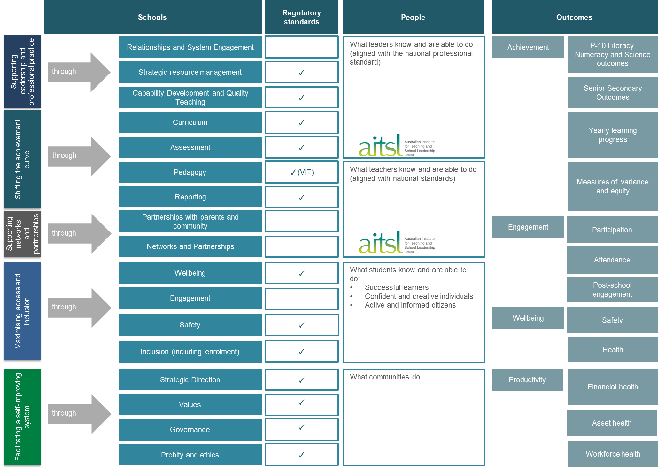

Annual Self-Evaluation & Peer Validation –
process guide
Engaging school communities, peers and the wider community (including business) in an annual cycle of self-evaluation supports whole-school learning and development. Self-evaluation is an opportunity to reflect on the school’s achievements in a systematic and comprehensive way by: conducting a thorough analysis of data from the previous year; recognising and celebrating the school’s successes; and identifying areas where the school could focus future effort. The value of the annual self-evaluation resides in the quality of the discussions within the school community and reflection on what factors impacted on the school.

A process of peer validation can extend the school’s reflective practice and inquiry by engaging with a small group of peers in a professional interaction to test the integrity of the school’s self-evaluation. Principals may select peers strategically, seeking out those with complementary strengths in areas requiring improvement. The process should be rigorous, data-orientated and outcomes-driven, with consideration given to the school context. Peer validation can be integral to moderating locally collected measures of student outcomes, and to building confidence in the quality and accuracy of these measures within and between schools. Peer validation can also be a critical mechanism for system improvement because it builds professional trust between schools, facilitates knowledge sharing, and shifts the accountability focus from the Department to peers and the community.
Key Attributes

Self-Evaluation:
- Focuses on school performance in terms of student achievement, wellbeing, engagement and productivity
- Assesses the extent to which performance has been supported by effective leadership and governance, a viable and engaging curriculum, evidence-based pedagogical practices, and a safe and orderly learning environment
- Addresses a minimum set of system-level performance thresholds
- Includes locally collected evidence of student outcomes
- Involves input from all members of the school community, including students and the school council
- Includes evaluation of progress on agreed school goals and priorities
- Reports on the school’s financial activity and budget position
- Can be made publicly available in a format that suits the needs and expectations of the local community and includes mandated Commonwealth reporting requirements resulting from receipt of National Partnerships funding
- Contributes to teacher and principal performance planning and appraisal.
Peer Validation (optional):
- Involves peers from at least two other schools
- Tests the integrity of the school’s self-evaluation and moderates locally collected measures of student outcomes
- Provides an opportunity, following the school’s self-evaluation, for professional feedback on the consistency and application of curriculum and learning standards following the school’s self-evaluation.

Annual Self-Evaluation & Peer Validation
Process Guide
Term 1
Optional annual plan template

Adjust annual plan and strategic plan if necessary
Optional communication templates

Communicate findings with staff and school community. Adjust staff performance plans if required
Self-evaluation (SE) will be an annual activity conducted during Term 4 and Term 1 of the following year.
Start
Term 4

End
Term 1

Peer/Priority Review (at least every 4 years)
Peer validation checklist
Self-evaluation guidelines
Optional templates/checklists
School Information Portal data
Regional Activity
Support/Resources
Optional SARPP involvement by invitation from principal

Optional self-evaluation report template
School Activity
Engage with peers in validation process. Complete peer validation checklist
Finalise self-evaluation, present to school council for endorsement.
Communicate self-evaluation process to the school community

Collect data (school based and school performance data)

Identify focus groups (including students, community groups), outline roles and responsibilities, and identify focus questions
Engage in self-evaluation discussion

Complete draft self-evaluation report Term 1

Identify at least 2 peers for optional peer validation process and agree on date and agenda

Peer Review – process guide
From 2014 the performance of all government schools will be assessed against a consistent set of statewide measures relating to student achievement, engagement and wellbeing. Schools with performance outcomes that meet or exceed clearly articulated performance thresholds will undertake a peer review within a four year cycle. Schools will have the opportunity to work with their peers and an accredited school reviewer, who will facilitate the peer review process. Principals will be provided with training opportunities to enhance their knowledge and understanding of school review, planning and improvement.

Peer review demonstrates professional trust in the expertise of the principal class and a commitment to profession-led school improvement. Peer review involves leaders from across Victorian schools working together to assess school performance and making recommendations for improvement by asking the questions: What are students learning? How are students learning and how is the school supporting learning? How does the school know students are learning? How are resources being used to support student learning?

Peer review will help build and sustain professional relationships between the leaders of Victoria’s schools, facilitating the exchange of knowledge and expertise and building greater levels of system knowledge in the pursuit of high quality educational outcomes for all students. Peer learning will be at the heart of peer review, providing an opportunity for principals to build their professional knowledge and capacity, foster collegial support, and share experiences of successful school practices to improve students’ achievement, engagement and wellbeing.

Key Attributes

Peer reviews will:

- Be conducted by a panel of at least two peers from the government, Catholic or independent sectors, along with the host school principal and an accredited reviewer
- Be facilitated by an externally accredited reviewer who supports the peer review team in ensuring a high level of challenge, rigour and quality assurance is applied to the process
- Examine performance against a consistent set of statewide measures, as well as lead indicators including curriculum documentation, assessment schedules, reporting, teaching practice and school leadership
- Examine the quality of relationships between the school and the wider community, including the impact of formal and informal partnerships the school has established
- Consider how effectively school resources are deployed to achieve school goals and priorities, including consideration of human, financial, physical and information resources
- Focus the discussion on high level recommendations for improvement based on the terms of reference for the review
- Undertake a registration requirements check (based on the VRQA minimum standards for school registration)
- Deliver findings that are reported to the school community and shared with the Department to increase transparency and facilitate sharing of evidence across the system
- Enhance school planning processes.

Peer Review
Process Guide
Each school participates in a performance review (either peer or priority) every four years as part of their school review cycle.
School Activity
Reviewer and Peer Activity

Region and SARPP Activity
Support/Resources
Schools notified of peer review
Term 4 Term 1 Term 4

Term 1
Conduct self-evaluation in preparation for review, drawing on previous self-evaluations
Undertake peer review, facilitated by the SR, including registration requirements check
Optional SARPP involvement by invitation from principal

Principal receives report from SR for validation and feedback from peers
SR facilitates review. SR completes registration requirements checklist and collects data
School develops strategic plan in consultation with school community. Plan is endorsed by school council, published and submitted to the Department. Accountabilities/priorities linked to leadership and staff performance plans
SR provides written review report to school, region and Performance and Accountability Branch
Region provided with report

Quality assurance of a random selection of school review reports
Review report informs principal performance and development process

Publish exemplars of peer review processes and school 4 year plans for system improvement
Principal facilitates feedback to the staff and wider school community about review findings
Engage accredited school reviewer (SR) from DEECD panel and provide data
Regions notified by Performance and Accountability Branch of peer review schools and SRs

Accredited SR selected by school to facilitate peer review
DEECD panel of accredited school reviewers
Accreditation and training programs for SR and peers
SE guidelines
Optional templates/checklists
School Information Portal data, registration requirements checklists
Select at least 2 peers, provide data and set date for review in consultation with SR and peers
SR and peers receive data
In consultation with the school community and SR, principal develops terms of reference (TOR) and methodology. Provide to peers
SR develops TOR and methodology in consultation with principal
Peer review guidelines
Optional templates/checklists

Priority Review – process guide
‘Every Victorian deserves a world-class education that gives them the skills to succeed in life. The Victorian Government is committed to lifting the performance of Victoria’s students into the global top tier.’
- Towards Victoria as a Learning Community

There are times when a school, for a variety of reasons, does not demonstrate sufficient progress or falls short of absolute minimum standards. Research suggests that timely and appropriate intervention can turn these schools around.

The Department will respond by determining the level of support a school requires to lift performance, and to restore the school’s autonomy and ability to self-improve. Where schools are performing below clearly articulated thresholds, support will be initiated through a priority review. These schools will benefit from a thorough diagnosis of their performance by an independent review team. The priority review will provide the evidence needed to ensure appropriate support. The specific support required, informed by the priority review findings, will be determined by an intervention design team. Support will be tailored to the school’s context and will aim to embed improvement strategies and support the school’s autonomous operations.

Key Attributes

Priority reviews will:
- Engage a panel of expert school reviewers who will be contracted by the Department to undertake priority reviews in schools
- Be differentiated depending on the size and structure of the school – review panels will comprise one to four reviewers
- Include four field work days undertaken by the review team after the terms of reference and methodology have been developed in consultation with the principal and the Senior Advisor Regional Performance and Planning (SARPP)
- Have a clear focus on diagnosing the major issues contributing to underperformance and undertaking a registration requirements check (based on the VRQA minimum standards for school registration)
- Include opportunities for involving external principals who can assist to build individual and system capacity and share knowledge
- Engage a lead reviewer as the point of contact for the principal
- Include a written report provided by the lead reviewer, outlining the issues contributing to underperformance
- Provide feedback through a meeting with staff, the school community and the lead reviewer.

Priority Review
Process Guide

A priority review can be triggered at any time during the school year should a school present as underperforming against the key performance thresholds and lead indicators.

School Activity

Reviewer Activity

Regional Activity

Support/Resources

4 months + (ongoing, as necessary)
2 weeks 2 weeks
Priority review triggered for schools below performance threshold (previous Extended Diagnostic Review findings also considered)

See Intervention and Support - process guide

Publish exemplars of priority review processes
QA to ensure high quality review, reports and value for money

Reviewer accreditation and training

School notified of priority review by the SARPP or regional representative

Reviewer/s centrally assigned to undertake review

Regions notify schools of priority reviews

Lead reviewer manages review process including; coordinating review team and the field work days (focus groups, classroom observation…)
SARPPs included in field work and review process where appropriate

SARPP contacted by reviewer and involved in development of TOR and methodology

Guidelines, sample letters, templates, report proformas, evaluation sheets

Principal communicates review process to school community

School actively participates in review process under direction of Lead reviewer

DEECD panel of school reviewers

Terms of reference and methodology co-constructed with Reviewer/s, principal and SARPP

Conduct self-evaluation in preparation for review, drawing on previous self-evaluations
Provide written report assessing underperformance and provide feedback to school
Diagnosis informs intervention/support

Intervention and Support – process guide
The coupling of peer-led accountability with targeted intervention and support for schools with performance outcomes below expected levels ensures all schools receive the support they need to lift Victoria’s students into the global top tier. Research suggests that underperforming schools can turn around with effective intervention involving early and determined action, targeted resources supported by strong governance and management, and simultaneous whole-school action at the leadership, teacher and classroom levels. By providing appropriate support in the domains required, the Department will maximise the effectiveness of school autonomy in Victoria.

The Department will intervene where schools are not demonstrating sufficient progress or are falling short of minimum standards. Intervention and support will be preceded by a priority review (or based on the findings of a previous extended diagnostic review where appropriate), which will provide a thorough diagnosis of the root causes behind the school’s underperformance. The diagnosis will lead to the design of tailored intervention approaches by a design team of school, regional and central office representatives. Intervention support will remain in place until the school can return to effective autonomous operation, with students’ achievement, engagement and wellbeing outcomes above the minimum thresholds.
Key Attributes

Intervention and Support will:
- Be determined by a design team with representation from the schools’ leadership team and council, the Senior Advisor Regional Performance and Planning (SARPP), and others as required
- Scope the intervention, based on the specific context and needs of the school, drawing on the diagnosis from the priority review report
- Be tailored, developed and implemented, focusing on building the capacity of teachers and leaders to sustain their school’s improvement and fostering whole-school approaches
- Be designed and delivered along a continuum, spanning:
  - Monitoring and support – a school may demonstrate the internal capability and capacity to sustain its improvement, and will be monitored and supported by the Department as needed
  - Structured system support – a school may adopt particular evidence-based approaches (for example, curriculum planning approach, teaching practice model) or receive specialised support from a high performing principal/school
  - Tailored external support – a school may receive specialised support from one or more intervention specialists who will be allocated from a panel, in accordance with the intervention design
- Include a panel of intervention specialists available to support schools requiring tailored external support. The panel will have expertise spanning the domains known to be common areas of weakness in schools in challenging circumstances (areas of focus for schools and specialists might include leadership, behaviour management, pedagogy, organisational culture, curriculum planning and community partnerships)
- Where possible, support the school’s autonomous operation within existing budget provision; however, system funding will be explored for schools that require financial assistance. The design team will determine the ability of the school to fund the agreed intervention

Intervention and Support
Process Guide

Interventions can be triggered at any time during the school year following a priority review.

School Activity

Design team

Regional Activity

Support/Resources

On completion of priority review (see Priority review - process guide), lead reviewer provides a diagnosis of the school’s performance through review report.

Third Month Second Month First Month

Term 1
Fourth Month + (ongoing, as necessary)

Term 1
Intervention/support strategies commence implementation.

Ongoing access to additional time with school reviewers if required, through the review and intervention services panel.
Ongoing regional monitoring of school and principal performance against agreed performance indicators and milestones.

School develops strategic plan in consultation with school community. Plan is endorsed by school council, published and submitted to the Department. Accountabilities/ priorities linked to leadership and staff performance plans

Where external intervention is determined, one or more intervention specialists sourced from DEECD panel according to the identified needs.

Design team convened.

Design team considers review recommendations (inviting lead reviewer where appropriate) and determines level of intervention required

Ongoing implementation and internal monitoring of progress.

School representatives participate in design team (determined on a case by case basis).

Design team determines the intervention required, sources appropriate support and develops intervention plan

Publish exemplars of intervention processes and 4 year plans for system improvement
Intervention specialists provide progress updates to SARPP.

DEECD officers with relevant expertise may be requested to participate in the design team.
SARPP monitors ongoing progress of intervention/support

SARPP leads formation of design team and intervention process

