|  |
| --- |
| **DESKTOP COMPUTERS** |
| **DELL Australia Pty Ltd** |
| **(ABN: 4600 3855 561)** |

**Current from November 2013**

|  |
| --- |
| **CONTENTS** |
| 1. **What’s available?** |
| **How do I order?** |
| **How do I obtain Hardware Support?** |
| **Who do I contact if I have a query about the Contract?** |
| **What are the Technical Specifications of the Products?** |

1. **What’s Available?**

The following table summarises the configurations of the desktop computer models available. Options to upgrade each model are provided below. More detailed technical specifications are included later in this schedule.

All purchase orders should include correct product codes and pricing from the list provided below.

| **Product Code** | **Product** | **Price $** | |
| --- | --- | --- | --- |
| **Ex-GST** | **Inc-GST** |
|  | **Entry Level Desktop – Model 1** |  |  |
| [**Optiplex 3010SF**](http://www.dell.com/au/business/p/optiplex-3010/pd.aspx?c=au&cs=aubsd1&l=en&s=bsd&~ck=mn) **–**Q# 19401977/4 | Intel(R) Pentium(R) G2130 Processor (Dual Core 3.2GHz,3MB, w/ Intel(R) HD Graphics), OptiPlex 3010 Small Form Factor Chassis with Standard Power Supply, 4GB (1x4GB) Non-ECC DDR3 1600MHz SDRAM Memory, 500GB 7200 RPM 3.5" 512e/4k SATA Hard Drive, 8X Max Slimline DVD+/-RW, Dell Professional P2214H 21.5" HAS Wide Monitor, VGA/DVI, 1GB AMD RADEON HD 7470,LP,with DVI-VGA Adapter, Internal Dell Business Audio Speaker, Dell(TM) MS111 USB Optical Mouse, Dell KB212-B USB Entry Business Keyboard, Windows(R) 7 Home Premium 32bit, 4 Yr Next Business Day Onsite Service. | **$720.00** | **$792.00** |
|  | **Standard Desktop – Model 2** |  |  |
| **Optiplex 3011 AIO** Q# 19401977/4 | Intel(R) i3-3220 Processor (Dual Core, 3MB Cache, 3.30GHz, w/ HD2500 Graphics), OptiPlex(TM) 3011 AIO Chassis w/ up to 90 Percent PSU, Non-touch, 4GB(1x4GB) DDR3 SDRAM Memory 1600MHZ, 500GB 7200 RPM 3.5" SATA Hard Drive, 8X 12.7 SATA Trayload DVD+/-RW, Dell(TM) 20" Monitor (Standard Non Touch Screen), Dell(TM) MS111 USB Optical Mouse, Dell KB212-B USB Entry Business Keyboard, Windows(R) 7 Professional 64 bit, 4 Yr Next Business Day Onsite Service | **$789.00** | **$867.90** |

The above configurations maybe modified using any of the components below. Please ensure that the correct component and pricing is detailed in the purchase order.

|  |  |  |
| --- | --- | --- |
| **Processor Upgrades** | **Ex GST** | **Inc GST** |
| Call for pricing | Call | Call |
| **Memory Upgrades** |  |  |
| 8GB (2x4GB) Non-ECC DDR3 1333MHz SDRAM Memory from 4GB | $48.00 | $52.80 |
| **Hard Drive Upgrades** |  |  |
| 1TB 7200 RPM 3.5" SATA Hard Drive | $59.00 | $64.90 |
| **Display Upgrades** |  |  |
| Dell (TM)UltraSharp U2311H 23" Wide Screen Flat Panel LCD Monitor | $48.00 | $52.80 |

1. **How do I order?**

Orders for products should be faxed or emailed to DELL. Please ensure your purchase order contains a valid quote number, delivery address, contact name & number. It is best to follow up with an email or phone call to ensure I have received your order, to avoid delays.

For assistance with ordering, quotes or information:

**Dell Direct:**

Primary Schools:Anwar_Azher[@Dell.com](mailto:Shammas_Iftikhar@Dell.com) or call 02 8972 5252 Fax: 02 8972 6252

Secondary Schools: [Ridha_Dahlan@dell.com](mailto:Ridha_Dahlan@dell.com) or call 02 8972 5694 Fax: 02 8972 6252

**Dell Accredited Education Reseller:**

**Network Neighbourhood**

Support Phone: 1300 730 548(Lucy Barton / Damien Taulien)

Support Email Address: [info@nn.net.au](mailto:info@nn.net.au), [lbarton@nn.net.au](mailto:lbarton@nn.net.au)

Fax:           1300 730 568

Address:    10 Caribbean Drive, Scoresby, VIC 3179

Website:     <http://portal.nn.net.au>

**Core Technology Partners**

Kaine Dennehy - Business Development Manager

PH: 02 8338 1111 Mob 0481 118 613

FAX: 02 8338 1101

Email: [kained@coretechnologypartners.com.au](mailto:kained@coretechnologypartners.com.au)

Support: [support@coretechnologypartners.com.au](mailto:support@coretechnologypartners.com.au)

PH: 02 88381111

**Dataflex Victoria Pty Ltd**

Support Phone: 02 6295 1999 (Cynthia Yap)

Support Email Address: [education@dataflex.com.au](mailto:education@dataflex.com.au)

Fax: 02 6295 3400

Southern Regional Manager: Michael Cefai - 0427 104 065

Email: [michael.cefai@dataflex.com.au](mailto:michael.cefai@dataflex.com.au)

**Barwon Computer Solutions**

Address: 15 The Boulevard, North Geelong, VIC 3215

Support Phone: 03 5221 8400

Support Email Address: [annie@barcomp.com.au](mailto:annie@barcomp.com.au)

Business Development Manager : Annie Vogel - [0421](mailto:michael.cefai@dataflex.com.au) 084 609

Fax: 03 5221 8284

**MYCOM PTY LTD**

Level 3, 289 Flinders Lane Melbourne Victoria 3000

Support Phone – 03 9671 3411

Support Email Address – [education@mycom.com.au](mailto:education@mycom.com.au)

(Victorian Education Manager) 0422 400 824 427 (Sam Cantwell)

Email – [sales@mycom.com.au](mailto:sales@mycom.com.au)

FAX : 03 9671 3211

Web : [www.mycom.com.au](http://www.mycom.com.au)

**Placing an order via leasing:**

To process an order via a third party leasing company there is additional documentation required. A letter from the leasing company stating that the funds are supplied by them to the school and that the invoice will be billed to them (Billing details required). In addition to this, Dell requires you to fill in third party leasing documentation to proceed.

**3. How do I obtain hardware support?**

**Schools**

Dell Technical Support for desktop and notebook computers is available 24x7 on 1800 060 889

The contract provides for next business day onsite warranty of the issue being logged with the supplier (excluding weekends and public holidays).

The desktop computer will be restored to full working order within twenty-four (24) elapsed hours of the initial arrival of the authorised technician (excluding weekends and public holidays)

DELL will ensure that products that are not able to be serviced on-site will be replaced with a product of similar or better capacity within twenty-four (24) elapsed hours of the initial arrival of the authorised technician (excluding weekends and public holidays)

DELL will ensure that products that are not able to be restored to full working order will be temporarily or permanently replaced by a product of similar or better capacity within forty eight (48) elapsed hours of the initial arrival of the authorised technician (excluding weekends and public holidays)

DELL will ensure that the restored or replaced product has been tested by the authorised technician prior to leaving the Customer’s site to the customer’s satisfaction, such that the product is able to be used for normal work purposes.

DELL will ensure the availability of the person placing a request for support (or his/her representative) before attending on site.

Hours of Service:

DELL will provide on site services during the Customer’s normal business hours. In the case of schools, this is generally between the hours of 8.30am and 3.30pm on each school day

DELL will provide help desk services from 8:00am to 5.00pm from Monday to Friday for normal working days.

**For Staff (purchases for personal use)**

For all hardware enquiries call DELL on 1800 060 889 or register a support call at the following website <Http://support.ap.dell.com>

1. **Who do I contact if I have a query about the Contract?**

Enquiries relating to the contract with Dell Computers should be directed by e-mail the Information Technology Division’s Contract Management Office to [ict.contracts@edumail.vic.gov.au](mailto:ict.contracts@edumail.vic.gov.au)

**What are the Technical Specifications of the Products?**

|  |  |  |
| --- | --- | --- |
| **Dell Optiplex 3010SF** | |  | | --- | |  | |
| The OptiPlex 3010 is designed to seamlessly integrate into the office environment and flexibly support users’ needs. Choose from three different chassis that are all optimized to maximize desk space: mini-tower, desktop, and small form-factor. The Dell OptiPlex 3010 shares the same visual identity as other OptiPlex models to offer a consistent look across the portfolio, and an All-in-One stands solution enable deployment as a single device with up to 24”displays. |  |

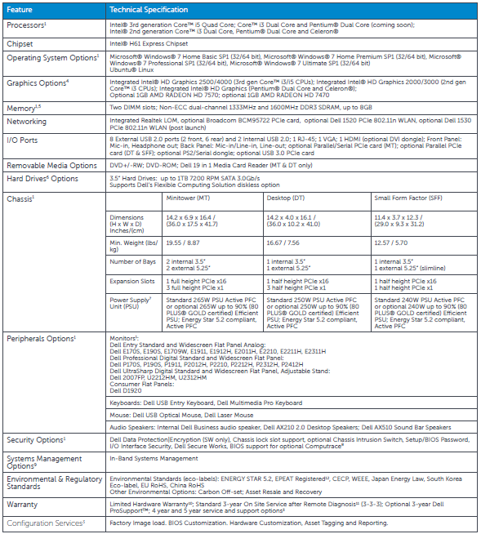

|  |  |  |
| --- | --- | --- |
| **Optiplex 3011 AIO** | |  | | --- | |  | |
| The OptiPlex 3011 All-in-One is designed to seamlessly integrate into the office environment and flexibly support users’ needs. Ideal for task workers, education and specialized deployments, this thin and space saving all-in-one desktop enables a clutter free desk environment. The cordless experience can be improved with the Dell wireless keyboard and mouse. The 20” All-in-One can be mounted on VESA mounting and offers optional wireless LAN to fit many specialized purposes or deployments. |  |

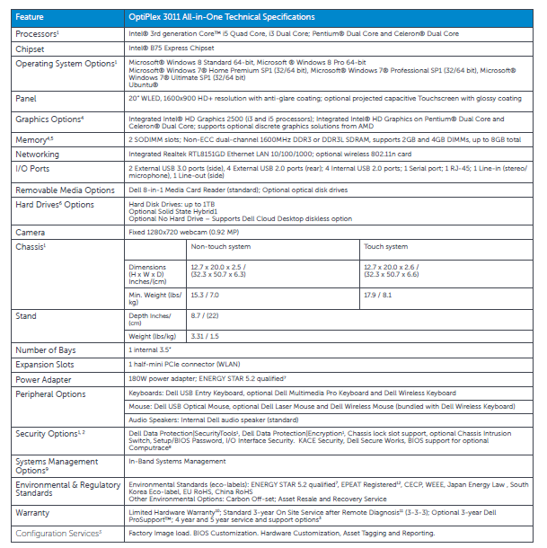

Check out this table