DESKTOP COMPUTERS
DELL Australia Pty Ltd
(ABN: 4600 3855 561)

Current from August 2014

CONTENTS
- What’s available?

How do I order?

How do I obtain Hardware Support?

Who do I contact if I have a query about the Contract?

What are the Technical Specifications of the Products?

- What’s Available?
The following table summarises the configurations of the desktop computer models available. Options to upgrade each model are provided below. More detailed technical specifications are included later in this schedule.
All purchase orders should include correct product codes and pricing from the list provided below.
Product Code | Product | Price $
Product Code | Product | Ex-GST | Inc-GST
 | Entry Level Desktop – Model 1
Optiplex 3020SF  Q# 20664077/3 | Intel® Core™ i3-4130 Processor (Dual Core, 3MB Cache, 3.40 GHz), AMD RadeonHD 8490, 1GB DDR3, LP, 1 DP 1 DVI, Windows(R) 7 Home Premium 32 bit (English), 4GB (1x4GB) NON-ECC,1600MHz Memory, 500GB 3.5inch Serial ATA (7,200 Rpm) Hard Drive, Dell KB212-B QuietKey USB Keyboard Black, Dell MS111 USB Optical Mouse, 8X Slimline DVD+/-RW drive , Chassis Intrusion Switch, Dell Professional P2214H 21.5" Wide Screen Monitor with LED Back Light, Dell Backup and Recovery Basic 1.6, Internal Dell Business Audio Speaker, 4 Yr Next Business Day Onsite Service | $720.00 | $792.00
 | Standard Desktop – Model 2
Optiplex 3030 AIO Q# 20664077/3 | Intel® Core™ i3-4150 Processor (Dual Core, 3MB Cache, 3.50GHz)  Integrated Graphics, Non-touch with Camera  Windows 7 Professional, English, 32-bit (includes Windows 8.1 Pro 32-bit License and Media)  4GB (1x4GB) 1600MHz DDR3L Memory  500GB 2.5inch Serial ATA (7,200 Rpm) Hard Drive  Intel Dual Band Wireless-N 7260 2x2 AGN  Up to 90% efficient PSU Base 49.5cm (19.5" LCD)  Dell KB212-B QuietKey USB Keyboard Black  Dell MS111 USB Optical Mouse  8X Slimline DVD+/-RW drive  AIO Stand  Dell Backup and Recovery Basic  4 Yr Next Business Day Onsite Service | $790.00 | $869.00
The above configurations maybe modified using any of the components below. Please ensure that the correct component and pricing is detailed in the purchase order.

Processor Upgrades | Ex GST | Inc GST
Call for pricing | Call | Call
Memory Upgrades
8GB (2x4GB) Non-ECC DDR3 1600MHz SDRAM Memory | $50.00 | $55.00
Hard Drive Upgrades
1TB 7200 RPM 3.5" SATA Hard Drive | $20.00 | $22.00
Display Upgrades (Entry Desktop only)
Dell Professional P2414H 23.8" Wide Screen Monitor with LED Back Light | $30.00 | $33.00

- How do I order?
Orders for products should be faxed or emailed to DELL. Please ensure your purchase order contains a valid quote number, delivery address, contact name & number. It is best to follow up with an email or phone call to ensure I have received your order, to avoid delays.

For assistance with ordering, quotes or information:

Dell Direct:
Primary Schools: Michael Lloyd-Thomas
P: 02 8972 5613 F: 02 8972 6613
E: michael_lloyd-thomas@dell.com

Secondary Schools: Michael Lloyd-Thomas
P: 02 8972 5613 F: 02 8972 6613
E: michael_lloyd-thomas@dell.com

Dell Accredited Education Reseller:

Core Technology Partners
Quotes/ Purchase orders/ Enquires
Email: education@coretechnologypartners.com.au
Free call: 1300 497 907 or 02 8338 1111
FAX: 02 8338 1101

Escalation Contact:
Dimantha Goonasekera – Education Business Manager
Mobile: 0425 397 157
Email: dimanthag@coretechnologypartners.com.au
Address: Unit 12, 809 Botany Rd Rosebery, NSW 2018

Support: support@coretechnologypartners.com.au
Online Purchasing Portal: http://estore.coretechnologypartners.com.au/schoolsvictoria
Website: www.coretechnologypartners.com.au

Barwon Computer Solutions

Address: 15 The Boulevard, North Geelong, VIC 3215

Support Phone: 03 5221 8400

Support Email Address: annie@barcomp.com.au

Business Development Manager: Annie Vogel - 0421 084 609
Fax: 03 5221 8284

Network Neighbourhood
Support Phone: 1300 730 548 (Lucy Barton / Damien Taulien)
Support Email Address: info@nn.net.au, lbarton@nn.net.au
Fax: 1300 730 568
Address: 10 Caribbean Drive, Scoresby, VIC 3179
Website: http://portal.nn.net.au

MYCOM PTY LTD

Level 3, 289 Flinders Lane Melbourne Victoria 3000

Support Phone – 03 9671 3411

Support Email Address – education@mycom.com.au

(Victorian Education Manager) 0422 400 824 427 (Sam Cantwell)

Email – sales@mycom.com.au

FAX : 03 9671 3211

Web : www.mycom.com.au

Placing an order via leasing:
To process an order via a third party leasing company there is additional documentation required. A letter from the leasing company stating that the funds are supplied by them to the school and that the invoice will be billed to them (Billing details required). In addition to this, Dell requires you to fill in third party leasing documentation to proceed.
3. How do I obtain hardware support?
Schools
Dell Technical Support for desktop and notebook computers is available 24x7 on 1800 060 889
The contract provides for next business day onsite warranty of the issue being logged with the supplier (excluding weekends and public holidays).
The desktop computer will be restored to full working order within twenty-four (24) elapsed hours of the initial arrival of the authorised technician (excluding weekends and public holidays)
DELL will ensure that products that are not able to be serviced on-site will be replaced with a product of similar or better capacity within twenty-four (24) elapsed hours of the initial arrival of the authorised technician (excluding weekends and public holidays)
DELL will ensure that products that are not able to be restored to full working order will be temporarily or permanently replaced by a product of similar or better capacity within forty eight (48) elapsed hours of the initial arrival of the authorised technician (excluding weekends and public holidays)
DELL will ensure that the restored or replaced product has been tested by the authorised technician prior to leaving the Customer’s site to the customer’s satisfaction, such that the product is able to be used for normal work purposes.
DELL will ensure the availability of the person placing a request for support (or his/her representative) before attending on site.
Hours of Service:
DELL will provide on site services during the Customer’s normal business hours. In the case of schools, this is generally between the hours of 8.30am and 3.30pm on each school day
DELL will provide help desk services from 8:00am to 5.00pm from Monday to Friday for normal working days.

For Staff (purchases for personal use)
For all hardware enquiries call DELL on 1800 060 889 or register a support call at the following website Http://support.ap.dell.com

- Who do I contact if I have a query about the Contract?
Enquiries relating to the contract with Dell Computers should be directed by e-mail the Information Technology Division’s Contract Management Office to ict.contracts@edumail.vic.gov.au
What are the Technical Specifications of the Products?
Dell Optiplex 3020SF
The Dell OptiPlex 3020 provides great customer value and performance, featuring 4th Generation Intel® Core™ processors for reliable workplace productivity while also delivering peace of mind with best-in-class security. This system was developed to meet users’ workplace requirements. Available with up to Intel® Core™ i5 Processors, Intel® HD Graphics 4600, and dual monitor capabilities, the Dell OptiPlex 3020 provides the vehicle for increased productivity and collaboration especially when combined with Dell essential accessories such as award winning monitors, keyboards, mice, and headsets for a complete computing experience. | 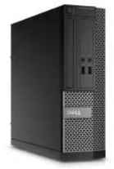
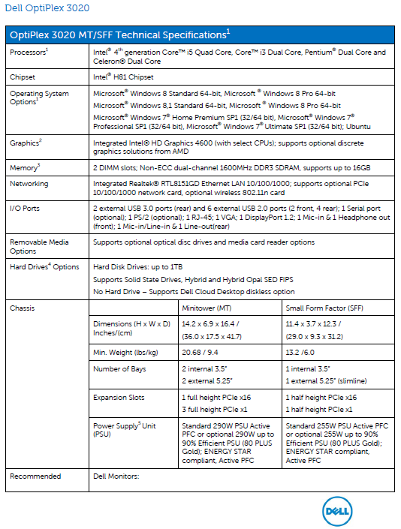
Dell Optiplex 3030 AIO
The OptiPlex 3030 All-in-One is Dell’s newest all-in-one solution that meets the needs of your students and your school system.
The OptiPlex 3030 All-in-One is thin, space saving and clutter free, with a 19.5” WLED touch screen as well as dual display capabilities that meets the practical and performance needs of educational settings.
The OptiPlex 3030 All-in-One provides power and performance with 4th Generation Intel® Core™ Processors that can run educational software packages with ease.
Not only is this all-in-one thinner and takes up less space on a desk than the previous generation; with a wireless keyboard and mouse, and a port cover that locks cables in place, this desktop keeps students focused on the task at hand.

