2016-17 Shared Facilities Fund Guidelines

2016-17 Shared Facilities Fund Guidelines

The 2016-17 Shared Facilities Fund contributes to local infrastructure needs by providing funding to develop community facilities on school sites across Victoria. The funding allocated through this program will support schools, local councils and other institutions to develop shared facilities arrangements. This fund can be used to implement a range of community infrastructure projects on school sites, including early learning centres, sporting facilities and community hubs.

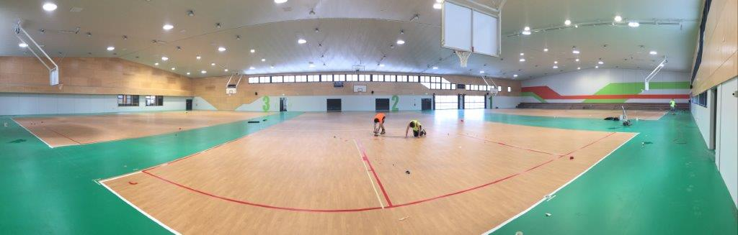

Published by the
Victorian School Building Authority
Department of Education and Training
Melbourne
September 2016

©September 2016 Victoria (Department of Education and Training) 2016

The copyright in this document is owned by the State of Victoria (Department of Education and Training), or in the case of some materials, by third parties (third party materials). No part may be reproduced by any process except in accordance with the provisions of the Copyright Act 1968, the National Education Access Licence for Schools (NEALS) (see below) or with permission.

An educational institution situated in Australia which is not conducted for profit, or a body responsible for administering such an institution may copy and communicate the materials, other than third party materials, for the educational purposes of the institution.

Authorised by the Victorian School Building Authority
Department of Education and Training
33 St Andrews Place, East Melbourne, Victoria, 3002.
This document is also available on the internet at (HYPERLINK)

Message from the Minister

Making Victoria the Education State means ensuring every child has access to a high quality learning environment. Schools are an integral part of the community, and the Shared Facilities Fund will support this role by providing greater access to community facilities on school land, and creating community hubs with services being delivered by, or in partnership with, local government. As schools are critical to the lifeblood of a community, the Victorian Government will provide the bricks and mortar for these services, enabling the schools role to grow.
In the last two years alone, we have committed over $200 million to address Victoria’s community infrastructure needs through the Growing Suburbs Fund, the Children’s Facilities Capital Program, the Community Sports Infrastructure Fund and the Better Indoor Stadiums Fund, implementing projects in areas where there is peak demand.
I am delighted that a $50 million investment through the 2016-17 Shared Facilities Fund will provide an infrastructure investment at school sites and establish partnerships with Local Government and community organisations to meet the needs of communities across Victoria. The infrastructure projects selected through this program will improve the amenity, liveability and resilience of communities, support connections, enhance services and provide local jobs.
These guidelines provide information to applicants about the objectives, criteria and process for the 2016-17 Shared Facilities Fund. I am pleased that they have been developed to reflect the strong partnership between state and local government to ensure the best possible outcomes for Victorians.
I welcome your interest and participation in the 2016-17 Shared Facilities Fund. Together we can deliver liveable, inclusive and sustainable communities.

The Hon James Merlino MP
Minister for Education
Deputy Premier

- Overview

The Government recognises that Victoria is experiencing population growth and development.
In the 2016-17 State budget, the Victorian Labor Government invested $50 million into the Shared Facilities Fund (SFF). This new fund will deliver integrated community facilities on school sites.
Integrated school and community facilities play an integral role in bringing together communities. They allow for increased access local services and participation opportunities, and foster a sense of community pride and value in schools.
Co-located and shared facilities build a sense of collective purpose between school and community. They facilitate diverse and positive learning experiences, increasing family involvement in children’s schooling, and improving attendance and achievement of students. They build a sense of community and foster improved connectivity with schools.
In addition to the Shared Facilities commitment, funding for infrastructure will be available through the following programs:
- $50 million over four years to develop modern and flexible early childhood centres across the state through the Children’s Facilities Capital Program, with an additional $10 million earmarked for capital projects in Victoria’s fastest-growing areas, and an improved approach to planning for Victoria’s future needs.
- $50 million for the Growing Suburbs Fund through the Department of Environment, Land, Water and Planning (DELWP) for Melbourne’s interface councils, plus an additional $20 million for the Living Libraries Fund.
- $100 million for the Community Sports Infrastructure Fund through the Department of Health and Human Services’ (DHHS) Sport and Recreation Victoria to develop and improve community sport and recreation infrastructure throughout the state plus an additional $22 million for the Better Indoor Stadiums fund.
The SFF will complement other government infrastructure investment in communities and build partnerships with local councils. Shared Facilities projects will be built by DET in coordination with successful applicants and delivered on current or future DET school sites. Typically, the government is looking for a project based on co-funding the capital costs, but other arrangements will be considered on their merits. For example, the governance ongoing operating costs being the responsibility of the service provider as agreed upon in a community joint use agreement.
This program is overseen by the Minister for Education and the State Treasurer, and administered by the Department of Education and Training (DET).

- Objectives

The 2016-17 SFF will contribute to a prosperous and liveable Victoria by delivering community facilities on school sites across the state.
The program will target high priority community infrastructure projects that contribute to:
- community strengthening and wellbeing
- improved ability to respond to community needs and demands
- enhanced school and community pride
- culture and community education

- Who can apply

Local Government Authorities located in Victoria are eligible to submit Expressions of Interest (EOI) for the Shared Facilities Fund.
Additionally, the Department of Education and Training will accept EOI submissions from third party organisations such as Universities and not-for-profit services.
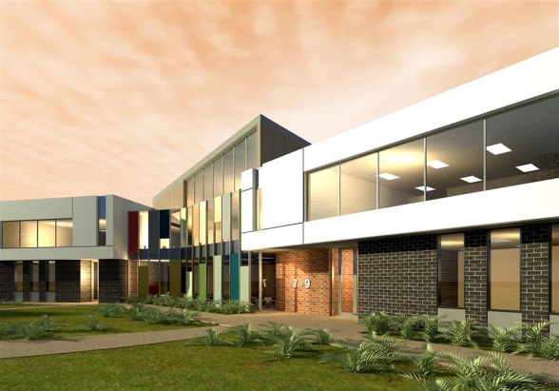
Third party organisations will be required to demonstrate how their service aligns with local council’s long-term provision planning, along with all other relevant information. Third party organisations that are successful in the EOI stage will have to provide proof of their long-term financial viability to operate the facility. The Department reserves the right to request any supplementary information as necessary.
Not-for-profit or third party organisations should demonstrate how they are partnering with local councils to put forward Expression of Interest proposals for the 2016-17 SFF.
Two-thirds of the program funding will be allocated to projects in the following seven growth areas - Casey, Wyndham, Whittlesea, Hume, Melton, Cardinia, and Mitchell.
Applicants should review these guidelines to confirm eligibility.

- What will be funded

The 2016-17 SFF will fund the construction of facilities on existing or new school sites. Recognising the complexity of some local infrastructure, five funding streams will be available in 2016-17.
Funding will be available for:
- Early learning hubs – including early childhood education and care services
- Performing Arts Centres and libraries (in addition to other multi-purpose community rooms)
- Sport and recreation facilities
- Community shaping, multiservice centres
- Community health facilities
4.1 Funding from other programs
The SFF will accelerate the delivery of critical community infrastructure, and complement, rather than replace, other funding sources available to these communities. As such, some projects might be suitable for funding by multiple programs (eg. DELWP’s ‘Growing Suburbs Fund’; the Victorian School Building Authority’s ‘Children’s Facilities Capital Program’).
Applications received for the 2016-17 program should identify any other sources of funding sought, including State and Commonwealth government programs, as well as eligibility for contributions from developers.
The Department reserves the right to provide strategic investment to projects outside the Expression of Interest process.
In submitting this application, the applicant agrees that some information may be shared with other state government agencies in order to seek clarification/alignment/performance issues.
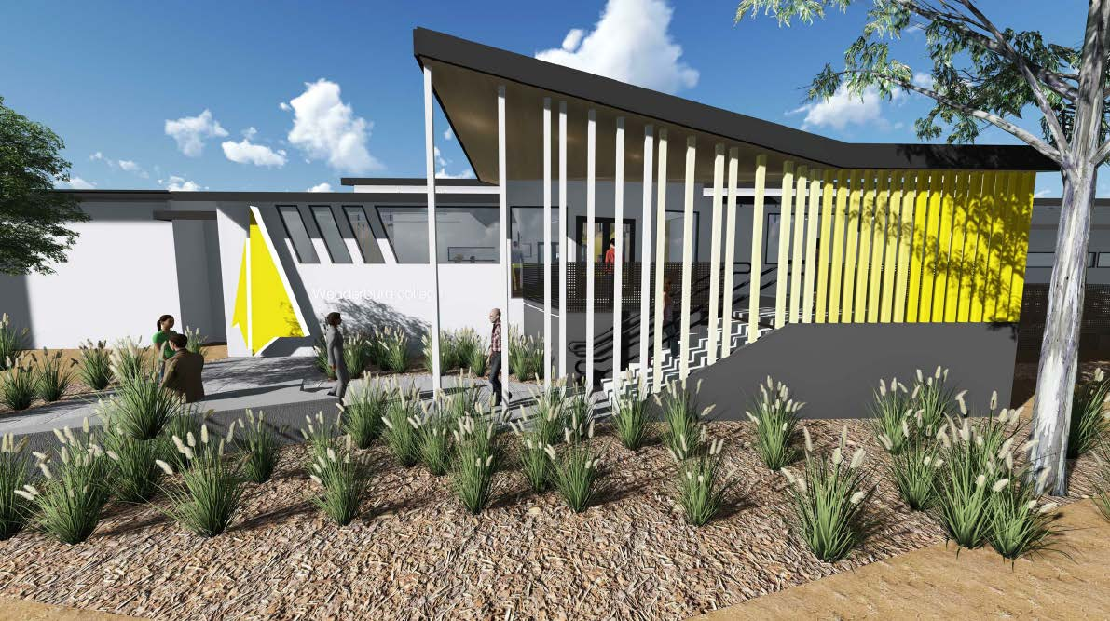
- Community Infrastructure Projects

5.1 Scope
The 2016-17 SFF will fund a mix of projects that can demonstrate a direct benefit to communities across these broad infrastructure categories:
- community health, well-being, and social interaction
- early education
- sport, recreation, and leisure
- arts, culture and community education
Infrastructure projects will commence construction within 12 months of being announced, and service delivery must be ready to commence once construction has been completed.
The 2016-17 SFF will not fund:
- Land acquisition. Projects will be delivered on current or future DET school sites.
- Infrastructure that is fully scoped and funded through a development contributions plan, unless it can be clearly demonstrated that SFF funds will bring forward delivery, or that the actual costs of delivering the infrastructure materially exceed the total of development contributions.
- Routine or ongoing maintenance activities, cosmetic works, or repair of facilities damaged by vandalism, fire or other natural disasters where the damage should be covered by insurance.
- Recurrent operating costs, including utilities and staffing resources.
- Drainage, waste and roads, including footpaths and public transport infrastructure.
- Construction of infrastructure that does not have a direct community benefit or address an identified community need.
- Sports facilities that do not meet relevant Australian Standards and standards for sports competition (e.g. court dimensions).
5.2 Assessment criteria
Percentage weightings are provided as a guide to the relative importance of different criterion in the assessment process. Applications should address all relevant criteria and provide relevant supporting documents.
Applications for the Shared Facilities Fund will be assessed against the following criteria:
Individual Project Assessment
Criterion 1 – Why is this project required? Who will benefit and how? – 60%
Applications will be required to demonstrate the extent to which the project addresses an identified need in the community by:
- Clearly identifying the need or gap in infrastructure provision that the project will address.
- Clearly identifying the expected benefits (social, economic, and/or environmental) that the project will deliver.
- Demonstrating (by quantifying) the breadth and depth of the need or gap in infrastructure provision.
- Demonstrating the breadth and depth of the expected benefits, including who will benefit and how.
- Demonstrating how the outcomes will deliver the objectives of the SFF.
Criterion 2 – What is the value of the service delivery model – 30%
Applications must:
- Demonstrate the relationship between the service delivery model of the proposal, the need for the project, and the expected benefits.
- Explain how the project benefits will be sustained once the infrastructure is delivered and the service commences.
Previous performance in service delivery of projects will also be taken into account in the assessment of this criterion.
Criterion 3 - Council and community support for the project – 10%
Applications must:
- Demonstrate that the project is a recognised strategic priority and is consistent with key plans such as the current Council Plan and Strategic Resource Plan, community plans or structure plans and/or policy documents.
- Demonstrate the level of support at the community level. This could be demonstrated by engagement activities from community members or groups.
Program-Wide Criteria
A program assessment panel will consider four program-wide factors. These factors are:
- Geographic distribution - no more than approximately 10 per cent of the total 2016-17 SFF funding pool will be allocated to a single council.
- Diversity of infrastructure/project types - the assessment will ensure that funded projects represent a mix of targeted infrastructure.
- Consistency with State priorities – the panel will consider how each project aligns with local and state priorities.
- Benefits to other local schools - the assessment will consider the benefit of a development in the context of accessibility and usage arrangements for other schools in a given local areaSite location – suitability of school site and land use.
- Site location – suitability of school site and land use. By exception, proposals that are not on school land but are directly adjacent to schools may be considered, where appropriate tenure arrangements can be negotiated.
- How to apply

6.1 Application process and key timing
The Expression of Interest round will open on 13 September 2016 and close on 18 November 2016. Following a review period, applicants may be required to provide additional information. Applications through other programs such as the Growing Suburbs Fund, Community Sports Infrastructure Fund and the Better Indoor Stadiums Funds may be considered for funding through the Shared Facilities Fund.
A brief overview of the steps in the process for the 2016-17 SFF is summarised below:
Expressions of Interest Open | 13 September 2016
Expressions of Interest Close | 18 November 2016
Additional information from short listed proposals | November-December 2016
Assessment and Government approval | January-March 2017
Community Joint Use Proposals Executed | March-April 2017
Announcements | May 2017

6.2 Application requirements
Expressions of Interest should:
- address the 2016-17 SFF project assessment criteria in the response to each question
- include all key information, data and evidence to support the responses
- provide a primary contact for any follow-up.
Departmental staff may contact applicants to seek further clarification of information submitted. Shortlisted Expressions of Interest will be invited to provide additional information, including a community joint use proposal.
If invited to submit additional information, the intent of the proposal must remain the same.
Applications must be submitted via the following link:
https://depteduearlychilddev.smartygrants.com.au/16_17_SSF_EOI
These should be received by no later than 18 November 2016 at 4pm.
If you have any queries, please email ifsd@edumail.vic.gov.au or contact (03) 9651 3399.

6.3 Funding conditions
Funding agreement
The sharing of facilities between schools and the community entails legal agreements that ensure all parties understand their responsibilities and obligations. Successful applicants will be required to enter into a Community Joint Use Agreement (CJUA) with the Department. CJUAs establish the parties and outline their commitments and responsibilities to each other, as well as setting out the general funding terms and conditions. It is recommended that applicants review the Department’s standard terms and conditions before applying. The development of a project will not occur until the Department and the applicant have executed the community joint use agreement. For more information, please visit:
http://www.education.vic.gov.au/school/principals/infrastructure/Pages/propertyshare.aspx
Project monitoring and delivery
Funding beneficiaries are required to comply with the project monitoring and reporting requirements outlined in the community joint use agreement.
Successful applicants must take full responsibility for the cost of ongoing operation and maintenance of any facilities through their asset management processes.
Acknowledgement
Successful applicants must acknowledge the Victorian Government’s support. They must also liaise with the Departmental program area to coordinate any public events or announcements related to the project.
Successful applicants may be required to contribute information on activity outcomes for use in program evaluation or in the Department’s communication materials.

