|  |  |  |
| --- | --- | --- |
|  |  |  |



**A resource to assist schools to reflect on drug education programs and practices and plan for the future**

Drug Education

**Introduction**

Schools implement drug education to maximise young people’s health and wellbeing. The model in Victorian schools uses a broad health promotion and early intervention prevention approach to student wellbeing and engagement in learning.

**Purpose of this resource**

This resource has been developed for schools to use to reflect on and plan their drug education programs and practices. The resource provides information on how to implement effective drug education and includes activities for school teams to work through, to assist in drug education review and planning. The resource will also support schools to deliver effective drug education with a minimum of 10 hours of drug education per year, per year level.

**What is a whole school approach to drug education?**

A comprehensive whole school approach is widely acknowledged as best practice in working holistically to promote student health and wellbeing. Through the inter-relationship of curriculum, ethos and environment and parents and community, classroom based drug education is consolidated by a supportive school environment and effective links to family and the community. A whole-school approach is dependent on schools, parents and communities working together to plan, implement, support and sustain drug education strategies and practices within the school community.

Research which led to the development of the *Principles for school drug education* demonstrates that drug education is more likely to achieve positive outcomes when schools, parents and communities work together.

National [*Principles for school drug education*](http://www.deewr.gov.au/Schooling/Programs/REDI/readingroom/profile/Pages/principles_school_drug_ed.aspx)

http://www.deewr.gov.au/Schooling/Programs/REDI/readingroom/profile/Pages/principles_school_drug_ed.aspx

By using the *Principles for School Drug Education* as a guide, school communities can be assured that:

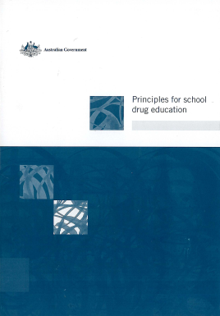

* They are following an evidence-based guideline which will promote the effectiveness of their school’s drug education approach.
* Drug education will form part of a broader health and well-being focus which can be applied to meet local needs and priorities.
* Areas of strength and areas which may require further planning will be identified.
* The best opportunity for improving health and wellbeing outcomes for young people will be provided.

**Harm Minimisation**

Harm minimisation refers to policies and programs designed to reduce drug-related harm. Harm Minimisation aims to build safe and healthy communities by preventing and minimising alcohol, tobacco and other drug related health, social and economic harms among individuals, families and communities.

Harm minimisation encompasses a wide range of approaches including:

**Demand reduction**

* Prevent uptake and delay onset of drug use
* Reduce use of drugs in the community
* Support people to recover from dependence and reconnect with the community
* Support efforts to promote social inclusion and resilient individuals families and communities

**Supply reduction**

* Reduce the supply of illegal drugs
* Control and manage the supply of alcohol, tobacco and other legal drugs

In this resource, ‘drug’ refers to alcohol, tobacco, illicit drugs, volatile substances and pharmaceutical drugs.

**Harm reduction**

* Reduce harms to community, safety and amenity
* Reduce harms to families
* Reduce harms to individuals

*(Commonwealth of Australia, National Drug Strategy 2010-15)*

**Effective School Drug Education Model**

The model for drug education in Victoria is based on a whole school approach that utilises research and evidence based practice, effective pedagogy and encourages a positive school climate and strong partnerships. Research which led to the development of the Principles for School Drug Education demonstrated that drug education is likely to achieve positive outcomes when schools, parents and communities work together to protect young people against a range of harms associated with drugs, emotional distress and problem behaviours.

The Health Promoting Schools Framework developed by the World Health Organisation in 1986 is widely acknowledged as best practice in working holistically to promote student health and wellbeing. The model below combines the Principles for School Drug Education with the Health Promoting Schools Framework.

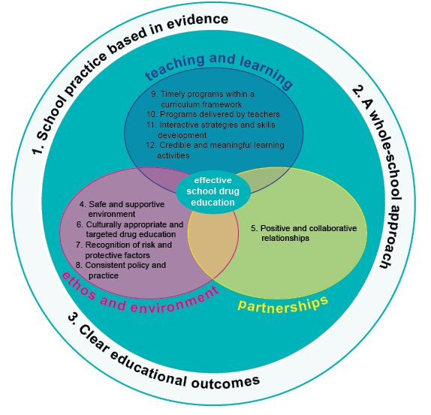

Adapted from SDERA, 2010, Getting *it Together: A Whole-School Approach to Drug Education*, Government of Western Australia

Adapted from Getting it Together, A whole school approach to Drug Education

For more information about Principles for School Drug Education visit <http://www.deewr.gov.au/Schooling/Programs/REDI/readingroom/profile/Pages/principles_school_drug_ed.aspx>

**Victorian government schools compliance checklist items**

This school:

* has an effective drug education program supported by whole school policies which include procedures to respond to drug related incidents
* reviews its drug education strategy every four years
* completes a minimum of 10 hours of drug education per year, per year level

**Activity one**

* **Defining the future?**
* **What will success look like?**

Imagine your ideal drug education program – that is, the drug education program you believe will be the most successful within your school. Brainstorm in a small group the ideal drug education program. Use words and /or pictures.

For example, elements of an ideal drug education program would be:

* delivered as a comprehensive program
* use participatory and interactive teaching approaches
* strongly supported by school leaders
* element of an integrated whole school approach to promote young people’s health and wellbeing.

When I think of the ideal drug education program for my school, I think of a program which has the following success indicators.

1.

2.

3.

4.

5.

Share your ideas with your table group. Are there common themes?

|  |  |
| --- | --- |
| **Common themes from table group** | **Common themes from whole group** |
|  |  |

**Activity two**

View and discuss Professor Richard Midford’s or Professor Steve Allsop’s video clip

<http://www.education.vic.gov.au/studentlearning/programs/drugeducation/videoresources.htm>

**About the video clips**

These very informative videos are a great way to stimulate discussion and promote interactive teaching and learning approaches.

* Professor Midford explains why the one-off or single approach to drug education does not work and why it’s best to implement interactive programs that are proven to work best. Richard also explains how important it is for students to develop skills that prepare them for making informed decisions when faced with confronting situations in their lives.
* Professor Allsop explains the reasons why it is important for schools to have a whole school community approach to drug education. He also articulates why teachers are best placed to educate our young people, the skills and strategies for managing challenging situations they may face throughout their school years and beyond.

**Activity three**

What are the enablers and barriers for successful delivery of school drug education programs? Discuss

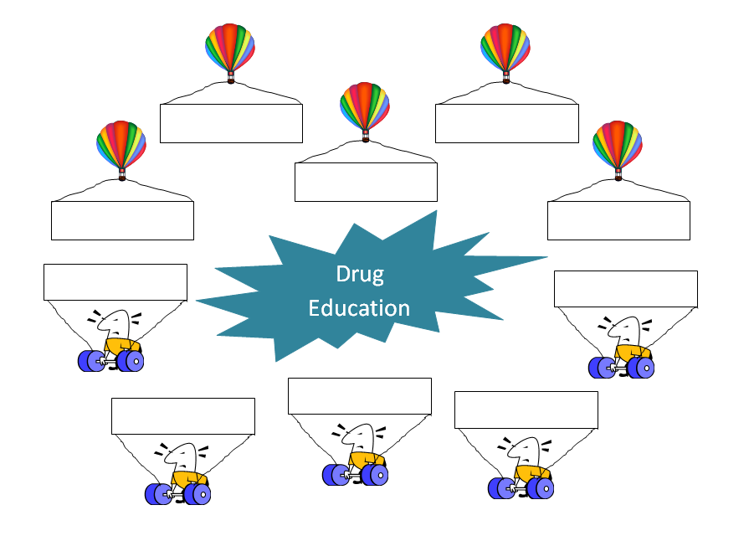

**Activity four**

**Drug Education and School Strategic Planning**

This reflection of whole school drug education will provide valuable input for the school leadership team in the development of the school Strategic Plan for the coming four years. To ensure alignment between drug education core team planning and whole school strategic planning, it is recommended that both groups collaborate. The core team has a role in ensuring that these drug education priorities are considered and recognised in the School Strategic Plan. Identify below how your drug education recommended actions contribute to the School Strategic Plan/Annual Implementation Plan.

For further information on drug education planning, go to the Department’s drug education website [School Drug Education Planning](http://www.education.vic.gov.au/studentlearning/programs/drugeducation/policy.htm#H2N1010B)  http://www.education.vic.gov.au/studentlearning/programs/drugeducation/policy.htm#H2N1010B

Government schools

|  |  |
| --- | --- |
| **Student Learning**  *Student Learning outcomes relate to what students know and can do* |  |
| **Student Wellbeing and Engagement**  *Student Wellbeing and Engagement outcomes relate to the extent to which students feel safe, secure and stimulated to learn at school* |  |
| **Pathways and Transitions**  *Student Pathways and Transitions outcomes relate to the quality of student transition into, through and out of a particular educational context and the extent to which pathways meet the needs of students* |  |

Catholic schools

|  |  |
| --- | --- |
| **Learning and Teaching** |  |
| **Student Wellbeing** |  |
| **School Community** |  |
| **Leadership and Management** |  |
| **Education in Faith** |  |

Independent schools

Independent schools ensure that students are provided with a supportive environment, where the care, safety and wellbeing of all individuals is incorporated into every aspect of school life.

**Activity five**

The focus of drug education in schools is one of continuous improvement. Having implemented comprehensive drug education programs that encompass the elements of teaching and learning, school organisation, ethos and environment and community partnerships and services, this activity has been developed to assist drug education core teams with future planning.

**Self Reflection**

**Community partnerships and services**

|  |
| --- |
| What would successful community partnerships and services in drug education look like? Reflect on your thinking from Activity one.  *For example*, a school is welcoming of parents and is clear on how parents and the broader and the community can be positively engaged, understanding that some parents can be more directly involved than other parents. Some parents may prefer to receive information on school activities. Projects that involve parents and students working together are particularly successful, especially those where the students ‘teach’ their parents. |

|  |  |  |  |  |  |  |
| --- | --- | --- | --- | --- | --- | --- |
| Self Assessment | | Fully implemented | Partially implemented | Not implemented | Don’t  know | comments |
| Our school promotes collaborative and inclusive partnerships with parents and the school community | |  |  |  |  |  |
| Collaborative and inclusive partnerships with local agencies support whole school drug education approaches | |  |  |  |  |
| Our school invites parents to be involved in drug education initiatives | |  |  |  |  |
| Our school develops referral processes and protocols with community agencies and health services | |  |  |  |  |
| Our school has a current and comprehensive list of drug related resources and agencies in the local area | |  |  |  |  |
| Our school provides a spectrum of opportunities for parent and community involvement and participation | |  |  |  |  |
| Our school ensures that external agency and student support staff work within a harm minimisation framework | |  |  |  |  |
|  | |  |  |  |  |  |
| **We should do more of……………..** | **We should do less of……………..** | | | | | |
|  |  | | | | | |

**Teaching and learning**

|  |
| --- |
| What would successful teaching and learning in drug education look like? Reflect on your thinking from Activity one.  *For example*, successful teaching and learning in drug education would send high expectations about what students can do and have students:   * acquire useful knowledge and skills * develop their problem solving skills * think about their own and others’ safety and develop and rehearse strategies and solutions to minimise or avoid harm * examine the social influences impacting on drug use |

|  |  |  |  |  |  |  |
| --- | --- | --- | --- | --- | --- | --- |
| Self Assessment | | Fully implemented | Partially implemented | Not implemented | Don’t  know | comments |
| Drug education programs at our school:   * are based on accurate, age-appropriate information on licit and illicit drugs | |  |  |  |  |  |
| * have a minimum of 10 hours per year of drug specific information to ensure program fidelity | |  |  |  |  |
| * are developmentally, culturally and gender appropriate | |  |  |  |  |
| * assist students in making informed choices to keep themselves healthy and safe | |  |  |  |  |
| * use interactive strategies to engage all students by using a range of learning styles | |  |  |  |  |
| * are student centred and collaborative | |  |  |  |  |
| * include small group activities, discussions and role-plays | |  |  |  |  |
| * develop critical thinking, problem solving, self-confidence, decision making, help seeking, and refusal skills | |  |  |  |  |
| * use current evidence based resources | |  |  |  |  |
| * are normative, debunk myths and discuss assumptions | |  |  |  |  |
| Our school regularly provides training and professional learning activities for teachers | |  |  |  |  |
| All teachers at our school delivering drug education programs have participated in drug specific professional learning activities | |  |  |  |  |
| Our school builds a climate of respect and inclusivity | |  |  |  |  |
| Our school drug education program has a focus on skill development | |  |  |  |  |
| Our school protects the safety and privacy of all students | |  |  |  |  |
|  | |  |  |  |  |  |
| **We should do more of……………..** | **We should do less of……………..** | | | | | |
|  |  | | | | | |

**School organisation ethos and environment**

|  |
| --- |
| What would successful school organisation, ethos and environment in drug education look like? Reflect on your thinking from Activity one.  *For example*, a school builds a safe, supportive and inclusive environment with consistent approaches to harm minimisation to promote resilience and wellbeing in students and staff. The school leaders support implementation of effective programs and development of policies and support professional learning for teachers.  The school has a whole school approach where healthy practices are embedded within the school’s values and mission. Positive and collaborative relationships between students, staff, families and the broader community are supported. |

|  |  |  |  |  |  |  |
| --- | --- | --- | --- | --- | --- | --- |
| Self Assessment | | Fully implemented | Partially implemented | Not implemented | Don’t  know | comments |
| Our school promotes a safe, supportive and inclusive environment as part of seeking to prevent or reduce drug-related harm | |  |  |  |  |  |
| Our school is engaging and inclusive and recognises and responds to the diverse needs of our students | |  |  |  |  |
| Social and emotional learning is highly regarded and reflected in programs and practices in our school | |  |  |  |  |
| Our school uses the Attitudes to School and local data, especially safety, and connectedness to school, teachers and peers, to revise and improve local practice | |  |  |  |  |
| Students have access to specialised support services as needed in our school | |  |  |  |  |
| Our school is engaging, inclusive and recognises and responds to the diverse needs of our students | |  |  |  |  |
| Positive and respectful relationships are evident in our school demonstrated through appropriate language and behaviours | |  |  |  |  |
| Our school provides drug education in a manner that is sensitive to cultural and experiential backgrounds of students | |  |  |  |  |
| In responding to drug related incidents our school takes a broad health approach and focuses primarily on the safety and wellbeing of those students directly and indirectly affected | |  |  |  |  |
| Harm minimisation underpins our school’s response and procedures in relation to managing drug related incidents | |  |  |  |  |
| Our school uses the Student Engagement Guidelines/ pastoral care policies to inform whole school approaches to wellbeing to engage, encourage and empower young people | |  |  |  |  |
| Our school increases protective factors and reduces risk factors for all students | |  |  |  |  |
| Our school supports staff to develop knowledge on the complexity and interrelationship of risk and protective factors | |  |  |  |  |
| Our school has clear procedures for responding to drug related incidents that have been developed in consultation with students and parents and respect confidentiality | |  |  |  |  |
| Our school updates staff on appropriate responses to drug related incidents | |  |  |  |  |
| **We should do more of……………..** | **We should do less of……….** | | | | | |
|  |  | | | | | |

**Activity six**

After completing the self reflection and review of school data, such as the Attitudes to School data, and to work towards the ideal whole school approach the following are the recommended actions for our school.

**Converting priorities to action consider:**

* **How** (activities, budget, equipment, IT, learning time, learning space)
* **Who** (individual or team responsible)
* **When**
* **Achievement Milestones** (what will it look like)

|  |  |  |  |
| --- | --- | --- | --- |
| **Actions** | **How** | **Who** | **When/Achievement Milestone** |
| Immediate  1.  2.  3. |  |  |  |
| Short Term - 6 – 12 months  1.  2.  3. |  |  |  |
| Longer Term - 1-3 years  1.  2.  3. |  |  |  |

**What conversations/actions do I need to have to ensure the whole school shares the thinking I have done today?**

|  |
| --- |
| With the Principal and Leadership team |
| With other staff |
| With the core team |

**Regional contacts:**

|  |  |  |
| --- | --- | --- |
| **Region** | **Senior Program Officers, Drug Education and Student Wellbeing** | **Phone** |
| Barwon South Western | Virginia Cherry  Jane Langley – Hamilton office | 5225 1033  5571 2940 |
| Grampians | Margaret Bolton – Ballarat Office  Sue Jackson – Ballarat Office  Kristy Price – Ararat office | 5337 8444  5352 5644 |
| Eastern Metropolitan | Kristen Douglas  Sandra Rogers-Neal | 9265 2427  9265 2426 |
| Gippsland | Anne Outhred  Rowena Cann | 5127 0406  5127 0400 |
| Hume | Karen McNamara  Claire Russell | 5761 2135  5761 2157 |
| Loddon Mallee | Lee Baxter  Amanda Wheeler – Mildura office | 5440 3121  5051 1304 |
| Northern Metropolitan | Paul Bowman  Ben Sacco | 9488 9448  9488 9417 |
| Southern Metropolitan | Lynne Venning  Donna Dalling | 8765 5637  8765 5636 |
| Western Metropolitan | Karen Marsh  Sue Wannan | 9291 6508  9291 6561 |

**Department of Education and Early Childhood Development Drug Education Website:**

[www.education.vic.gov.au/drugeducation](http://www.education.vic.gov.au/drugeducation)

