Accessible Buildings Program guidelines
July 2014

Document owner: Contracts and Procurement Unit, Infrastructure and Sustainability Division, DEECD

Published by the Infrastructure and Sustainability Division,
Department of Education and Early Childhood Development
Melbourne, July 2014

©State of Victoria (Department of Education
and Early Childhood Development) 2014

The copyright in this document is owned by the State of Victoria (Department of Education and Early Childhood Development), or in
the case of some materials, by third parties (third party materials). No part may be reproduced by any process except in accordance with the provisions of the Copyright Act 1968, the National Education Access Licence for Schools (NEALS) (see below) or with permission.

An educational institution situated in Australia which is not conducted for profit, or a body responsible for administering such an institution may copy and communicate the materials, other than third party materials, for the educational purposes of the institution.

Authorised by the Department of Education
and Early Childhood Development,
2 Treasury Place, East Melbourne, Victoria, 3002.

1. Background 3
Standards 3
2. Eligibility Requirements 4
Students 4
Hearing Augmentation 4
Commonwealth Government’s Employment Assistance Fund 5
Exclusions 5
3. Application Process 6
How to make an application? 6
Supporting Documentation 6
Notification of outcomes 7
Delivering projects – key steps 7
Variations to Capital Works 8
Additional Information for Schools 8
4. Contacts 10
Victorian Regional Offices 10
Central DEECD Office 10

Background
The Department of Education and Early Childhood Development undertakes a limited annual program to provide improved access to mainstream school facilities for students and parents with injuries or disabilities. The program is called the Accessible Buildings Program and provides funding for projects to:
- meet the reasonable needs of new students with disabilities;
- meet the needs of students where accessibility issues occur as a result of a deteriorating condition;
- modify existing facilities to cater for the curriculum requirements for the student; and
- provide access provisions for staff and visitors.

Facility modifications may include:
- ramps and handrails (including temporary ramps);
- toilet and shower modifications;
- modifications for vision or hearing impairments;
- change tables and hoists; and
- limited external works to improve access for the applicant.
Facilities modifications for special and specialist school settings will only be considered where suitable pre-existing facilities do not exist.

Priority will be provided in situations where:
- the student with disabilities is a new enrolment; or
- the school is unable to provide sufficient access to school facilities essential to the curriculum, toileting and health care needs of the student.

Every endeavour will be made to complete all works prior to the commencement of a school year. It is important that schools submit applications as early as possible in the new financial year.
Schools should note that stair lifts and platform lifts will not be removed after installation, in accordance with the commitments of the Disability Action Plan 2013-16.

Standards

Works will be undertaken in accordance with the:
- Building Code of Australia
- Australian Standards
- DEECD Building Quality Standards Handbook
- Disability Access to Premises Building Standards 2010

Eligibility Requirements
The Department’s main focus under the Accessible Buildings Program is to provide curriculum and building access to as many students with disabilities as possible. This means ensuring value for money is achieved with the limited funding available.

Students

Applications must:
- directly relate to the needs of the person who is the subject of the application;
- demonstrate that the request will enable the student to access facilities essential to their curriculum and/or toileting needs;
- confirm that alternative solutions, in accordance with the Disability Standards for Education, have been considered and are not possible (e.g. possible changes to curriculum to further enable access without building works, or the use of alternative buildings, facilities and equipment).
To be eligible for hearing augmentation, schools must apply on behalf of students who have a hearing loss and who use aids such as Hearing Aids, cochlear implants or assistive listening devices or as an alternative:
- include a signed, professional report from an occupational therapist, in the case of an access issue, or an audiologist report, in the case of hearing augmentation requirements. This report must include the professional’s contact information; and
- be supported by the relevant Regional Provision and Planning Manager and visiting teacher for hearing or visually impaired students. The visiting teacher should provide a written report in support of the application.
The program is also able to address specific requirements for students with new or supplementary needs on account of accident or deterioration of existing conditions.

Hearing Augmentation

The Accessible Buildings Program’s focus for future hearing augmentation provision will be directed to systems which are portable and can follow the applicant as they progress through their educational years.
Portable sound field systems provide greater flexibility for relocation and are a more cost effective option than fixed systems.
If a school has been the recipient of hearing augmentation equipment in the past, the application should identify the nature of the modifications made to date, highlighting the relevant classrooms that have already had equipment installed and those classrooms that require new equipment. The Department expects equipment to be relocated by the school if it is no longer required in a particular classroom before new applications are made.
It is expected that schools rationalise timetables and classrooms where possible, so that maximum use is made of the hearing augmentation equipment.
All modifications and equipment are to be maintained by the school. Any unused equipment will be removed and reallocated by the Department.
The application should also include a list of the brands of the equipment the school has already had installed and indicate if they are happy to continue with the same supplier. Mix and matching technology brands is not recommended.
Please note: schools must list all equipment provided through the Accessible Buildings Program on their assets register.

Commonwealth Government’s Employment Assistance Fund
The Commonwealth Government’s Employment Assistance Fund is available for staff who require modifications to access their school. Schools can also apply for funding to provide teachers of students with hearing impairments with a paging system.
The Department can provide support to schools in applying to the Commonwealth Fund.
See the below link for more information on the Fund and how to apply:
http://jobaccess.gov.au/content/employment-assistance-fund-2

Exclusions

Please note the following exclusions under the Accessible Buildings Program:
- loose furniture and equipment (e.g. specialty chairs and toilet frames);
- maintenance upgrades and hearing technology upgrades; and
- Real Time Captioning, as it is not a hearing accommodation and does not fall under the Program guidelines.
Please note that acoustic treatments and all works estimated to be less than $3000 will not be funded under the Accessible Buildings Program. These are to be implemented and funded by the school.
FM frequency change devices will only be supplied if more than one hearing impaired student is enrolled in a school.
This program is not intended to provide maintenance funding for wear and tear of existing compliant facilities and/or works, and it is not a reimbursement program.

Application Process
The Accessible Buildings Program is coordinated centrally by the Accessible Buildings Program Manager. It is supported by Regional Provision and Planning Managers and their teams, who manage the initial interface with the schools and the applicants.
All school applications are automatically referred to Regional Provision and Planning Managers for endorsement. If endorsed by the Regional Provision and Planning Managers, the application is then referred to the Accessible Buildings Program Manager for final approval and delivery.
To ensure works are completed by Term 1, applications must be submitted by 19 August the previous year. These students must be currently enrolled at the time of application. If applications have been received after 19 August of the previous year, the Accessible Buildings Program Manager will still make every effort to have the works completed for term 1, however this cannot be guaranteed.
Hearing applications that are submitted in Term 1 and that require the works to be completed within the year will only be considered for new enrolments.

How to make an application?
All applications are made directly on the Department’s EduGate site via the following link, using the school edumail account; https://edugate.eduweb.vic.gov.au/Services/Schools/Infrastructure/accessiblebuilding/default.aspx

This site also provides users with a range of information specific to Accessible Buildings Program applications.

Supporting Documentation
It is essential that all necessary documentation is uploaded with the application, including:
- the completed application form with the endorsement of the school principal;
- a signed professional report (e.g. occupational therapist or audiologist report). Where one is not available, appropriate documentation to support the request is to be provided;
- quotes for the works (if the project is low complexity/low value – see below section);
- a school map indicating the rooms and/or locations relating to the application;
- details and locations of existing hearing augmentation technology (where applicable); and
- notification of whether the student is provided with support through the Traffic Accident Commission (if applicable).

Notification of outcomes

Schools may track the progress of their application online.

Delivering projects – key steps
Where the application is approved by the Accessible Buildings Program Manager, the school principal will be contacted by the Department.

Low Complexity/Low Value projects (Non-Hearing Applications <$25K)
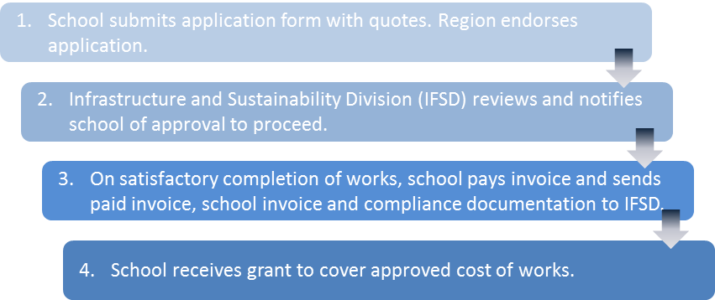
- Small and simple projects do not require a school visit. If the school believes the project is low complexity/low value, they should obtain quotes and load them onto the EduGate site with the application. All quotes must be itemised showing the cost breakdown for all line items on the quote for complete transparency.
- If approved, schools will be notified to proceed with the project.
- Once the project is completed and signed off by the Principal:
  - the contractor invoices the school;
  - the school pays the invoice and sends a copy of the paid invoice including compliance documentation with a school invoice to the Department via email;
  - the school will receive a grant to cover the approved cost of the works.

High Complexity/High Value projects (Applications >$25K or Hearing Related)
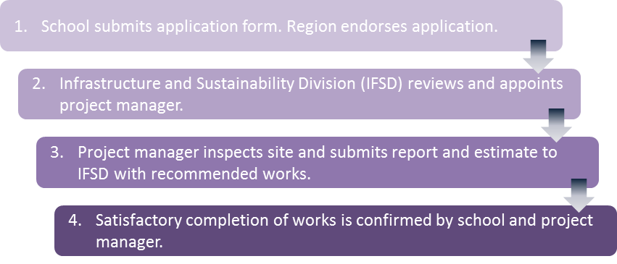
The ABPM will engage a project manager to:
- visit the school to develop a scope of works for the facility modifications that itemises the required works, provides an estimate of cost, and prioritises the facility modification requirements needed to accommodate the specific needs of the student; and
- brief the school on the proposed amenity modifications and maintain ongoing relationship with the school during the entire process from site visit through to the completion of the project.

Following project approval to proceed, the project manager will develop contract documents and manage the tender and construction process. This includes:
- notifying the school of pending works;
- managing and coordinating access arrangements with the school for the contractors;
- managing contractor claims, certification and advice to the Department regarding contractor payments;
- coordinating the completion and hand-over process, including notification to School Asset Management System (SAMS) of facility modifications.

Variations to Capital Works
From time to time unanticipated changes will be required to building works in order to deliver the accessibility requirements at each school. The process of negotiating any such variation is to be undertaken by the Department. Schools are not to negotiate directly with contractors around changes to the scope of works.

Additional Information for Schools
Additional accessibility works requiring funding must be requested in a separate application. Note that the majority of works for this program need to take place during school hours due to the volume of work and the availability of contractors. Out of hours work will only be approved in exceptional circumstances. The school may be requested to pay any increases in cost if out of hours work is required.
Any concerns or enquiries that a school may have with regard to contractors on site need to be communicated by the school to the appointed project manager and the Department’s Accessible Buildings Program Manager.

Contacts

In the first instance schools should contact the relevant Regional Office for support with their application.

Victorian Regional Offices

South-Western Victoria Region |  |  | North-Western Victoria Region
West Footscray | 9291 6500 |  | Coburg | 9488 9488
Geelong | 5225 1000 |  | Bendigo | 5440 3111
Ballarat | 5337 8444
Horsham | 5310 5300
North-Eastern Victoria Region |  |  | South-Eastern Victoria Region
Glen Waverly | 9265 2400 |  | Dandenong | 8765 5600
Benalla | 5761 2100

Central DEECD Office
Accessible Buildings Program Manager
Infrastructure and Sustainability Division
Telephone: (03) 9637 3595
Department of Education and Early Childhood Development
Level 2, 2 Treasury Place
East Melbourne 3001

