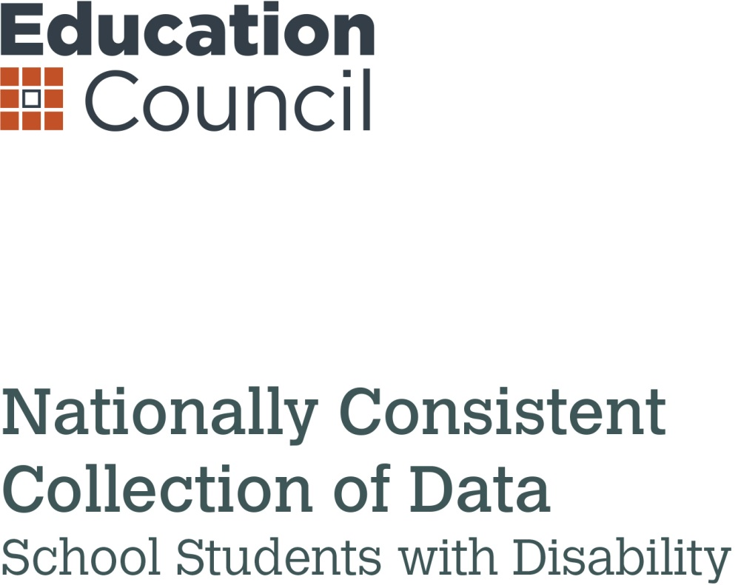

Moderation ResourcE FOR SCHOOLS

Version 1.0

Acknowledgement

Prepared by
Monash University
Prepared for
Education Council Joint Working Group to Provide Advice on Reform for Students with Disability
Authored by
Assoc. Prof. Umesh Sharma, Monash University
Professor Michael Arthur Kelly, The University of Newcastle
Dr Kate de Bruin, Monash University
Claire Menagé, Monash University
Suggested citation
Sharma, U., Arthur-Kelly, M., de Bruin, K., and Menagé, C. (2017). Nationally Consistent Collection of Data on School Students with Disability: Moderation resource for schools. www.schooldisabilitydatapl.edu.au.

Contents
Acknowledgement 2
Introduction 4
PART A: Understanding Moderation and Key Principles 4
A.1. What is moderation? 4
A.2. Why moderate for the NCCD? 5
A.3. Who should be involved in NCCD moderation? 5
A.4. When should NCCD moderation occur? 6
PART B: NCCD Moderation Process 8
B.1. Establish a moderation team 8
B.2. Select sample students for moderation 8
B.3. Summarise student information 8
B.4. Independently examine student cases 9
B.5. Moderators compare judgements 9
B.6. Reach consensus 9
B.7. Complete the NCCD reporting process 10
PART C: Reference Material 12
Bibliography 12
Appendix 1 13
Appendix 2 14
Appendix 3 15

Introduction
All schools in Australia participate annually in the Nationally Consistent Collection of Data on School Students with Disability (NCCD). Through this process, data are collected about students across Australia who receive an adjustment to participate in education because of disability. This collection relies on the professional judgement of principals, teachers and other school staff about the level of reasonable adjustments provided to students with disability to access and participate in education on the same basis as other students, as well as their broad category of disability. This is consistent with the obligations of all schools under the Disability Discrimination Act 1992 (DDA) and the Disability Standards for Education 2005 (the Standards).
All schools across Australia have been required to participate in the NCCD since 2015. In this context, the purpose of this resource is to assist schools in undertaking within-school moderation to support them in making consistent and reliable decisions about students’ level of adjustment and category of disability. This may be used to inform policy decisions about how to best support students with disability. The moderation resource should be used in conjunction with the current NCCD Guidelines available at https://www.education.gov.au/nationally-consistent-collection-data-students-disability-guidelines
This resource has three parts.
Part A (Understanding moderation and key principles) offers a general overview of moderation, suggested membership of the moderation team, and advice on the best time to moderate.
Part B (Moderation process) provides a sample moderation process that a school might use to undertake moderation.
Part C (Reference material) presents links to key resources that schools should refer to during the process of moderation to improve the consistency and reliability of their data.

PART A: Understanding Moderation and Key Principles

A.1. What is moderation?
Moderation is one of the most important tools that teachers use to align professional judgements about student achievement. When moderating, teachers engage in professional conversations and calibrate their judgements by selecting and reviewing a sample of student work or other student data. The moderation process enables teachers to develop a shared understanding of curriculum and student achievement and it enhances fairness and consistency in teacher judgements.
The NCCD moderation process can be understood as an extension of existing school moderation practices. When moderating school-based decisions for the NCCD, teachers engage in professional dialogue about students’ level of adjustment and category of disability to make decisions that are consistent, reliable and defensible. Professional dialogue is characterised by interactions that are collegial (e.g. value the input of all), respectful (e.g. resolve differences in a professional manner) and draw on evidence (e.g. informed by data to support decision-making). Collegial discussions throughout the school year can enable school staff to learn from one another when identifying and making decisions about appropriate support for their students. This in turn validates decisions about the NCCD and reduces variability in data reported.
In the NCCD moderation process, staff review all evidence and build a shared understanding of:
- the level of adjustment being provided for each student to meet the identified educational needs arising from their disability,
- and the broad category of disability for which support is provided.
The NCCD captures the ongoing work undertaken by teachers and school staff throughout the year in providing personalised learning and support for students with disability. It reflects the valuable knowledge teachers acquire about students’ educational needs, and decisions they make about how these needs can be best supported. Implementing quality learning and support practices places schools in a strong position to complete the NCCD.

A.2. Why moderate for the NCCD?
There are many benefits of moderation:
- It helps to increase reliability and consistency of teachers’ professional judgements;
- It facilitates conversations that draw upon teachers’ knowledge of their students and practice regarding personalised learning and support (DET, 2005);
- It assists schools in aligning the decisions about which students to include with requirements under the Standards and the definitions and descriptors of the levels of adjustment and categories of disability in the NCCD model;
- It increases schools’ confidence in the decisions being made for the NCCD.

A.3. Who should be involved in NCCD moderation?
Many schools will already have a team or teams in place to manage the NCCD process, and may already be engaging in some form of moderation process. NCCD moderation requires the participation of two or more individuals who are involved in the educational planning for and support of students with disability at a school. In small schools where it is not possible to form a moderation team within the school, external moderators may be invited to support in the process (e.g. a NCCD coordinator from another school or an individual from the system level). It is important to highlight that strong, strategic and effective school leadership involvement at this stage of the NCCD will add value to the overall process. All members of the moderation team should have a good understanding of the following:
- the Disability Discrimination Act 1992
- the Disability Standards for Education 2005
- the NCCD model (http://www.schooldisabilitydatapl.edu.au/)
- the criteria for a student’s inclusion in the NCCD
- the levels of adjustment and broad categories of disability as defined in the current NCCD Guidelines (https://www.education.gov.au/nationally-consistent-collection-data-students-disability-guidelines).

A.4. When should NCCD moderation occur?
Schools should engage in moderation well before the official data entry period. By engaging in the structured moderation process well before the data entry date, schools are better able to address any significant discrepancies that could affect the consistency and reliability of data.

The moderation process and timeline is shown in Figure 1 on the next page.

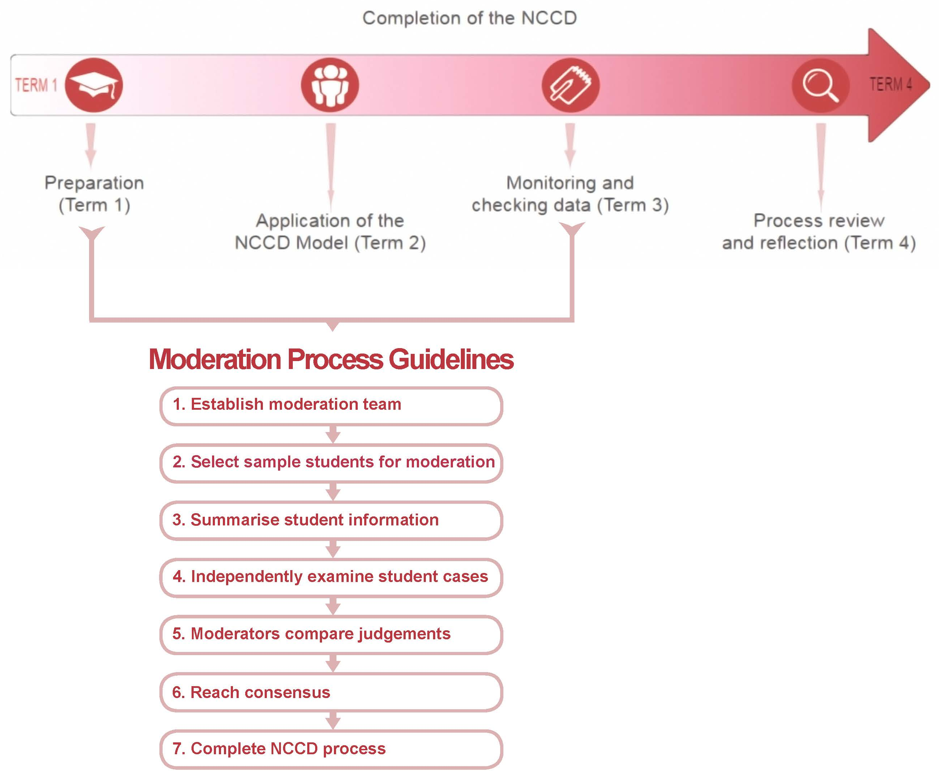
Figure 1: Contextualising the NCCD moderation within the NCCD process and the school year
Image Description: Figure 1 shows the timing of the NCCD moderation process within the school year and the completion of the NCCD process. There is a horizontal arrow pointing to the right with four icons denoting the four school terms. The term one icon is a mortarboard and is labelled “Preparation”. The term two icon is a group of people and is labelled “Application of the NCCD Model”. The term three model is a notepad and pen and is labelled “Monitoring and checking data”. The term four icon is a magnifying glass and is labelled “Process review and reflection”. Beneath this horizontal arrow there is a vertical flow chart that contains the seven steps of the NCCD moderation process in labelled boxes linked by arrows to show the process of the moderation is linear. A square bracket and arrow show that the seven steps of the moderation process are to take place between term one and term three with review of the process in term four.

PART B: NCCD Moderation Process
The process described in Figure 1 is provided as a guide to support schools when undertaking moderation for the NCCD. Schools may find it useful to adapt the moderation process outlined in this resource to suit their local context.

B.1. Establish a moderation team
(or utilise existing arrangements). This team should comprise of a minimum of two professionals familiar with the NCCD process and may involve one or more staff member(s) responsible for overseeing programming/support arrangements for individual students (e.g. classroom teacher(s), the head of learning support, the head of house, a year level coordinator, a homeroom teacher, an assistant principal, a school welfare officer or counsellor).

B.2. Select sample students for moderation
The moderation team should select a small sample of students to moderate. These students should be drawn from those who will be included in the school’s NCCD reporting. If possible, a minimum of eight students should be selected and these should ideally include:
- students receiving varying levels of adjustment across the four levels (from Quality Differentiated Teaching Practice to Extensive) and
- students from a range of NCCD categories of disability.
In smaller schools, all students receiving adjustments because of disability should be considered. A higher sample size should be used in larger schools.

B.3. Summarise student information
(At this point, the moderators do not make a decision about the NCCD level of adjustment or category of disability.) From the sample selected, a team member summarises the documented evidence and data for each sample student. This evidence may include evidence about:
- the adjustments provided to the student to address the specific individual education needs arising from the disability, for example:
- provision of extra time,
- explicit teaching,
- modified curriculum and assessments,
- the use of a Hearing Augmentation system (e.g. FM system),
- the implementation of personal/health care, provision of well-being supports

When summarising adjustments, note the following points in relation to the frequency, intensity and range of adjustments being provided:
- Is the adjustment/support provided occasionally, periodically or every day?
- Is the adjustment/support made only during parts of the day or continuously over the whole day?
- Is the adjustment/support provided during some activities and key learning areas or across all activities and key learning areas?
- What evidence is available to determine the level of adjustment?

- the student’s diagnosed or imputed disability
- the evidence that will be used to support decision making. This includes evidence in four general areas:
- consultation and collaboration with the student and parent(s) and/or carer(s)
- assessed individual needs of the student
- adjustments being provided to the student to address the disability
- ongoing monitoring and review of the adjustments.

B.4. Independently examine student cases
Each summarised student case should be independently examined by a minimum of two moderators. After the careful examination of evidence each moderator decides:
- the level of adjustment that is being provided for the student to address the functional impact of a disability, and
- the identification of the NCCD broad category of disability that is the main driver or focus of the adjustments being provided for the student to support their learning.

B.5. Moderators compare judgements
Moderators meet to discuss and compare their judgements and the data/evidence that informs their judgements for the selected students. This crucial step is the point at which the moderation team determines the consistency of judgements. Moderators may find it helpful to use a table to record judgements. Table 1 (on page 11) presents an example of two moderators independently rating eight students. A blank version of this sample table is provided in Appendix 1 as a template school teams may use to compare judgements or to modify if the team consists of more than two members.

B.6. Reach consensus
To reach consensus, moderators discuss those judgements where there were disagreements and draw upon evidence to support their position. The desired outcome of the moderation process is to resolve all disagreements and reach a consensus (about the level of adjustments and category of disability).
- To reach consensus regarding level of adjustment, moderators should (1) review the level of adjustment descriptors available on the national NCCD professional learning website hosted by Education Services Australia (ESA) (http://www.schooldisabilitydatapl.edu.au/data-collection-steps/step-2---what-is-the-category-of-adjustment; see also Appendix 2) and (2) carefully examine evidence in terms of frequency, intensity and range of adjustments provided for individual cases.

- To reach consensus regarding student category of disability, moderators should (1) review the category of disability resource available on the ESA hosted website (http://www.schooldisabilitydatapl.edu.au/data-collection-steps/step-3---what-is-the-category-of-the-disability; see also Appendix 3) and (2) examine evidence in terms of imputed and diagnosed disability within the NCCD model for individual cases.

Where moderators are unable to reach consensus, the involvement of an external moderator from the system level is recommended. This individual could be a representative from the sector or the NCCD coordinator from another school as appropriate to the jurisdiction and sector.
The example presented in Table 1 (on the next page) indicates that there were some disagreements between moderators on both level of adjustment and category of disability prior to engaging in team discussions. In most cases, these disagreements were resolved and consensus achieved after the members of the team discussed their judgements and provided evidence to support their decisions [see Column “Agree (after Moderation)”]. However, for one student (Student D) consensus could not be achieved for the level of adjustment. In that case, the school invited an independent external moderator to provide input to achieve consensus between the school team members.

Where disagreement exists and consensus is not reached, it is recommended that moderators note why the student was placed in a particular level of adjustment and disability category so that this information is available to inform the subsequent year’s moderation process.

B.7. Complete the NCCD reporting process
Once the moderation process has been completed for the selected sample, the team can be confident that they are making reliable and consistent judgements. They are now ready to proceed with completing the NCCD process for the remaining eligible students.

Table 1: Independent rating of six students by two moderators before and after NCCD moderation
SAMPLE
 | Student Identifier | Moderator 1: Level of Adjustment | Moderator 2: Level of Adjustment | Agree (before moderation) Y/N | Agree (after moderation) Y/N | Moderator 1: Category of Disability | Moderator 2: Category of Disability | Agree (before moderation)  Y/N | Agree (after moderation) Y/N | Notes regarding decisions
1 | Student A | Supplementary | Supplementary | Y | Y | Sensory | Sensory | Y | Y
2 | Student B | Supplementary | Substantial | N | Y | Cognitive | Cognitive | Y | Y | - Checked NCCD Resource: level of adjustment  - Supplementary
3 | Student C | QDTP | QDTP | Y | Y | Cognitive | Cognitive | Y | Y
4 | Student D | QDTP | Supplementary | N | N | Social/Emotional | Cognitive | N | Y | - External moderator called in for level of adjustment.  - QDTP
5 | Student E | Extensive | Extensive | Y | Y | Physical | Physical | Y | Y
6 | Student F | QDTP | QDTP | Y | Y | Sensory | Sensory | Y | Y
7 | Student G | Substantial | Substantial | Y | Y | Sensory | Physical | N | Y | - Checked NCCD Resources: Primary Disability Categories & Sample Case Studies on NCCD website  - Sensory disability
8 | Student H | Supplementary | QDTP | N | Y | Social/Emotional | Social/Emotional | Y | Y | - Checked NCCD Resource: level of adjustment  - QDTP

PART C: Reference Material
Below are reference materials that can assist teachers in engaging in the moderation process.
- Moderation Template – See Appendix 1
- Determining appropriate level of adjustment. See Appendix 2 (Also available at: http://www.schooldisabilitydatapl.edu.au/data-collection-steps/step-2---what-is-the-category-of-adjustment
- Determining appropriate category of disability. See Appendix 3 (Also available at: http://www.schooldisabilitydatapl.edu.au/data-collection-steps/step-3---what-is-the-category-of-the-disability
- Examples of decision making through case studies available at http://www.schooldisabilitydatapl.edu.au/resources

Bibliography
DECD (2016). Moderation matters: A guide to leading collaborative moderation in schools, South Australia: DECD.
DET (n.d.) Fact Sheet: Disability Standards for Education 2005. Canberra: DET, Available at https://docs.education.gov.au/documents/fact-sheet-2-disability-standards-education-2005
DET (2015). Planning for personalised learning and support: A National Resource, Canberra: DET.
Hipkins, R., & Robertson, S. (2011). Moderation and teacher learning: What can research tell us about their relationships?, Wellington: New Zealand Council for Educational Research.

Appendix 1
NCCD Moderation Template
 | Student Identifier | Moderator 1: Level of Adjustment | Moderator 2: Level of Adjustment | Agree (before moderation) Y/N | Agree (after moderation) Y/N | Moderator 1: Category of Disability | Moderator 2: Category of Disability | Agree (before moderation)  Y/N | Agree (after moderation) Y/N | Notes regarding decisions
1
2
3
4
5
6
7
8

Appendix 2
LEVEL OF ADJUSTMENT PROVIDED TO THE STUDENT
SUPPORT PROVIDED WITHIN QUALITY  DIFFERENTIATED TEACHING PRACTICE |  | SUPPLEMENTARY ADJUSTMENTS | SUBSTANTIAL ADJUSTMENTS | EXTENSIVE ADJUSTMENTS
LEVEL OF ADJUSTMENT | Quality teaching practice is responsive to the differential needs of all students. Some students with disability may not need educational adjustments beyond those that are reasonably expected as part of quality teaching or school practice to address disability related needs.  These students may have been considered for some level of active support (i.e. active monitoring or provision of adjustments). Their identified needs would be subject to close monitoring and review.  If the school team, in consultation with the student, their parent or carer, has agreed that the student’s needs as a result of the disability are being met through quality differentiated teaching practice then these students should be counted under this level of adjustment.  Changes to student needs that require changes to the level of adjustment would be reflected in the next data collection period.  Further information on the definition of disability for the NCCD, and on students with disability for whom support is provided within quality differentiated teaching practice, is available in the Strategies that Support Decision Making resource. | Supplementary adjustments are provided when there is an assessed need at specific times to complement the strategies and resources already available (for all students) within the school. These adjustments are designed to address the nature and impact of the student’s disability and any associated barriers to their learning, physical, communication or participatory needs. | Substantial adjustments are provided to address the specific nature and significant impact of the student’s disability. These adjustments are designed to address the more significant barriers to their engagement, learning, participation and achievement. | Extensive adjustments are provided when essential specific measures are required at all times to address the individual nature and acute impact of the student’s disability and the associated barriers to their learning and participation. These adjustments are highly individualised, comprehensive and ongoing.
TYPICAL ADJUSTMENT | Quality differentiated teaching practice caters to the needs of a diverse student population. Students in this category do not require the sorts of adjustments that are captured in the other three levels. However, their teachers are conscious of the need for explicit, albeit minor, adjustments to teaching and school practice that enable them to access learning on the same basis as their peers. This category would include general adjustments that have been made in a school as part of developing or maintaining a culture of inclusion.  Examples for this category could include:  - a differentiated approach to curriculum delivery and assessment that anticipates and responds to students’ learning differences  - personalised learning that is implemented without drawing on additional resources  - a student with a health condition or a mental health condition that has a functional impact on their schooling and requires ongoing monitoring but who does not require a higher level of support or adjustment during the period they are being considered for the data collection  - whole school professional learning for the management of health conditions such as asthma or diabetes. This forms part of a school’s general, ongoing practice to equip teachers and education staff with the skills and knowledge to support students’ health needs  - a facility such as building modifications, that already exists in the school and caters for a student’s physical disability, where no additional action is required to support the student’s learning. | Adjustments to teaching and learning might include modified or tailored programs in some or many learning areas, modified instruction using a structured task-analysis approach, the provision of course materials in accessible forms, separate supervision or extra time to complete assessment tasks and the provision of intermittent specialist teacher support. Adjustments might include modifications to ensure full access to buildings and facilities, specialised technology, programs or interventions to address the student’s social/emotional needs and support or close supervision to participate in out-of-school activities or the playground. These adjustments may also include the provision of a support service that is provided by the education authority or sector, or that the school has sourced from an external agency. | These adjustments are generally considerable in extent and may include frequent (teacher directed) individual instruction and regular direct support or close supervision in highly structured situations, to enable the students to participate in school activities. They may also include adjustments to delivery modes, significantly modified study materials, access to bridging programs, or adapted assessment procedures (e.g., assessment tasks that significantly adjust content, mode of presentation and/or the outcomes being assessed).  Other adjustments may be the provision on a regular basis of additional supervision, regular visiting teacher or external agency support, frequent assistance with mobility and personal hygiene, or access to a specialised support setting. Close playground supervision may be required at all times or essential specialised support services for using technical aids, or alternative formats for assessment tasks, to enable these students to demonstrate the achievement of their intended learning outcomes. | These adjustments will generally include personalised modifications to all courses and programs, school activities and assessment procedures, and intensive individual instruction, to ensure these students can demonstrate the development of skills and competencies and the achievement of learning outcomes. Other adjustments might be the provision of much more accessible and relevant curriculum options or learning activities specifically designed for the student. They may involve the use of highly specialised assistive technology, alternative communication modes, the provision of highly structured approaches or technical aids to meet their particular learning needs, and some students may receive their education in highly specialised facilities.
STUDENT CHARACTERISTICS | The student’s identified needs do have a functional impact on their schooling and require active monitoring. However, the student is able to participate in courses and programs at the school and use the facilities and services available to all students, on the same basis as students without a disability, through support provided within quality differentiated teaching practice.  Examples might include:  - students with health conditions such as asthma and diabetes, that have a functional impact on their schooling, but whose disability related needs are being addressed through quality differentiated teaching practice and active monitoring  - a student with a mental health condition who has strategies in place to manage the condition in consultation with medical professionals, that can be provided within quality differentiated teaching practice  - a student who has been provided with a higher level of adjustment in the past or may require a higher level of adjustment in their future schooling.  The needs of all students, but in particular students with disability, should be regularly monitored and reviewed to enable the school and teachers to respond with an appropriate adjustment should the level of need change. | Students with disability and lower level additional support needs access and participate in schooling on the same basis as students without disability through the provision of some personalised adjustments. Accessing the curriculum at the appropriate year level (i.e. the outcomes and content of regular learning programs or courses) is often where students at this level have particular learning support needs. For example, many of these students will have particular difficulty acquiring new concepts and skills outside a highly structured environment. The needs of other students at this level may be related to their personal care, communication, safety, social interaction or mobility, or to physical access issues, any of which may limit their capacity to participate effectively in the full life of their mainstream school. | Students with disability who have more substantial support needs generally access and participate in learning programs and school activities with the provision of essential measures and considerable adult assistance.  Some students at this level require curriculum content at a different year level to their same-age peers, while others will only acquire new concepts and skills, or access some of the outcomes and content of the regular learning program, courses or subjects, when significant curriculum adjustments are made to address their learning needs.  Other students at this level might have limited capacity to communicate effectively, or need regular support with personal hygiene and movement around the school. These students may also have considerable, often associated support needs, relating to their personal care, safety, self-regulation or social interaction, which also impact significantly on their participation and learning. | Students with disability and very high support needs generally access and participate in education with the provision of extensive targeted measures, and sustained levels of intensive support. The strengths, goals and learning needs of this small percentage of students are best addressed by highly individualised learning programs and courses using selected curriculum content tailored to their needs. Many students at this level will have been identified at a very young age and may have complex, associated support needs with their personal care and hygiene, medical conditions and mobility, and may also use an augmentative communication system. Students may also have particular support needs when presented with new concepts and skills and may be dependent on adult support to participate effectively in most aspects of their school program. Without highly intensive intervention, such as extensive support from specialist staff or constant and vigilant supervision, these students may otherwise not access or participate effectively in schooling.
For additional information, refer to the following resources, Strategies to support decision making, and Guidance on adjustment level selection

Appendix 3
BROAD CATEGORIES OF DISABILITY

Definitions from the Disability Discrimination Act 1992 and the Disability Standards for  Education 2005 | Australian Human Rights Commission interpretation of the DDA definition | Primary disability categories used in the Nationally Consistent Collection of Data on School Students with Disability
b) total or partial loss of a part of the body | Neurological  Physical  Physical disfigurement  The presence in the body of disease causing organisms | Physical
e) the malfunction, malformation or disfigurement of a part of the person's body
c) the presence in the body of organisms causing disease or illness
d) the presence in the body of organisms capable of causing disease or illness
a) total or partial loss of the person's bodily or mental functions | Intellectual | Cognitive
f) a disorder or malfunction that results in the person learning differently from a person without the disorder or malfunction | Learning Disabilities
a) total or partial loss of the person's bodily or mental functions | Sensory | Sensory
f) a disorder or malfunction that results in the person learning differently from a person without the disorder or malfunction
g) a disorder, illness or disease that affects the person's thought processes, perception of reality, emotions or judgement, or that results in disturbed behaviour | Psychiatric | Social/Emotional

“An adjustment is a measure or action taken to assist a student with disability to participate in education and training on the same basis as other students. An adjustment is reasonable if it achieves this purpose while taking into account the student’s learning needs and balancing the interests of all parties affected, including those of the student with disability, the education provider, staff and other students” (DET, n.d., p. 2) ‘Adjustment’ means one of: support provided within quality differentiated teaching practice; supplementary adjustments; substantial adjustments; or extensive adjustments, as defined in the NCCD Guidelines (https://www.education.gov.au/nationally-consistent-collection-data-students-disability-guidelines).
Quality Differentiated Teaching Practice.

