International Student
Visa Fee Table
This is the International Student Visa Fee Table, as made pursuant to Clause 34 (1) of
Ministerial Order 819 - Fees for Overseas Students in Government Schools

What is an international student?
An international student is an overseas national who comes to Australia on a visa that allows them to study in Australia.
They may come to Australia on a student visa with the express purpose of studying, such as a secondary student who intends to study their VCE at a Victorian government school, or as a dependant student who is in Australia with their parents, who are themselves studying in Victoria. Or they may be in Australia as a dependant on their parent’s visa with a purpose other than studying, but their visa allows the dependant to study while in Australia.

Do international students need to pay fees?
Some international students need to pay fees to study in a Victorian government school and some students are exempt from paying fees, it all depends on the visa they hold.

Which international students pay fees?
It is very easy for you to work out which students need to pay fees. You must:
- Obtain a copy of the student’s visa grant notice from the student or parent.
- Sight the visa grant notice yourself, take a copy and file in your records.
- Check that the visa grant notice is in the student’s name (students can have different visa types than their parents)
- Check that the visa has not expired.
- Refer to the visa fee table in the following pages. This table lists the different visa types in numerical order and tells you whether the visa holder is fee exempt or is required to pay fees and enrol in the International Student Program.
Please see the last two pages of this document for visa examples.
It is important to get this right because your school may not be paid for the cost of educating a student if they have not been correctly identified as fee liable by you and instructed to enrol in the International Student Program.

What about Bridging Visas?
Bridging visas are issued when someone enters Australia on one type of visa and later applies for another visa. A bridging visa allows the applicant to stay in Australia lawfully once their original visa has expired and while the Department of Immigration and Border Protection makes a decision on their new visa application.
Whether a student is fee liable or fee exempt when they are on a bridging visa is determined by the visa held by the student immediately prior to receiving their bridging visa. If that visa was exempt from paying fees to study in a Victorian government school, the student does not need to pay fees while they are on the bridging visa. If that visa was fee liable, the student needs to pay fees and enrol in the International Student Program.

The international student needs to pay fees, now what?
Direct the student or their family to enrol in the International Student Program online via the www.study.vic.gov.au website. The student cannot study at your school until they have applied to study in a Victorian government school and paid application and tuition fees in advance. Once the International Education Division confirms that the student has enrolled and paid tuition fees, the student can commence. You should record the student’s details in CASES21, including the international student ID number provided by the International Education Division, and continue to monitor the student’s visa status and visa expiry date.

The international student does not need to pay fees, now what?
The student can be enrolled and start immediately at your school. You do not need to enter an international student ID number against the student in CASES21. You must continue to monitor the student’s visa status and visa expiry date and, if the student stays beyond their initial visa, you must check their new visa status for fee liability and keep a record of the student’s new visa on file.

How do schools get paid for international students?
Schools receive funding for international students who are not required to pay school fees through student resource package (SRP) funding. This means the student should be counted in the school census to ensure the school is funded.
Schools receive funding for international students who are required to pay school fees from the International Education Division. Once full payment has been received from the student for each Semester, the funds are disbursed to schools on a quarterly basis. Schools are provided with a school disbursement report to show the disbursement breakdown for each international student. If the international student has not paid their tuition fees, the school is not paid until the fees have been received. This is why schools are asked to help follow up on any outstanding fees with the families of international students.

What about Protection Visa applicants?
An international student is not charged tuition fees to attend a government school in Victoria if they have applied for a Protection Visa. The student becomes fee exempt from the day the protection visa application is lodged. The family must provide evidence they have applied for a protection visa to the school and to the International Education Division if the student is already enrolled as a fee liable student. A copy of the evidence of lodgement should be emailed to international@edumail.vic.gov.au. Acceptable evidence of lodgement includes: a visa lodgement receipt or letter from the Red Cross (Asylum Seeker's Assistance Scheme) or Department of Immigration and Border Protection which clearly indicates that the student is included in the Protection visa application.
The school must continue to monitor the student’s visa status. If the student’s protection visa application is rejected by the Department of Immigration and Border Protection the student may become fee liable again. Schools receive Student Resource Package funding for protection visa applicants. Please contact the International Education Division on 9637 2990 or via international@edumail.vic.gov.au if you have any questions about protection visa applicants.

Does a student need to pay fees if their parent is studying their Masters in Victoria?
Dependant children of a parent studying their Masters in Victoria may be fee exempt or fee liable – it all depends on the visa that the parent and student hold.
If the parent is studying their Masters in Victoria and the parent and student hold a 500 – Higher Education Visa, the student is fee liable.
If the parent is studying their Masters in Victoria and the parent and student hold a 500 – Postgraduate Research Visa, the student is fee exempt.

Does a student need to pay fees if their parent is an Australian Government or Victorian Higher Education Institution scholarship holder?
Dependant children of a parent studying in Victoria are fee exempt when studying in a Victorian government school if their parent is receiving a fully-funded award or scholarship from the Australian Government or from a Victorian Higher Education Institution which meets the full cost of the education component of the award and the parent and student hold a 500 – Higher Education Visa.
You are required to sight documentary evidence that the parent is receiving a full scholarship from the Australian Government or a Victorian Higher Education Intuition and to contact the International Education Division on 9637 2990 or via international@edumail.vic.gov.au if you have a student you think qualifies for a fee exemption under these circumstances.

What is the school’s responsibility regarding the enrolment of an international student?
It is the school’s responsibility to:
- Check whether a prospective student is an international student
- Ensure that a current visa in the international student’s name is sighted and a copy of this visa is kept on record
- Use this visa table to determine whether the international student is fee liable or fee exempt
- Record the student’s details in CASES21
- Instruct fee-liable students to enrol in the International Student Program before accepting the student’s enrolment and commencement
- Keep a track of the international student’s visa expiry date and follow the student up when their visa is expiring
- Check whether any new visas granted are fee liable or fee exempt.

Where can I get further information?
Enquiries relating to the dependants of overseas students :
Contact the International Education Division, Department of Education and Training by calling 9637 2990 or via email at: international@edumail.vic.gov.au.
Enquiries relating to the dependants of permanent residents:
For information relating to schools and enrolments, please contact the relevant regional office: http://www.education.vic.gov.au/about/contact/Pages/regions.aspx
Search for schools in your area using Find an early childhood service or school at: http://www.education.vic.gov.au/findaservice/Home.aspx
If your query relates to CASES21, please contact the CASES21 helpdesk via https://servicegateway.eduweb.vic.gov.au.

Visa Sub Class | Overseas Student Category |  | DET Visa Category | Must pay fees and enrol in the International Student Program | Eligible for Student Resource Package funding through census | Eligible for English Language School/Centre enrolment | International Education Division student ID to be entered on CASES21
10 | Bridging (Class A) |  | Bridging | Fee liability or exemption is based on the visa held immediately prior to the bridging visa. Please look up the previous visa in this table to determine fee status.  Please note, bridging visas only come into effect  when the previous visa expires. |  |  | Refer to previous  visa held
20 | Bridging (Class B) |  | Bridging
30 | Bridging (Class C) |  | Bridging
40 | Bridging (Prospective Applicant) D |  | Bridging
41 | Bridging (Non-Applicant) D |  | Bridging
42 | Bridging (Class A) |  | Bridging
50 | Bridging (General) E |  | Bridging
51 | Bridging (Protection Visa Applicant) |  | Humanitarian | No | Yes | Yes | No
60 | Bridging Visa F |  | Bridging | Fee liability or exemption is based on the visa held immediately prior to the bridging visa. Please look up the previous visa in this table to determine fee status.  Please note, bridging visas only come into effect  when the previous visa expires. |  |  | Refer to previous  visa held
70 | Bridging Visa R (Removal Pending) |  | Bridging
100 | Partner |  | Permanent Resident | No | Yes | Yes | No
101 | Child |  | Permanent Resident | No | Yes | Yes | No
102 | Adoption |  | Permanent Resident | No | Yes | Yes | No
103 | Parent |  | Permanent Resident | No | Yes | Yes | No
104 | Preferential family (repealed 1/11/99) |  | Permanent Resident | No | Yes | Yes | No
105 | Skilled – Australian-linked (repealed 1/7/12) |  | Permanent Resident | No | Yes | Yes | No
106 | Regional-linked (repealed 1/7/12) |  | Permanent Resident | No | Yes | Yes | No
110 | Interdependency (repealed 1/11/99) |  | Permanent Resident | No | Yes | Yes | No
114 | Aged Dependent Relative |  | Permanent Resident | No | Yes | Yes | No
115 | Remaining Relative |  | Permanent Resident | No | Yes | Yes | No
116 | Carer |  | Permanent Resident | No | Yes | Yes | No
117 | Orphan Relative |  | Permanent Resident | No | Yes | Yes | No
118 | Designated Parent (repealed 28/4/00) |  | Permanent Resident | No | Yes | Yes | No
119 | Regional Sponsored Migration Scheme (repealed 1/7/13) |  | Permanent Resident | No | Yes | Yes | No
120 | Labour Agreement (repealed 1/7/13) |  | Permanent Resident | No | Yes | Yes | No
121 | Employer Nomination (repealed 1/7/13) |  | Permanent Resident | No | Yes | Yes | No
124 | Distinguished Talent - Australian Support |  | Permanent Resident | No | Yes | Yes | No
126 | Independent (repealed 1/7/12) |  | Permanent Resident | No | Yes | Yes | No
127 | Business Owner (repealed 1/3/03) |  | Permanent Resident | No | Yes | Yes | No
128 | Senior Executive (repealed 1/3/03) |  | Permanent Resident | No | Yes | Yes | No
129 | State/Territory sponsored business owner (repealed 1/3/03) |  | Permanent Resident | No | Yes | Yes | No
130 | State/Territory Sponsored Senior Executive (repealed 1/3/03) |  | Permanent Resident | No | Yes | Yes | No
131 | Investment-linked (repealed 1/3/03) |  | Permanent Resident | No | Yes | Yes | No
132 | Business Talent |  | Permanent Resident | No | Yes | Yes | No
134 | Skill Matching (repealed 1/7/12) |  | Permanent Resident | No | Yes | Yes | No
135 | State/Territory Nominated Independent (repealed 1/7/12) |  | Permanent Resident | No | Yes | Yes | No
136 | Skilled – Independent (repealed 1/7/12) |  | Permanent Resident | No | Yes | Yes | No
137 | Skilled – State/Territory Nominated Independent (repealed 1/7/12) |  | Permanent Resident | No | Yes | Yes | No
138 | Skilled – Australian-sponsored (repealed 1/7/12) |  | Permanent Resident | No | Yes | Yes | No
139 | Skilled – Designated Area-sponsored (repealed 1/7/12) |  | Permanent Resident | No | Yes | Yes | No
143 | Contributory Parent |  | Permanent Resident | No | Yes | Yes | No
150 | Former Citizen (repealed 1/7/00) |  | Permanent Resident | No | Yes | Yes | No
151 | Former resident |  | Permanent Resident | No | Yes | Yes | No
152 | Family of NZ Citizen (repealed 1/7/00) |  | Permanent Resident | No | Yes | Yes | No
155 | Five Year Resident Return |  | Permanent Resident | No | Yes | Yes | No
157 | Three Month Resident Return |  | Permanent Resident | No | Yes | Yes | No
159 | Provisional Resident Return |  | Permanent Resident | No | Yes | Yes | No
160 | Business Owner (Provisional) |  | Business / Investment | No | Yes | Yes | No
161 | Senior Executive (Provisional) |  | Business / Investment | No | Yes | Yes | No
162 | Investor (Provisional) |  | Business / Investment | No | Yes | Yes | No
163 | State/Territory Sponsored Business Owner (Provisional) |  | Business / Investment | No | Yes | Yes | No
164 | State/Territory Sponsored Senior Executive (Provisional) |  | Business / Investment | No | Yes | Yes | No
165 | State/Territory Sponsored Investor (Provisional) |  | Business / Investment | No | Yes | Yes | No
173 | Contributory Parent (Temporary) |  | Overseas Provisional Parent | Yes | No | No | Yes
175 | Skilled - independent (repealed 1/7/13) |  | Permanent Resident | No | Yes | Yes | No
176 | Skilled - sponsored (repealed 1/7/13) |  | Permanent Resident | No | Yes | Yes | No
186 | Employer Nomination Scheme |  | Permanent Resident | No | Yes | Yes | No
187 | Regional Sponsored Migration Scheme |  | Permanent Resident | No | Yes | Yes | No
188 | Business Innovation and Investment |  | Business / Investment | No | Yes | Yes | No
189 | Skilled – independent |  | Permanent Resident | No | Yes | Yes | No
190 | Skilled- nominated |  | Permanent Resident | No | Yes | Yes | No
200 | Refugee |  | Permanent Resident | No | Yes | Yes | No
201 | In-country Special Humanitarian |  | Permanent Resident | No | Yes | Yes | No
202 | Global Special Humanitarian |  | Permanent Resident | No | Yes | Yes | No
203 | Emergency Rescue |  | Permanent Resident | No | Yes | Yes | No
204 | Woman at Risk |  | Permanent Resident | No | Yes | Yes | No
209 | Citizens of the former Yugoslavia (displaced persons) (repealed 1/11/00) |  | Permanent Resident | No | Yes | Yes | No
211 | Burmese in Burma (repealed 1/11/00) |  | Permanent Resident | No | Yes | Yes | No
212 | Sudanese (repealed 1/11/00) |  | Permanent Resident | No | Yes | Yes | No
213 | Burmese in Thailand (repealed 1/11/00) |  | Permanent Resident | No | Yes | Yes | No
217 | Vietnamese (repealed 1/7/99) |  | Permanent Resident | No | Yes | Yes | No
300 | Prospective Marriage |  | Overseas Partner | No | Yes | Yes | No
302 | Emergency (Permanent Visa Applicant) (Repealed 1/07/14) |  | Humanitarian | No | Yes | Yes | No
303 | Emergency (Temporary Visa Applicant) (Repealed 1/07/14) |  | Humanitarian | No | Yes | Yes | No
309 | Partner (Provisional) |  | Overseas Partner | No | Yes | Yes | No
310 | Interdependency (Provisional) |  | Overseas Partner | No | Yes | Yes | No
400 | Temporary Work (Short Stay) |  | Overseas Visitor | Yes | No | No | Yes
401 | Temporary Work (Long Stay) (repealed 19/11/16) |  | Specialist Entrant | No | Yes | Yes | No
402 | Training and Research (repealed 19/11/16) |  | Specialist Entrant | No | Yes | Yes | No
403 | Temporary Work (International Relations) |  | Specialist Entrant | No | Yes | Yes | No
405 | Investor Retirement |  | Specialist Entrant | No | Yes | Yes | No
406 | Government Agreement (repealed 24/11/12) |  | Specialist Entrant | No | Yes | Yes | No
407 | Training Visa |  | Specialist Entrant | No | Yes | Yes | No
408 | Temporary Activity |  | Specialist Entrant | No | Yes | Yes | No
410 | Retirement (repealed 1/05/05) |  | Specialist Entrant | No | Yes | Yes | No
411 | Exchange (repealed 24/11/12) |  | Specialist Entrant | No | Yes | Yes | No
415 | Foreign Government Agency (repealed 24/11/12) |  | Specialist Entrant | No | Yes | Yes | No
416 | Special Program (repealed 19/11/16) |  | Specialist Entrant | No | Yes | Yes | No
417 | Working Holiday |  | Overseas Visitor | Yes | No | No | Yes
418 | Educational (repealed 14/9/09) |  | Specialist Entrant | No | Yes | Yes | No
419 | Visiting Academic (repealed 24/11/12) |  | Specialist Entrant | No | Yes | Yes | No
420 | Temporary Work Entertainment (repealed 19/11/16) |  | Specialist Entrant | No | Yes | Yes | No
421 | Sport (repealed 24/11/12) |  | Specialist Entrant | No | Yes | Yes | No
422 | Medical Practitioner (repealed 24/11/12) |  | Specialist Entrant | No | Yes | Yes | No
423 | Media and Film Staff (repealed 24/11/12) |  | Specialist Entrant | No | Yes | Yes | No
424 | Public Lecturer (repealed 1/11/05) |  | Specialist Entrant | No | Yes | Yes | No
425 | Family Relationship (repealed 1/11/05) |  | Specialist Entrant | No | Yes | Yes | No
426 | Domestic Worker (Temporary) - Diplomatic or Consular (repealed 24/11/12) |  | Specialist Entrant | No | Yes | Yes | No
427 | Domestic Worker (Temporary) - Executive (repealed 24/11/12) |  | Specialist Entrant | No | Yes | Yes | No
428 | Religious Worker (repealed 24/11/12) |  | Specialist Entrant | No | Yes | Yes | No
430 | Supported Dependant (repealed 1/11/05) |  | Specialist Entrant | No | Yes | Yes | No
432 | Expatriate (repealed 1/11/05) |  | Specialist Entrant | No | Yes | Yes | No
442 | Occupational Trainee (repealed 24/11/12) |  | Specialist Entrant | No | Yes | Yes | No
444 | Special Category (NZ Citizens) |  | Permanent Resident | No | Yes | Yes | No
445 | Dependent Child |  | Overseas Partner | No | Yes | Yes | No
446 | Confirmatory (Temporary) (repealed 1/11/05) |  | Humanitarian | No | Yes | Yes | No
447 | Secondary Movement Offshore Entry (Temporary) (repealed 9/8/08) |  | Humanitarian | No | Yes | Yes | No
448 | Kosovar Safe Haven (Temporary) (Repealed 1/07/14) |  | Humanitarian | No | Yes | Yes | No
449 | Humanitarian Stay (Temporary) |  | Humanitarian | No | Yes | Yes | No
450 | Resolution of Status - Family Member (Temporary) (repealed 01/07/14) |  | Humanitarian | No | Yes | Yes | No
451 | Secondary Movement Relocation (Temporary) (repealed 9/8/08) |  | Humanitarian | No | Yes | Yes | No
456 | Business (Short Stay) (repealed 23/3/13) |  | Overseas Visitor | Yes | No | No | Yes
457 | Temporary Work (Skilled) |  | Specialist Entrant | No | Yes | Yes | No
459 | Sponsored Business Visitor (Short Stay) (repealed 23/3/13) |  | Overseas Visitor | Yes | No | No | Yes
461 | NZ Family Relationship Visa |  | Permanent Resident | No | Yes | Yes | No
462 | Work & Holiday (Temporary) |  | Overseas Visitor | Yes | No | No | Yes
470 | Professional Development (repealed 24/11/12) |  | Skilled Employees | No | Yes | Yes | No
471 | Trade Skills Training (repealed 10/09/07) |  | Skilled Employees | No | Yes | Yes | No
475 | Skilled Regional Sponsored (repealed 1/7/13) |  | Skilled Employees | No | Yes | Yes | No
476 | Skilled - Recognised Graduate |  | Skilled Employees | No | Yes | Yes | No
485 | Skilled or Temporary – Graduate |  | Skilled Employees | No | Yes | Yes | No
487 | Skilled - Regional Sponsored (repealed 1/7/13) |  | Skilled Employees | No | Yes | Yes | No
488 | Superyacht Crew (repealed 19/11/16) |  | Skilled Employees | No | Yes | Yes | No
489 | Skilled - Regional Provisional |  | Skilled Employees | No | Yes | Yes | No
495 | Skilled Independent Regional (Provisional) (repealed 1/7/12) |  | Skilled Employees | No | Yes | Yes | No
496 | Skilled - Designated Area Sponsored (Provisional) (repealed 1/7/12) |  | Skilled Employees | No | Yes | Yes | No
497 | Graduate - Skilled (repealed 1/7/12) |  | Skilled Employees | No | Yes | Yes | No
500 | Student – AusAID and Defence | Select 5AD on CASES21 | Overseas Student | No | Yes | Yes | No
500 | Student – ELICOS | Select 5EL on CASES21 | Overseas Student | Yes | No | No | Yes
500 | Student – Higher Education | Select 5HE on CASES21 | Overseas Student | Yes | No | No | Yes
500 | Student – Non-Award | Select 5NA on CASES21 | Overseas Student | Yes | No | No | Yes
500 | Student – Postgraduate research | Select 5PR on CASES21 | Overseas Student | No | Yes | Yes | No
500 | Student – Schools (VRQA Exchange Students ONLY) | Select 5SC on CASES21 | Overseas Student | No | Yes | Yes | No
500 | Student – Schools (All other international students) | Select 5SC on CASES21 | Overseas Student | Yes | No | No | Yes
500 | Student – Vocational Education and training | Select 5VE on CASES21 | Overseas Student | Yes | No | No | Yes
570 | Independent ELICOS Sector (repealed 30/6/16) |  | Overseas Student | Yes | No | No | Yes
571 | Schools Sector (VRQA Exchange Students ONLY) (repealed 30/6/16) |  | Overseas Student | No | Yes | Yes | No
571 | Schools Sector (All other international school students) (repealed 30/6/16) |  | Overseas Student | Yes | No | No | Yes
572 | Vocational Education and Training (repealed 30/6/16) |  | Overseas Student | Yes | No | No | Yes
573 | Higher Education Sector Masters by Coursework (repealed 30/6/16) |  | Overseas Student | Yes | No | No | Yes
574 | Masters and Doctorate Sector (Postgraduate by Research or PhD) (repealed 30/6/16) |  | Overseas Student | No | Yes | Yes | No
575 | Non-award Foundation / Other Sector (repealed 30/6/16) |  | Overseas Student | Yes | No | No | Yes
576 | AusAID and Defence Sector (repealed 30/6/16) |  | Overseas Student | No | Yes | Yes | No
600 | Visitor |  | Overseas Visitor | Yes | No | No | Yes
601 | Electronic Travel Authority |  | Overseas Visitor | Yes | No | No | Yes
602 | Medical Treatment |  | Overseas Visitor | Yes | No | No | Yes
651 | e-Visitor Visa |  | Overseas Visitor | Yes | No | No | Yes
675 | Medical Treatment (Short Stay) (repealed 23/3/13) |  | Overseas Visitor | Yes | No | No | Yes
676 | Tourist (Short Stay) |  | Overseas Visitor | Yes | No | No | Yes
679 | Sponsored Family Visitor (Short Stay) (repealed 23/3/13) |  | Overseas Visitor | Yes | No | No | Yes
685 | Medical Treatment (Long Stay) (repealed 23/3/13) |  | Overseas Visitor | Yes | No | No | Yes
686 | Tourist (Long Stay) (repealed 1/7/05) |  | Overseas Visitor | Yes | No | No | Yes
771 | Transit |  | Overseas Visitor | Yes | No | No | Yes
773 | Border |  | Overseas Visitor | Yes | No | No | Yes
785 | Temporary Protection |  | Humanitarian | No | Yes | Yes | No
786 | Temporary (Humanitarian Concern) |  | Humanitarian | No | Yes | Yes | No
787 | Witness Protection (Trafficking) (repealed 1/7/09) |  | Humanitarian | No | Yes | Yes | No
790 | Safe Haven Enterprise |  | Humanitarian | No | Yes | Yes | No
800 | Territorial Asylum (Residence) |  | Permanent Resident | No | Yes | Yes | No
801 | Partner |  | Permanent Resident | No | Yes | Yes | No
802 | Child (Residence) |  | Permanent Resident | No | Yes | Yes | No
804 | Aged Parent |  | Permanent Resident | No | Yes | Yes | No
805 | Skilled (repealed 1/11/99) |  | Permanent Resident | No | Yes | Yes | No
806 | Family (repealed 1/11/99) |  | Permanent Resident | No | Yes | Yes | No
808 | Confirmatory (Residence) |  | Permanent Resident | No | Yes | Yes | No
814 | Interdependency (Permanent) (repealed 1/7/09) |  | Permanent Resident | No | Yes | Yes | No
820 | Spouse (Extended Eligibility) |  | Permanent Resident | No | Yes | Yes | No
826 | Interdependency (Provisional Onshore) (repealed 1/7/09) |  | Overseas Partner | No | Yes | Yes | No
828 | Limited Extended Eligibility |  | Permanent Resident | No | Yes | Yes | No
831 | Prospective Marriage Spouse (repealed 1/7/05) |  | Overseas Partner | No | Yes | Yes | No
832 | Close Ties (repealed 1/11/05) |  | Permanent Resident | No | Yes | Yes | No
834 | Permanent Resident of Norfolk Island |  | Permanent Resident | No | Yes | Yes | No
835 | Remaining Relative |  | Permanent Resident | No | Yes | Yes | No
836 | Carer |  | Permanent Resident | No | Yes | Yes | No
837 | Orphan relative |  | Permanent Resident | No | Yes | Yes | No
838 | Aged Dependent Relative |  | Permanent Resident | No | Yes | Yes | No
840 | Business Owner (repealed 1/3/03) |  | Permanent Resident | No | Yes | Yes | No
841 | Senior Executive (repealed 1/3/03) |  | Permanent Resident | No | Yes | Yes | No
842 | State/Territory sponsored business owner (repealed 1/3/03) |  | Permanent Resident | No | Yes | Yes | No
843 | State/Territory sponsored business executive (repealed 1/3/03) |  | Permanent Resident | No | Yes | Yes | No
844 | Investment-linked (repealed 1/3/03) |  | Permanent Resident | No | Yes | Yes | No
845 | Established Business in Australia (repealed 1/7/13) |  | Permanent Resident | No | Yes | Yes | No
846 | State/Territory Sponsored Regional Established Business (repealed 1/7/13) |  | Permanent Resident | No | Yes | Yes | No
850 | Resolution of Status (Temporary) (repealed 1/7/14) |  | Permanent Resident | No | Yes | Yes | No
851 | Resolution of Status (Permanent) |  | Permanent Resident | No | Yes | Yes | No
852 | Referred Stay (Permanent) |  | Permanent Resident | No | Yes | Yes | No
855 | Labour Agreement (repealed 1/7/13) |  | Permanent Resident | No | Yes | Yes | No
856 | Employer Nomination Scheme (repealed 1/7/13) |  | Permanent Resident | No | Yes | Yes | No
857 | Regional Sponsored Migration Scheme (repealed 1/7/13) |  | Permanent Resident | No | Yes | Yes | No
858 | Distinguished Talent |  | Permanent Resident | No | Yes | Yes | No
859 | Designated Parent (repealed 1/7/14) |  | Permanent Resident | No | Yes | Yes | No
861 | Skilled - Onshore Independent NZ Citizen (repealed 1/7/12) |  | Permanent Resident | No | Yes | Yes | No
862 | Skilled - Onshore Australian-sponsored NZ Citizen (repealed 1/7/12) |  | Permanent Resident | No | Yes | Yes | No
863 | Skilled - Onshore Designated Area-sponsored NZ Citizen (repealed 1/7/12) |  | Permanent Resident | No | Yes | Yes | No
864 | Contributory Aged Parent (Residence) |  | Permanent Resident | No | Yes | Yes | No
866 | Protection |  | Permanent Resident | No | Yes | Yes | No
880 | Skilled – Independent Overseas Student (repealed 1/7/12) |  | Permanent Resident | No | Yes | Yes | No
881 | Skilled – Australian-sponsored Overseas Student (repealed 1/7/12) |  | Permanent Resident | No | Yes | Yes | No
882 | Skilled – Designated Area - sponsored Overseas Student (repealed 1/7/12) |  | Permanent Resident | No | Yes | Yes | No
883 | Skilled Designated Area Sponsored (Residence) (repealed 1/7/12) |  | Permanent Resident | No | Yes | Yes | No
884 | Contributory Aged Parent (temporary) |  | Overseas Provisional Parent | Yes | No | No | Yes
885 | Skilled - Independent (repealed 1/7/13) |  | Permanent Resident | No | Yes | Yes | No
886 | Skilled - Sponsored (repealed 1/7/13) |  | Permanent Resident | No | Yes | Yes | No
887 | Skilled – Regional |  | Permanent Resident | No | Yes | Yes | No
888 | Business Innovation and Investment |  | Permanent Resident | No | Yes | Yes | No
890 | Business Owner |  | Permanent Resident | No | Yes | Yes | No
891 | Investor (Residence) |  | Permanent Resident | No | Yes | Yes | No
892 | State/Territory sponsored business owner (Residence) |  | Permanent Resident | No | Yes | Yes | No
893 | State/Territory sponsored investor (Residence) |  | Permanent Resident | No | Yes | Yes | No
944 | APEC Travel Authority |  | Overseas Visitor | Yes | No | No | Yes
956 | Electronic Travel Authority (Business Entrant - Long) (repealed 23/3/13) |  | Overseas Visitor | Yes | No | No | Yes
976 | Electronic Travel Authority (Visitor) (repealed 23/3/13) |  | Overseas Visitor | Yes | No | No | Yes
977 | Electronic Travel Authority (Business Entrant - Short) (repealed 23/3/13) |  | Overseas Visitor | Yes | No | No | Yes
988 | Maritime Crew |  | Specialist Entrant | No | Yes | Yes | No
995 | Diplomatic (Temporary) |  | Specialist Entrant | No | Yes | Yes | No

Example of Department of Immigration Letter confirming visa – Example 1
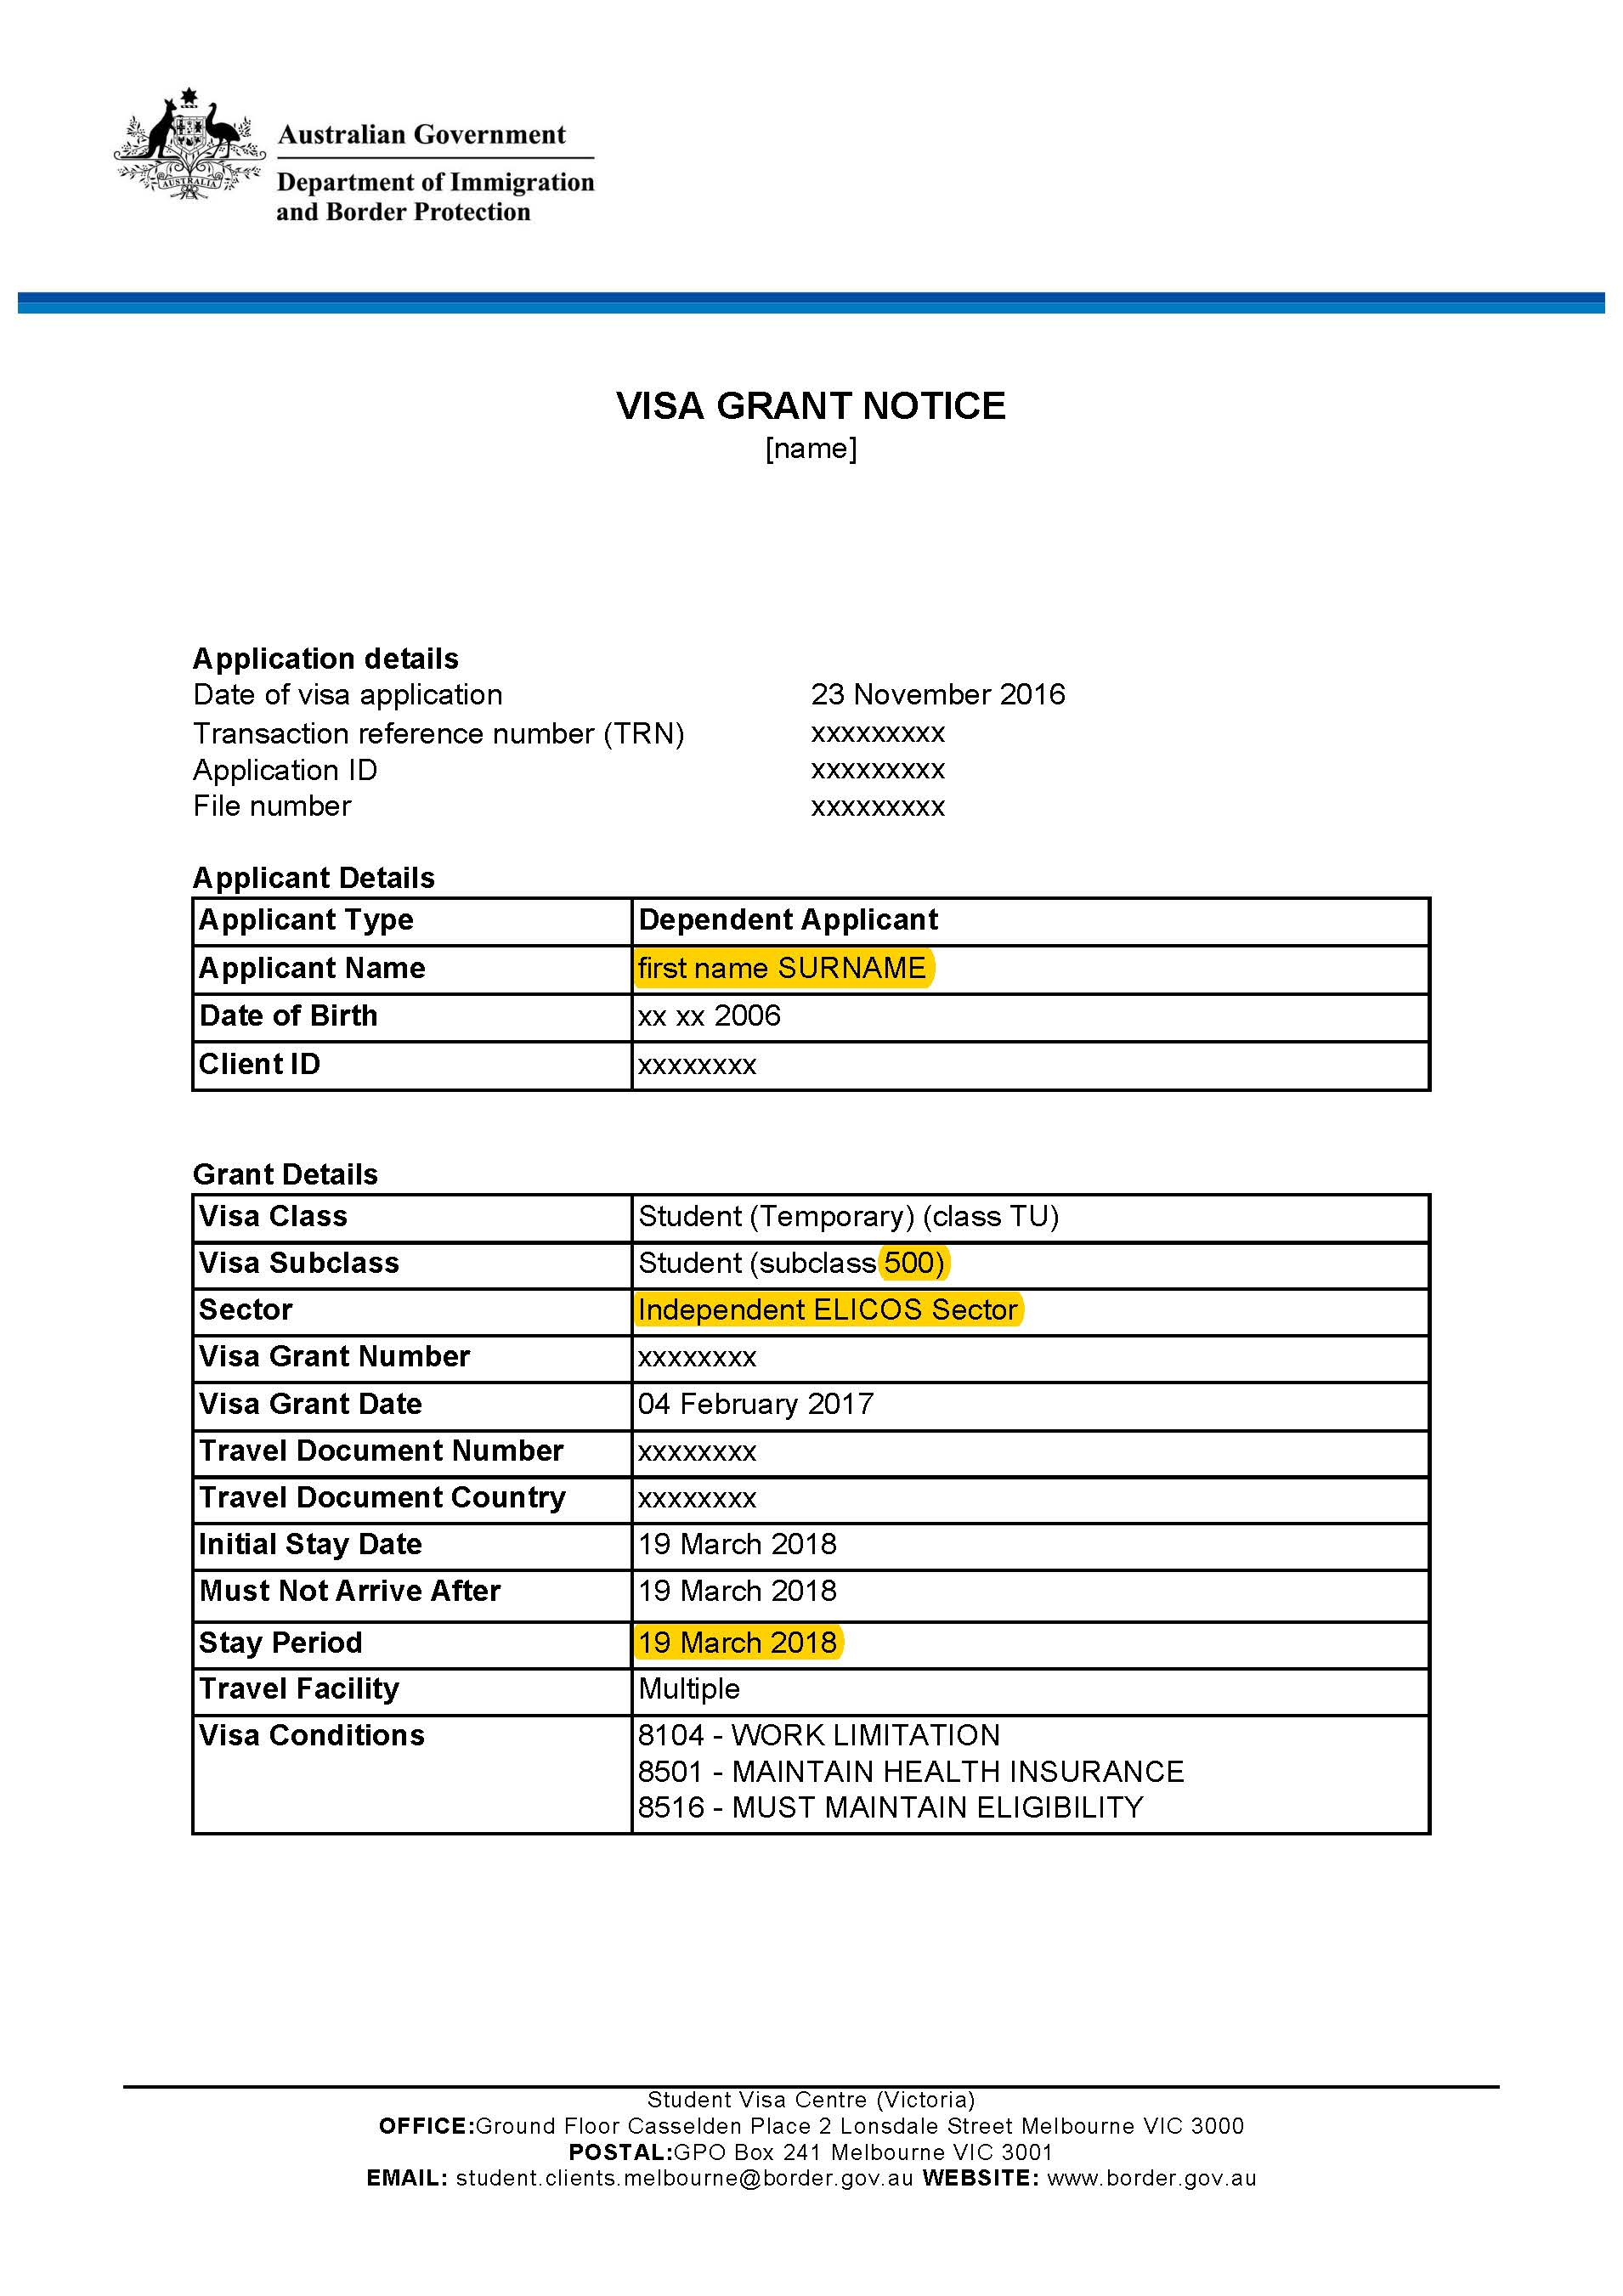

Example of Department of Immigration Letter confirming visa – Example 2
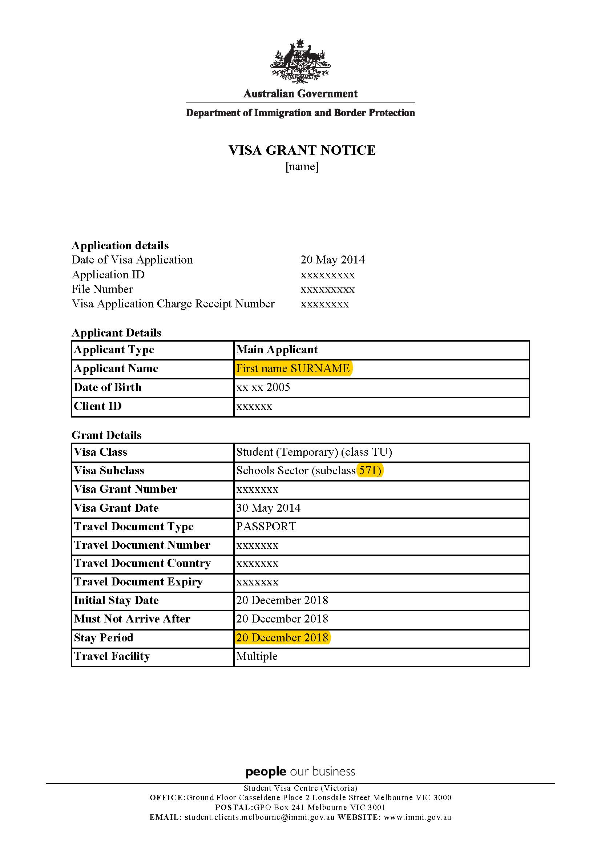

For the purpose of this document, an international student is the same as an overseas student, as defined by Ministerial Order 819 - Fees for Overseas Students in Government Schools.

