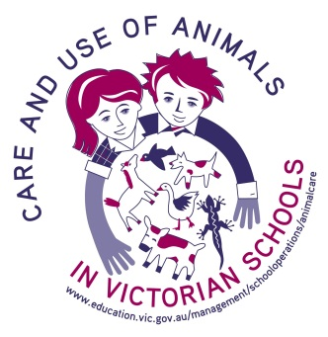
Domestic Fowl – Chickens (Chicks)
Animal Adoption Form

Date:
Dear Parent/Carer
As a part of the year/grade __ course, students will be studying ‘Chickens’. Providing the teacher has granted permission, at the end of this topic a student may be allowed to adopt chickens permanently, into their family, if the following conditions are met:
- The consent form at the bottom of this form is signed by both the parent and student;
- The family are experienced poultry owners with a dedicated brooding set-up, e.g. provision of supplementary heat;
- To better suit the animals’ need for socialisation, a minimum of two chickens must be adopted, unless there are already chickens on the property;
- The student has demonstrated throughout the unit of study his/her capability in caring for the chickens;
- In signing the consent slip, the parent/carer and student also agree to:
  - arrange appropriate safe transport, including provision of a suitable carrier in order to move the chickens to their new home;
  - provide suitable long-term care and housing providing adequate space for free movement;
  - read information about keeping chickens and discuss the species notes (see link below) and the chickens’ needs, and find out about local council laws on keeping chickens (especially roosters), prior to signing the adoption form; it is important to realise the sex of the birds may not have been determined due to their young age
- Should the family be unable to continue the adoption at any point they will contact the school immediately regarding return/re-adoption of the chickens.
It should be noted that a chicken, like any pet, is a long-term commitment. Before an adoption is sought the family should discuss and consider the level of commitment required to ensure it fits with the family’s lifestyle. The chicken adoption is also subject to: (Detail below or N/A)
…………………………………………………………………………………………………………………………………………………………
NB: Species Notes can be found by accessing the following link:
http://www.eduweb.vic.gov.au/edulibrary/public/schadmin/schops/animalethics/Domestic_fowls.doc

Animal Adoption Consent Slip
Student’s name ……………………………………………………
Class ……………………………………………………
I consent to my son/daughter adopting chickens from school. I will provide adequate care for them in
them in the long term.
The chickens will need to be collected from school on ...................... at............am/pm
Signature of Parent/Carer ……………………………………………………
Signature of Student ………………………………………………….. Date __ / __ / ____
Sample information for parents
Thinking of adopting a chick?

Chicks are gorgeous, but they require specific care.
Consider these questions before you adopt chicken hatchlings.
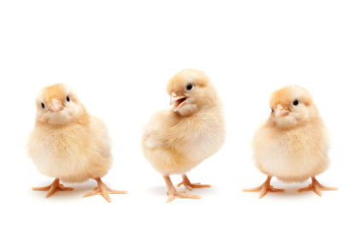

First three weeks
- Who is responsible for looking after the chicks?
- Where will the chicks live? In the house? In the backyard?
- What will the cage/box look like?
- What will you feed them?
- When you are taking the chicks home in the box, how will you know if they are too hot or cold?
- Are there some shavings/paper towelling in the box to cushion the chick whilst transporting?
- How will you provide heat for them?

You will need to keep the chicks in a box until 6 weeks of age.
How will you ensure the chicks are separated from household pets during this time?

Chickens
As the chickens grow older they will need to be housed in a suitable enclosure outside. They may need to
be protected from other chickens if they are to be introduced to an existing flock.
- Who will monitor the introduction of the chicken to the flock?
- What will you feed them when they are adults?
- Where will the chickens live once they are older?
- What are your council regulations about keeping chickens? What will you do if either of the chicks
turns out to be a rooster?
- Who will take responsibility for cleaning up after the chickens?

Finally
Chickens can live to be at least 12 years old. Are you prepared to care for your chickens for their
entire lives?
