(Insert School Name) recognises the importance of the partnership between schools and parents to support student learning, engagement and wellbeing. We share a commitment to, and a responsibility for, ensuring inclusive, safe and orderly environments for children and young people.
This Statement of Values sets out our behavioural expectations of all members in this school community, including the principal, all school staff, parents, students and visitors. It respects the diversity of individuals in our school community and addresses the shared responsibilities of all members in building safe and respectful school communities.
Discrimination, sexual and other forms of harassment, bullying, violence, aggression and threatening behaviour are unacceptable and will not be tolerated in this school.
Our Statement of Values acknowledges that parents and school staff are strongly motivated to do their best for every child. Everyone has the right to differing opinions and views and to raise concerns, as long as we do this respectfully as a community working together.
Responsibilities
As principals and school leaders, we will:
- Work collaboratively to create a school environment where respectful and safe conduct is expected of everyone.
- Behave in a manner consistent with the standards of our profession and meet core responsibilities to provide inclusive, safe and orderly environments.
- Plan, implement and monitor arrangements to ensure the care, safety, security and general wellbeing of all students in attendance at the school is protected.
- Identify and support students who are or may be at risk.
- Do our best to ensure every child achieves their personal and learning potential.
- Work with parents to understand their child’s needs and, where necessary, adapt the learning environment accordingly.
- Respond appropriately when inclusive, safe or orderly behaviour is not demonstrated and implement appropriate interventions and sanctions when required.
- Make known to parents the school’s communication and complaints procedures.
- Ask any person who is acting in an offensive or disorderly way to leave the school grounds.

As Teachers and all non-teaching staff, we will:
- Model positive behaviour to students consistent with the standards of our profession.
- Proactively engage with parents about student outcomes.
- Work with parents to understand the needs of each student and, where necessary, adapt the learning environment accordingly.
- Work collaboratively with parents to improve learning and wellbeing outcomes for students with additional needs.
- Communicate with the principal and school leaders in the event we anticipate or face any tension or challenging behaviours from parents.
- Treat all members of the school community with respect.

As Parents, we will:
- Model positive behaviour to our child.
- Ensure our child attends school on time, every day the school is open for instruction.
- Take an interest in our child’s school and learning.
- Work with the school to achieve the best outcomes for our child.
- Communicate constructively with the school and use expected processes and protocols when raising concerns.
- Support school staff to maintain a safe learning environment for all students.
- Follow the school’s complaints processes if there are complaints.
- Treat all school leaders, staff, students, and other members of the school community with respect.
As Students, we will:
- Model positive behaviour to other students.
- Comply with and model school values.
- Behave in a safe and responsible manner.
- Respect ourselves, other members of the school community and the school environment.
- Actively participate in school.
- Not disrupt the learning of others and make the most of our educational opportunities.

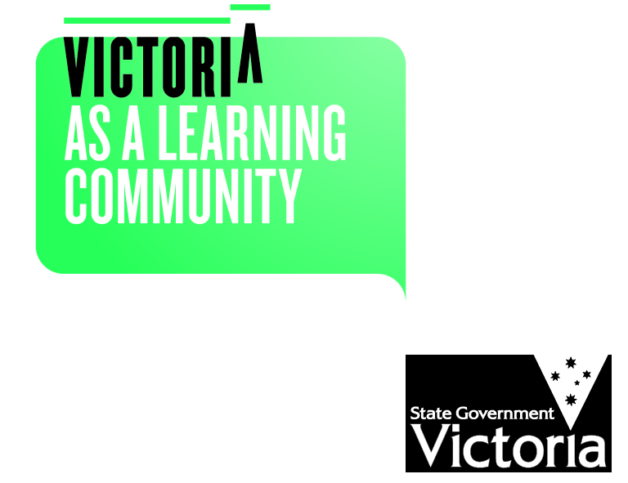
As Community MEMBERS, We will:
- Model positive behaviour to the school community.
- Treat other members of the school community with respect.
- Support school staff to maintain a safe and orderly learning environment for all students.
- Utilise the school’s communications policy to communicate with the school.

THE DEPARMENT OF EDUCATION AND EARLY CHILDHOOD DEVELOPMENT WILL:
- Provide support and advice to principals to equip them to manage and respond to challenging behaviour of students, parents and staff.
- Provide practical guidance and resources to support schools to manage and respond to challenging behaviour of students, parents and staff.
- Provide practical guidance and resources to support schools respond to and prevent bullying and promote cyber-safety and wellbeing.
- Provide access to evidence based resources and strategies to increase student safety, wellbeing and engagement.
- Provide schools with practical and legal support as required.
- Provide parents with practical guidance and resources to resolve conflicts with the school.
consequences for failing to uphold the statement of values
Unreasonable behaviours
Behaviours that are considered inappropriate on and adjacent to school grounds or in relation to school business and that do not uphold the principles of this Statement of Values include when a person:
- is rude, aggressive or harasses others
- sends rude, confronting or threatening letters, emails or text messages
- is manipulative or threatening
- speaks in an aggressive tone, either in person or over the telephone
- makes sexist, racist or derogatory comments
- inappropriately uses social media as a forum to raise concerns/make complaints against the school
- is physically intimidating, e.g. standing very close.

Consequences
Principals are responsible for determining what constitutes reasonable and unreasonable behaviour.
Unreasonable behaviour and/or failure to uphold the principles of this Statement of Values may lead to further investigation and the implementation of appropriate consequences. This may include:
- utilising mediation and counselling services
- alternative communication strategies being applied
- formal notice preventing entry onto school premises or attendance at school activities. Written notice will follow any verbal notice given.
- an intervention order being sought
- informing the police which may result in a charge of trespass or assault
By agreeing to meet specified standards of positive behaviour, everyone in our school community can be assured that they will be treated with fairness and respect. In turn, this will help to create a school that is safe and orderly, where everyone is empowered to participate and learn.

