Hard Words

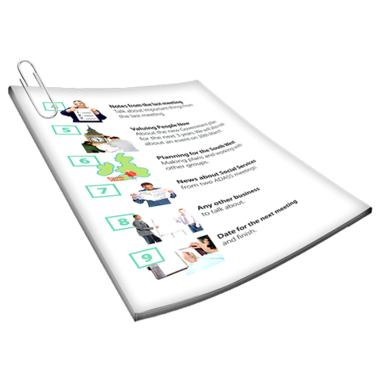

This paper has some hard words.

The first time we write a hard word

- the word is in blue

- we write what the hard word means next to it.

stopping AND HAVING LESS restraint and seclusion in schools

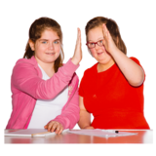

All students have the right to learn in a safe place.

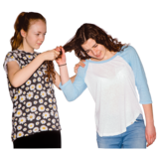

Sometimes people can do things that can hurt themselves or other people (called behaviours of concern).

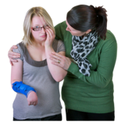

Teachers have to make sure that all students are safe; this is called “duty of care”.

Teachers have to make sure that they are safe as well.

stopping student behaviours of concern

Victorian Government Schools need to know why behaviours of concern happen, and what we can do to change them.

Victorian Government Schools need to teach students other ways to speak up about what they need.

Victorian Government Schools think it is important to look at:

- positive behaviour support

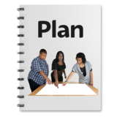

- good planning

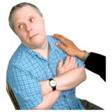

- getting in early

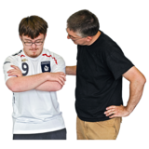
- what works well to calm students down.

If you want to know more go to: http://www.education.vic.gov.au/school/principals/participation/Pages/behaviourofconcern.aspx

Physical restraint or seclusion

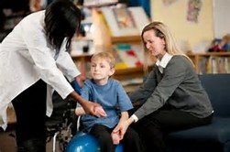
Sometimes staff need to use physical restraint to keep everyone safe.

Physical restraint means stopping a person from being able move all or part of their body.

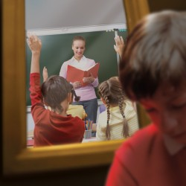

Seclusion means leaving a person alone in a room or area that they believe they cannot get out of.

Victorian government schools have rules about the use of restraint and seclusion.

http://www.education.vic.gov.au/school/teachers/studentmanagement/Pages/behaviourofconcern.aspx

DEPARTMENT Policy and the Law

The law says staff in Victorian government schools can only use physical restraint or seclusion when:

- a person is about to hurt themselves or others; and

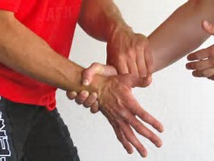

- it is what most staff would do when a person is hurting themselves or others

- there is no other way of keeping people safe.

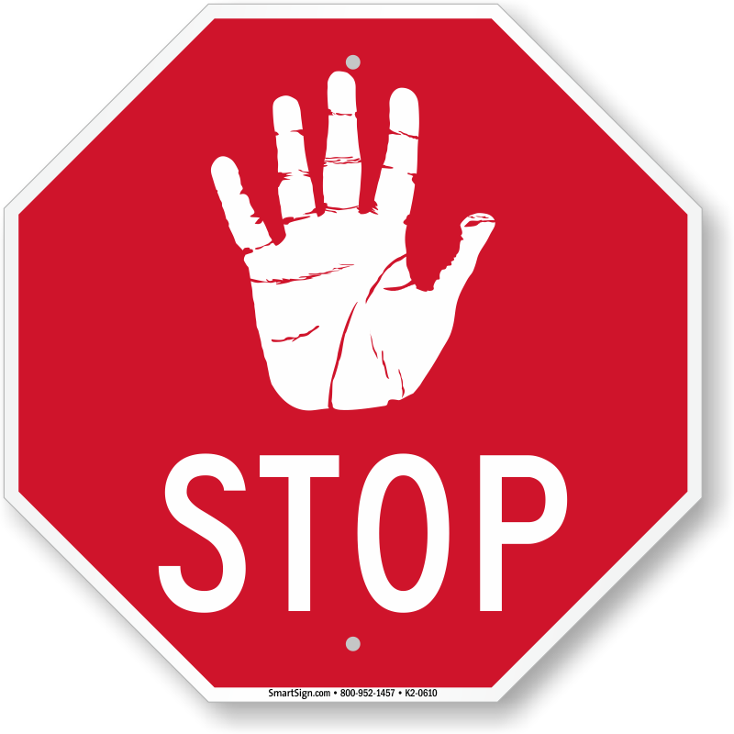

Staff must stop using physical restraint or seclusion when the harm or danger has gone.

what the school will do if YOUR child has been restrained or secluded

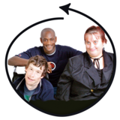
The school will:

- make sure that everyone is ok

- tell you as soon as they can about what happened and why

- Talk to you about supports you might need

- look at or make a behaviour support plan(a plan that talks about what can be done to stop a behaviour of concern)

- Let the Department know.

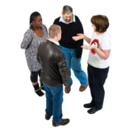

You can work with your school to try to stop behaviour of concern from happening.

i’m worried about my child’s behaviour

- If you are not happy or worried, talk to your child’s teacher, year level coordinator or a wellbeing staff member.

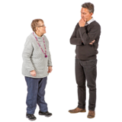

- You can ask the school about getting Student Support Services or other people who might help

- Your doctor (GP) can make sure there are no health reasons for the behaviour.

- You can talk to your doctor about getting help from professionals like psychologists or psychiatrists.

- If your child has a disability, call the Disability Intake and Response Service on 1800 783 783 or the NDIS on 1800 800 110 for information on other support you can get.

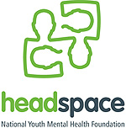

- If you are worried about your child’s mental health, contact your local Headspace centre on the website: http://www.headspace.org.au/headspace-centres

I AM worried ABOUT what the school is doing to support my child’s behaviour

If you are worried or not happy you can:

1. talk to the teacher

2. talk to the school principal.

3. call a Community Liaison Officer at your local Department of Education and Training (DET) office.

This website has the phone numbers for your local area: http://www.education.vic.gov.au/about/contact/pages/regions.aspx

Or ring the Department’s switchboard on (03) 9637 2000.

4. If you are still not happy you can write to DET on this website. http://www.education.vic.gov.au/about/contact/Pages/complaintslanding.aspx

5. The Department might send your complaint to the Independent Office for School dispute resolution.

You can phone the Office on 1300 017 593 or email school.resolution@edumail.vic.gov.au

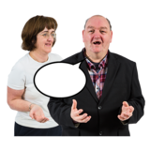
You can call an advocate at any time. An advocate can help you to speak up.

