Victorian Maternal and Child Health Service Statewide consent form

Insert council logo here
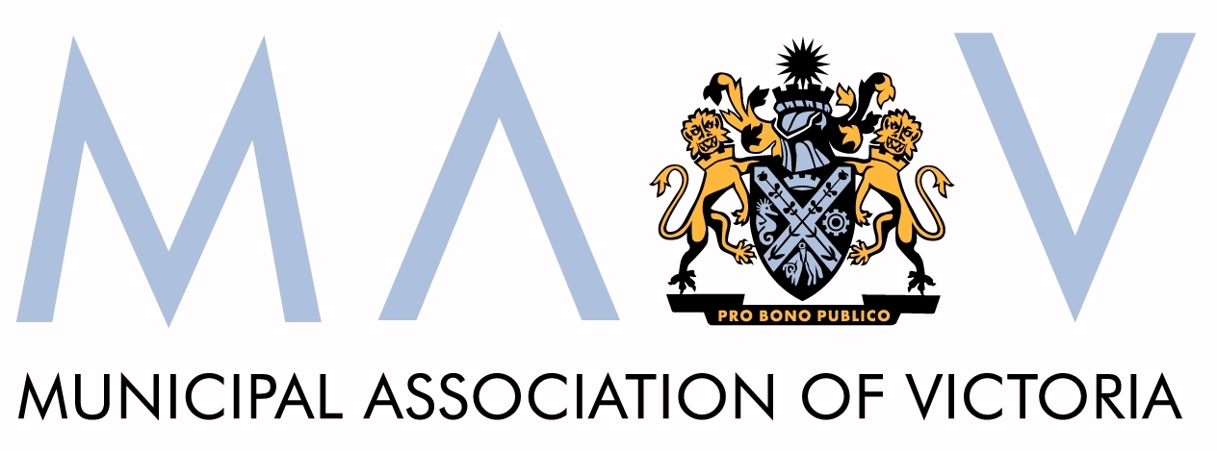

Child’s name Date of Birth____/____/20____

Please complete either the written or verbal consent section.

Written consent from parent/guardian

The Maternal and Child Health nurse has discussed with me how and why certain information about my child and family may be collected and stored. I understand that this information will be handled in accordance with the Health Records Act 2001 (Vic).

First Name: | Last Name:
Signed: | Relationship:
Date: / / 20 | Contact number:

Verbal consent from parent/guardian

I have discussed with the client how and why certain information may be collected and stored. I am satisfied that this has been understood and that informed consent for the information to be handled in accordance with the Health Records Act 2001(Vic) has been given.

Discussed with:
First Name: | Last Name:
Relationship: | Contact number:

Translator/support, if present or involved (e.g. language, visual or literacy challenges)
Name: | Contact Number:

Written or verbal consent was obtained and witnessed by:
First Name: | Last Name:
Signed: | Council:
Date: / / 20 | Contact number:

Please complete:

This family have been given information about privacy & consent:
- "What happens to information about you and your family?"
- “About Maternal & Child Health Service Consent.”
- Any additional resources as necessary.

This family will be given a copy of this completed form.

