Regulation and Quality Assessment Update

This newsletter includes information for early childhood services operating under the National Quality Framework and services operating under the Children’s Services Act 1996.

Issue 16 | September 2015

Evaluating risks when going on an excursion
Latest news
Welcome to the sixth edition of the Regulation and Quality Assessment Update.
This edition includes articles in relation to:
- information about the proposed No Jab No Play legislation. Support materials to assist services to implement this policy are being developed. This policy does not apply to children whose enrolment has been completed by 31 December 2015.
- early childhood teacher registration applications to the Victorian Institute of Teaching due by 30 September 2015.
I would like to encourage you to participate in the recently announced Early Childhood Consultation sessions being held through September and early October 2015. I invite everyone to read the Early Childhood Consultation Paper and contribute their ideas for the future of early childhood education in Victoria, more information is available at: www.educationstate.education.vic.gov.au.
I also wish to stress the importance of vigilant and active supervision of children to keep children safe and ensure that their behaviors during play are appropriate.
I recommend that you share the newsletter with all educators and staff members at your service.
I hope you enjoy reading this edition.
Madeleine Smith Executive Director
Quality Assessment and Regulation Division Department of Education and Training
Now that the weather is getting warmer, many services will be planning excursions.
A requirement of the Education and Care Services National Regulations 2011 is to identify and evaluate all the risks that may be present when leaving the service and returning to the service (regulations 100-101). Risk factors may include the method of travel, the behaviour of children and the destination.
As part of the risk assessment you must put in place strategies to manage any identified risks. This will include increasing the number of educators and ensuring that staff members accompanying the children on the excursion understand their responsibilities. For example, where children are going to the swimming pool there should be educators who can swim and assist children in the water.
Educators’ practices must reflect the policies and procedures of the service. Regular monitoring of all children in attendance at the excursion is important to ensure that they are accounted for at all times particularly during transition times and at the end of excursions. Having an accurate list of names of children on the excursion will assist educators to ensure that each child is accounted for.
The service may choose to review their excursion policy to make sure it includes all of the practices and procedures required of educators and staff members during an excursion.
Further information about the requirements and considerations for excursions is available in the fact sheets:
- Excursions and regular outings
- Transporting children in centre-based service
- Transporting children in family day care
These fact sheets are available at: www. education.vic.gov.au/childhood/providers/ regulation/Pages/nqffactsheets.aspx.
Changes to educator to child ratios 1:11
From 1 January 2016 the educator to child ratios for children 36 months to preschool age will be 1 educator to every 11 children (1:11). To assist services to transition to the new ratio requirements, two fact sheets have been developed:
- Educator to child ratios from 1 January 2016 – Centre-based services, which provides general information for centre-based services, including the ratio requirements and waivers.
- Educator to child ratios for funded kindergarten programs from 1 January 2016, which provides specific information for services in receipt of kindergarten funding.
In some circumstances services may require additional time to transition to the new ratio requirements and may consider applying for a waiver. Services should consider the information in the fact sheet regarding applying for a waiver. Waiver applications should be submitted via
NQA ITS portal at: www.acecqa.gov.au/national-quality-agenda-it-system.
These fact sheets are available at: www.education.vic.gov.au/childhood/providers/regulation/ Pages/nqffactsheets.aspx.

Children’s Services Act services

Educational program
The Children’s Services Act 1996 (CS Act) and the Children’s Services Regulations 2009 (CS Regulations) specify the requirements children’s services must meet in their day-to-day operation. The CS Act contains important standards including that an educational or recreational program is available for children (section 26B).
The educational or recreational program that is provided at your service must:
- be based on the child’s developmental needs, interests and experiences
- be designed to take into account each child’s individual differences
- enhance each child’s development.
A program for children (sometimes called a curriculum) refers not only to planned learning experiences provided for children but to all experiences, both planned and unplanned (intentional and spontaneous), that children have throughout the day.
An outline of the educational or recreational program must be displayed at the service (regulation 40(1)(e)).
Children’s programs should be guided by the Victorian Early Years Learning and Development Framework and the National Early Years Learning Framework and for school age programs My Time, Our Place – Framework for School Age Care.
Services must provide furniture, materials and developmentally appropriate equipment that is suitable for the educational or recreational program provided for that child (regulation 93). The design, arrangement and variety of resources and equipment assist in creating an environment where children are engaged and interested, are able to explore and discover and to make choices.
In setting up the learning environment, staff members should ensure that it promotes learning, meets individual needs and enhances children’s emotional and social wellbeing.

Further information is available at: www.education.vic.gov.au/childhood/ providers/regulation/Pages/vcs.aspx
Victorian Early Years Learning and Development Framework: www.education. vic.gov.au/Documents/childhood/providers/edcare/veyldframework.pdf
The Early Years Learning Framework for Australia and My Time Our Place – Framework for School Age Care in Australia are available at: www.acecqa. gov.au
NQS PLP e-Newsletters: www.earlychildhoodaustralia.org.au/nqsplp/e- newsletters
Practice Guide and Evidence Paper for each of the eight Practice Principles: www.education.vic.gov.au/childhood/providers/edcare/Pages/ profresource.aspx
Delivering a children’s program in a limited hours service: www.education.vic. gov.au/childhood/providers/regulation/Pages/vcsguides.aspx.

Cultural competence
Both the Early Years Learning Framework for Australia (EYLF) and the Victorian Early Years Learning and Development
Framework (VEYLDF) highlight the importance of creating a culturally inclusive environment as a foundation for supporting children’s identity and sense of belonging, and in developing trusting and secure relationships with both children and families.
What is culture? Culture can be defined as ‘what we create beyond our biology’. Not given to us, but made by us (Williams, in MacNaughton, 2003, p.14). Using this definition, culture incorporates the scope of human diversity and ways of being, such as gender, ethnicity, class, religion, ability, age, and sexuality (DEEWR, 2010, p. 22).
To effectively develop respectful and supportive relationships with all children and families, educators need to value the influence that culture has on experiences, understandings, expectations and practices.
Culturally competent educators are also able to identify this in relation to their own cultural context and examine and address any bias or stereotyping.
Cultural competence is not the ability to be ‘competent in a culture’, rather the ability to competently work with children and families from all cultural backgrounds. The Cultural Competency Continuum is defined as ‘a set of congruent behaviours, attitudes and policies that come together in a system, agency or professional and enable that system, agency or professional to work effectively in cross-cultural situations’ (Cross, 1989, cited in New York State Citizens Coalition for Children, Inc., 2006).
One of the first steps towards cultural competence is to reflect on your own world view and how that has been influenced by the cultural values implicit in your life. Educators who identify the cultural influences in their own experiences and perspectives are able to recognise that others also experience life in a cultural context. This understanding can assist early childhood services to embed cultural perspectives throughout all programs, practices, policies and relationships to create a culturally rich and safe environment for all children and families.
Fka Children’s Services (FkaCS) advocates for children’s cultural and linguistic rights and provides support to early childhood services in the provision of culturally rich environments that reflect a civil society.
Educators are supported on their journey to cultural competency by:
- onsite support visits to enhance educators cultural competency
- individual child and family support in the child’s home language
- multilingual material to support the cultural and linguistic rights of children
- telephone support and advice
- professional learning, coaching and training.
Information on FkaCS bicultural support program is available at:
www.fka.org.au or call (03) 9428 4471.

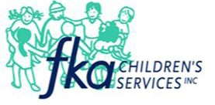
Fact sheets for services operating under the Children’s Services Act are available at: www.education.vic.gov.au/childhood/providers/ regulation/Pages/vcsfactsheets.aspx

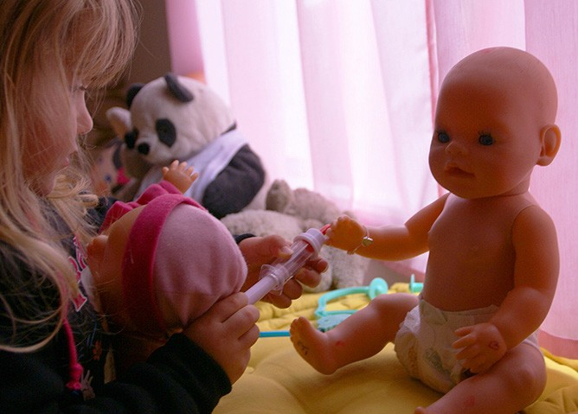No Jab No Play work underway
The Department of Education and Training (DET) and the Department of Health and Human Services (DHHS) are working closely with the Municipal Association of Victoria to finalise details and sector support materials for the proposed No Jab No Play legislation.
The proposed legislation will require children to be fully immunised for their age before enrolment in an early childhood service can be finalised and is expected to come into effect on 1 January 2016.
The legislation will apply to all early childhood education and care services providing long day care, kindergarten, occasional care and family day care. It will not apply to:
- outside school hours care
- casual occasional care services that offer care of less than 2 hours per day and less than 6 hours per week, this includes crèches at gyms and shopping centres
- playgroups
- enrolment in primary or secondary school.
A letter containing details of the proposal was sent by the Ministers for Health and Education to early childhood services likely to be impacted by the proposed legislation.
Support materials in development for early childhood education and care services include a toolkit that contains a detailed explanation of acceptable documentation, assessing eligibility for the proposed ‘grace period’ for vulnerable and disadvantaged families, and recommended responses to likely scenarios that services may encounter.
Many enquiries have been received by service
providers, DET and DHHS. A web page of common Questions and Answers was established on the DHHS website www.health.vic.gov.au/immunisation/factsheets/no-jab-no-play.htm and continues to be updated in line with incoming queries.
More detail will be made available at this web address as the legislation progresses through Parliament. Updates will also be included in future editions of this newsletter.

Updating contact details
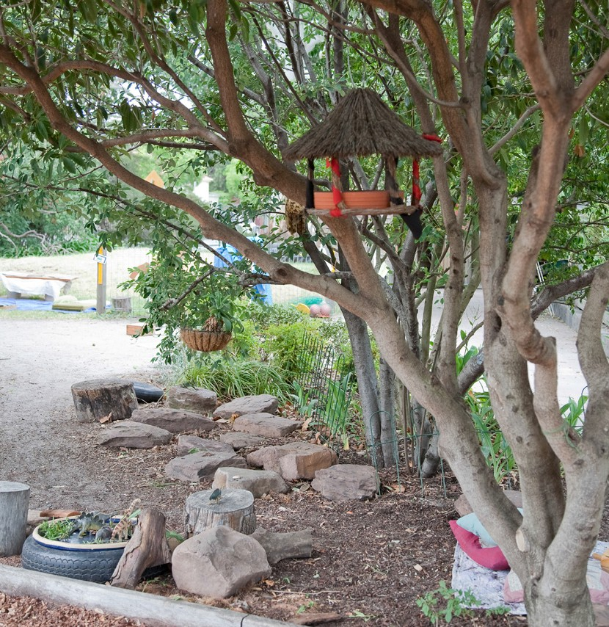NQF services can update their details via the NQA ITS portal at: www.acecqa.gov. au/national-quality-agenda-it-system and Children’s Services Act services wishing to update details can contact the Department at: 1300 307 415 or via email at: licensed. childrens.services@edumail.vic.gov.au.
Licensees of Children’s Services Act services regulated under the Children’s Services Act 1996 will receive communication in the coming weeks advising them of the details that the Department has on their records. This will be an opportunity for updated information to be provided so that we can ensure your records are accurate.

Preparation for bushfire season 2015-16
Information sessions
Information sessions for centre-based early childhood services on emergency
management planning and how to complete your emergency management plan (EMP) are being conducted at a number of regional and metropolitan centres across Victoria over a two month period September-October 2015.
To view the training schedule and register your attendance at one of the workshops please follow the link: http://www.eventbrite. com.au/o/ng-det-emergency-management- planning-information-session- 8364226588?s=42335554
Victoria has a number of fire-prone areas where there is a higher risk of bushfire activity. Centre-based early childhood services operating in these locations are placed on the Department’s Bushfire At-Risk Register (BARR). A list of the services placed on the BARR is published on the Department’s website and is available at: www.education.vic.gov.au/about/programs/health/Pages/bushfirerisk.aspx.
Services listed on the BARR are required to meet the conditions that are imposed on their service approval/licence, these are:
- the approved provider/licensee of a service on the BARR must ensure that on any day declared to be a Code Red day for the region in which a service is located, that the service is closed and
remains closed for the duration of the Code Red day
- services named on the BARR must submit their current emergency management plan annually to their respective QAR Regional Office by 21 November.
Contact details of the relevant Quality Assessment and Regulation (QAR) Regional Offices of the Department are available at: www.education.vic.gov.au/childhood/providers/regulation/Pages/ nqf.aspx.
Resources
The Department has developed a range of resources to assist early childhood services in developing their emergency management plans:
- Guide to developing an emergency management plan
- Emergency management planning FAQs
- Emergency management plan template for early childhood services
- Short video tutorials to assist with developing area maps, evacuation diagrams
and communication trees within the Emergency Management Plan template document.
These resources available at: www.education. vic.gov.au/childhood/providers/support/ Pages/emergency.aspx.
Services that have submitted an emergency management plan in 2015 are not required to submit the same emergency management plan, unless it has been changed or updated.
Further information is available in the fact sheet Managing bushfire risks in centre-based services available at: www.education.vic.gov.au/childhood/providers/regulation/Pages/nqffactsheets. aspx.
The approved provider of each family day care service must:
- Assess the location of each residence and/or venue to determine whether the residence or venue is located in an area considered as high risk of bushfire. The Department’s BARR can be used to determine locations at high risk of bushfire and is available at: www.education.vic.gov.au/about/programs/health/Pages/bushfirerisk.aspx.
- Incorporate procedures for monitoring bushfire risks for each family day care residence or venue.
- Ensure that education and care is not provided at a family day care residence or venue located in an area considered as high risk of bushfire on a declared Code Red day in their Bureau of
Meteorology district. Inform families of any family day care residence or venue where education and care cannot be provided due to a Code Red day in their Bureau of Meteorology district.
Further information is available in the fact sheet Managing bushfire risks in family day care available at: www.education.vic.gov.au/childhood/providers/regulation/Pages/nqffactsheets.aspx.

To all scholarship recipients – participation in survey
If you have applied for a scholarship from the Department of Education and Training (DET) from 2008–15 to support completion of an early childhood education qualification, you would have received an email on 7 September asking you to participate in an online survey.
The survey will take approximately15 minutes.
DET is undertaking an evaluation of scholarship programs to determine future workforce policies and programs so please take the time to complete the survey which will cover:
  - your scholarship experience
  - the quality of your course
  - your participation in other workforce programs
  - how completing the course has impacted on the way you do your job.
All information collected as part of the survey is confidential and will not be used for any purpose other than that stated above.

Early childhood scholarships for Aboriginal people
Early childhood scholarships are available for Aboriginal people working in a Victorian early childhood setting, or Aboriginal people who can demonstrate willingness and commitment to working in an early childhood setting, to attain or upgrade an early childhood education qualification.
Following completion of the course, successful recipients are required to work for a minimum period of time in a Victorian early childhood setting, including Multicultural Aboriginal children’s services (MACS), Children and family centres (CFCs), Aboriginal Best Start, Aboriginal Playgroups, In Home Support, Home based learning or Child and Family Services in an Aboriginal cooperative or corporation.
Early childhood teacher mentoring program
Registrations for the 2015 Early Childhood Teacher Mentoring Program are now open.
This program is for experienced and qualified early childhood teachers who anticipate taking on the role of mentor for beginning early childhood teachers.
The program provides the opportunity for early childhood teachers to strengthen their mentoring skills and to provide the support required to build the professional practice of beginning early childhood teachers. It is a one day program facilitated by Ed Partnerships International and is provided at no cost to participants. Services will not be reimbursed for the cost of replacing their teacher on the day.
The program will be held from 9:00a.m. – 3:15p.m. at four locations:
- 8 October, Karstens Conference Centre, 123 Queen Street, Melbourne
- 9 October, Box Hill Golf Club, 202 Station Street, Box Hill
- 22 October, Century Inn Traralgon, 5 Airfield Rd, Latrobe Valley
- 23 October, All Seasons Bendigo, 171-183 McIvor Road, Bendigo.
The program will not cover details about the process for beginning teachers to achieve full registration with the Victorian Institute of Teaching. For information on the process, please see: www.vit.vic.edu.au/registering-as-a-teacher/registration-catgories/early-childhood-teacher
To register, please complete the online registration form at: www.education.vic.gov.au/childhood/ professionals/profdev/Pages/mentoring.aspx by 25 September 2015. Up to 40 registrations will be accepted at each of the mentor training days.
Scholarships range from $1,500 for a Certificate III in Early Childhood Education and Care
to $12,000 for an Early Childhood Teaching Degree.
Applications are accepted at any time, and are available at: www.education.vic.gov.au/about/ careers/Pages/aboriginal.aspx
For more information contact 1300 651 662 or email: early.years.workforce@edumail.vic. gov.au

What information must an enrolment record contain?
The Education and Care Services National Law Act 2010 and Education and Care Services Regulations 2011 require that an approved provider of a centre-based service or family day care service and family day care educator must keep an enrolment record for each child enrolled at an education and care service. The enrolment record must contain details relating to the child, authorisations given by parents (or other specified persons), court orders and related legal documents (regulations 160-162).
A checklist has been developed in the fact sheet Enrolment records to ensure that all enrolment record requirements are met and maintained. The service must use a method of collecting the information which ensures that all of the prescribed information set out in regulation 160 is included and parents have the opportunity to provide the information. Where relevant, court orders, medical management plans, risk minimisation plans, authorisations and other relevant documents should be attached to the enrolment record.
The approved provider and family day care educator must keep enrolment records available for inspection by an authorised officer (section 175).
An approved provider and family day care educator must also take reasonable steps to ensure the enrolment records are:
- accurate
- made available to the parents of the child upon request, unless otherwise stated by a court order (regulations 177 and 178).
Reflective questions
- What do we do with the information obtained from the enrolment records, how do we assess and share relevant information with educators?
- How do we include this information in our programs and practices?
- Do we use this information to support children and families? For example, if we know English is a second language and/or there are specific cultural or religious considerations for a child/
family – are we using this information to support families and establish meaningful and respectful relationships and experiences for the child/family?
- Have we accessed information from the fact sheet available on the Department’s website to assess the content of our enrolment form?
- Do we have an effective process in place to ensure information on the enrolment forms is current?
Further information is available in the fact sheet Enrolment records available at: www.education. vic.gov.au/childhood/providers/regulation/Pages/nqffactsheets.aspx
Early childhood teacher registration
All qualified early childhood teachers who are employed or engaged as an early childhood teacher in a Victorian education and care service or children’s service need to be registered with the Victorian Institute of Teaching (VIT) from 30 September 2015.
If you need to register as an early childhood teacher, it’s important you apply for registration NOW. This will ensure your application is processed in time for your name to appear on the online teacher register by 30 September 2015.
You can access more information and the early childhood teacher application form from the VIT website: www.vit.vic.edu.au. If you are unable to find the information you need about early childhood registration on VIT website, call on 1300 977 263. VIT is open from 8a.m. to 6p.m.
Monday to Friday except on public holidays. A good time to call is between 10:30a.m. and 12:30p.m. and from 4:30p.m. to 6p.m.

Focus on the National Quality Standard
The information below represents the top 5 elements not met in Victoria in the last 12 months, grouped by care type. Services may wish to consider how they are meeting these requirements.

Top elements not met | TOTAL
 | Element | Total number
1 | 1.2.1 | 127
2 | 7.2.2 | 92
3 | 1.2.3 | 92
4 | 3.3.2 | 90
5 | 3.3.1 | 72

Kindergarten
Element | Total number
1.2.1 | 19
7.2.2 | 13
1.2.3 | 11
1.1.4 | 8
1.1.2 | 8

OSHC
Element | Total number
1.2.1 | 54
7.2.2 | 45
3.3.2 | 37
1.2.3 | 36
3.3.1 | 32

LDC
Element | Total number
1.1.2 | 33
1.2.1 | 28
2.1.1 | 26
3.3.2 | 25
1.2.3 | 22

FDC
Element | Total number
1.2.1 | 26
3.3.2 | 25
1.2.3 | 23
7.2.2 | 21
3.3.1 | 20

Focus on element 1.2.1 Each child’s learning and development is assessed as part of an ongoing cycle of planning, documentation and evaluation
For authorised officers to assess elements 1.2.1 and 1.1.4 sighting documentation will be the major source of evidence and for the remaining elements, observations of the program being delivered will be the major source of evidence. Discussions with educators will clarify the evidence collected and at times program documentation will be the reference.
A documented plan of the educational program that provides information about the contents and the operation of the program to be delivered to all children in the service is required (regulation 75).
A critically important part of the planning process is recording the plan. This means that planning involves the process of thinking, reflecting and deciding and documenting that process.
Planning is making decisions about the program, thinking ahead of time about individual children, the children as a group and the program you want to offer, and then preparing for it. Planning needs to happen ahead of time and be part of an ongoing cycle of planning, implementing the plan, reflecting and evaluating.
Plans need to be intentional and to link to documentation of the overall program plan and the information collected and documented about each child. Plans should reflect the service’s statement of philosophy. Plans enable all educators in the children’s room to understand the program and work together to implement the program.
This article is provided by Victorian Curriculum and Assessment Authority

Assessment for learning – tool
The Early Years Planning Cycle (EYPC) is used to support assessment for learning ‘which is designed to discover what children know and understand based on what they make, write, draw, say and do.’ (Victorian Early Years Learning and Development Framework p.13)
The EYPC outlines the process early childhood professionals use to collect and analyse evidence. This contributes to a detailed, up-to-date, strengths-based picture of children’s learning and development to inform planning and practice decisions. The EYPC is an ongoing, reflective process that is adapted to support children’s learning in the context
of family, culture, community and individual settings. Early childhood professionals recognise families as the primary influence on children’s learning and development and work in partnership to develop shared understandings that extend
learning and development in all contexts.
A prompts section includes key questions to support recording children’s learning and thinking about the meaning of children’s learning.
It suggests beginning with a proposed program plan and using all elements of the Planning Cycle. A fourth column supports ongoing learning and reflective

Element 7.2.2 The performance of educators,
practice.
Reflecting on all events and

The Early Years Planning Cycles is adapted from Educator’s guide to the EYLF (2010)

co-ordinators and staff members is evaluated and individual development plans are in place to support performance improvement
Information addressing this element is available in the Regulation and Quality Assessment Update issue 13 (May 2015) pg3-4, available at: www.education.vic.gov.au/childhood/providers/regulation/Pages/ newsletters.aspx

Resources
Fact sheets for NQF services are available at: www.education. vic.gov.au/childhood/providers/regulation/Pages/nqffactsheets. aspx
Keeping in touch
Department of Education and Training GPO Box 4367, MELBOURNE VIC 3001
You can get in touch with us by:
Visiting our website www.education.vic.gov.au
Phoning us on 1300 307 415
Emailing us on licensed.childrens.services@edumail.vic.gov.au
experiences supports practitioners to review and inform decisions about children’s learning and their planning and practice decisions.
This resource can be used to guide team discussions about children’s learning linked to practice decisions, as is available at: www.vcaa.vic. edu.au
  - A resource to support documentation of children’s learning, available at: www.vcaa.vic.edu.au/Documents/earlyyears/eye/ EYE10_SuppChildLearn_FA.pdf
  - Documentation of children’s learning tool. This sample tool can be saved to your own files and adapted and expressed in
various ways to suit individual service settings, and is available at: www.vcaa.vic.edu.au/Documents/earlyyears/eye/ EYE10SupportChildLearnTemplateWord.doc

