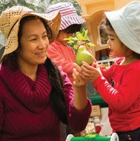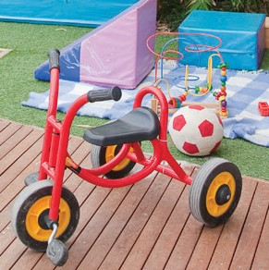

Issue 11 | February 2015

Quality Framework and services operating under the Victorian children’s services legislation.

Excellent rating for Doveton College Early Learning Centre

Congratulations to Doveton College Early Learning Centre on its recent Excellent rating. This is

Victoria’s fourth education and care service to receive an excellent rating. The Excellent rating, awarded by ACECQA, is the highest rating possible under the NQF.

Doveton College’s innovative programs and inclusive partnerships were praised for their exceptional engagement with the local community many of whom are newly arrived refugees and migrants. As ACECQA’s Board Chair Rachel Hunter commented in her report “They understand that to help children thrive it is important to support their families as well and their approach is nothing short of inspiring”.

The service partners with 15 organisations including collaborating to running English lessons, a men’s support group and skill development classes as well as assisting families with basic needs such as food, clothing, accommodation, travel and furniture.

Further information on the Doveton Early Learning Centre is available at [www.dovetoncollege.vic.](http://www.dovetoncollege.vic.edu.au/) [edu.au](http://www.dovetoncollege.vic.edu.au/)

Approved providers with a service that has received an overall rating of ‘Exceeding National Quality Standard’ can apply for the Excellent rating. Further information is available at [www.acecqa.gov.au/excellent-rating](http://www.acecqa.gov.au/excellent-rating)

*Pictured: Children from Doveton College Early Learning Centre*

Welcome back for 2015, I hope you all had a restful break.

We are now into our third year of the National Quality Framework (NQF) and we have conducted an assessment and rating visit for

63 per cent of our services. Our target is that by the end of 2015, all education and care services will have had their first assessment and rating visit.

A number of consultation sessions were held in late 2014 to gain feedback from the education and care sector in Victoria on the Consultation Regulation Impact Statement (RIS). Nine face to face sessions were run across Victoria, presented by the Department of Education and Training (DET) and Commonwealth Department of Education and Training with the Australian Children’s Education and Care Quality Authority

(ACECQA). There was also an opportunity to give feedback by 15 January 2015.

Thank you to all education and care services and stakeholders for your contributions at these sessions and the feedback through the online

process. The sector was supportive of the majority of the proposed changes, especially to remove unnecessary regulatory burden while maintaining quality outcomes for children. Feedback

received will inform the Decision RIS currently under preparation. Any changes flowing from this process will not be in place until mid-2016.

Transitional arrangements and further guidance to the sector will accompany any changes.

The Productivity Commission final inquiry report on Childcare and Early Childhood Learning was published on 20 February 2015. Further information about the inquiry can be found at [www.pc.gov.au.](http://www.pc.gov.au/)

Bookings are now open for the ACECQA workshops focusing on Quality Area 1: Educational Program and Practice that are being delivered

with the Department and the Professional Support Coordinator Gowrie Victoria. The workshops

are open to all educators and providers, but are particularly targeted at services that have received a rating of Working Towards National Quality Standard or have not yet been rated. Further information is available and bookings can be made at [www.acecqa.gov.au/events.](http://www.acecqa.gov.au/events)

**Madeleine Smith Executive Director**

*Quality Assessment and Regulation Division*

*Department of Education and Training.*

Regulation and Quality Assessment Update Issue 11 | February 2015 Pg 1

Regulation and Quality Assessment Update

This newsletter includes information for children’s services operating under the National



collect the child from the service or the family day care educator.

included in the service’s enrolment records. The best way of ensuring that

Achievement Program is available at www.achievementprogram.

Healthy eating

When young children are encouraged to eat healthily and drink sufficient water they are on the right path to healthy living, good dental hygiene and overall wellbeing with the energy to play and learn.

Education and care services can provide many ways to promote healthy eating and plan for experiences where children and families can learn about nutritious food and drinks.

The Healthy Together *Healthy Eating Advisory Service* supports staff and management to give children the best start in life. The service offers

telephone and email advice, menu assessments, menu planning resources, recipes and training for staff and health professionals who work within education and care services. More information is available at [www.heas.](http://www.heas.healthytogether.vic.gov.au/early-childhood-services/early-childhood-services) [healthytogether.vic.gov.au/early-childhood-services/early-childhood-](http://www.heas.healthytogether.vic.gov.au/early-childhood-services/early-childhood-services) [services](http://www.heas.healthytogether.vic.gov.au/early-childhood-services/early-childhood-services)

The Healthy Eating Advisory Service can assist education and care services to:

* understand appropriate foods and serving sizes for young children
* plan nutritionally-balanced menus
* provide healthy foods and drinks
* make healthy foods appealing for young children
* select foods for variety and cultural appropriateness
* develop a healthy eating policy
* promote healthy eating to families, where food is provided from home.

Their qualified dieticians and nutritionists can also help services meet the healthy eating requirements of:

* the National Quality Standard for Early Childhood Education and Care is available at [www.acecqa.gov.au/national-quality-framework/the-](http://www.acecqa.gov.au/national-quality-framework/the-national-quality-standard) [national-quality-standard](http://www.acecqa.gov.au/national-quality-framework/the-national-quality-standard)
* the Healthy Eating and Oral Health Benchmarks of the Healthy Together

healthytogether.vic.gov.au

* Smiles for Miles information is available at [www.dhsv.org.au/oral-health-](https://www.dhsv.org.au/oral-health-programs/smiles4miles) [programs/smiles4miles](https://www.dhsv.org.au/oral-health-programs/smiles4miles)

Regulation and Quality Assessment Update Issue 11 | February 2015

**National Quality Framework**

It’s the start of a new year

The start of a new year is an opportune time to review all the information in the documents at the education and care service and ensure that it is up to date for families, children, staff and family day care educators. A

useful checklist to assist you to update your documents can be found in the fact sheet, Meeting children’s health needs at [www.education.vic.gov.au/](http://www.education.vic.gov.au/childhood/providers/regulation/Pages/nqffactsheets.aspx) [childhood/providers/regulation/Pages/nqffactsheets.aspx](http://www.education.vic.gov.au/childhood/providers/regulation/Pages/nqffactsheets.aspx)

**Does your enrolment record meet the requirements of the National Quality Framework?**

It is important that services ensure that their enrolment records are up to date and use language which is consistent with the NQF. For example, the term ‘parent’ is used in the National Law in place of ‘parent or guardian’ and ‘parenting orders and parenting plans’ have been added to the term ‘court orders’ in relation to family law matters. The NQF contains a range of authorisations in relation to matters such as emergencies and medical treatment. There is also a reference to an ‘authorised nominee’ – a person who has been given permission by a parent or family member of a child to

Care should be taken to ensure that each specific authorisation has been this is achieved is by using the check list of enrolment record requirements

contained in the Enrolment Records fact sheet available at [www.education.](http://www.education.vic.gov.au/Documents/childhood/providers/regulation/enrolmentrecords.pdf) [vic.gov.au/Documents/childhood/providers/regulation/enrolmentrecords.pdf](http://www.education.vic.gov.au/Documents/childhood/providers/regulation/enrolmentrecords.pdf)

**Medications and first aid**

The start of the year is a good opportunity to ensure that the contents of first aid kits and any children’s medication are within expiry dates

(regulation 95). The first aid kit must be suitably equipped and some first aid kits may require replenishing (regulation 89).

Pg 2

**Other useful resources for healthy eating:**

* Packing a Healthy Lunchbox - [www.nutritionaustralia.org/national/](http://www.nutritionaustralia.org/national/resource/packing-school-lunchbox) [resource/packing-school-lunchbox](http://www.nutritionaustralia.org/national/resource/packing-school-lunchbox)
* Healthy Snacks for Under 5’s -

[www.nutritionaustralia.org/national/resource/healthy-snacks-under-5s](http://www.nutritionaustralia.org/national/resource/healthy-snacks-under-5s)

* Food activities -

[www.nutritionaustralia.org/national/resource/food-activities](http://www.nutritionaustralia.org/national/resource/food-activities)

* Sample two-week menu for long day care - www[.heas.healthytogether.vic.gov.au/early-childhood-services/policies-](http://heas.healthytogether.vic.gov.au/early-childhood-services/policies-and-guidelines/sample-two-week-menu-long-day-care) [and-guidelines/sample-two-week-menu-long-day-care](http://heas.healthytogether.vic.gov.au/early-childhood-services/policies-and-guidelines/sample-two-week-menu-long-day-care)
* The keys to a healthy sandwich - www[.heas.healthytogether.vic.gov.au/](http://heas.healthytogether.vic.gov.au/early-childhood-services/Food-drink-ideas/The-keys-to-a-healthy-sandwich) [early-childhood-services/Food-drink-ideas/The-keys-to-a-healthy-sandwich](http://heas.healthytogether.vic.gov.au/early-childhood-services/Food-drink-ideas/The-keys-to-a-healthy-sandwich)
* Breakfast ideas for Outside School Hours Care - www[.heas.](http://heas.healthytogether.vic.gov.au/sites/default/files/OSHC-breakfast-ideas.pdf) [healthytogether.vic.gov.au/sites/default/files/OSHC-breakfast-ideas.pdf](http://heas.healthytogether.vic.gov.au/sites/default/files/OSHC-breakfast-ideas.pdf)

**Children with health needs**

The policies and procedures in place at both centre-based and family day care services should be reviewed regularly to ensure they are accurate and reflective of current practices. The start of a new year provides an opportunity for services to review their policies and procedures and child enrolment records, particularly where there are children enrolled that have been diagnosed with a specific health care need, allergy or relevant medical condition.

As part of this review process, it is recommended that services also take the opportunity to review the status of the first aid qualifications and other training of educators and identify any further training or resources that may be required at the service to adequately care for children with a specific health care need, allergy or relevant medical condition.

Guidance has been developed to assist services in reviewing a range of requirements in relation to caring for children with a specific health care need, allergy or relevant medical condition and is available at [www.education.vic.](http://www.education.vic.gov.au/childhood/providers/regulation/Pages/nqffactsheets.aspx) [gov.au/childhood/providers/regulation/Pages/nqffactsheets.aspx](http://www.education.vic.gov.au/childhood/providers/regulation/Pages/nqffactsheets.aspx)

**Enrolment forms**

Up to date and current information on each child’s enrolment form is essential (regulation 160). Some areas in the enrolment form to check include:

* Are the contact details of authorised nominees on the enrolment forms up to date?
* Are there any modifications to the details of court orders, parenting orders or parenting plans?
* Are there any changes to the health information of each child?
* Are the medical management plans and risk minimisation plans current (regulation 162)?
* Are the contact details of parents correct?

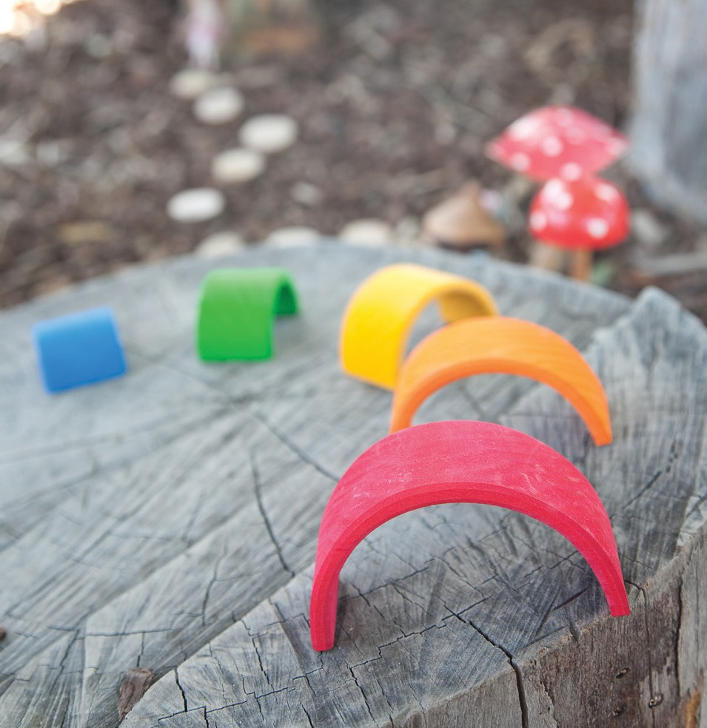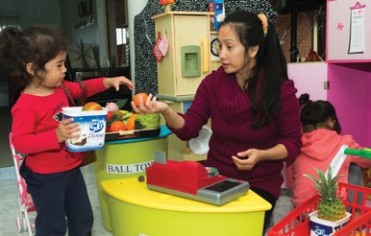

**NQAITS - Managing access to your services**

The National Quality Agenda IT System (NQAITS) is a useful online tool

for educators and providers. Registered users of the NQAITS can view

provider and service details, submit applications and notifications and pay

invoices related to their provider, service and certified supervisor approvals.

NQAITS has been recently updated to give providers greater control over

restricting users from accessing specific provider and service information,

and also restrict users from submitting applications/notifications.

ACECQA has put together a video for the sector on how to manage users.

The video can be found on the NQAITS section of the ACECQA website

called Managing access to your services [www.acecqa.gov.au/educators-](http://www.acecqa.gov.au/educators-and-providers1/national-quality-agenda-it-system)

[and-providers1/national-quality-agenda-it-system](http://www.acecqa.gov.au/educators-and-providers1/national-quality-agenda-it-system)

**Self-assessment and quality improvement**

**plans (QIP)**

The beginning of the year is a good time to consider how your service

will continue on its path of ongoing service improvement and how the

reflections of educators and the contributions of staff, educators, families

and children are considered and feed into the continuous process of service

improvement. QIPs must be reviewed and revised at least annually or at

any time requested by the regulatory authority (regulation 56).

**New persons with management or control**

When the persons with management or control change, for example,

following an annual general meeting of an incorporated association, the

Department must be notified (section 173(1)(b)). The following forms

can be found at [www.acecqa.gov.au/provider-approvals:](http://www.acecqa.gov.au/provider-approvals)

PA08 Notification of Change to Approved Provider

PA02 Declaration of Fitness and Propriety. You will also need to attach:

* + a current (not more than 6 months old) Criminal History Check
  + a current Working with Children Check
  + photo identification.

This notification including attachments can be emailed to

[licensed.childrens.services@edumail.vic.gov.au.](mailto:licensed.childrens.services@edumail.vic.gov.au)

The Department must be notified of any new nominated supervisor

(regulation 35). Please submit online SA12 Notification or Change of

Information about an Approved Service ensuring Part E - nominated

supervisor consent form is uploaded.

Regulation and Quality Assessment Update Issue 11 | February 2015 Pg 3

**Prescribed information**

If the service has any changes to the persons with management or control or the nominated supervisor or to the hours of operation, the display of the prescribed information may require updating (regulation

173) and notifications to the Department will need to be made (regulation 175).

**Regular outings and excursions**

For services that have regular outings, authorisations for excursions must be obtained once in a 12 month period. Now is the time to check these authorisations (regulation 102). Risk assessments must be completed before authorisations are sought for all excursions. The risk assessment must identify and assess risks that the excursion may pose to the safety, health and wellbeing of any child and detail how the identified risks will

be managed and minimised (regulation 101). Children must also not be taken outside the education and care service premises unless written authorisations are obtained from the parent or authorised nominee named in the enrolment record. Authorisations must contain the information required in regulation 102(4).

**New staff**

Services may also have a new nominated supervisor, staff member or educator. It is important that their staff records are complete and contain all the relevant information. It is a good opportunity to ensure that:

* the working with children check (WWCC) is current
* for any educators that are actively working towards their qualification, the information in their staff record is updated with the progress towards their qualification, for example, a current transcript from

the training organisation. It is important that the educator is making satisfactory progress towards completion of the course and is meeting the requirements for maintaining the enrolment

* any new staff members, nominated supervisors, family day educators and volunteers at the service know about the policies and procedures of the service and follow these (regulations 168, 169 and 170)
* the requirements for first aid, asthma and anaphylaxis qualifications

are covered at all times the service is educating and caring for children.

**For family day care**

* is the register of family day care educators up to date with all the information required in regulation 153 for each family day educator?
* do all persons residing in the family day care residence have a current WWCC or Victorian Institute of Teaching (VIT) registration?
* is the record of staff, of family day care co-ordinators and of family day care educator assistants up to date with current information about the educational leader, the nominated supervisor, other staff members, volunteers and students, and family day care educator assistants (regulation 154)?

**Outside school hours care services**

Many new children starting school will be attending outside school hours care programs for the first time. To ensure the safety of children it is important that services check their bookings for the day and consider how they collect young children to ensure children know when and where to go for the OSHC service. Good communication and agreed procedures between the school and the service is important.

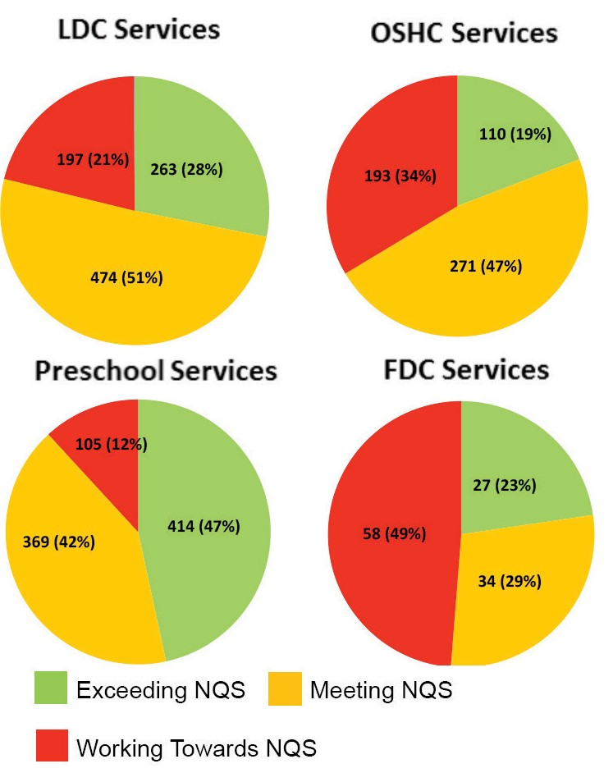

The pie charts below reflect the ratings of Victorian education and care

ratings in the last twelve months as at 23 February 2015.

and anaphylaxis management

[www.education.vic.gov.au/childhood/providers/regulation/Pages/](http://www.education.vic.gov.au/childhood/providers/regulation/Pages/nqffactsheets.aspx)

[www.gowrievictoria.org.au/Learning/ProgramGuide.aspx](http://www.gowrievictoria.org.au/Learning/ProgramGuide.aspx)

Visiting our website [**www.education.vic.gov.au**](http://www.education.vic.gov.au/)

Focus on the

National Quality Standard

services by service type. The data is drawn from published assessment and

**Victorian Services**

Staff records for Victorian services operating under the *Children’s Services Act 2009*

Staff records for Victorian services may require updating and must contain the following information for staff:

* + their name, address and date of birth
  + a copy of any relevant qualifications or certificates of completed training
  + their working hours
  + the date on which they undertook and completed training in the administration of an adrenaline auto-injection device and cardio- pulmonary resuscitation
  + the date on which they undertook and completed training in first aid
  + the date on which the current working with children assessment notice (or VIT registration) was read by the licensee, primary nominee or nominee currently present and in charge of the service, the reference number of the notice and the expiry date of the notice, or the details of when the VIT register was checked (regulation 38).

**Resources**

New or updated resources for services are available at **Other resources**

[nqffactsheets.aspx](http://www.education.vic.gov.au/childhood/providers/regulation/Pages/nqffactsheets.aspx) • The blue book: guidelines for the control of infectious diseases in a

* + - Managing bushfire risks in centre-based services – New range of settings – <http://ideas.health.vic.gov.au/bluebook.asp>
    - Managing bushfire risks in family day care – New • Gowrie Victoria has published the Semester 1, 2015 Professional
    - Bush kinders – New Learning Program Guide and this is available at
    - Meeting children’s health needs – New
    - FAQ: Supervisor certificates – Updated

**Keeping in touch You can get in touch with us by:**

**Department of Education & Training** Phoning us on **1300 307 415**

**GPO Box 4367, MELBOURNE VIC 3001** Emailing us on [**licensed.childrens.services@edumail.vic.gov.au**](mailto:licensed.childrens.services@edumail.vic.gov.au)

Regulation and Quality Assessment Update Issue 11 | February 2015 Pg 4

Delivering a children’s program in a limited hours service

A guide to assist educators in Victorian services to think about the planning and delivery program is available at [www.education.vic.gov.au/](http://www.education.vic.gov.au/Documents/childhood/providers/regulation/limitedhrsserv.pdf) [Documents/childhood/providers/regulation/limitedhrsserv.pdf](http://www.education.vic.gov.au/Documents/childhood/providers/regulation/limitedhrsserv.pdf)

**Bush kinders**

An increasing number of education and care services in Victoria have included a bush kinder in the program they deliver to children. Bush kinders are generally located in natural environments away from the education and care service and provide valuable opportunities for children to explore the natural environment and to extend the educational program. A bush kinder fact sheet has been developed by the Department to assist education

and care services to meet requirements under the *Education and Care Services National Law Act 2010* and *Education and Care Services National Regulations 2011* when operating a bush kinder program.

Further information is available in the Bush kinder fact sheet, together with contact details of the Department regional office at [www.education.vic.gov.](http://www.education.vic.gov.au/childhood/providers/regulation/Pages/nqffactsheets.aspx) [au/childhood/providers/regulation/Pages/nqffactsheets.aspx](http://www.education.vic.gov.au/childhood/providers/regulation/Pages/nqffactsheets.aspx)