How To Add, EDIT OR Remove AN Enrolment in the year before school
Quick Reference Guide

About Kindergarten Enrolments
The Department of Education and Training (the Department) provides kindergarten per capita (per child) grants as a contribution towards the cost of running a kindergarten program.
The Department provides the kindergarten fee subsidy to enable an eligible child to access a funded kindergarten program free of charge or at minimal cost.
Eligibility criteria for kindergarten per capita grants and kindergarten fee subsidy are outlined in the Kindergarten Funding Guide.
Eligible service providers receive a per capita grant, and kindergarten fee subsidy where applicable, for each eligible child who is enrolled and attending a 15+ hour funded kindergarten program.
You are required to provide details of all enrolments, including information about which children are eligible for kindergarten fee subsidy, in the funded kindergarten program(s) for children in the year before school at the service(s) you operate via the Kindergarten Information Management (KIM) system.
This Quick Reference Guide provides instructions on how to:
- Add enrolments (page 1)
- Edit enrolments (page 4)
- Remove enrolments (page 4)
Add Enrolments
- You have a choice of either adding multiple enrolments via an uploaded spreadsheet or by entering the enrolments individually.
- From the Service Provider Home page, select the relevant service from the My Services list by clicking on the service name.
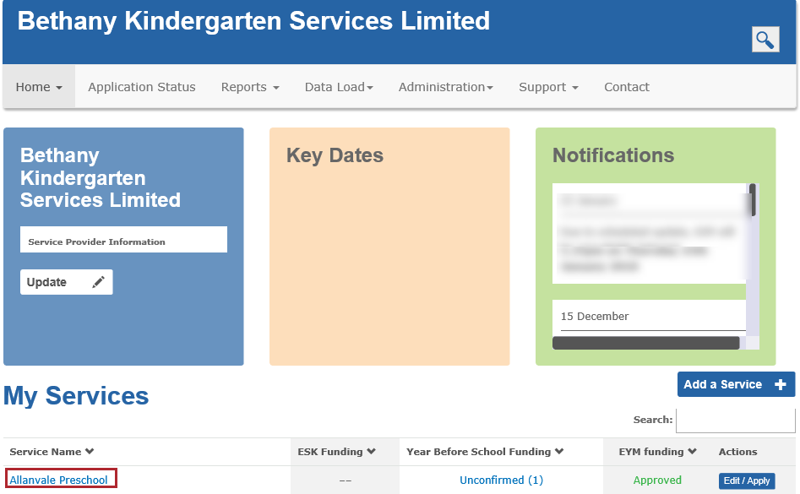
Result: the Service Home screen displays.
- In the Service Home page, click Enrolments.
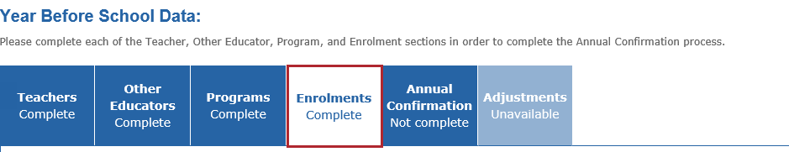
If you would like to add individual enrolments proceed to Step 4.
If you would like to add multiple enrolments by uploading a spreadsheet, proceed to Step 7.

Add individual enrolments
- If you want to add each enrolment one at a time, click
- Complete the Child Details section. When all questions on the screen are answered, click Next. Follow the instructions, help guides and correction messages.
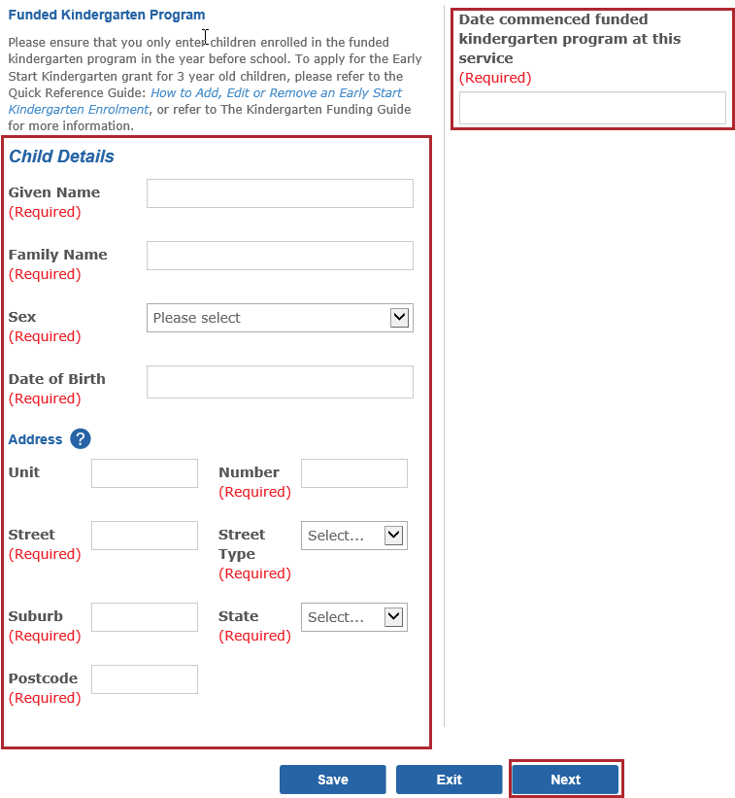
Information required in the Child Details section includes:
- the child’s name, sex, date of birth, address and commencement date at the funded kindergarten program,
- if applicable, whether the parents have requested for the child’s early entry into kindergarten or whether the child has been exempted from school. If early entry, a copy of the parent’s written request must be uploaded by clicking Upload+ or a reason provided if the request has not been sighted.
- the child’s indigenous status,
- whether the child has a developmental delay or disability, and if the child is receiving a Kindergarten Inclusion Support (KIS) Package,
- the main language spoken at home (if not English),
- whether the child has out of home care (e.g. foster or kinship care)
- the immunisation status of the child
- if the child is eligible for and attending a Second Year of Kindergarten,
- if a child is enrolled in sessional program, the name of the group they are enrolled in,
- if the child participated in Early Start Kindergarten in the previous year, the type of grant received and the name of the service that delivered the program.
- if the child attends a sessional kindergarten program, whether the child is eligible for kindergarten fee subsidy and the date the child became eligible.
- The highest year of primary or secondary school the child’s parents/guardians have completed (e.g. Year 12 or equivalent).
- The level of the highest qualification the child’s parents/guardians have completed (e.g. Bachelor Degree or above). All qualifications from overseas are acknowledged, and should be ranked at the equivalent level. So, a Bachelor from any country would still be ranked at the “Bachelor’s degree or above level”.

- The occupation group of the child’s parents/guardians (e.g. A, B, C, D, N, H) as reflected in the Parental Occupation Index
Ensure you complete both parents/guardians details for all Student Family Occupation Education (SFOE) information if known.
- Eligibility criteria for Kindergarten Fee Subsidy (KFS), (e.g. Health Care Card, refugee or asylum seeker visa, Aboriginal or Torres Strait Islander, triplet or quadruplet).
Note: Long Day Care centres are not eligible for KFS and will not have this section displayed.

Note: Different sections and information requests display depending on the varied Enrolment selections and responses. E.g. if the date of birth indicates the child will be older than five as of 30 December in the kindergarten year, you will be asked to certify that an approved exemption from school entry has been sighted. If the child is younger than for on 30 April, you will be asked to certify that the request for early entry into kindergarten has been sighted and to attach a copy of the parent’s request.
- When you have completed all of the child’s details, click
Result: If all required information for the child has been entered, the child will display with the status Complete. If there is incomplete information, the child will display with the status Not Complete.
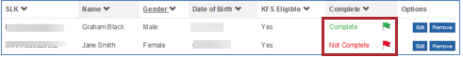

Add Multiple enrolments
- From the Enrolments tab, click the Upload Multiple Enrolments+ button.
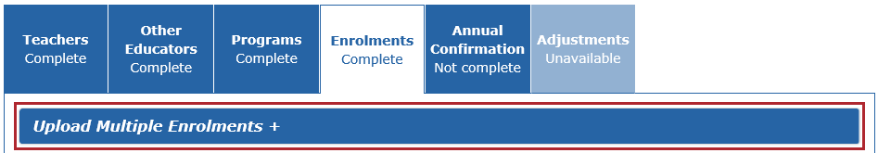
- If you would like to add multiple enrolments, download the spreadsheet template and follow the instructions to create a .csv file in the Quick Reference Guide: How to upload multiple enrolments for a single service.
Only include enrolments in a kindergarten program for children in the year before school.
If you would like to add multiple enrolments for multiple services, follow the instructions in the Quick Reference Guide: How to upload multiple enrolments for multiple services.
- Save the spreadsheet and ensure it is somewhere you can locate easily.
- Once the spreadsheet is completed, click
Result: The Choose File to Upload box displays.
- Locate the .csv file you saved earlier, click on the file name and click Open. Ensure that the file Type is Microsoft Excel Comma Separated (.csv) file.
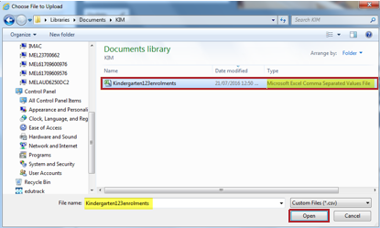
Result: If the file has uploaded successfully, the child enrolments display in a list in the Enrolments tab.

If the file has not uploaded successfully (e.g. it contains some incorrect formatting), an error message displays. You will need to check and re-format the spreadsheet as required, and repeat the file upload.

Note: Some of the children may require additional editing after the upload. These child enrolments will display with a status of Not Complete.
Click Edit next to the relevant child enrolment to update the required information (see Edit Enrolments on page 4).
Enrolments with all the mandatory information display with a status of Complete.

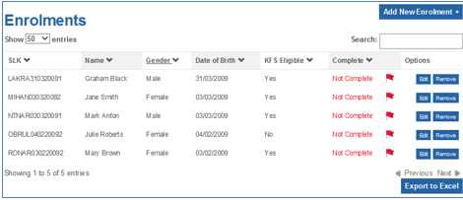

Edit enrolments
The Edit option is available to update or complete information for a child enrolment, including updating their record to indicate eligibility to receive the kindergarten fee subsidy.
- Click Edit next to the child you wish to edit.
Result: The Child Details screen displays.
- Edit the relevant details and click Save.

Remove enrolments
Note: It is important to remove any child enrolments that are no longer enrolled and attending the funded kindergarten program to ensure accuracy of your KIM enrolment data.
- From the Enrolments tab, click next to the child you wish to remove.
- From the Remove a Child screen, ensure the following fields are completed:
- Child’s Name
- Reason for leaving
- The date the child last attended kindergarten
- Click Remove.
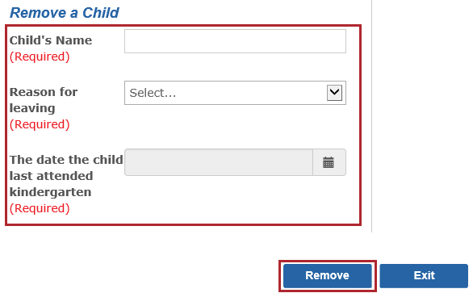

Result: The child’s enrolment record is removed from the enrolment list.

