HOw to add, edit or remove a teacher
Quick Reference Guide

About early childhood teachers
As outlined in The Kindergarten Guide, funded service providers must offer a kindergarten program delivered by an early childhood teacher who is registered with the Victorian Institute of Teaching (VIT), or in the case of a graduate teacher, be provisionally registered with the VIT and working towards full registration.
Service providers must contact their Department regional office if they are unable to meet this requirement.
Using the Kindergarten Information Management (KIM) system, Service providers are required to provide details of all qualified early childhood teachers that are employed to deliver the kindergarten program at their service/s.

Add an early childhood teacher
- Under My Services, click on the relevant service name to open the service home page.
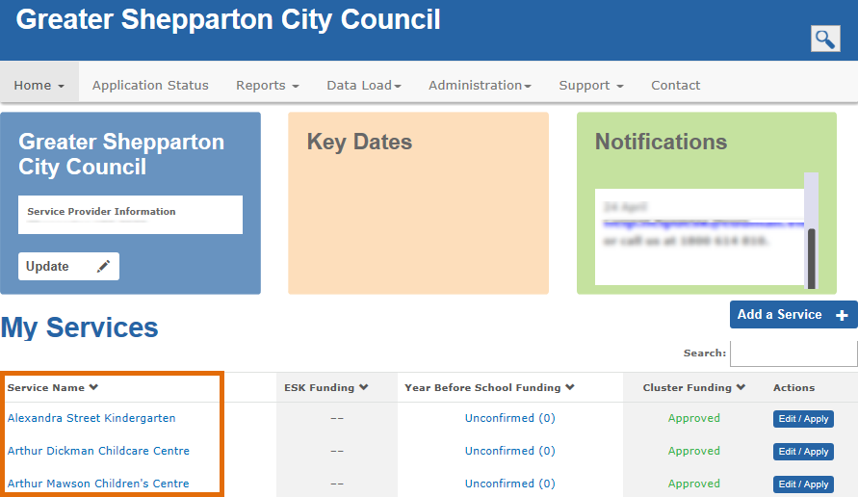
Result: The Teachers tab displays with a list of previously added teachers. If no teachers have been added, the tab is empty.
- Click Add New Teacher.
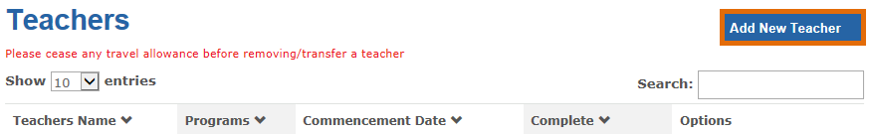
Result: the Teacher Lookup window displays.
- In the VIT Number field, enter the teacher’s VIT number and click Search to check if they already exist in the KIM system.
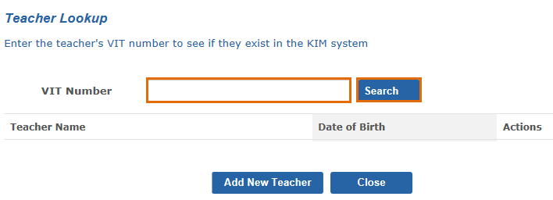
This search function allows you to copy an existing teacher’s details rather than create a new teacher record (e.g. for teachers who move services or teach at multiple services). If the teacher does not have a VIT number or the search result is blank, click Add New Teacher and go to step 6.

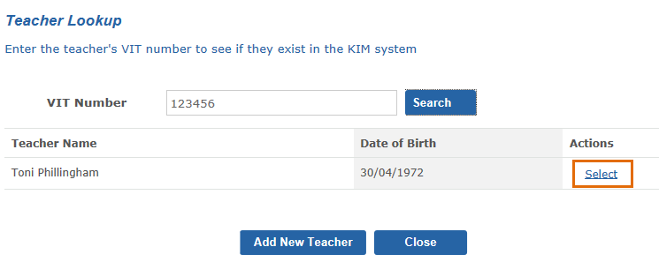
- Click Select to open the teacher record.
- Update the teacher’s details if required and click Save.
Result: the added teacher will display under the Teacher tab.
- If creating a new record for a teacher, in the Teacher Details section, complete the following fields: Given Name, Family Name, Gender, Date of Birth and Commencement Date.
Note: Enter the teacher’s Date of Birth and Commencement Date using the format DD/MM/YYYY.
- Select an option that reflects the teacher’s Early Childhood Victorian Institute of Teaching (VIT) registration status.
- If the teacher is registered, provisionally or fully, enter their VIT Number in the VIT Number field.
- In the Qualification Details section, select the relevant option that reflects whether the teacher has:
- An Early Childhood teaching qualification on the approved ACECQA list; or
- An Early Childhood teaching qualification not on the approved ACECQA list or other qualification
Result: Depending on your answer above, either an Australian Qualification Details or Overseas Qualifications Details section appears on the right side of the screen.
- Complete the fields by selecting or entering the teacher’s highest qualification relevant to their role in planning and delivering the funded kindergarten program, including university, course, year awarded.
- To upload a teacher’s qualification documents that are saved to your computer, click Upload+.
Note: If the qualification is not listed in the approved ACECQA list, you must also attach a letter of equivalency from ACECQA (if obtained).

Note: Only one Qualification document can be uploaded. If you have multiple qualification documents to upload, they must be collated together into a single PDF or Word document.
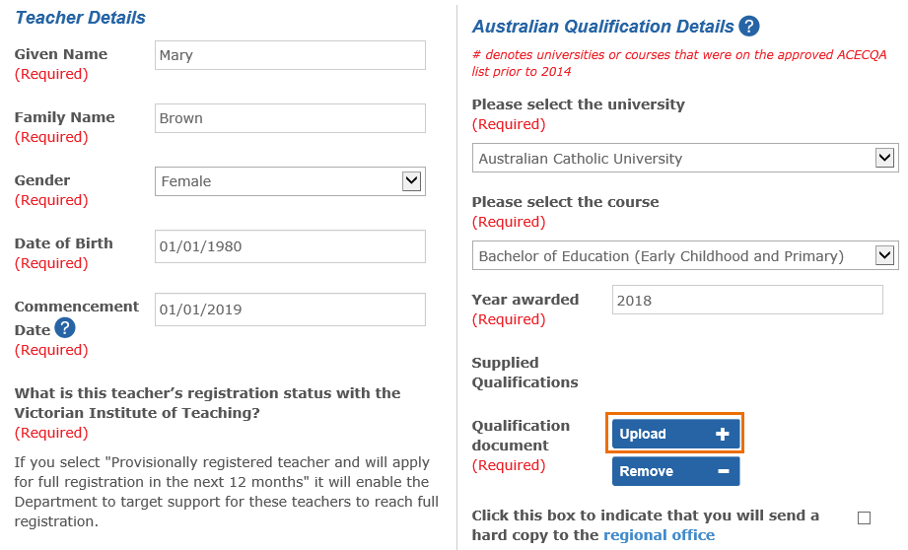
- Click Browse.
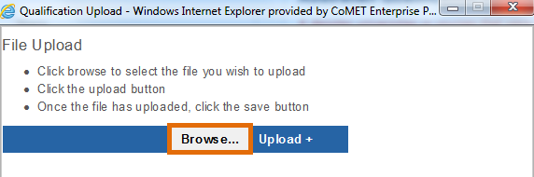
Result: a Choose File to Upload window displays.
- Locate the document on your computer, click the file name and click Open.
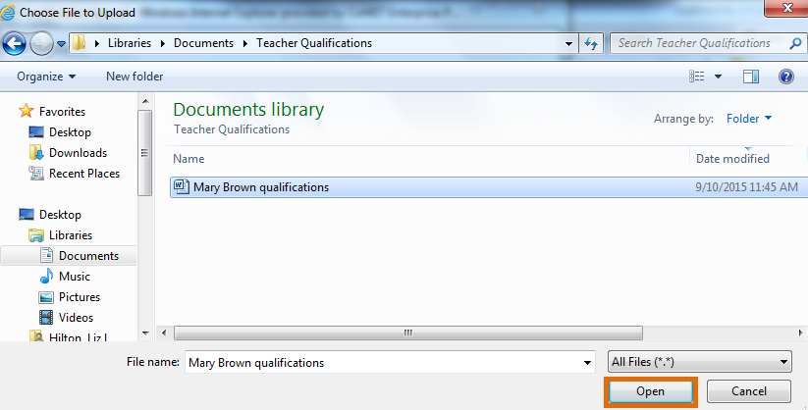
Result: The file name will display in the File Upload window.
- Click Upload+.
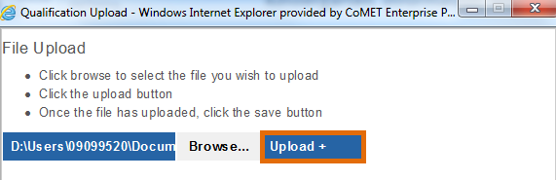
Result: A message displays that the file has been uploaded.
- Click Save.
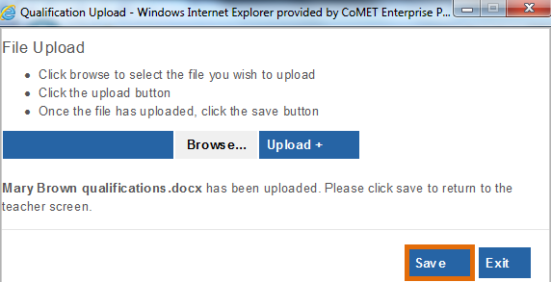
Result: You are returned to the teacher screen. The teacher qualification is saved to the teacher record and displays as an attachment next to Supplied Qualifications.
- Click the tickbox beside Click this box to indicate that you will send a hard copy to the regional office.
- In the 3 or 4 year Qualification Details section, indicate whether the teacher’s qualification is a 3 or 4 year qualification (or other). If you select 3 year and the teacher is completing a fourth year of study, you are required to give details about the course and institution. If you select Other, you are required to provide comments.
- Click Next.
- In the Employment Hours Details section, enter the hours of employment per week at this service in the funded four year old kindergarten program. When entering teacher hours indicate the number of hours in the left hand drop down list and select the number of minutes (to the nearest quarter hour) in the right drop down list.
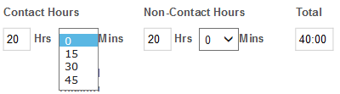
- Enter the number of funded groups taught by this early childhood teacher.
- Indicate whether the teacher shares the teaching of any of the funded groups with another teacher.
- If you answer Yes, you must enter:
- The total number of kindergarten children that are taught solely by this early childhood teacher and for which the service receives funding
- The total number of kindergarten children that are taught by this early childhood teacher in a team teaching model for which the service receives funding.
- If you answer No, you only need to enter the total number of kindergarten children that are taught solely by this early childhood teacher for which the service receives funding.

Enter the hours of employment per week in any program (or leave blank if not applicable).
- To the right of the screen, from the drop-down list, select the award or industrial agreement used in the employment of this teacher for the funded kindergarten program.
- If VECTEA or EEA (or equivalent) is selected, you must select the level at which the teacher is classified and paid.
- Enter the total number of hours of professional development undertaken by this teacher in the previous year.
Note: Do not include any hours associated with progression towards formal academic qualifications.
- Click Save.
Result: The added teacher displays in the Teachers tab. If all required information is complete for that teacher, their status is Complete. If information is still required, the status is Not Complete.

Edit an early childhood teacher
- From the Teachers tab, click Edit next to the teacher you wish to edit.
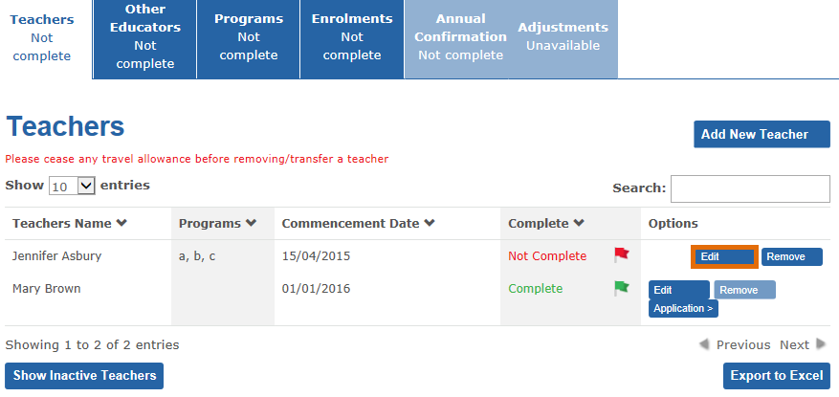
Result: the Teacher Details screen displays with the information previously entered.
- Edit details as required, following steps 6 – 28 from Add an early childhood teacher (previous section of this guide).
- When finished, click Save.
Result: The teacher’s details have updated. If all information is completed, the teacher record displays a status of Complete. If information is still required to be entered, the status will display as Not Complete.
Tip: To view the details of a teacher without changing them, click the Edit, view the information by clicking Next or Previous to navigate through the screens. Click Exit when you have finished viewing the information. If the message All required fields have not been completed. Please tick the box and click next to continue displays, tick the box and click Next to navigate to the next page.

Remove an early childhood teacher
Note: A funded kindergarten program must be delivered by an early childhood teacher who is registered with the Victorian Institute of Teaching (VIT), or in the case of graduate teachers, be provisionally registered with the VIT and working towards full registration. Service providers who are unable to meet this requirement must contact their Department regional office.
- From the Teachers tab, click Remove next to the teacher you wish to remove.
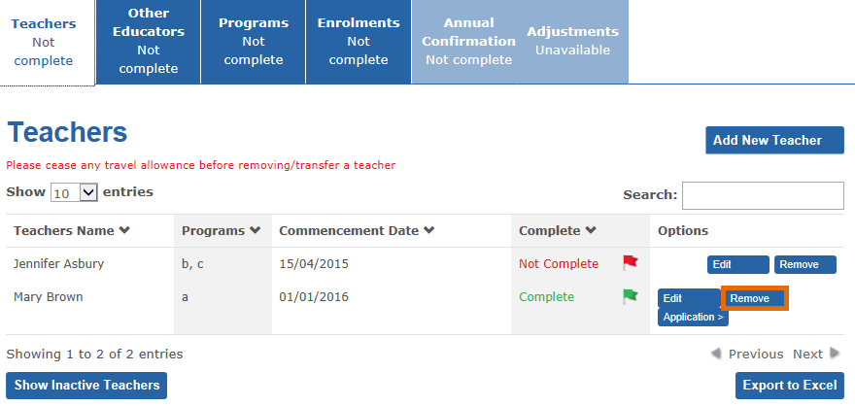
Result: the Kindergarten teacher leaving the service screen displays.
- From the Remove a teacher screen, click the calendar icon beside The final date of work for the early childhood teacher leaving the service and select a date.
- Select a Reason for leaving from the dropdown list. 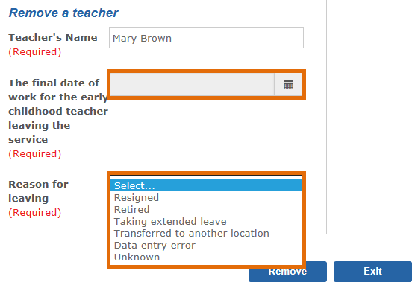
- Click Remove.
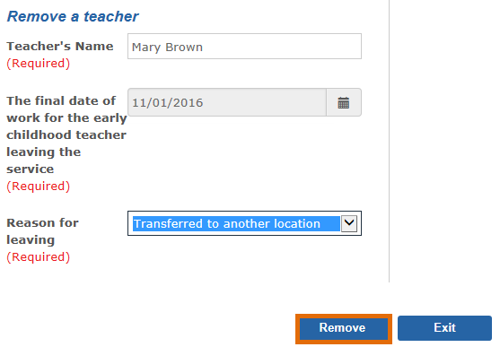
Result: The teacher no longer displays in the Teachers tab for the service. The record is now Inactive.

Change a teacher from Inactive to Active
When a teacher is removed from KIM, their record becomes Inactive.
To change a teacher record from Inactive to Active (e.g. if they re-commenced employment at the service):
- From the Teachers tab, click Show Inactive Teachers.
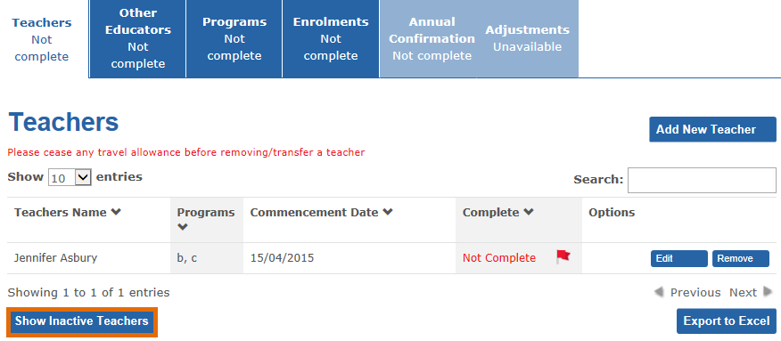
Result: The Inactive Teachers screen displays.
- Click Activate next to the teacher you wish to make Active.
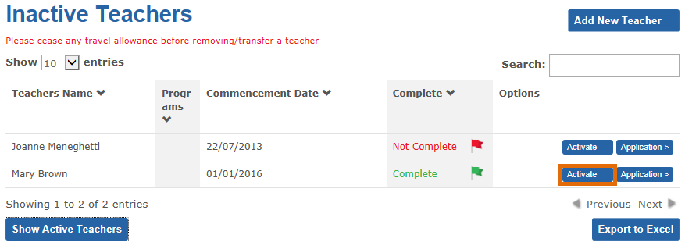

Result: The teacher is removed from the Inactive list.
- Click Show Active Teachers.
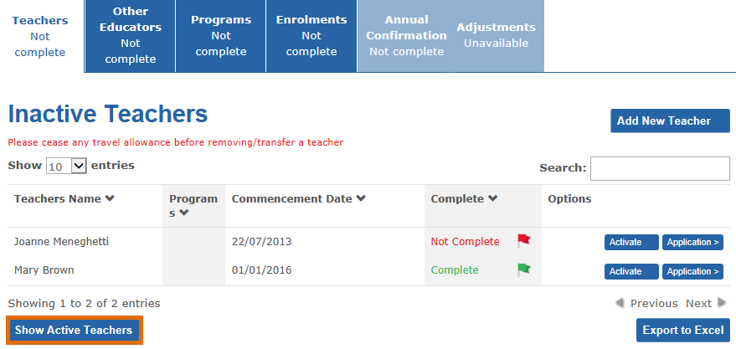

Result: the Teachers tab displays and lists the Active teachers.
