Please note that the Kindergarten Information Management system (KIM) is a separate system from the Funded Agency Channel (FAC) and the National Quality Agenda IT system (NQAITS). Any updates to a service provider’s address or contacts in KIM will not automatically update FAC or NQAITS.

- On your KIM home page, click Update below the service provider details.
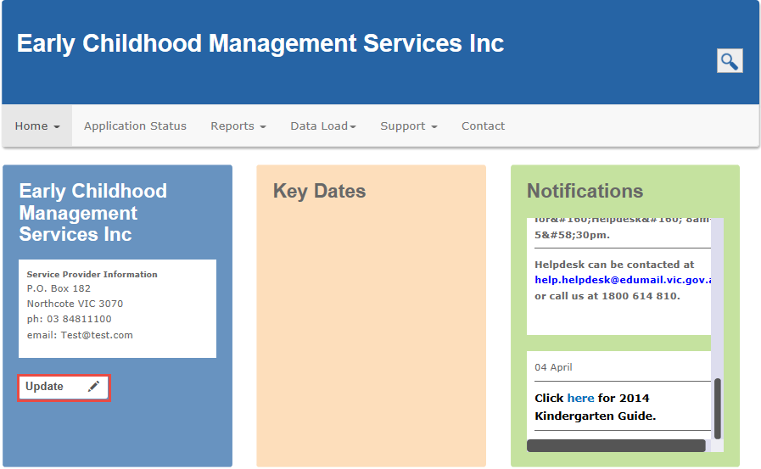
Result: The service provider contact details page displays.
All fields on this page are editable except the service provider name. If it is incorrect, please contact your Department regional office.
- Update the service provider contact details as required.
The Contact Person should be the person who the Department can contact in case of queries about information submitted in KIM.
- Click Next.
Result: the service provider’s funding status and payroll service page displays.
- Check the details and complete or update as required.
Note: If you are required to complete the Payroll Service Function Checklist and you are having issues in downloading the checklist, the checklist can also be downloaded from the Support menu on the service provider home page.
- When all information is complete, click Save.
Result: the service provider details are read only until the changes/updates are processed.

