About teacher travel allowance
The Department of Education and Training (the Department) provides a travel allowance to help services in rural regions attract qualified early childhood teachers.
The eligibility criteria and further information about teacher travel allowance is available in The Kindergarten Guide.
http://www.education.vic.gov.au/childhood/providers/funding/Pages/kinderfundingcriteria.asp
Services Receiving per capita funding at the rural rate can access the travel allowance application.
Applications for teacher travel allowance are subject to approval by the Department.
Please ensure you have updated the early childhood teacher’s information in KIM is up to date before applying for teacher travel allowance. Click the Edit button next to the staff member to check and/or update information.

Part 1 – Apply for a new teacher travel allowance
- In the Teachers tab of the KIM Service Home page, click Application next to the relevant teacher and then select Travel Allowance from the drop-down list.
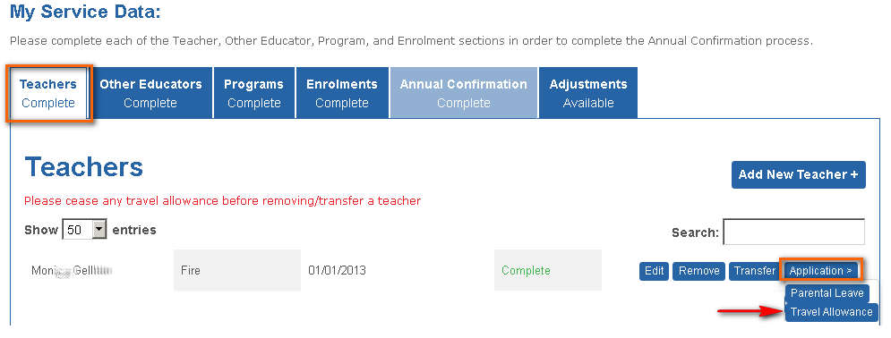
Result: The Travel Allowance screen displays
- Select the service where the teacher is traveling to or from, from the drop-down list
- Enter the expected first day of travel in the format dd/mm/yyyy ( this can be backdated to the start of the year or start of term 1).
- Enter the number of Travel weeks and expected number of kilometres per week.
The total number of kilometres will calculate automatically.
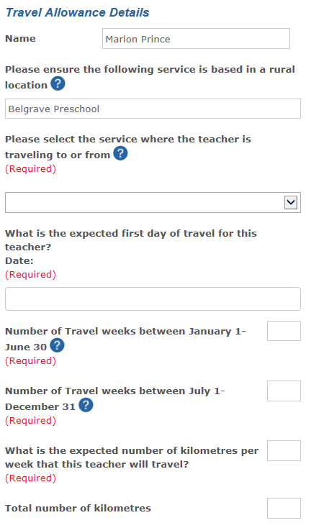
- Click Next to navigate to the Certification screen. Complete the Name, Position and Date fields.
- Click Submit.
Result: the application is submitted for Department approval. The submitted form will display in the Submitted tab under Application Status in the main service menu.
Note: You can save the application at any time by clicking the Save button. To re-open the saved application, go to Application Status in the main service menu and click on the Saved tab. Open the saved application by clicking on the application name.
