How to add a new service or recommence a service
Quick Reference Guide

To enable a service provider to apply to the Department of Education and Training (the Department) for kindergarten funding for a service, the service must be added in the Kindergarten Information Management system (KIM).
An eligible service can be added for which the service provider:
- has never received kindergarten funding
- has previously received kindergarten funding but is no longer funded (recommence a service)
If a service is transferring from one funded service provider to another with at least 45 days’ notice and there is no break in funding, please refer to the Quick Reference Guide: How to Transfer a Service.
If a service provider is adding a service that has never received kindergarten funding, the service provider must also submit a SA01 Application for service approval through the Australian Children’s Education & Care Quality Authority (ACECQA): www.acecqa.gov.au.

Add a service that has never received kindergarten funding
This is the first step in applying for kindergarten per capita funding.
An application to add a service which has never received kindergarten funding will only be approved by the Department once the SA01 is approved by ACECQA (this can take up to 90 days).
Following approval by the Department, the service provider must submit information in KIM about the workforce, program and enrolments for the funded kindergarten program at this service and confirm this information via the Annual Confirmation process in KIM. Approval of Annual Confirmation will calculate the base per capita funding for the service.
Please refer to the Quick Reference Guide: How to complete the annual confirmation process for more information.

- On your KIM home page, click Add a Service+
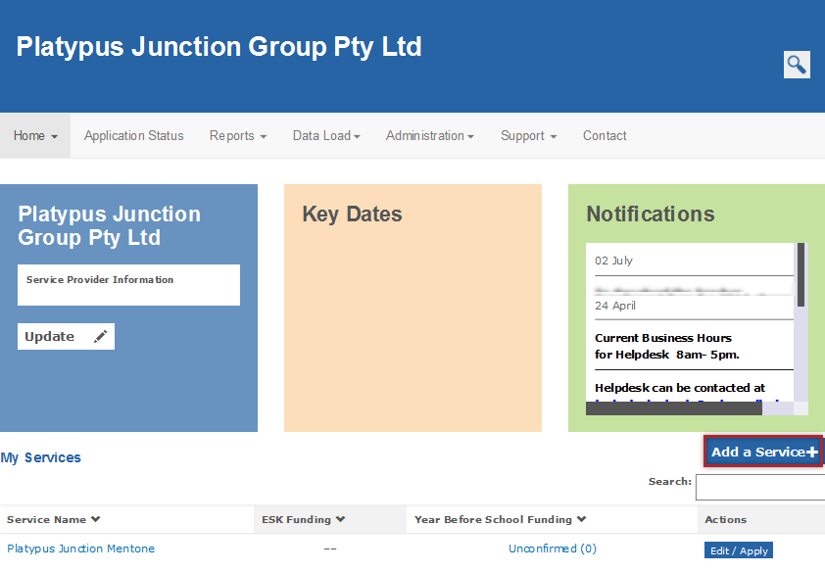
Result: A screen with Service Details, Street Address and Emergency Contact Details displays.
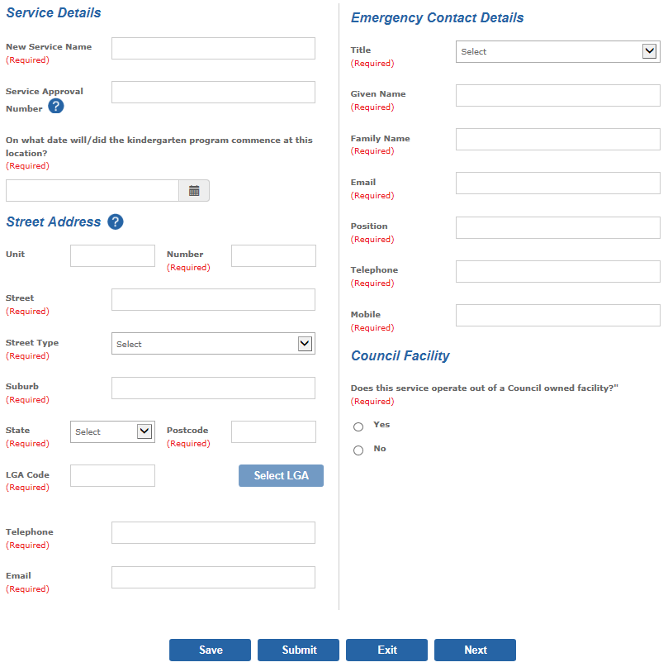
- In the Service Details section, enter the service’s name and Service Approval Number for which you are applying for funding.
- Select the date the kindergarten program commenced or is commencing.
- In the Street Address section, enter the address, telephone number and email of the service for which you are seeking funding and select the Local Government Area (LGA) which will auto-populate the LGA Code.
- In the Emergency Contact Details section, enter the name, address, email and telephone number of a person who can be contacted in case of an emergency.
- Indicate whether the service operates out of a Council owned facility.
- Click Next.
- If you are a local government managed organisation, a church organisation, a hospital or a tertiary education institution, you are required to indicate whether your organisation uses an incorporated association (for example, a parent committee of management) to manage the day to day operation of the service. This is to determine eligibility for the DET Community Service Organisation (CSO) Insurance Program. If Yes, enter the legal entity name and Incorporated Association Registration Number or ABN.
- If the service provider is Early Years Management, indicate whether you wish to apply for Early Years Management (EYM) funding for the service.
- Select whether the core nature of education and care provided at this location is Preschool / Kindergarten or Long Day Care
- Select the service’s current National Quality Framework rating. If Other is selected, you are required to enter further details.

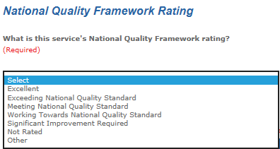
- Select Yes or No to Is the funded kindergarten program the only program offered at this service.
If the answer is No, select the services, programs or activities that are also available at the service.
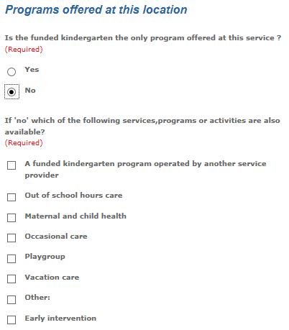
- Click Submit.
If you indicated in step 9 that you are applying for EYM funding for the service, the EYM application screen will open. Refer to the Quick Reference Guide: How to Apply for Early Years Management (EYM) Funding for instructions on completing the application.
Once submitted, the application will display under the Submitted tab until it is approved.

Recommence funding for a service for which this service provider has previously received funding
- From the KIM Home screen in the My Services section, locate the service to be recommenced. If the service is not in the list, follow the previous instructions to add a new service.
- Click Edit/Apply.
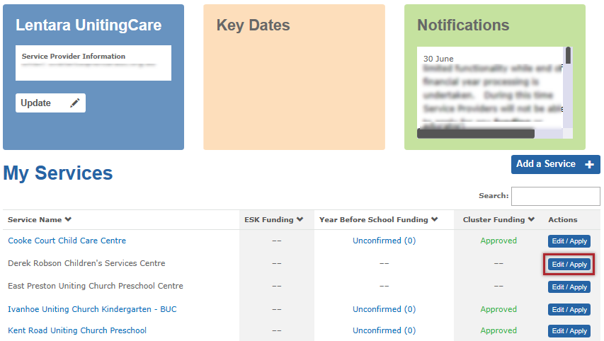
- In the Apply column, click Recommence and click Apply.
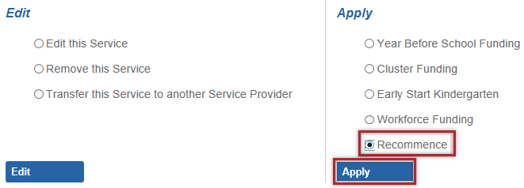
Result: Service Details, Street Address and Emergency Contact Details for the service display.
- If the name of the service has changed, update the name in the text box in the If the name of the service has changed, please insert the new name in the box below field.
- Select the date the kindergarten program recommenced or is recommencing at this location.
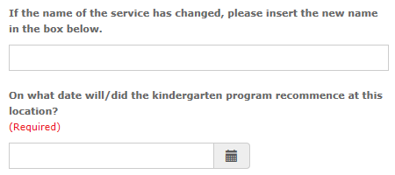
- Ensure that the street address, LGA Code, telephone, email and emergency contact details are correct and update if required.
- Indicate whether the service operates out of a Council owned facility.
- Click Next to navigate to the next page.
- If you are a local government managed organisation, a church organisation or a tertiary education institution, you are required to indicate whether your organisation uses an incorporated association (for example, a parent committee of management) to manage the day to day operation of the service. This is to determine eligibility for Victorian Managed Insurance Authority (VMIA) insurance coverage. If Yes, enter the legal entity name.
- If the service provider is Early Years Management, indicate whether you wish to apply for EYM funding for the service.
- Select the core nature of education and care provided as either Preschool / Kindergarten or Long Day Care.
- Select the service’s current National Quality Framework Rating. If Other is selected, you are required to enter further details.
- Indicate whether the funded kindergarten program is the only program offered at this service.
If you answer No, select the services, programs or activities that are also available at the service.
- Click Submit.
If you indicated in step 9 that you are applying for EYM funding for the service, the EYM application screen will open.
Refer to the Quick Reference Guide: How to Apply for Early Years Management (EYM) Funding for instructions on completing the application.
Once submitted, the application will display under Application Status > Submitted tab in the main menu until it is approved.

