How to add, edit or remove an early start kindergarten enrolment
Quick Reference Guide

About early start kindergarten
The Department of Education and Training (the Department) provides targeted funding for some children to attend a kindergarten program for the two years before school, with the aim of improving access and diminishing barriers to participation for vulnerable children and Aboriginal children (research shows these children are underrepresented in kindergarten).
Early Start Kindergarten grants are available for eligible children attending a three-year-old kindergarten program, a mixed age program or a four-year-old kindergarten program.
The eligibility criteria and further information about the Early Start Kindergarten grant is available in The Kindergarten Funding Guide.
This Quick Reference Guide is in three parts:
- Part 1 – Add an Early Start Kindergarten enrolment
- Part 2 – Edit an Early Start Kindergarten enrolment (including applying for funding for an increase in hours the child is attending kindergarten)
- Part 3 – Remove an Early Start Kindergarten enrolment (child has either left the program or was entered in error)

Part 1 – add an early start kindergarten enrolment
- On your KIM home page, click on Edit/Apply for the corresponding service.
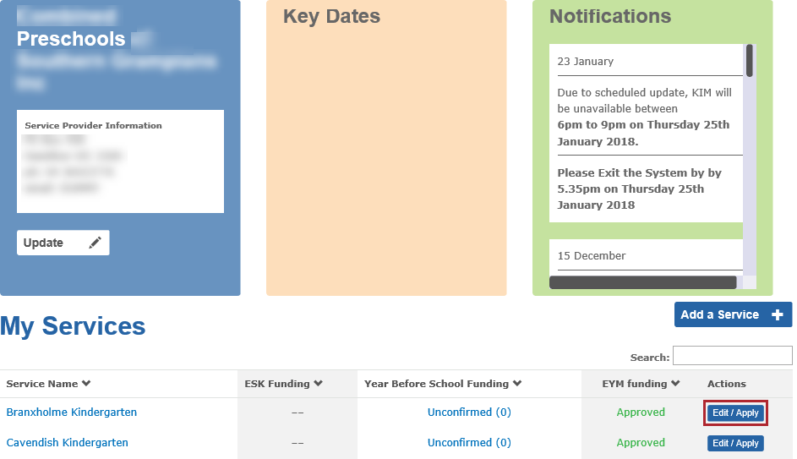
- From the Apply column select the radio button beside Early Start Kindergarten.
- Click Apply.
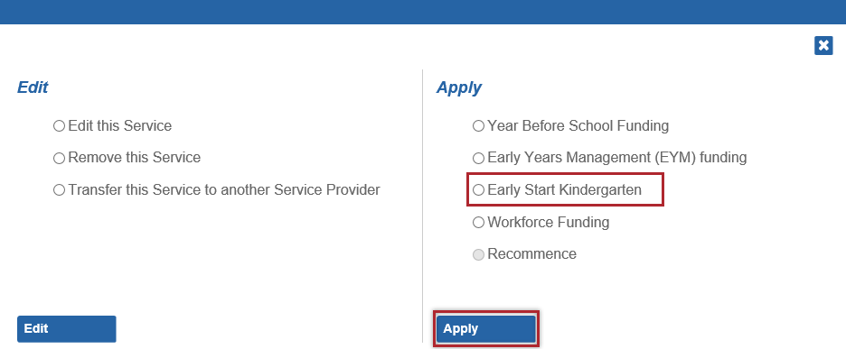
Result: The ESK Enrolment screen displays.
- If the teacher who delivers the ESK program is not already listed under the Teacher tab, click Add New ESK Teacher +.
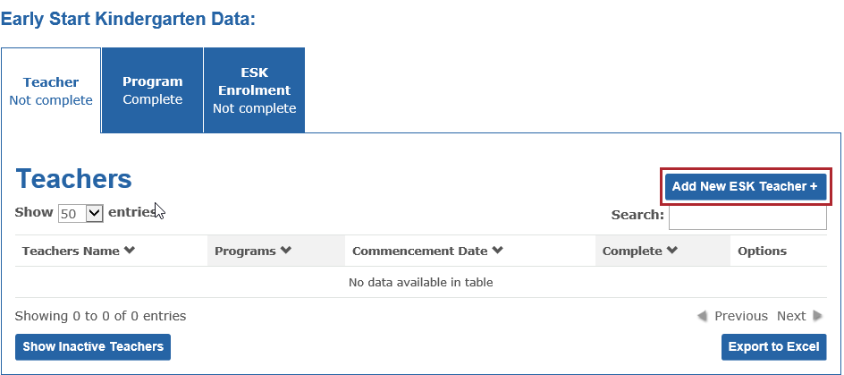
Result: The Teacher Details section displays.
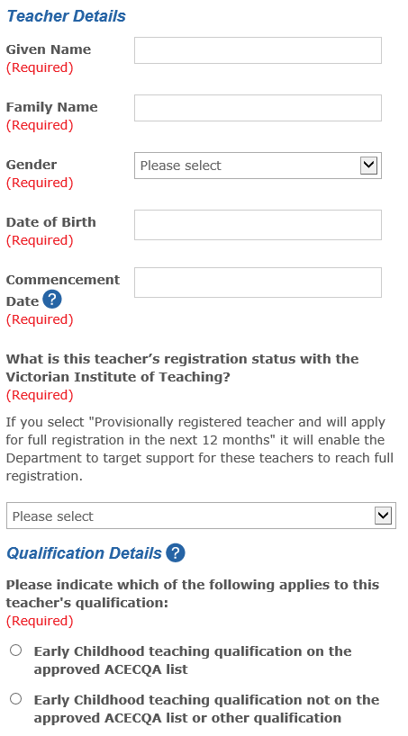
- In the Teacher Details section, complete the following fields: Given Name, Family Name, Gender, Date of Birth and Commencement Date.
Note: Enter the teacher’s Date of Birth and Commencement Date using the format DD/MM/YYYY.
- Select an option that reflects the teacher’s Early Childhood Victorian Institute of Teaching (VIT) registration status.
- If the teacher is registered, provisionally or fully, enter their VIT Number in the VIT Number field.
- In the Qualification Details section, select the relevant option that reflects whether the teacher has:
- An Early Childhood teaching qualification on the approved ACECQA list; or
- An Early Childhood teaching qualification not on the approved ACECQA list or other qualification
Result: Depending on your answer above, either an Australian Qualification Details or Overseas Qualifications Details section appears on the right side of the screen.
- Complete the fields by selecting or entering the teacher’s highest qualification relevant to their role in planning and delivering the funded kindergarten program, including university, course, year awarded.
- To upload a teacher’s qualification documents that are saved to your computer, click Upload+.
Note: If the qualification is not listed in the approved ACECQA list, you must also attach a letter of equivalency from ACECQA (if obtained).

Note: Only one Qualification document can be uploaded. If you have multiple qualification documents to upload, they must be collated together into a single PDF or Word document.
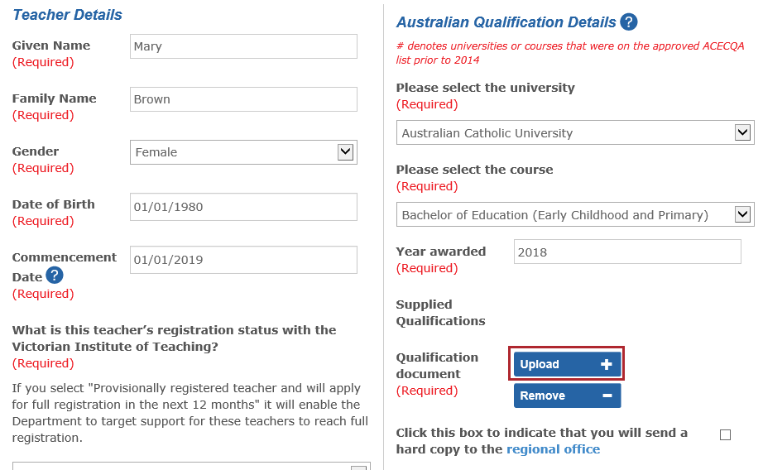
- Click Browse.
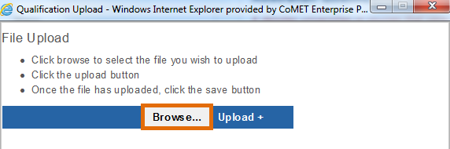
Result: a Choose File to Upload window displays.
- Locate the document on your computer, click the file name and click Open.
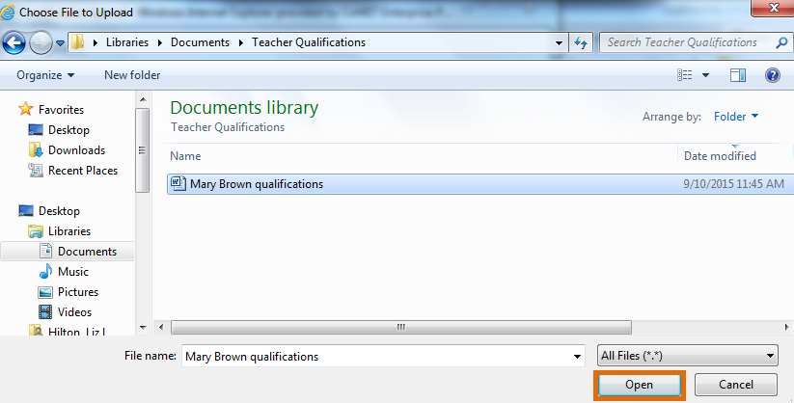
Result: The file name will display in the File Upload window.
- Click Upload+.
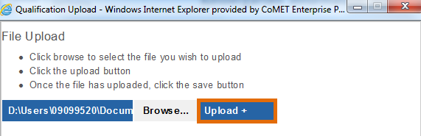
Result: A message displays that the file has been uploaded.
- Click Save.
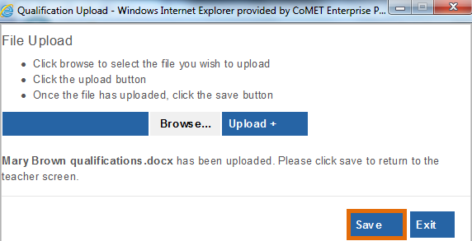
Result: You are returned to the teacher screen. The teacher qualification is saved to the teacher record and displays as an attachment next to Supplied Qualifications.
- Click the tickbox beside Click this box to indicate that you will send a hard copy to the regional office.
- In the 3 or 4 year Qualification Details section, indicate whether the teacher’s qualification is a 3 or 4 year qualification (or other). If you select 3 year and the teacher is completing a fourth year of study, you are required to give details about the course and institution. If you select Other, you are required to provide comments.
- When all required fields have been entered, click Save.
Result: The added teacher displays in the Teacher tab.
- Click the Program tab.
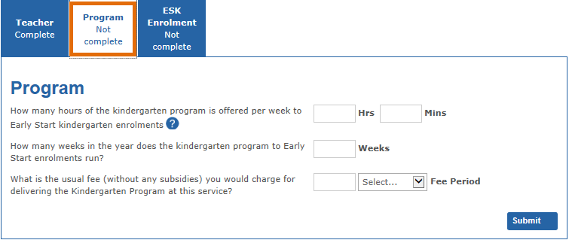
- Enter the hours the kindergarten program is offered per week to ESK enrolments.
- Enter the number of weeks the kindergarten program is run for ESK enrolments.
- Enter the usual fee (without any subsidies) that would be charged for delivering the kindergarten program at this service.
- Click Submit.
Result: The message “This screen is restricted to read only as we are currently processing your application” displays.
- Click the ESK Enrolment tab.
- Click Add New ESK Enrolment+.
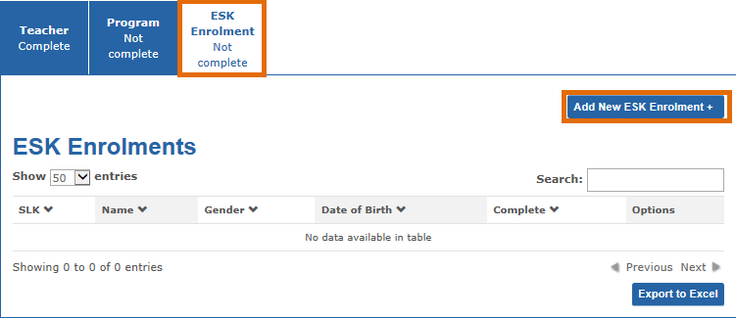
- In the Child Details section, enter the Given Name, Family Name, Sex, Date of Birth, Address and the date the child commenced the Early Start Kindergarten program.
- In the Early Start Kindergarten Eligibility section, select the category for which the child is eligible to receive an Early Start Kindergarten program (Aboriginal and/or Torres Strait Islander descent, Child known to Child Protection, or both) and indicate whether the child has been identified as eligible for funding.
- In the Early Start Kindergarten Enrolment Details section, indicate whether the child will receive the kindergarten program in either a three year old group, a mixed age/multi aged group, a four year old group or a combination of more than one group.
- Select the name of the early childhood teacher delivering the kindergarten program that this child will attend.
- In the Access to Early Learning (AEL) section, indicate if the child is being supported by an AEL lead agency.
IMPORTANT NOTE THAT CHILDREN CURRENTLY PARTICIPATING IN AEL SHOULD NOT BE ENTERED INTO KIM. IF THE ANSWER TO THIS QUESTION IS 'YES' PLEASE DO NOT SUBMIT THIS ENROLMENT. Contact the AEL lead agency for more information about invoicing for children enrolled in AEL.
- If you select Yes, indicate whether the child receives the AEL program in a three year old group, a mixed age/multi-aged group, a four year old group or a combination of more than one group. Then select the lead agency for AEL supporting this child.
- Once all required fields have been completed, click Next.
- In the Coordinated Child Support Details section, select the child’s living arrangements.
- Answer Yes, No or Unknown by clicking the relevant radio to the following questions:
- Are all Key Age and Stages (KAS) MCH visits up to date (i.e. 2 year old KAS and/or 3 ½ year KAS)?
- Has permission been sought from parent/carers to share health and development information from MCH Key age and Stage visits, including PEDS (parent evaluation of developmental status) or Brigance assessment?
- Does this child receive a Kindergarten Inclusion Package (KIS)?
- Has the child and service been supported been supported by Koorie Engagement Support Officer (KESO)?
- Is this child and parent/carer currently attending a supported parent and playgroup (SPPI)?
- Does this child have additional needs?
- If you answer Yes to the child having additional needs, indicate whether a Preschool Field Officer or Inclusion Support Facilitator has been contacted to support the service in relation to this child.
- In the Pre-purchased places section, if the Child is eligible, you may select if this child to be allocated to a PPP. This cannot be changed after the child enrolment is submitted.
- In the Funding Related Question section, enter the hours of kindergarten the child is enrolled to attend per week.
- Ignore the question If applying for funding for an increase in hours for a child previously funded, from what date will the increase in hours take effect? unless you are editing the hours of an existing ESK child.
- Enter the number of weeks that this child is enrolled to attend the kindergarten program per year.
- Enter the usual weekly fee this service would charge families for the kindergarten hours if there were no subsidies.
- Indicate if the child receives the kindergarten program as integrated into Long Day Care.
- If Yes is selected, enter the following details about Child Care Hours:
- Hours a day this service operates
- Minimum number of days of care per week this child must be enrolled in to receive the full 15 hours of kindergarten program for ESK
- Daily fee without subsidies
- CCB percentage rate that applies to hours of care for this child.
- Select the immunisation status of the child from the drop-down list.
- When all fields are complete, click Submit.
Result: The ESK Enrolment screen displays with the list of enrolled children.
Note: All tabs should now be marked as Complete and ‘read-only’ until the application is approved.
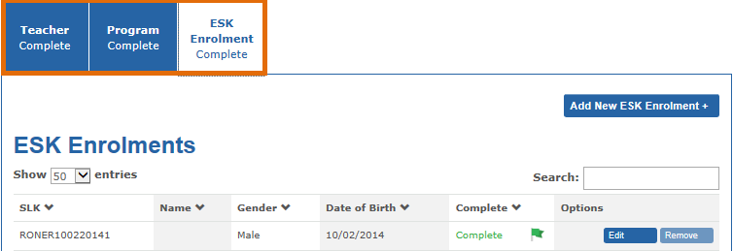
- If you want to add another child, click the Add New ESK Enrolment + button and repeat steps 18 to 34.
To check the status of the application, return to the KIM Home page. The ESK Funding column displays the status Submitted until the application is approved by the Department. The status will then change to Approved.

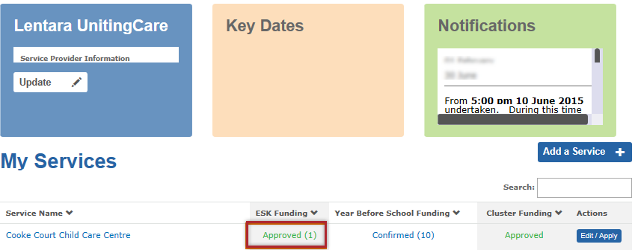
Part 2 – Edit an Early Start Kindergarten enrolment
You can edit all details for an Early Start Kindergarten enrolment including applying for funding for an increase in hours.
- To access the ESK Enrolment screen, click Approved in the ESK Funding column for the respective service.
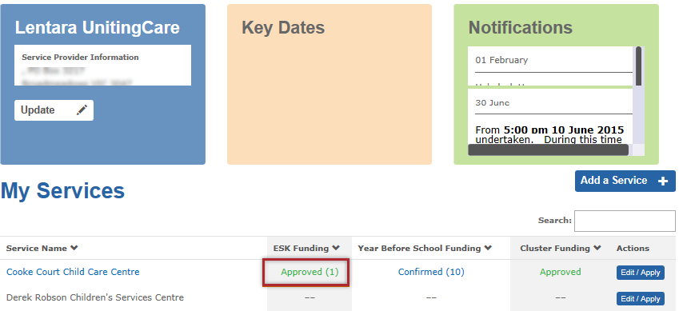
- Click ESK Enrolment.
- Find the child record you wish to edit and click Edit.
If the Edit button is disabled, the application is still being processed by the Department and is in ‘read only’ mode. You will be unable to make any changes.
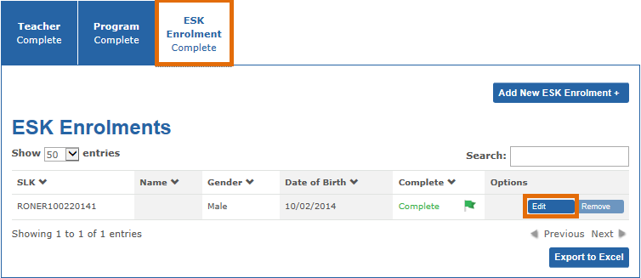
Result: information previously submitted about the child displays.
- If you are applying for funding for an increase in hours for the child, click Next to navigate to the Funding Related Questions section.
- Update the hours the child is enrolled to attend. Then enter the date from which the increased hours should take effect.
- Edit all other information as required and click Submit.
Result: you will be returned to the ESK Enrolment section with the list of enrolled children.

Part 3 – Remove an Early Start Kindergarten enrolment
It is very important to remove any Early Start Kindergarten enrolments that have left the program, been entered in error or are requested to be removed by the Department.
If a child has left the program, your funding will not be affected when you remove the child from KIM. If you do not remove the child from KIM it may affect the ability of the child’s new service to apply for the Early Start Kindergarten grant.
- Navigate to the ESK Enrolment screen by clicking Approved in the ESK Funding column for the respective service.
- Click on the ESK Enrolment tab.
- Find the child record you wish to remove and click Remove. If the Remove button is disabled, the application is still being processed by the Department and is therefore in ‘read only’ mode.
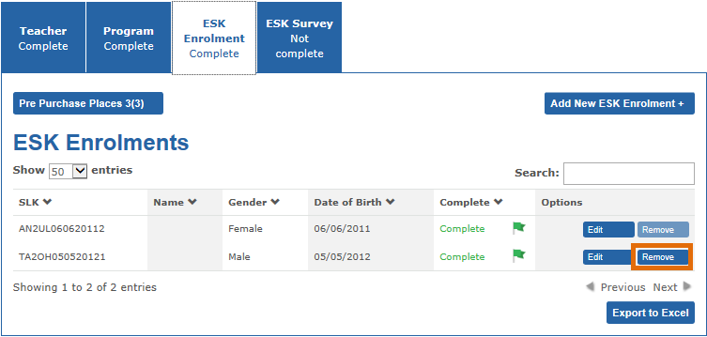
Result: a screen displays asking for information about the child being withdrawn.
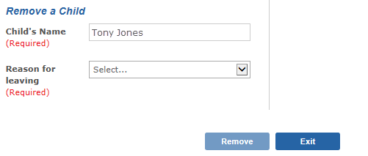
- Select the reason for leaving:
- Child has left the program, or
- Data entry mistake – delete child
- If you select Data entry mistake – delete child, go to step 7
- If you select Child has left the program, you are required to select the final date of kindergarten for the child and provide a reason for the child leaving.
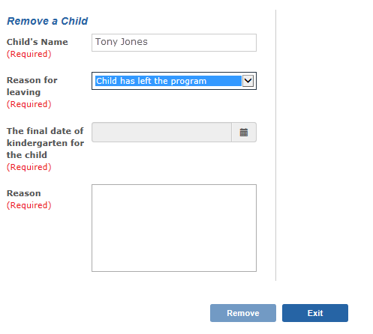
- Click Remove.
Result: The child’s record is removed from the ESK Enrolment list.

