How to complete the annual confirmation process
Quick Reference Guide

About the annual confirmation process
As outlined in The Kindergarten Funding Guide, service providers receiving funding from the Department of Education and Training (the Department) are required to comply with operational requirements to continue to receive funding.
This includes confirming data on an annual basis regarding the year before school kindergarten program. Information collected through this process enables per capita and kindergarten fee subsidy funding to be calculated. It also allows the Department to verify that service providers continue to meet eligibility criteria and operational requirements outlined in The Kindergarten Funding Guide.
The first step in the annual confirmation process is to ensure that the required information is submitted in the Kindergarten Information Management (KIM) system about your organisation and its service(s). This includes entering information about the early childhood teacher(s), other educators, program and enrolments for the funded kindergarten program in the year before school.
Note: Only enter the details of the enrolments that are enrolled and attending the 15+ hour kindergarten program in the year before school.
This information will pre-populate the Annual Confirmation tab. You need to certify this information as true and correct to continue to receive funding.

how to complete the annual confirmation process
You will only be able to complete the annual confirmation process for a service once all required information is entered about the teacher(s), other educator(s), programs, and enrolments. When all the required information has been entered, each tab will display as Complete from the service screen. Once the data has been processed, the Annual Confirmation tab will be available.
- From the KIM Home screen, click the relevant service.
- Click on the Annual Confirmation tab.
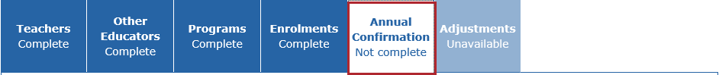
Result: A summary of the data submitted will display.
- Click
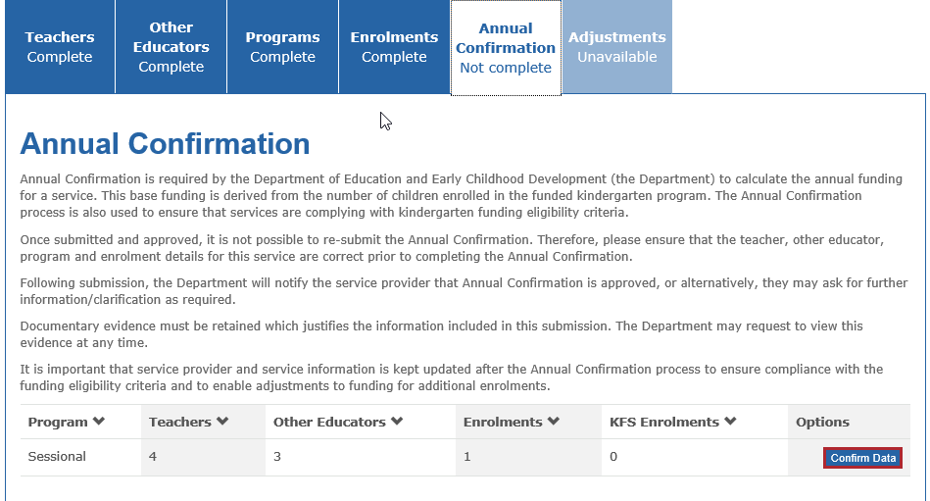
Result: The Annual Confirmation pop-up window displays.
- In the Central Enrolment section, answer Yes or No to the question Is your service part of a central system.
- If Yes is selected, select the enrolment scheme from the drop-down list (local government or other – provide details).
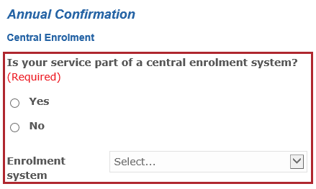
- In the Transition Learning and Development Statements (TLDS) section, enter the number enrolments to the question, How many TLDS (Section 1) were completed by this service for these children? (if none, enter 0).
- Complete the following fields to the question, Of the x (number) TLDS not completed, how many of these were for children in receipt of a Kindergarten Fee Subsidy or ESK Extension Grant because:
- Child is known to Child Protection (if none, leave blank)
- Child is Aboriginal and/or Torres Strait Islander (if none, leave blank)
- Child or their parent/guardian hold an eligible concession card or humanitarian visa (if none, leave blank)
- Child is a triplet (or more) (if none, leave blank)
- Enter the number of enrolments to the question, Of the x (number) TLDS completed, how many were forwarded to schools by this service for children in receipt of a Kindergarten Fee Subsidy or ESK Extension Grant?
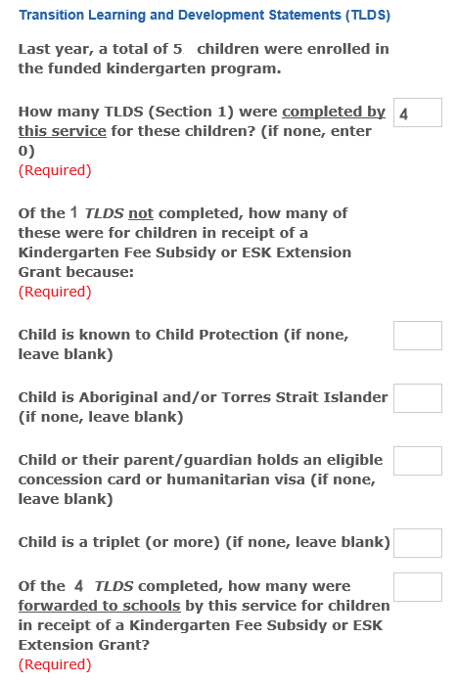
- If you previously indicated that the service offers a 3 year old program or a combined 3 and 4 year old program delivered by a qualified early childhood teacher, the following questions will display:
- How many three year old children are enrolled in the kindergarten program delivered by a qualified early childhood teacher? (Enter the total number of 3 year old children enrolled in the 3 year old funded kindergarten program OR the combined 3 and 4 year old kindergarten program including Early Start Kindergarten enrolments)
- How many hours per week is a kindergarten program, delivered by a qualified early childhood teacher, available to 3 year olds? (Enter the total number of 3 year old children enrolled in the 3 year old funded kindergarten program OR the combined 3 and 4 year old kindergarten program including Early Start Kindergarten enrolments)
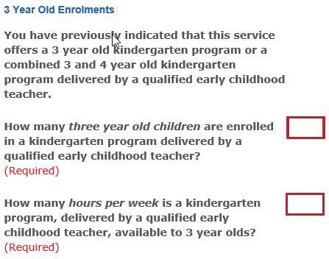
- If the service delivers the kindergarten program using a sessional model, a question will display asking whether the service offers before and/or after-program care. Select Yes or No.
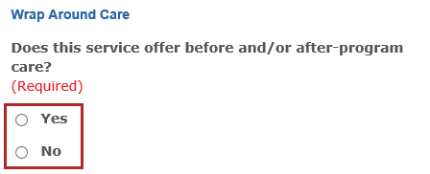
- Answer the questions relating to kindergarten fee subsidy and fee subsidy surplus.
A kindergarten service has a surplus when the kindergarten program fee is less than the kindergarten fee subsidy. See The Kindergarten Guide for more information.
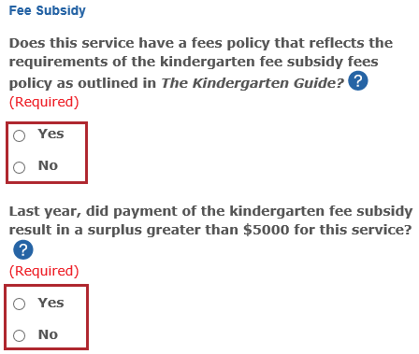
- Click
- If there are any other qualified early childhood teachers employed at this service delivering unfunded programs such as 3 year old or long day care, please indicate the total number of teachers and then the number at each qualification level.
Do not include details of early childhood teachers employed in the funded kindergarten program in this section.
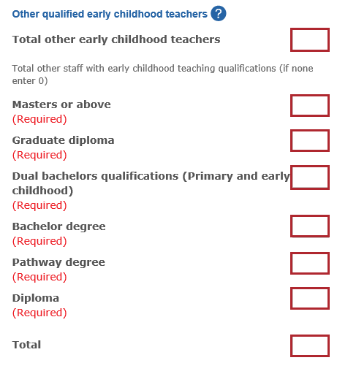
- A summary of Enrolments, Kindergarten Fee Subsidy, Early Childhood Teachers and Other Educators is pre-populated with data previously entered in KIM.
Note: If the data is incorrect, please Exit the Annual Confirmation screen and correct the information from the tabs on the Service Home page.
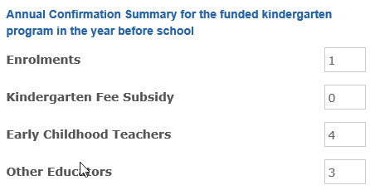
- In the Funding Eligibility Checklist section, by clicking the tickboxes, you are confirming that:
- each eligible child is receiving a kindergarten program planned and delivered by a qualified early childhood teacher.
- each eligible child is receiving a minimum of 15 hours of kindergarten per week for a minimum of 40 weeks per year (or 600 hours per year).
- written confirmation has been / will be provided to parents that their child is receiving a funded kindergarten program at this service.
- When all sections are complete, click
- If you are a community based organisation, the Insurance cover at the service level section displays. Please check and update the answers to the questions about the service’s eligibility for the Community Service Organisation Insurance Program.
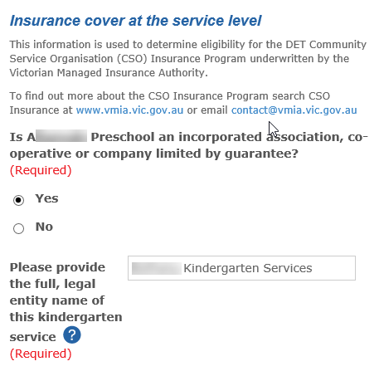
- Complete the Certification details (Name, Position/Title and Date).
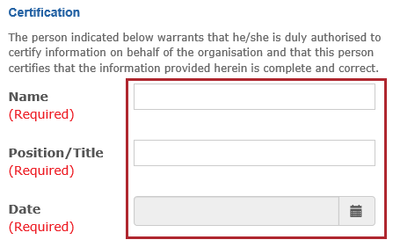

- Click
Result: the Annual Confirmation tab displays with a status of Submitted.
Note: All other tabs are Read only (information cannot be updated/edited) until the Annual Confirmation data is approved by the Department.
Note: When the Annual Confirmation data is approved by the Department, the tab displays with a status of Complete and all the other tabs will become available for updating/editing as required.

