Kindergarten Rotational Model

Fact Sheet
Funded services operating a sessional kindergarten program may choose to use a rotational model where a number of smaller sub-groups are brought together to create a larger group. This not only allows the children to build friendships outside of their allocated group, it allows services with limited capacity to deliver a 15 hour kindergarten program to a greater number of children. Examples of rotational models are provided on pages 6-7 of this fact sheet.

The importance of entering rotational models in the Kindergarten Information Management (KIM) system
The Department of Education and Training (the Department) determines a service’s eligibility for ratio supplement funding based on information entered in the KIM system. If the service delivers the kindergarten program using a rotational model, this must be indicated in KIM to ensure the correct calculation of the ratio supplement payment.
If the model of program delivery changes or information about the rotational groups change, this information must be updated in KIM.

How to enter a rotational model in KIM
The following steps outline how a service enters a rotational model in the KIM system. We have used the group information in Rotational Model - Example 1 on page 6 for these steps. For additional information about entering program information in KIM, please refer to the Quick Reference Guide How to Provide and Update Program Details which is available under the Support menu on the KIM home page.
- In the Service Home page, click on the Programs tab.
- Click the Edit button under the text “This service currently delivers the kindergarten program as:”
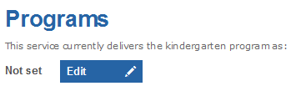
- Select how the program is offered; ‘Using a sessional model’ or ‘Both sessional groups AND integrated in a LDC program’.
- Select ‘Yes’ to indicate that the service uses a rotational model to deliver the kindergarten program.
- Complete the remainder of the questions and click ‘Save’.
- Click ‘Edit’ to enter information about the first sub-group of the rotational model.
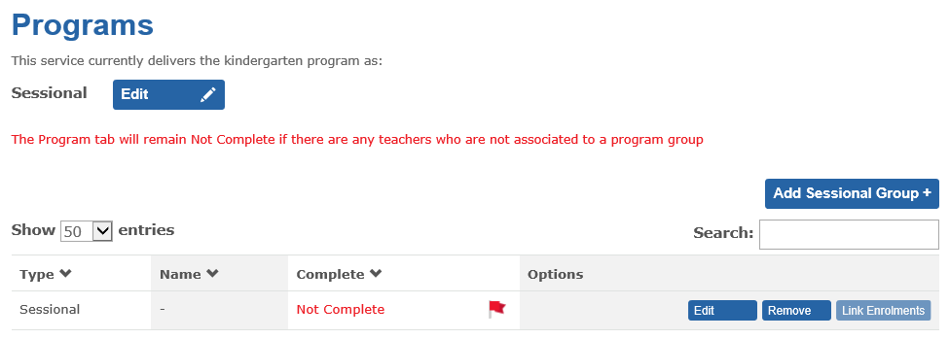
- Enter the name of the sub-group and the hours the sub-group operates per day (for a total of at least 15 hours per week).
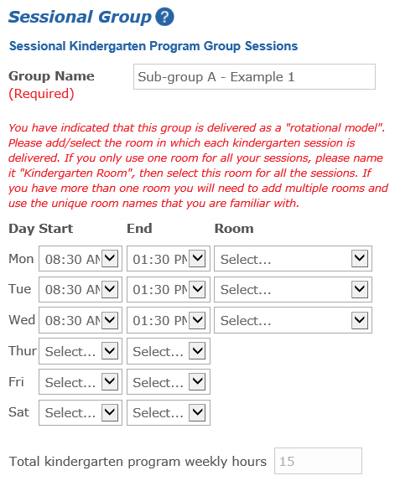
- Click Add + to add a room.
- Enter the Room Name and click OK. If the service only uses one room for all the sessions, name it “Kindergarten Room”.
- When all rooms are added, select the applicable room for each of the sub-group’s session times.
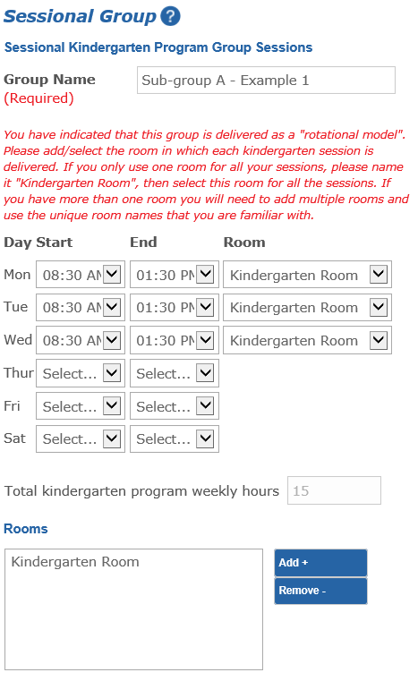
- Enter the Group Fees.
- In the Available box, click on the name of the teacher who is planning and delivering the kindergarten program to this particular sub-group. In the example below, Mary Brown is the assigned teacher.
If no teachers display, save and exit the screen and check that the teacher records are ‘Complete’ under the Teachers tab.
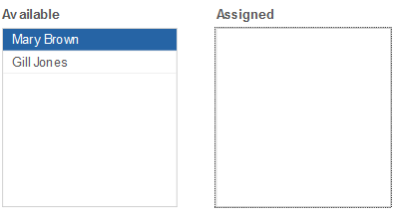
Result: The selected teacher will display in the Assigned box.
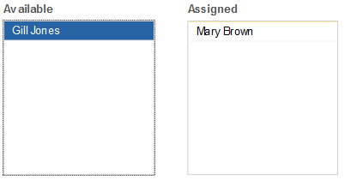
- Click Save.
Result: If all the required information has been entered, the group will display with the status Complete.
- To add the next sub-group (in this example, sub-group B) click Add Sessional Group+ and repeat steps 7 – 13.
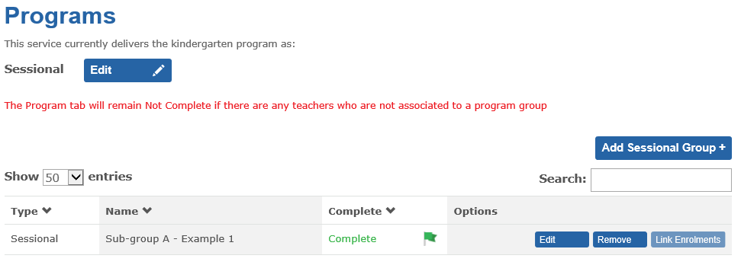

Who to contact for more information and assistance
For KIM technical assistance, contact the Health and Early Learning Practitioners help desk:
Tel: 1800 614 810
Email: HELP.helpdesk@edumail.vic.gov.au
The help desk is available from 8.00am to 5.30pm, Monday to Friday.
For all kindergarten operational and funding enquiries, please contact your local Department regional office:
Glen Waverley (Metro) Tel: (03) 8392 9300
Benalla (Rural) Tel: (03) 8392 9500
Coburg (Metro) Tel: (03) 9488 9488
Bendigo (Rural) Tel: (03) 5440 3111
Dandenong (Metro) Tel: (03) 8765 5600
Moe (Rural) Tel: (03) 5127 0400
Geelong (Metro) Tel: (03) 5225 1000
Footscray (Metro) Tel: (03) 8397 0300
Ballarat (Rural) Tel: (03) 5337 8444

Rotational Model – Example 1
Session Times: 8.30am – 1.30pm (5 hours), Monday to Thursday.
Each child attends 3 x 5 hour sessions per week (total of 15 hours per child)
Licensed capacity: 23 children
Time | Monday | Tuesday | Wednesday | Thursday | Friday
8.30 | A, B & D  23 children | A, B & C  23 children | A, C & D  22 children | B, C & D  22 children
9.00 |  |  |  |  |  |  | Sub-Group | No. of enrolments
9.30 |  |  |  |  |  |  | A | 8
10.00 |  |  |  |  |  |  | B | 8
10.30 |  |  |  |  |  |  | C | 7
11.00 |  |  |  |  |  |  | D | 7
11.30 |  |  |  |  |  |  | Total | 30
12.00
12.30
13.00
13.30

Rotational Model – Example 2
Session Times: 8.30am – 1.30pm (5 hours), Monday, Wednesday and Friday
11.30am – 4.30pm (5 hours), Tuesday and Thursday
Each child attends 3 x 5 hour sessions per week (total of 15 hours per child)
Licensed capacity: 30 children
Time | Monday | Tuesday | Wednesday | Thursday | Friday
8.30 | A, B & C  30 children |  | B, C & D  30 children |  | C, D & E  30 children
9.00
9.30
10.00
10.30
11.00 |  |  |  |  |  |  | Sub- Group | No. of enrolments
11.30 |  | A, D & E  21 children |  | A, B & E  21 children |  |  | A | 7
12.00 |  |  |  |  |  |  | B | 7
12.30 |  |  |  |  |  |  | C | 16
13.00 |  |  |  |  |  |  | D | 7
13.30 |  |  |  |  |  |  | E | 7
14.00 |  |  |  |  |  |  | Total | 44
14.30
15.00
15.30
16.00
16.30

Rotational Model – Example 3
Session Times: 8.30am – 4.00pm (7.5 hours), Monday to Thursday
Each child attends 2 x 7.5 hour sessions per week (total of 15 hours per child)
Licensed capacity: 30 children
Time | Monday | Tuesday | Wednesday | Thursday | Friday
8.30 | A & C  30 children | A & D  30 children | B & D  30 children | B & C  30 children
9.00
9.30
10.00
10.30
11.00 |  |  |  |  |  |  | Sub-Group | No. of enrolments
11.30 |  |  |  |  |  |  | A | 20
12.00 |  |  |  |  |  |  | B | 20
12.30 |  |  |  |  |  |  | C | 10
13.00 |  |  |  |  |  |  | D | 10
13.30 |  |  |  |  |  |  | Total | 60
14.00
14.30
15.00
15.30
16.00
16.30

