How to update parent occupation and education information
Quick Reference Guide

- From the KIM home page, click the relevant service.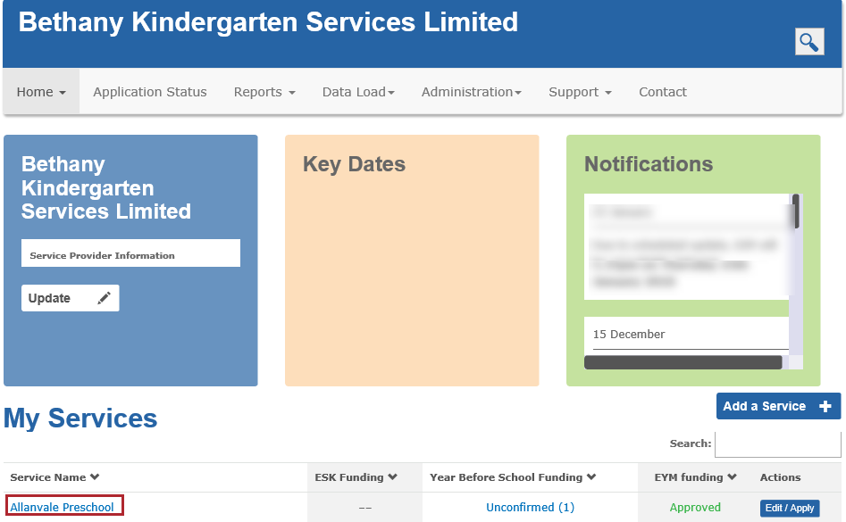
- Click Enrolments.
- Click Edit to open the enrolment record.
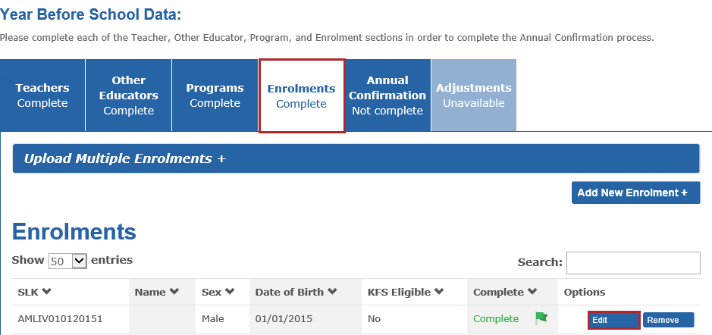
- Click until you reach the Student Family Occupation Education (SFOE) information section.

- Update the drop-down lists for Adult A and Adult B. Adult B can remain blank if the child is from a single parent family or there is only one primary carer.
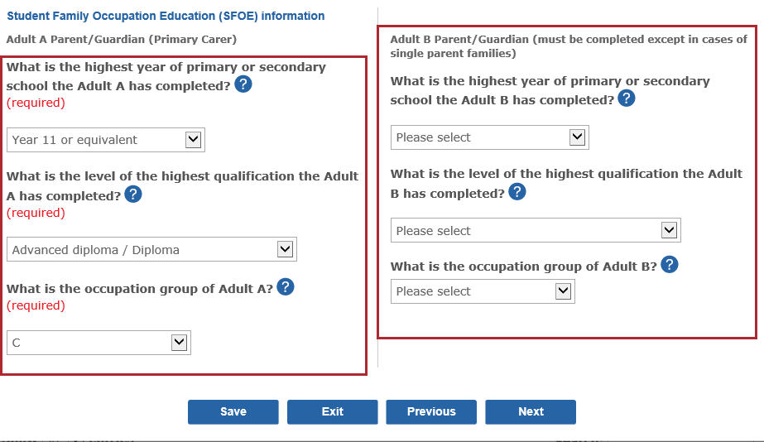
- Click

- For step-by-step instructions on entering information in KIM click Support in the main menu and then click Support.
- For more information about school readiness funding including translated information sheets for parents, click Support in the main menu and then click Kindergarten Funding Resources in the sub-menu.
- If you have questions about school readiness funding or other types of kindergarten funding, click Contact in the main menu and call your local Department regional office.
- For technical assistance with the KIM system, click Contact in the main menu and call or email the KIM help desk.

