Children’s facilitIes

capital program
2017-18 MAJOR Grant
guidelines

Published by the
Victorian School Building Authority
Department of Education and Training
Melbourne
May 2017

©May 2017 Victoria (Department of Education and Training)

The copyright in this document is owned by the State of Victoria (Department of Education and Training), or in the case of some materials, by third parties (third party materials). No part may be reproduced by any process except in accordance with the provisions of the Copyright Act 1968, the National Education Access Licence for Schools (NEALS) (see below) or with permission.

An educational institution situated in Australia which is not conducted for profit, or a body responsible for administering such an institution may copy and communicate the materials, other than third party materials, for the educational purposes of the institution.

Authorised by the Department of Education and Training
2 Treasury Place, East Melbourne, Victoria, 3002.
This document is also available on the internet at
www.education.vic.gov.au/ecsmanagement/capitalprogram

CONTENTS

1. Introduction 4
2. Integrated Children’s Centre Grants 7
3. New Early Learning Facility Grants 9
4. Early Learning Facility Upgrade Grants 10
5. Application Process 11
6. Permission from land/builder owner 14
7. Further Information 15
Attachment 1 – Program Criteria 17
Attachment 2 – Assessment Criteria 18

Introduction

The Andrews Labor Government has a vision to make Victoria the Education State. To this end, it has committed $70 million between 2015-19 to support local governments and other service providers to invest in early childhood infrastructure. Of this $70 million, $10 million was committed to address early years demand in high growth areas, and a further $10 million to collocate early years infrastructure to school sites.
Access to high quality early years services is central to giving every Victorian child the best start in life. Families deserve a choice of flexible, accessible and affordable early childhood education and care services, including kindergarten programs delivered in a range of settings, alongside other key services such as Maternal and Child Health, early childhood intervention services, playgroups and family services.
The Children’s Facilities Capital Program (CFCP) supports the provision of high quality early years programs for children and their families by:
- increasing infrastructure capacity to deliver kindergarten programs for children in the year before school
- promoting integrated service delivery at one location where families can access early childhood education and care, health and development and family services
- improving access to local and responsive early childhood services for children from vulnerable and/or disadvantaged families
- establishing early childhood infrastructure on or near school sites.
Applications for 2017-18 CFCP Major Grants round open on Thursday 15 June 2017.
The 2017-18 CFCP Major Grants applications must be submitted via the online application form by midnight on Friday 15 September 2017 (AEST).
The 2017-18 CFCP Major Grants application is a one-stage process. Applicants will be asked to demonstrate the benefits and readiness of their project in relation to the 2017-18 CFCP guidelines. Further details can be found in the ‘Application Process’ section below. A copy of the Common Funding Agreement that applicants are required to sign if they are successful is located on the Victorian School Building Authority website. It is recommended applicants read this document before completing their application to ensure they understand full requirements for completing their project. Late submissions will not be accepted. DET may seek clarification about a project application or ask applicants to provide further information where required.
‘For profit’ organisations are ineligible for any Major grant type in 2017-18.
NOTE: Details of the 2017-18 Children’s Facilities Capital Program Minor Grants round are provided in a separate document.

Summary of MAJOR grants available in the Children’s Facilities Capital Program 2017-18 grant round:

Grant Type | Maximum Grant Amount | Purpose of Grant | Minimum Co-contribution from Applicant | Eligible Organisations
Integrated Children’s Centre | 40% of the total project cost, capped at $1,600,000 | Integrated Children’s Centres  - are key hubs for the community, bringing together a range of services where professionals work together to deliver education, care, health and support services to children and their families.  - are important community assets that meet the needs of families and children across the early years.  - provide a focal point for new communities in growth areas, but are equally valuable in improving the accessibility, quality and integration of early childhood services in established metropolitan and regional areas. | 60% of the total project cost | - Local Governments  - Not-for-profit community organisations  - Government schools  - Non-government schools  NOTE:  If the land and/or building are owned by local government then only the relevant local government can be the applicant for a Major Infrastructure Grant.  If the land and/or building are not owned by local government, and are leased by a service provider, a service provider may be the applicant with evidence provided in the form of a lease between the land/building owner. The lease must be for a minimum of 10 years.
New Early Learning Facility | 75% of the total project cost, capped at $650,000 | New Early Learning Facilities  - enable the provision of high quality early learning, including kindergarten in the year before school, at a neighbourhood level.  - The location and design of New Early Learning Facilities should respond to the needs of local families and support partnerships with other local services for children and families. | 25% of the total project cost
Early Learning Facility Upgrade | 75% of the total project cost, capped at $350,000 | Early Learning Facility Upgrade Grants  - are for the renovation or refurbishment of existing, licensed early childhood education and care facilities, to expand licensed capacity and / or improve the quality of the learning environment. | 25% of the total project cost

Potential utilisation of funding:

What can be funded? | What cannot be funded?
For all Major Infrastructure Grant categories, the following items can be included as part of the total cost of the project for the calculation of the maximum Victorian Government contribution:  - planning and design costs  - project management costs  - site prep, including clearing/demolition if needed  - construction and commissioning  - fittings, furniture and equipment. | The following items cannot be included in project cost estimates for the calculation of the maximum Victorian Government contribution:  - site acquisition costs  - purchase of cars, buses and other vehicles  - staff salaries and training  - ongoing administration costs  - toys, consumables and routine maintenance  - cosmetic upgrades.

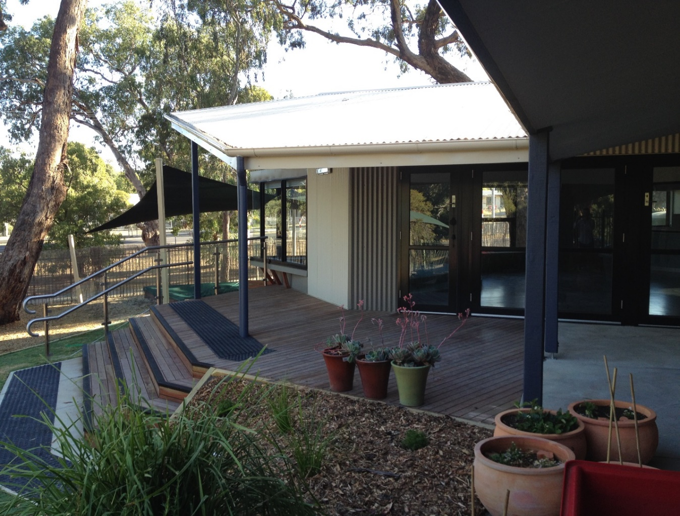

Integrated Children’s Centre Grants

Purpose of grant
Integrated Children’s Centres are key hubs for the community, bringing together a range of services where professionals work together to deliver education, care, health and support services to children and their families. They can provide a focal point for new communities in growth areas, but are equally valuable in improving the accessibility, quality and integration of early childhood services in established metropolitan and regional areas. Integrated service delivery is particularly important in establishing and maintaining engagement with vulnerable and disadvantaged families as their children move through the service system, e.g. from Maternal and Child Health to playgroups and then formal early learning programs.
Integrated Children’s Centres may be co-located with schools or community facilities such as neighbourhood houses, community centres or libraries.
For more information visit: www.education.vic.gov.au/integratedservices

PROJECT REQUIREMENTS
To be eligible for funding, Integrated Children’s Centres funded through the CFCP must provide, at a minimum, all of the following:
- Two rooms for a funded kindergarten program for children in the year before school. This can be sessional and/or integrated within long day care. The licensed capacity of the service must be at least 66 (unless otherwise agreed with DET)
- Long day care (unless evidence is provided that there is no unmet demand for long day care in the local area)
- Maternal and Child Health services
- Allied health services for early years such as early childhood intervention services
- Family services.
Integrated Children’s Centres should also incorporate flexible, multi-purpose spaces and provision for other services that meet the needs of the local community, for example:
- Three year old kindergarten
- Supported playgroups and / or community parent-led playgroups
- Parenting groups or programs
- Occasional care
- Family day care program coordination
- Counselling services
- Community meeting spaces
- Outside school hours care
- Adult education programs.
See the Application process section for details on the assessment criteria.

Funding available
Eligible organisations can apply for up to 40 per cent of the total project cost, capped at $1.6 million per grant (GST exclusive). The 40 per cent cap on the contribution to the total project cost should be calculated in relation to early childhood and directly related facilities only. For example, if a library or sporting and recreational facilities form part of the centre, the estimated costs for these elements cannot be included in the calculation of the 40 per cent maximum contribution. Potential applicants should contact DET if they are unsure about how the 40 per cent requirement applies in relation to a proposed project.

PROJECT COMPLETION
Integrated Children’s Centres must be completed within 24 months of executing the Common Funding Agreement or as otherwise agreed with DET. All Common Funding Agreements must be signed no later than 8 weeks following official notification of a successful grant application.
In cases where a project is delayed for an unreasonable length of time, or where substantive changes to scope are made after funding has been approved, DET reserves the right to cancel the grant and, if applicable, recoup any payments that have already been provided.
To apply for an Integrated Children’s Centre Grant, please visit:
www.education.vic.gov.au/ecsmanagement/capitalprogram

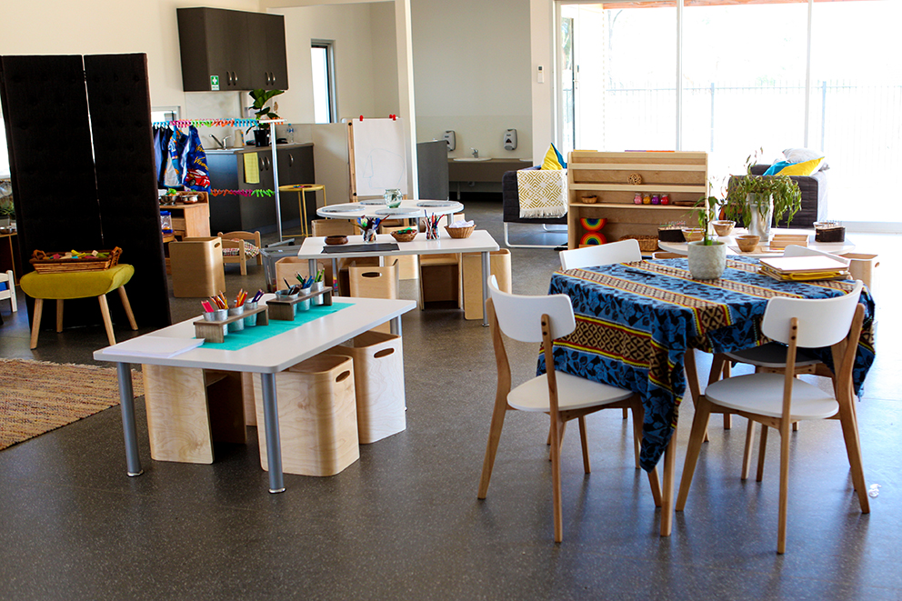

New Early Learning Facility Grants

Purpose of Grant
New Early Learning Facilities enable the provision of high quality early learning programs, including a funded kindergarten program in the year before school, at a neighbourhood level. The location and design of New Early Learning Facilities should respond to the needs of local families and support partnerships with other local services for children and families.

PROJECT REQUIREMENTS
New Early Learning Facilities funded through the CFCP must include two rooms. The licensed capacity of the service must be at least 66 (unless otherwise agreed with DET) for the delivery of a funded kindergarten program for children in the year before school – and provision for AT LEAST ONE other early childhood service from the following:
- Long day care
- Three year old kindergarten
- Maternal and Child Health
- Playgroups.
A new early learning facility must be on a site that is not currently used by a licensed children’s service.
See the Application Process section for details on the assessment criteria.

FUNDING AVAILABLE
Eligible organisations can apply for up to 75 per cent of the total project cost, capped at $650,000 per grant (GST exclusive).

PROJECT COMPLETION
New Early Learning Facilities will be expected to be completed within 18 months of executing the Common Funding Agreement or as otherwise agreed with DET. All Common Funding Agreements must be signed no later than 8 weeks following official notification of a successful grant application.
In cases where a project is delayed for an unreasonable length of time, or where substantive changes to scope are made after funding has been approved, DET reserves the right to cancel the grant and, if applicable, recoup any payments that have already been provided.
To apply for a New Early Learning Facility Grant, please visit:
www.education.vic.gov.au/ecsmanagement/capitalprogram

Early Learning Facility Upgrade Grants

Purpose of Grant
Early Learning Facility Upgrade Grants are for the renovation or refurbishment of existing, licensed early childhood education and care facilities (including those not currently used for the delivery of a funded kindergarten program) to expand licensed capacity and/or improve the quality of the learning environment.

PROJECT REQUIREMENTS
Facilities renovated or refurbished through the CFCP must be used for the provision of a funded kindergarten program for children in the year before school. Applicants are also encouraged to consider the potential for renovated facilities to support the provision of other early childhood services.
See the Application Process section for details on the assessment criteria.

FUNDING AVAILABLE
Eligible organisations can apply for up to 75 per cent of the total project cost, capped at $350,000 per grant (GST exclusive). Exemptions may be made to the co-contribution requirement where a service is located in an area of significant disadvantage and there is clear evidence that the applicant does not have the financial capacity to meet the additional costs. Exemptions will be made at the discretion of DET and the total State Government contribution will remain within the $350,000 limit.

PROJECT COMPLETION
Facilities refurbished with an Early Learning Facility Upgrade Grant are expected to be completed within 12 months of executing the Common Funding Agreement, or as otherwise agreed with DET. All Common Funding Agreements must be signed no later than 8 weeks following official notification of a successful grant application.
In cases where a project is delayed for an unreasonable length of time, or where substantive changes to scope are made after funding has been approved, DET reserves the right to cancel the grant and, if applicable, recoup any payments that have already been provided.
To apply for an Early Learning Facility Upgrade Grant, please visit:
www.education.vic.gov.au/ecsmanagement/capitalprogram

Application Process
Eligible organisations are invited to submit an application for Integrated Children’s Centre, New Early Learning Facility, and Early Learning Facility Upgrade projects. The application process is designed to identify high priority projects that align with the Children’s Facilities Capital Program objectives and assessment criteria. Application forms for all CFCP grants can be accessed via the DET website at: www.education.vic.gov.au/ecsmanagement/capitalprogram

PROGRAM CRITERIA REQUIREMENTS
Applicants are required to submit a detailed application providing the following information:
- A project proposal that addresses the aims of the Children’s Facilities Capital Program, including the identified service need and responses to each of the assessment criteria (and supporting evidence as required)
- Indicative scope, cost, value of grant sought and commencement/completion dates including the following:
  - Total estimated investment for the project including estimated building cost, organisational contribution, other contributions and the Grant amount requested
  - Confirmation of all other funding including contributions from the Federal Government and other Victorian Government grant programs, Local Government or other sources.
  - Schematic design drawings
  - Licensed Quantity Surveyors Report or better (estimated costing of the project will be acceptable if project is less than $200,000)
  - Confirmation the project meets all National and DET regulatory requirements
  - Evidence of the financial viability of the organisation (except local government and government schools)
- Evidence of land ownership or signed documents/lease confirming legal permission to undertake the works and operate the building as a licensed service for ten years minimum (if not currently owned, evidence that the proposed site will be available within 90 days of the grant round closing date)
- Evidence of service providers that will be directly affected by the proposal have been consulted and their views (e.g. community-based kindergarten services operating in existing facilities that are being proposed to be relocated)
- All required services for the grant type will be delivered
- Relative priority where an applicant is submitting multiple business case applications
- A letter of support from the relevant CEO (or authorised delegate) of the Local Government Area (LGA) for the project dated within 6 months of the 2017-18 Children's Facilities Capital Program application lodgement. This letter must possess an explicit statement by the LGA addressing why the proposed project will be beneficial to the community and if it has been included in council plans and where possible recommended priority if the LGA is supporting more than one project.
Applicants that submitted an unsuccessful application in the 2016-17 Children’s Facilities grant round, but are still interested in funding, are strongly encouraged to resubmit their applications to reflect this year’s criteria.
Further detail about program criteria, including examples of evidence that can be submitted can be found in Attachment 1.

The following assessment criteria will be used to prioritise projects for funding:
- The project will respond to unmet demand for funded kindergarten provision in the year before school and other early childhood services
- The project will support the integrated delivery of early childhood and related family services and/or the establishment of partnership arrangements with other services
- The project will improve access to high quality early childhood services for the local community, particularly for disadvantaged and vulnerable families
- The project is co-located with a government school, or supports the establishment of other connections with local schools
- The proposed project facilitates access for children of all abilities
- The project is ready to commence construction
Further detail about the assessment criteria, including examples of evidence that can be submitted can be found in Attachment 2. For Frequently Asked Questions (FAQs), visit:
www.education.vic.gov.au/ecsmanagement/capitalprogram

ASSESSMENT OF FUNDING APPLICATIONS
DET will assess applications for all Major Infrastructure Grant categories against eligibility and program criteria. To support the assessment process, DET may also consult with relevant local councils in their municipal planning role, seek advice from internal/external experts, and have reference to demographic and other data sets, for example population projections and Australian Early Development Census (AEDC) data. The selection of projects to be considered for funding will be primarily based on ratings against the assessment criteria, however, other factors may be taken into account including:
- the distribution of approved projects across applicants, local government areas and different regions of the state
- new early childhood education and care infrastructure in Victoria's growth areas. Growth areas are defined by the Metropolitan Planning Authority (MPA) as the following councils: Cardinia, Mitchell (inside the urban zone), Whittlesea and the Cities of Casey, Hume, Melton and Wyndham
- councils supporting their applications with a co-contribution sourced from local government funds rather than supplementary funding from other Victorian Government sources such as Regional Development Victoria (RDV)
- the availability of funding in each financial year, noting that the number and value of eligible, highly rated projects may exceed the total available funding.

RELATIONSHIP WITH OTHER FUNDS
There are a number of other grant programs that provide funding for the development of early childhood facilities and services. DET reserves the right to consider grant applications made for other programs, operated by DET or other government departments, as part of the CFCP assessment process. Likewise, where appropriate, DET will submit CFCP applications to other programs for consideration for funding under those programs.

DUE DILIGENCE
If DET is satisfied that all specified requirements have been met, the project will be deemed eligible to potentially receive a capital grant (subject to availability of funding, approval by the Minister for Families and Children and execution of a Common Funding Agreement).
To remain eligible for funding, applicants must not enter into a contract for any works proposed in their application prior to being informed of the application outcome.
Follow up questions or information may be sought by assessors to clarify project details. In instances where project costs are particularly complex or clarification is required, further project cost assessment may be undertaken by DET. Assessors may engage applicants in preliminary discussions about potential contractual terms and monitoring arrangements, or to further explore and negotiate the scope of projects.

FUNDING AGREEMENTS
Organisations receiving a Major Infrastructure Grant will enter into a Victorian Government Common Funding Agreement. This includes a commitment to a designated use period of at least 10 years after the date from which the new or upgrade facility is available for service delivery.
DET will not vary this agreement unless exceptional circumstances exist.
No funding can be released until DET and the applicant have executed the Common Funding Agreement.
Projects involving facilities on government school sites will be required to enter into a separate leasing agreement. Applicants must not enter into a contract for any works proposed in their application, or access a school site until the lease is executed.
Each party to the Common Funding Agreement must pay its own legal costs in the preparation, negotiation, execution and any variation of the agreement. The applicant must pay for the Department’s legal costs relating to the preparation, negotiation, execution, and any variation of the lease. These costs may be budgeted into the total project cost for the project and funded through the grant.

MONITORING AND REPORTING OF PROJECT DELIVERY
Recipients of Major Infrastructure Grants will be required to comply with project monitoring and reporting requirements, including:
- online, bi-monthly progress reports with supporting evidence as required by DET
- site inspections and teleconferences by DET staff or representatives if required
- production of building contracts, receipts and/or invoices if required by DET
- final acquittal documentation within agreed timeframes.

PAYMENTS AND ACQUITTALS
All Major Infrastructure Grant payments will be provided in milestone instalments at the discretion of DET. Unless otherwise agreed, the first instalment will be paid as agreed in the Common Funding Agreement. Grant funds will be paid to successful applicants via an electronic funds transfer to a nominated account or through a variation of an existing service agreement.
In cases where a project is delayed for an unreasonable length of time, or where substantive changes to scope are made after funding has been approved, DET reserves the right to cancel the grant and, if applicable, recoup any funds that have already been provided. On completion of the project, all grant recipients are required to complete and return the appropriate Certificate of Expenditure Acquittal form which will be provided through the online reporting process.

Permission from land/builder owner

Land / Building owner permission
If the land and/or building are owned by local government then only the relevant local council can be the applicant for a Major Infrastructure Grant.
Where the land and/or building is not owned by local government, a service provider may be the applicant with evidence provided in the form of an amended lease between the land / building owner. If the service provider owns the property, the applicant is also eligible to apply, and must provide proof of land ownership. Details can be found in the application form.

land ownership
If DET owns the land, the applicant must complete a DET Land Use Proposal Form and submit it with the application. The DET Land Use Proposal Form is available at:
http://www.education.vic.gov.au/childhood/providers/funding/Pages/capitalprogresources.aspx
The Victorian School Building Authority will determine whether or not the proposed project is appropriate for the selected site (in addition to approval from the school). It is important that applicants allow sufficient time (6 weeks) to submit the DET Land Use Proposal Form for it to be reviewed and returned, to enable it to be attached to the application prior to the closure of the funding round.

Service Approvals
If the service is undertaking works of a structural nature that will change the design of an approved education and care service – for example, the addition of a children’s room or expansion of a children’s space, and/or where there will be an increase in the approved number of places – your service may be required to seek approval from DET prior to completion of the works. These applications may take some time to consider and approve. Please contact the Quality Assessment and Regulation Division at DET on 1300 307 415, or email licensed.childrens.services@edumail.vic.gov.au to discuss your circumstances if you have specific concerns.

Notifications and applications may be submitted via the National Quality Agenda IT system. The system may be accessed from https://public.nqaits.acecqa.gov.au. Further information is available from the ACECQA website www.acecqa.gov.au

Further Information

General Enquiries
For general enquiries regarding all grant categories under the Children’s Facilities Capital Program 2017-18 Grants Round email: childrens.capital.program@edumail.vic.gov.au or phone: (03) 9651 3399.
For assistance with any technical difficulties with the online application form, please contact Smarty Grants Support Desk: service@smartygrants.com.au or call (03) 9320 6888. This service is available Monday to Friday from 9am to 5pm.

Announcement and acknowledgement
The Minister for Families and Children or a nominated representative will announce the successful grant applicants.
All communications in relation to the promotion of projects receiving a grant under the Children’s Facilities Capital Program must cite the Victorian Government contribution.

Requirements for Major capital grants
Recipients of the Major Infrastructure grants are required to:
- comply with the Victorian Government’s guidelines on signage, available at: http://www.dpc.vic.gov.au/index.php/communication/policies-and-guidelines
- hold a ground breaking event to which the Minister is invited (Integrated Children’s Centres and New Early Learning Facilities only)
- hold an official opening once the project is completed
- submit a completed event alert three months prior to the proposed official opening date and/or ground breaking event, to ensure that the Minister for Families and Children is able to open the facility or nominate a representative to open the facility.

Project Extension Requests
All successful applicants requiring a project extension must immediately contact DET. Project extension requests of more than 4 weeks are required to include detailed evidence in the form of written documentation from the organisation, in addition to any supplemental documents (consulting fees, contractor statement, etc.) the provider may have.
All projects are expected to adhere to relevant building guidelines and regulations. The link below provides additional information:
http://www.education.vic.gov.au/Documents/about/programs/infrastructure/building-quality-standards-handbook.pdf

Attachment 1 – Program Criteria
Program Criteria Requirements | Summary Detail of Criterion | Examples of evidence
- Information and data that confirms eligibility of each applicant | Organisations will be required to demonstrate that they are an eligible service provider by providing their Australian Business Number (ABN) for the Department of Education and Training to verify applicant’s eligibility status. | - Australian Business Number  - Applicant / Organisation details (type of organisation as per eligibility table)
- Indicative scope, cost, value of grant sought and commencement / completion dates | The proposed project must provide evidence of total financial costings for each contributing organisation, in addition to anticipated construction start dates and expected completion dates. | - Total estimated investment table for the project  - Confirmation of all other funding contributions  - Schematic design drawings  - Licensed Quantity Surveyors Report or better (estimated costing of the project will be acceptable if project is less than $200,000)  - Confirmation the project meets all regulatory requirements  - Evidence of the financial viability of the organisation (except local government and government schools)
- Land ownership or signed documents/lease confirming legal permission to undertake the works and operate the building as a licensed service for ten years minimum | The proposed project must adequately demonstrate land ownership (if not currently owned, evidence that the proposed site will be available within 90 days of grant round closing date). If the applicant leases the land from a building/land owner, the applicant must provide an amended lease that sufficient demonstrates the service provider will operate the licensed kindergarten program for a minimum of ten years (the ten year agreement will also be stipulated in the Common Funding Agreement). | - Property and / or land title  - Certified amended lease  - DET land use proposal form (if applicable)  - Land use management documents (if applicable)  - If the property is not currently owned, however will be available within 90 days of business case grant round closure, a letter indicating inevitable land transfer from the current property owner will suffice.
- Evidence of service providers that will be directly affected by the proposal have been consulted about their views (e.g. community-based kindergarten services operating in existing facilities that are being proposed to be relocated) | In order to ensure service providers who will be directly affected by the nominated project have been consulted about the possible affect it may have on their kindergarten, the program requires that applicants demonstrate they have consulted with local service providers about these impacts by providing their perspective. | - Written, or demonstrable, communications between local service providers and the submitting party indicating that the applicant has consulted with the service provider directly affected by the plan.
- All required services for the grant type will be delivered | The proposed project must include dedicated licensed space for each of the services specified in the relevant category (e.g. for an Integrated Children’s Centre this includes a funded kindergarten program in the year before school, long day care, Maternal and Child Health, allied health services for early years and family services) and a commitment to delivering these services (either directly or through another service provider). | - Applicants are asked to confirm that the required services will be delivered and demonstrate the demand for these in their response.
- Relative priority where an applicant is submitting multiple applications | The Department of Education and Training (DET) understands that applicants may wish to provide numerous submissions, especially in high-growth areas. | - DET requests that upon submission of an application, an organisation provides details of how many Major grant applications the organisation has submitted and a priority ranking of importance for each submission.
- Letter of support from the Local Government Authority (LGA) | It is essential the LGA support the project proposal as the increase in kindergarten services will have a direct impact on the communities within their boundaries. | - The letter must possess an explicit statement by the CEO (or authorised delegate) from the LGA addressing why the proposed project is beneficial to the community. The letter must be no older 6 months prior to the 2017-18 CFCP application lodgement.

Attachment 2 – Assessment Criteria
Assessment criteria | Summary Detail of Criterion | Examples of evidence
- The proposed project will respond to unmet demand for kindergarten provision in the year before school and other early childhood services | The proposed project should demonstrate:  - Existing / future demand for funded kindergarten and other early childhood services in the local area  - Alignment with local government’s municipal plan for early childhood services and infrastructure  - Gaps in existing infrastructure provision. | - Local area population forecasts  - Australian Early Development Census (AEDC) data).  - Waiting lists / enrolment projections for existing services  - Reference to the project (or its need) in the Municipal Early Years Plan  - Council verification of demand for additional kindergarten places  - Evidence that existing infrastructure is insufficient / inadequate for meeting existing and long term demand.
- The proposed project will support the integrated delivery of early childhood and related family services and / or the establishment of partnership arrangements with other services | The proposed project should demonstrate:  - Established or planned partnerships between early childhood services to work together to meet the needs of families and children  - established or planned partnerships with related child and family services  - Any additional services that will be provided to support greater integration and meet the local needs of the community  . | - A description of how the proposed co-location of services will be used to maximize integration and coordination of service delivery to best meet the needs of families, particularly vulnerable families  - Evidence of specific partnerships that are or will be in place with other organisations that enhance integration with other services, e.g. MOUs, partnership arrangements and governance structures  - Evidence of partnerships with local Child Protection, Child First and Out of Home Care providers.
- The proposed project will improve access to high quality early childhood services for the local community, particularly for disadvantaged and vulnerable families | The proposed project should demonstrate:  - Accessibility for all in the local community  - An understanding of and specific response to the characteristics and needs of the local community  - How services will respond to the particular needs of vulnerable / disadvantaged families | - Details of how the location of the new / upgraded facilities supports accessibility (i.e. proximity to service users, transport, co-location)  - Details of how the community will be engaged in the planning process  - Analysis of the characteristics and needs of the local community, in particular disadvantaged and vulnerable cohorts  - Evidence of current policies used by the service or service provider and / or strategies to engage disadvantaged and vulnerable families
- The proposed project is co-located with a government school or supports the establishment of other connections with local schools | The proposed project is co-located on or adjacent to a government school site and / or has established links with government schools locally. Credit will also be given to projects that are co-located with non-government schools where it is demonstrated that the service is broadly accessible to and used by the local community. | - The location of the existing or proposed facility, i.e. on or adjacent to a school site.  - Evidence of partnership arrangements to support learning outcomes and transitions for children.  - Details of planning / partnership approaches for the planning of co-located facilities on new school sites, e.g. in growth areas
- The proposed project facilitates access for children of all abilities | Applicants will be requested to demonstrate how their potential project will improve or develop access for children in order to accommodate children of all abilities | - Schematic design drawings which demonstrates access points  - Written or demonstrable evidence through assessment criteria questions
- Confirmation the project is ready to commence construction | The proposed project should demonstrate:  - The above assessment criteria have been met  - Substantial evidence has been provided that land ownership is confirmed so that construction can commence within grant timeframes | - All applicable documents have been provided  - The project has effectively met the assessment criteria

