Children’s facilitIes

capital program
2017-18 Minor Grant
guidelines

Published by the
Victorian School Building Authority
Department of Education and Training
Melbourne
March 2017

©March 2017 Victoria (Department of Education and Training)

The copyright in this document is owned by the State of Victoria (Department of Education and Training), or in the case of some materials, by third parties (third party materials). No part may be reproduced by any process except in accordance with the provisions of the Copyright Act 1968, the National Education Access Licence for Schools (NEALS) (see below) or with permission.

An educational institution situated in Australia which is not conducted for profit, or a body responsible for administering such an institution may copy and communicate the materials, other than third party materials, for the educational purposes of the institution.

Authorised by the Department of Education and Training
2 Treasury Place, East Melbourne, Victoria, 3002.
ISBN [to be inserted if required]
This document is also available on the internet at
www.education.vic.gov.au/ecsmanagement/capitalprogram

CONTENTS

1. Introduction 4
2. Minor Infrastructure Expansion Grants 5
3. Minor Infrastructure Refurbishment Grants 6
4. Information Technology Grants 7
5. Further Information 9

Introduction

The Victorian Government has a vision to make Victoria the Education State. To this end, it has committed $50 million between 2015-19 to support local governments and other service providers to invest in early childhood infrastructure. An additional $10 million was also committed to address early years demand in high growth areas, making a total of $60 million invested in early years infrastructure over four years.
Access to high quality early years services is central to giving every Victorian child the best start in life. Families deserve a choice of flexible, accessible and affordable early childhood education and care services, including kindergarten programs delivered in a range of settings, alongside other key services such as Maternal and Child Health, early childhood intervention services, playgroups and family services.
The 2017-18 Children’s Facilities Capital Program Minor Grants round provides support to services delivering a funded kindergarten program that require small infrastructure improvements and information technology assistance.
These guidelines provide details of the 2017-18 Children’s Facilities Capital Program Minor Grants round. The Department of Education and Training will assess Minor Grant applications prior to the assessment of Children’s Facilities Capital Program Major Grants, thus ensuring that successful recipients of Minor Grants receive approval and funding sooner. The 2017-18 Children’s Facilities Capital Program Major Grants guidelines will be released as a separate document.
The 2017-18 Children’s Facilities Capital Program Minor Grants Program opens on Wednesday 19 April 2017
Applications for the 2017-18 Children’s Facilities Capital Program Minor Grants round must be submitted via the online application form by midnight (Eastern Standard Time) on Tuesday 6 June 2017.

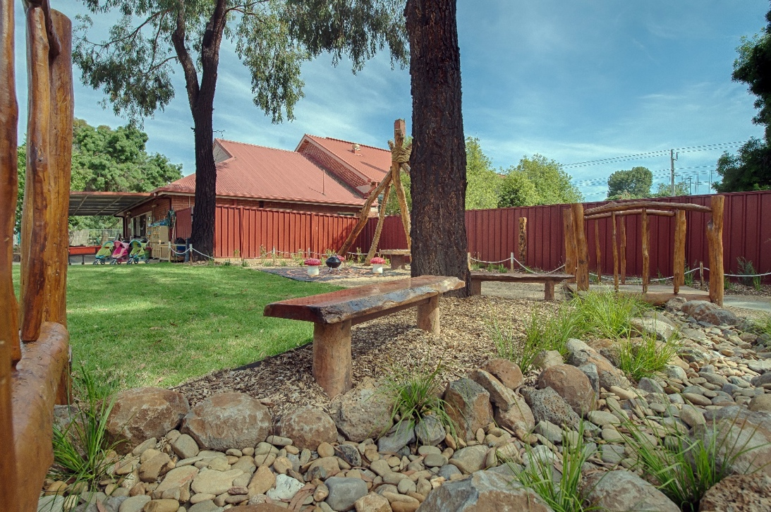

Summary of Minor grants available in the Children’s Facilities Capital Program 2017-18 grant round:
Grant Type | Max. Grant | Purpose of Grant | Eligible Organisations | Ineligible Organisations
Minor Infrastructure Expansion | $25,000 | This grant is a contribution towards the cost of a small refurbishment project designed to increase the usable space of a licensed service. | - local governments  - not-for-profit community organisations offering a funded kindergarten program  - early years management organisations  - government schools offering a funded kindergarten program  - services that applied for grants as part of the 2016-17 Children’s Facilities Capital Program but were not successful are eligible to apply in 2017-18. | - organisations not registered as a not-for-profit with the Australian Charities and Not for Profits Commission with exception provided for Local Government Authorities  - non-government schools service providers are eligible for major grants, but not minor grants  - services that received grants as part of the 2016-17 Children’s Facilities Capital Program are not eligible to apply in 2017-18.
Minor Infrastructure Refurbishment | $10,000 | This grant is a contribution towards the cost of a small refurbishment project designed to enhance education and care for children attending a funded kindergarten program. The grant can be used to improve any indoor or outdoor spaces used by children during the program, including bathrooms, particularly where they are designed to improve access for children of all abilities.  The grant can be used by facilities that are on the Department’s ‘Bushfire At-Risk’ Register to make bushfire preparations such as the installation of gutter guards.
Minor Infrastructure Information Technology | $1,500 | This grant is a contribution to the cost of the purchase of desktops, laptops, tablets, and televisions for services for administrative use or for use as part of the learning program. | - not for profit community-based stand-alone kindergartens  - early years management organisations. | In addition to all ineligible organisations mentioned above in Minor Infrastructure Expansion and Refurbishment grants section:  - local governments  - government schools offering a funded kindergarten program  - non-standalone non-profit delivering funded kindergarten programs (i.e. service providers offering long-day care).

2. Minor Infrastructure Expansion Grants

Purpose of grant
This grant is a contribution towards the cost of a small refurbishment project that will increase the capacity of a licensed children’s service.
It is acknowledged that the scope for older facilities to be expanded in a cost-effective way will vary and that this will not be practical in all cases. Interested organisations are encouraged to seek advice from their regional Quality, Assessment and Regulation Division (QARD) officers regarding proposed changes to increase licensed capacity.

Funding available and project completion
Eligible organisations can apply for up to $25,000 (ex GST) per Minor Infrastructure Expansion Grant. There is no mandatory co-contribution.
Projects funded through Minor Infrastructure Grants will be expected to be completed within six months of the funding being received (unless otherwise agreed with the Department for projects of greater scope and complexity).

Eligible organisations
Organisations eligible to apply for a Minor Infrastructure Expansion Grant:
- local government
- not-for-profit community organisations offering a funded kindergarten program
- early years management organisations
- Government schools offering a funded kindergarten program.
If the applicant is not the building owner it is mandatory that they have written evidence of permission from the building owner to undertake the proposed works.

Ineligible organisations
Organisations ineligible to apply for a Minor Infrastructure Expansion Grant:
- Organisations not registered as a not-for-profit with the Australian Charities and Not for Profits Commission with exception provided for Local Government Authorities.
- Non-government schools service providers are eligible for Major Grants, but not Minor grants.

Assessment Criteria
Applications for a Minor Infrastructure Expansion Grant will be required to demonstrate that the project will increase the licensed capacity of the service and that demand exists to fill the additional licensed places that will be created.
Applicants will be required to provide sufficient details of the proposed works (e.g. plans, photographs, descriptions) for review by QARD staff to ensure consistency with requirements for usable space set out in the National Law and National Regulations, noting that the actual variation of the license to increase capacity can only occur once works are complete. Where required, QARD staff may contact an applicant to seek further clarification of the proposed works.
Where a grant is provided it is required that the service will accept enrolments up to the new licensed capacity.
Priority will be given to applicants in areas with identified infrastructure suitability and capacity constraints for accommodating the new educator to child ratios and/or in areas with high levels of disadvantage and vulnerable populations. Priority will also be given to strong applications that were not successful in receiving Children’s Facilities Capital Program funding last year.

Services that received a Minor Infrastructure Expansion Grant in the 2016-17 round are ineligible to apply for a Minor Infrastructure Expansion Grant in the 2017-18 round. Note that applicants that received a grant in 2016-17 for a service are eligible to apply for the same grant category for other services.

Application process
The application form for Minor Infrastructure Expansion Grants is available at:
www.education.vic.gov.au/ecsmanagement/capitalprogram

The form requires information about:
- how the project will increase the usable space of the service to assist in meeting the new educator-to-child ratio changes
- quotes or detailed cost estimates on proposed work.

3. Minor Infrastructure Refurbishment Grants

Purpose of Grant
This grant is a contribution towards the cost of a small refurbishment project designed to enhance the quality of education and care for children attending a funded kindergarten program. The grant can be used to improve any indoor and/or outdoor spaces used by children during the program, particularly where they are designed to improve access for children of all abilities.
This grant cannot be used for routine maintenance works, cosmetic upgrades, staff offices or other areas not used as part of the delivery of the program or for the purchase of consumables.
The grant can be used by facilities that are on the Department’s ‘Bushfire At-Risk Register’ to make bushfire preparations, such as the installation of gutter guards.

Funding available and project completion
Organisations can apply for up to $10,000 (ex GST) per Minor Infrastructure Refurbishment Grant. There is no mandatory co-contribution.
Projects funded through Minor Infrastructure Refurbishment Grants should be completed within six months of the funding being received.

Eligible organisations
Organisations eligible to apply for a Minor Infrastructure Refurbishment Grant:
- local government
- not-for-profit community organisations offering a funded kindergarten program
- early years management organisations
- government schools offering a funded kindergarten program.
If the applicant is not the building owner it is mandatory that they have written evidence of permission from the building owner to undertake the proposed works.
Funding cannot be applied to services operated by or on non-government school sites.

Ineligible organisations
Organisations ineligible to apply for a Minor Infrastructure Refurbishment Grant:
- Organisations not registered as a not-for-profit with the Australian Charities and Not for Profits Commission, with exception provided for Local Government Authorities.
- Non-government schools service providers are eligible for Major Grants, but not Minor grants.

Assessment Criteria
Applications for a Minor Infrastructure Grant will be required to demonstrate that the project will contribute to improving the indoor and/or outdoor space used by the children.
Priority will be given to:
- Services located in areas with high levels of disadvantage and vulnerable populations (as indicated by Socio-Economic Indexes for Areas (SEIFA) data)
- Services with higher numbers of children under 5 years old (as indicated in Australian Early Development Census (AEDC) data)
- Grant applications that seek improvements to access for children of all abilities.
Priority will also be given to strong applications that were not successful in receiving Children’s Facilities Capital Program funding last year. Consideration will be given to the geographic distribution of grants, with an objective to ensure all metropolitan, regional and rural areas have equal access.
Services that received a Minor Infrastructure Refurbishment Grant in the 2016-17 round are ineligible to apply for the Grant in the 2017-18 round, and services that received the Grant in 2015-16 will be prioritised below other applicants. Note that applicants that received a grant in 2016-17 for a service are eligible to apply for the same grant category for other services.

Application process
The application form for Minor Infrastructure Refurbishment Grants is available at:
www.education.vic.gov.au/ecsmanagement/capitalprogram
The form requires information about:
- how the project will support services to improve the indoor and outdoor areas used by the children
- quotes or detailed cost estimates on proposed work.

4. Information Technology Grants

Purpose of Grant
This grant is a contribution to the cost of the purchase of desktops, laptops, tablets, and televisions for services for administrative use or for use as part of the learning program. If an applicant is successful in receiving an Information Technology Grant, accessories that enable support of the major purchase will be accepted, this includes items such as wall brackets for smart TVs.

Funding Available
Organisations can apply for up to $1,500 (ex GST) per Information Technology Grant.

Eligible Organisations
Organisations eligible to apply for an Information Technology Grant:
- community-based, stand-alone kindergartens
- early years management organisations.
Funding cannot be applied to services operated by schools and/or on non-government school sites.
Note: when a kindergarten service is operated by an early years management organisation, the management organisation must be the applicant.

Ineligible organisations
Organisations ineligible to apply for a Minor Information Technology Grant:
- local governments
- government schools offering a funded kindergarten program
- non-government schools service providers
- non-standalone non-profit delivering funded kindergarten programs (i.e. services providers offering long-day care)
- organisations not registered as a not-for-profit with the Australian Charities and Not for Profits Commission.

Assessment Criteria
Applications will require a brief statement that specifies the need for new information technology hardware.
Applicants are able to apply for both an Information Technology Grant and one of either a Minor Infrastructure Expansion Grant or a Minor Infrastructure Refurbishment Grant. Priority will be given to services located in areas with high levels of disadvantage and vulnerable populations, and those with higher numbers of children under 5 years old (as indicated in AEDC and SEIFA data). Consideration will also be given to the geographic distribution of grants, with an objective to ensure all metropolitan, regional and rural areas have equal access.
Services that received a Minor Information Technology Grant in the 2016-17 round are ineligible to apply for the Grant in the 2017-18 round, and services that received the Grant in 2015-16 will be prioritised below other applicants. Note: applicants that received a grant in 2016-17 for a service are eligible to apply for the same grant category for other services.

Application process
The application form for Information Technology Grants is available at:
www.education.vic.gov.au/ecsmanagement/capitalprogram

The form requires information about:
- the need for new digital hardware
- quotes or cost estimates on proposed purchases.

5. Further Information

General Enquiries
For general enquiries regarding all grant categories under the Children’s Facilities Capital Program 2017-18 grants round, email: childrens.capital.program@edumail.vic.gov.au or phone: (03) 9651 3399.
For assistance with any technical difficulties with the online application form, please contact Smarty Grants Support Desk: service@smartygrants.com.au or call (03) 9320 6888. This service is available Monday to Friday from 9am to 5pm.

Announcement and acknowledgementS
The Minister for Families and Children or a nominated representative will announce the successful grant applicants.
All communications in relation to the promotion of projects receiving a grant under the Children’s Facilities Capital Program must cite the Victorian Government contribution.

Financial check and project acquittal
The annual Service Agreement Compliance Certification (the financial requirements submitted by all Government funded service providers to the Department of Health and Human Services), will be checked by DET on submission of a Minor Grant application.
An acquittal form will need to be submitted on completion of the project.

