Professional Learning Resources : Victorian Early Years Learning and Development Framework

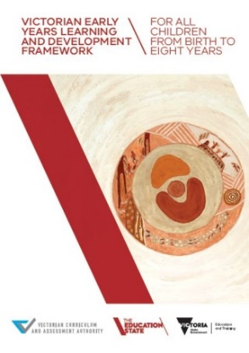
Early childhood professionals, early childhood services, registered training organisations and universities are encouraged to obtain a copy of the framework.
Hard copies of the revised VEYLDF have been distributed to all services that work with children from birth to 8 years. Additional copies can be requested online at:
www.education.vic.gov.au/childhood/providers/edcare/Pages/veyladf.aspx

Online copies of the VEYLDF, appendices and illustrative maps can be downloaded at:
www.vcaa.vic.edu.au/Pages/earlyyears/index.aspx

Early Years Alerts

To keep up to date about activities and professional learning resources to support implementation of the VEYLDF, subscribe to the Early Years Alert through the Victorian Curriculum and Assessment Authority’s (VCAA) Early Years website at:
www.vcaa.vic.edu.au/Pages/earlyyears/subscribe.aspx

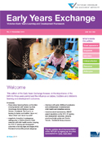
Early Years Exchange (the EYE)

The EYE is a series of online publications designed to assist early childhood professionals to implement and embed the VEYLDF in their practice. Each issue provides a video presentation from early childhood professionals and academics in a range of settings. The EYE is produced by the VCAA and is available at:
www.vcaa.vic.edu.au/Pages/earlyyears/eye/index.aspx

EYE editions and the VEYLDF:
Number | Theme | Number | Theme
1 - 5 | To support getting started with the VEYLDF | 10 | Outcome 3: Wellbeing
6 | High expectations for every child | 11 | Wellbeing and involvement
7 | Family-centred practice | 12 | Transitions
8 | Equity and diversity | 13 | Literacy development
9 | Assessment practice | 14 | Birth to 3 learning

Professional Learning Modules
Four professional learning modules on the VEYLDF are available online:
Module 1: Leading the Way: Reflecting on the Frameworks
Module 2: Working Together: Collaborative Practice Principles
Module 3: Decision Making: Effective Practice Principles
Module 4: Assessment for Learning & Development: The Early Years Planning Cycle
Each module contains short videos, exercises suitable for individual or team use, and supporting materials.
www.education.vic.gov.au/childhood/providers/edcare/Pages/veyldfproflearn.aspx

Practice Principles – Guides, Evidence Papers and Videos

Evidence Papers, Practice Guides and videos are available for each of the eight Practice Principles. The Evidence Papers document key research and describe what each principle is, why it’s important, and its implications for best practice. The Practice Guides provide advice and activities to support using the principles across a variety of settings. Videos on the Practice Principles include footage from a range of ECEC settings that exemplify effective ways for supporting children's learning and development, in line with each Practice Principle. A new video has been developed to assist in visualising the Ecological model.

www.education.vic.gov.au/childhood/providers/edcare/pages/profresource.aspx

High Expectations for Every Child

Babies and Toddlers: Amazing Learners

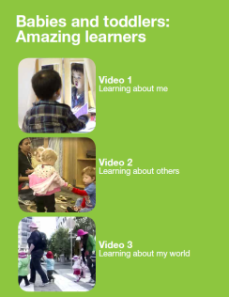
The VCAA, in collaboration with Anne Stonehouse AM and Early Childhood Australia (ECA), has developed a video resource and information booklet highlighting selected examples of significant learning in the birth-to-three-years period. The 3 videos (Learning about me; Learning about others; Learning about my world) and information booklet are available at:
www.vcaa.vic.edu.au/Pages/earlyyears/assesspractice.aspx

Making a Difference for Young, Gifted and Talented Children
This online resource booklet provides early childhood professionals with information and resources to help identify and provide learning for young gifted and talented children (from infancy to eight years old) and their families. The resource is available at: www.education.vic.gov.au/giftedchildren
Equity and Diversity
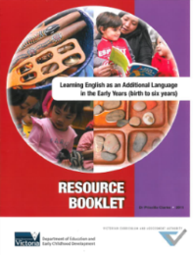

Learning English as an Additional Language

The Learning English as an Additional Language in the Early Years (birth to six years) Resource Booklet provides comprehensive information to support early childhood professionals in their work with young children from culturally and linguistically diverse communities and is linked to the VEYLDF.
www.vcaa.vic.edu.au/Pages/earlyyears/eal.aspx

Assessment for Learning and Development

Assessment practices in the early years

Assessment practices in the early years focuses on children’s learning and development to support implementation of the VEYLDF. Six key themes highlight approaches to assessment for learning and development practice.

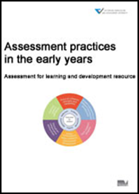
The resource can be used to support individual and group learning overtime. A PowerPoint presentation with background notes is available to download and use in early years’ settings, including at team meetings, induction programs, and continuous improvement discussions:
www.vcaa.vic.edu.au/Pages/earlyyears/assesspractice.aspx
Assessment for Learning Tool

The Assessment for Learning Tool supports the collection of evidence of children's learning and includes key questions to guide thinking about the meaning of children’s learning and reflective practice.

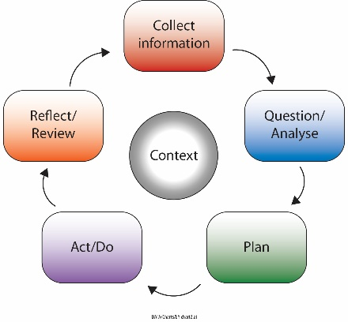
www.vcaa.vic.edu.au/Pages/earlyyears/assesspractice.aspx

Partnerships with Professionals

VCAA Research and Evaluation Reports

Review and Evaluation of the Inquiry to Implementation Project Final Report (Monash University): Drawing on project data and focus group interviews, Monash University provide an account of early childhood professionals’ experiences of inquiry based professional learning in the context of multidisciplinary networks. The Report delivers research findings on key trends in assessment practice and network relationships and engagement. The Report provides case studies from the networks and describes a relational agency framework that can be used to describe practitioner experiences and professional relationships in networks.

Understanding and Supporting Young Writers: Research Report by Dr Noella Mackenzie (Charles Sturt University): An inquiry-based professional learning project conducted in 2015 sought to examine the impact of early childhood educators working with teachers in the early years of school to support early writers, to consider a shared approach to the support of young writers across early childhood and school settings, and what difference this approach makes for children, their families and the early childhood professionals involved.

www.vcaa.vic.edu.au/Pages/earlyyears/evaluation-reports.aspx

Early Years Learning and Development Outcomes

Children have a strong sense of wellbeing

Wellbeing Practice Guide
The resource is designed to inform a greater understanding of wellbeing and its place as both a prerequisite for, and an outcome of learning. The Wellbeing Practice Guide provides scenarios and learning activities to support engagement with key concepts of the VEYLDF, including Learning and Development Outcome: Children have a strong sense of wellbeing.

http://www.vcaa.vic.edu.au/Documents/earlyyears/EYWellbeingPracticeGuide.pdf
The guide links to the Department of Education and Training Respectful Relationships initiatives.
www.education.vic.gov.au/about/programs/health/pages/respectfulrelationships.aspx

Assessment of Wellbeing in Early Childhood Education and Care: Literature Review

A literature review commissioned from the University of Melbourne is available that documents research that underpins and defines Outcome 3 Wellbeing: Children have a strong sense of wellbeing. The Literature Review defines wellbeing in the birth to five year period; identifies six principles for assessing wellbeing in practice; profiles 10 evidence based tools for assessment of children’s wellbeing; and outlines children’s trajectory of wellbeing and the learning environments and responsive interactions that support development of wellbeing.

www.vcaa.vic.edu.au/Documents/earlyyears/EYLiteratureReview.pdf

Children are effective communicators

Becoming a Writer – A Digital Story
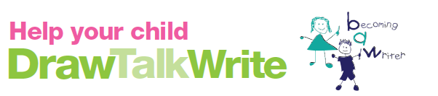

The VCAA, in partnership with Dr Noella Mackenzie (Charles Sturt University), has developed this literacy-based resource to support partnerships with families around children’s learning, and planned and spontaneous opportunities for diverse drawing and writing experiences.

The digital story is available at: www.vcaa.vic.edu.au/Pages/earlyyears/literacyresources.aspx

The Report builds from two previous inquiry research projects (the Assessment for Learning and Development Project, 2012 and the Outcomes Project, 2010-11) and on the recommendations from the independent evaluation of VEYLDF implementation. These reports are available at:
www.vcaa.vic.edu.au/Pages/earlyyears/evaluation-reports.aspx

Transition: A Positive Start to School Initiative
Transition: A Positive Start to School is available through the Department’s website. The guide provides information on:

- the transition to school context and approach
- transition to school programs
- the Transition Learning and Development Statement

www.education.vic.gov.au/childhood/professionals/learning/Pages/transition.aspx
Resources include:
Using the Transition Statement to Inform Curriculum Design
www.education.vic.gov.au/Documents/school/principals/curriculum/transitionstat.pdf
Strength Based Approach: A Guide to Writing Transition Learning and Development Statements
www.education.vic.gov.au/childhood/professionals/learning/Pages/transition.aspx

Supporting Reciprocal Visits

To strengthen transition to school processes for children and families, a series of professional learning sessions and reciprocal visits were delivered across four Victorian sites. Read the reports and watch a 3-minute introduction and videos from each site at:
www.education.vic.gov.au/childhood/professionals/learning/Pages/transtoschoolreciprocalvisits.aspx

Supporting English as an Additional Language (EAL) at transition to school

This resource provides advice and practical examples of how children and families, with English as an Additional Language (EAL), can be supported to make a successful transition to school. It is designed to assist and guide early childhood professionals and teachers in schools.

www.vcaa.vic.edu.au/Pages/resources/eyeal/welcome.aspx#

Other Resources

National Quality Framework

The National Quality Framework (NQF) applies to long day care, family day care, outside school hours care and kindergartens/preschools. These services are governed by the Education and Care Services National Law Act 2010 and the Education and Care Services National Regulations 2011.

More information about the NQF is available at the Australian Children’s Education and Care Quality Authority (ACECQA) website. This website includes links to the legislation; frequently asked questions; resources to support implementation of the National Quality Standard (NQS); and links to approved learning frameworks.
www.acecqa.gov.au

Licensed Children’s Services

The Victorian Children’s Services Act and Regulations continue to apply for services not covered by the NQF. Further information and resources to support children’s services to meet the requirements of this legislation is available online:
www.education.vic.gov.au/childhood/providers/regulation/Pages/vcs.aspx

Belonging, Being and Becoming: The Early Years Learning Framework for Australia
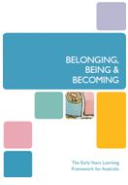

The Belonging, Being and Becoming: The Early Years Learning Framework (EYLF) for Australia, and The Educators’ Guide to the EYLF for Australia are available at:
education.gov.au/early-years-learning-framework

My Time, Our Place: Framework for School Age Care

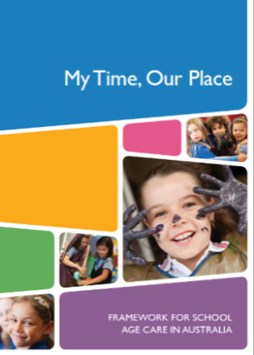
The My Time, Our Place: Framework for School Age Care is designed for use by school age educators working in partnership with children, their families and the community. It is linked to the EYLF and the VEYLDF.
An educators’ guide to the framework is available at:
files.acecqa.gov.au/files/National-Quality-Framework-Resources-Kit/educators_my_time_our_place.pdf

Newsletters for Families

The Department has created a series of newsletters based on the Victorian Early Years and Development Framework (VEYLDF) to assist all early childhood professionals to support families to understand the VEYLDF and how it relates to their child; and gain a deeper understanding of their children’s learning and development.
www.education.vic.gov.au/childhood/professionals/health/Pages/newsletters.aspx

Foundations for Learning: Relationships between the EYLF and the Australian Curriculum
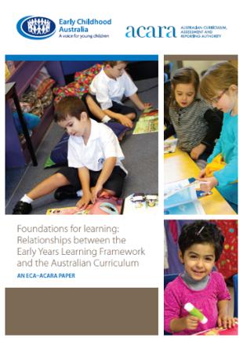
Early Childhood Australia (ECA) in collaboration with the Australian Curriculum, Assessment and Reporting Authority (ACARA) has developed an information paper, Foundations for Learning, which describes the key connections between the Early Years Learning Framework (EYLF) and the Australian Curriculum. It provides a continuum of teaching and learning between the early years’ sector and the first years of school.

www.education.vic.gov.au/childhood/providers/regulation/Pages/nqf.aspx
The National Quality Standard Professional Learning Program

The National Quality Standard Professional Learning Program (NQS PLP) includes a number of resources to support early childhood educators to embed the EYLF in daily practice as a key element of achieving the NQS. Resources include:
- an Interactive online forum
- e-Newsletters on the EYLF and NQS
- ‘Talking about practice’, ‘Observing practice’ and ‘Have you thought about…?’ videos
- Connecting with practice – EYLF and NQS practice and training videos
- ‘What do you think?’ Free articles by Anne Stonehouse
Resources are available at: www.earlychildhoodaustralia.org.au/nqsplp/

