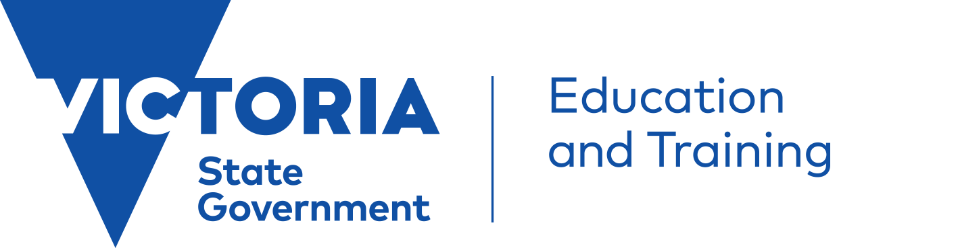 | Engaging with the VEYLDF Practice Principle Video  Partnership with Professionals
This resource has been developed to be used alongside the Victorian Early Years Learning and Development Framework (VEYLDF) video on Partnerships with Professionals available at: http://www.education.vic.gov.au/childhood/providers/edcare/Pages/profresource.aspx
It includes questions and discussion starters to stimulate thinking and critical reflection processes for the purpose of deepening your understanding of how best to promote learning and development for all children from birth to eight years. You can work through this resource, on your own or with colleagues.
Introduction:
The video on Partnerships for Professionals complements existing VEYLDF resources and helps demonstrate best practice for Early Childhood Professionals.
Partnerships with Professionals
‘Early childhood professionals are from diverse professional backgrounds. They use multi-disciplinary approaches to provide better support to families and draw on the skills and expertise of their peers. Early childhood professionals:
- Work collaboratively to share information and plan to ensure holistic approaches to children’s learning and development
- Understand each other’s practice, skills and expertise, and make referrals when appropriate
- Acknowledge the significance of transitions within and across early childhood services and schools, and ensure that children understand the process and have an active role in preparing for these transitions
- Build on children’s prior learning and experiences to build continuity for their learning and development from birth to eight years of age’. (VEYLDF, 2009, p.10)

How to use this resource
- Watch the video on your own or with colleagues.
- After watching the video, use some of the key questions or actions below to critically reflect on your own practice.
- Use a copy of the Partnerships with Professionals Practice Principle Guide to inform your discussions.
- Record your collective or individual thoughts, ideas and responses as evidence of your commitment to continuous improvement.
What is critical reflection?
(Critical) Reflection is more than thinking and discussing - it is also about deconstructing, unpacking or pulling things apart to gain better understanding, seeing connections and appreciating different perspectives (Kennedy, Stonehouse, 2012 p. 3).
Beginning critical reflection about Partnerships with Professionals
- Think about your local community. List the early childhood professionals in your community with whom you could potentially collaborate to promote children’s learning and wellbeing? What steps can you take to build connections with these people?
- Think about your local context. What professional services and human resources are available for you to utilise to share information and to support children’s learning and wellbeing?
- Can you think of examples when you share information and collaborate with other professionals to support a child’s or family’s wellbeing? How regularly?
- Why do you think partnerships with other professionals are important? How does collaboration benefit children and their families?
- Do you need family consent to share information with other professionals? What do you know about Victorian privacy laws? (See links below).

Extending critical reflection about Partnerships with Professionals
- How does collaboration with other professionals support you to build relationships with every child at your service?
- Do your leadership and governance structures support collaborative partnerships with professionals? Does your service/organisation have referral policies, practices and procedures?
- Do you think of transition to another environment as an event or a process?
- Make a list of the possible professionals you could liaise with to support children through transitions?
- How do you orientate children and families to your service? Transitioning to another service? Could this process be improved?
- The United Nations Conventions on the rights of the Child (1989) advances an image of children as subjects of rights and full members of society, capable of participating in their social worlds through their relationships with others. VEYLDF - (DEECD, 2011, p. 52.)
What are the rights of children and families during transitions?
What can professionals do to support the rights of children and their families during transitions?
- What kind of training or professional learning would you design to develop a shared capacity to promote every child’s learning and wellbeing with and between professionals and services? Do you feel safe to comment on collaboration within your service and with other professionals?

Deepening critical reflection about Partnerships with Professionals
- In the video, Anne Stonehouse asks the question, “What does collaboration mean for you as a professional”? What is a professional network? Are you a member of a professional network? If not, what can you do to develop a professional network?
- How do you challenge professional practices that you feel are unfair, unequitable and that are not inclusive? How can you develop opportunities to learn from each other? In the video, one speaker stated, ‘we’re an outward looking school, looking for opportunities to work with partners, not gain from partners – that’s a very fundamental difference”. What do you think of this statement?
- Are individual plans for all children developed in collaboration with other professionals? Do these plans ensure that children’s environments and daily routines are reflected upon, in consultation with families, professionals, staff members or educators? If not, what can you do to invite other professionals to assist in their development? If you do consult with other professionals, are there any ways that shared goals could be developed more effectively?
- Is it the role of the leaders in the organisation to develop relationships with other professionals or is this a shared responsibility? What are some of the barriers to establishing and building partnerships with professionals?
- Do your relationships with other professionals result in an environment where issues relating to quality, equity, ethics and children’s wellbeing can be raised and debated? Think about how professionals could work together toward shared goals that support children’s learning and development.

Links to the National Quality Standard: Quality Area 6. Elements 6.3.1, 6.3.2, 6.3.3, 6.4.4
Glossary
These keywords should be discussed with colleagues to establish shared understandings.
Partnerships - Partnerships are based on the foundations on understanding each other’s expectations and
attitudes, and build on the strength of each other’s knowledge. EYLF(DEEWR, 2009, p.12)

Inclusion and Inclusive practices – involves taking into account all children’s social, cultural and linguistic diversity(including learning styles, abilities, disabilities, gender, family circumstances and geographic location) in curriculum decision making processes. EYLF (DEEWR, 2009 p.45)

Transitions - the process of moving between home and childhood setting, between a range of different early childhood settings, or from childhood setting to full-time school. EYLF(DEEWR, 2009 p.46)

Other words, ideas or concepts that could be discussed and defined are: Collaboration, Engagement and Shared responsibility

Map to Video
Department of Education Victoria (home page), Early Childhood, For Service Providers, Education and Care, Victorian Early Years Learning and Development Framework, Resources for Professionals, Video resources.
Useful links
- Victorian Legislation and Parliamentary Documents: http://www.legislation.vic.gov.au
- Department of Education and Training Victoria Privacy Policy: http://www.education.vic.gov.au/Pages/privacypolicy
- Commissioner for Privacy and Data Protection: https://www.cpdp.vic.gov.au/

Suggested additional resources

Kennedy, A. Stonehouse, A. (2012) Victorian Early Years Learning and Development Framework. Practice Principle Guide. 2. Partnerships with Professionals. Department of Education and Early Childhood Development.
http://www.education.vic.gov.au/Documents/childhood/providers/edcare/practiceguide2.PDF

Transition: A Positive Start to School Resource Kit
http://www.education.vic.gov.au/childhood/professionals/learning/Pages/transkit.aspx
References

Department of Education and Early Childhood Development (DEECD) (2011), Victorian Early Years Learning and Development Framework: For all Children from Birth to Eight Years. Published by Early Childhood Strategy Division, DEECD and Victorian Curriculum and Assessment Authority.

Department of Education and Workplace Relations, 2009, Belonging, Being and Becoming: The Early Years Learning Framework for Australia, Commonwealth of Australia.

Kennedy, A. Stonehouse, A. (2012) Victorian Early Years Learning and Development Framework. Practice Principle Guide. 8. Reflective Practice. Department of Education and Early Childhood Development.

Victorian Early Years Learning and Development Framework (2009) Department of Education and Early Childhood Development.

