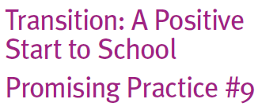

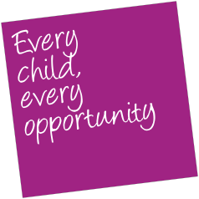

What are social story boards?

A social story board is a short story made about an individual child starting school. They provide one way of giving that child repeated opportunities to think about, and to talk to others about, starting school.
In addition, the stories can explain the sequence of events or routines that school involves, and provide visual cues about
the new school environment. They have been used extensively with children with disabilities or developmental delays but are appropriate for any child. They help children manage change by understanding appropriate behaviours and social situations, such as starting school.
Some stories may also contain information about the child, their family and early childhood experiences leading up to going to school.
Formats for these stories vary, but are frequently hand-made books or electronic documents (such as PowerPoint documents with photos or other images and sounds) that provide a reference point for the
child about who they are now and their upcoming new role of going to school (in words and pictures). For instance, they may contain pictures about their experiences at kindergarten, drawings made about what school looks like, photos of children in school uniform and information about the Prep teacher or school.
How can these be put into practice?

To explain the sequence of events or routines that school involves accurately, it is worthwhile liaising with the school the child is enrolled in to make sure the information is correct.
This can be something families assist with as it can help them understand how the school operates and what their child is like to be involved in. Alternatively, the stories can be more general so they are appropriate for any school environment.
These stories seem to work particularly well if co-constructed with the child, to give them individual meaning and relevance.
A useful reference on ‘What is a social story?’ (and how to make them) can be found at

www.cheri.com.au/PDF_Files/professionals/Whatisasocialstory.pdf

Stories can be read with or by the child, alongside family members, friends and early childhood educators. They are often constructed during the Term 4 transition activities, and the stories can be read over the summer holidays, sparking excitement about starting school.
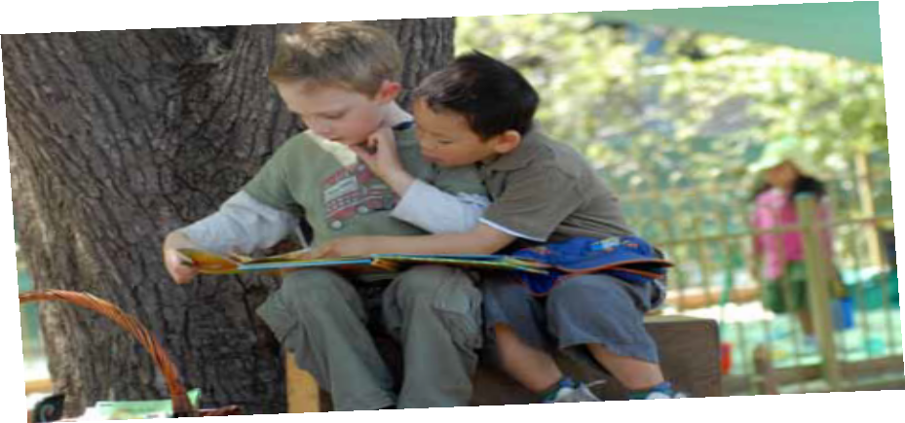
Once the child is at school, the stories can still serve a purpose in helping children get to know their classmates. For teachers, they are another means of building positive relationships with the child and family by asking them to share the story.

