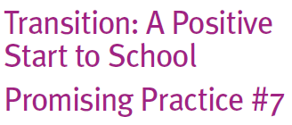
ransition: A Positive
Start to School
Promising Practice #7

What are family involvement activities?

Family involvement activities refer to
those things that promote the engagement of families with early childhood services, outside school hours care services and schools.
Meeting the needs of families can be a challenge for busy services and schools. However, quality transition programs consider how best to engage with local families. There is no one way of doing this.
How can these be put into practice?

Finding out what families’ experiences of recent transition programs is a common stage in developing a more responsive transition program. To do this, local networks can use
a range of different methods from simple surveys, focus group interviews and co-opting family representatives into network committees to act as advocates. The data generated from these lines of enquiry is then analysed to provide an evidence-base to support community decision-making and program planning.
When planning family involvement activities, it will be important to consider:

• offering transition activities over a period of time, and at different times of the day
provides families with choices of when they can be involved

• providing child care arrangements during information sessions

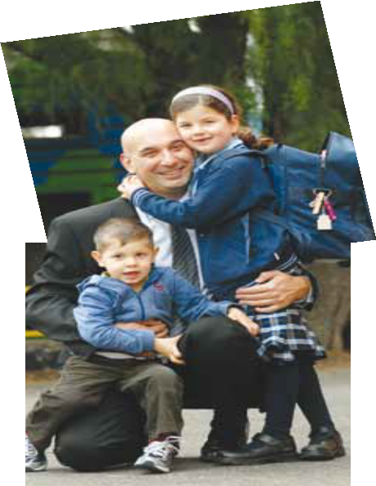
• providing information in a range of formats (such as CDs/DVDs, pictorial information, translated materials), use local radio and print media, as well as word-of-mouth from other families in the community
• providing information about the available transition programs to families in accessible places (such as local shopping centres, Centre Link offices, General Practitioners/ Medical Centres, Local Government Offices, etc)
Some activities that can help promote family involvement in services may include:

• cultural fun days on weekends

• evening welcome BBQs or breakfasts

• open sessions at school or early childhood services

• inviting families from early childhood services to school performances
throughout the year

• offer volunteering options for reading programs, school councils, parent groups, etc.

