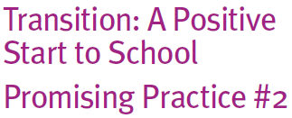

What are reciprocal visits for educators?

Providing opportunities for staff from early childhood services and schools to visit each other can be a powerful way of deepening professional understanding of early childhood and school-based learning environments and practices.
Reciprocal visits for educators may include:

• physical visits by school staff to early
childhood services
- physical visits by early childhood service staff to schools.
How can these be put into practice?

When planning a visit to another service, it may be useful to consider incorporating some of the following activities:

• observing and interacting with the children in different contexts and environments

• discussing professional transition experiences with staff from other services

• talking with staff about different ways of working with children in general (such as
ways to listen to children and assisting them manage their own behaviour)

• sharing program planning ideas and strategies

• working with staff from another setting to critically reflect on the
successes of transition programs, practices and systems

• establishing informal or formal mentoring arrangements with staff from other
settings

• discussing the set up of the physical environment and program
planning arrangements.

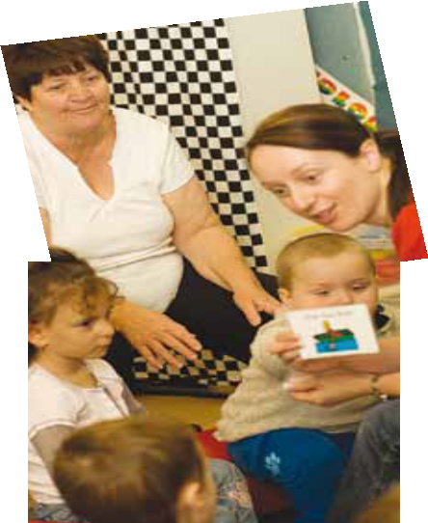
Professional release time to participate in reciprocal visits is best managed using well-planned local transition timetables, negotiated between local schools and early childhood settings (For more information see Transition: A Positive Start to School – Promising Practice #10.) This allows for the needs of each educator and service/school to be considered and supported.
For those educating a child with a disability or developmental delay, it has been useful to connect with early childhood intervention services to better understand the child’s and family’s other experiences and develop a stronger, all-round support network.

