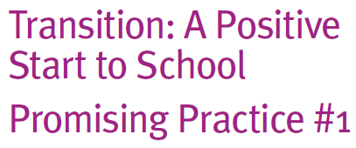

Start to School

Promising Practice #1

Reciprocal visits for chil

What are reciprocal visits for children?

Reciprocal visits include:

• Visits to schools by children, commonly known to as orientation programs. These programs are designed to help children and their families become familiar with the school environment. Taking groups of children from early childhood settings to

school allows opportunities for children to experience the new environment with the support of familiar peers and adults, and reduces their anxiety and stress about new environments.

• Visits to early childhood services by children currently enrolled in school. These programs allow children currently attending school to talk about what

school is like and can form part of a buddy program (see Promising Practice #6). These programs can also provide children with an opportunity to reconnect with people they have known if they have attended an early childhood service.

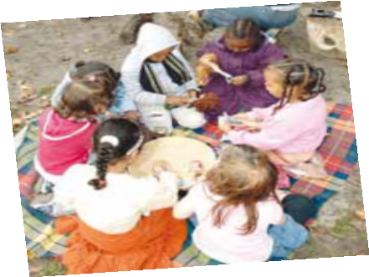

How can these be put into practice?

Visits to schools are most commonly undertaken through off-site excursions where children and families are taken to see one or many local schools environments (even for those children not yet enrolled in a specific school).

Activities are planned to allow time for children to interact with school children and school staff such as the Prep teacher. These interactions may include:

• shared story-time

• prep children taking tours around the school, explaining where important features of the school are located (such as the Prep classrooms, drink taps, toilets, library, art rooms and the playground)

• meeting with the Principal and other key school staff at the school (e.g. school nurse).

The requirements of regulation 73 and 74 of the Children’s Services Regulations 2009 must be met. The service must conduct a risk assessment to determine whether there is adequate adult supervision for the visit to the school. Changes in child/staff ratios through additional adults may be required dependent on what is proposed. The arrangements will depend on whether all the children from the early childhood service are going to the school or only some of the children, the mode of travel and the distance between the service and the school. For further information please visit:

[**www.education.vic.gov.au/ecsmanagement/licensedchildservices/review.htm**](http://www.education.vic.gov.au/ecsmanagement/licensedchildservices/review.htm)

Parents must give authorisation for the child to take part in the excursion or routine outing

(r. 73(1)) and be advised of the details of the excursion or routine outing (r. 73(2)).

Visits by school children back to early childhood services are also undertaken through off- site excursions. Activities are planned to allow school children to share their early school experiences both with early childhood service staff and other children, and may include:

• shared story-time

• presentations by children about what school is like

• pretend-play activities around school (e.g. dress up corner)

• group discussion activities about school which give children the time to ask and respond

to any questions they may have.

Each individual service should ensure that the arrangements made do not compromise the health, safety or well being of the children at the service. Where school children are just visiting the service, they are not required to be considered as part of the child/staff ratio as they will be accompanied by a teacher from their school.