What does a diagnosis of

hearing loss mean?

A small number of babies are born with a hearing loss,
which means they are unable to detect sounds in the
same way as other children. Hearing loss can occur if there is interruption to the passage of sound anywhere along the hearing pathway.1
Hearing tests usually involve taking specific measurements that provide information about the type and degree of loss. Results are usually displayed on a graph called an audiogram. These results are used to determine the appropriate next step for each child.
Hearing loss is described by where the source of the hearing loss is, and it will also be described as mild, moderate, severe or profound. Regardless of the label given to your child’s hearing loss, it’s important to remember that each hearing loss is unique.2

What types of hearing tests are used with babies?

Behavioural tests
Behavioural tests are based on causing or observing a change in behaviour
in response to sound. They include behavioural observation audiometry (BOA), visual reinforcement audiometry (VRA) and play audiometry. Behavioural testing involves the baby or child responding to sound, for example by turning the head.

Objective tests
These tests measure the physical response of a specific part of the auditory system and require little or no cooperation from the child.
They include the auditory brainstem response (ABR) test, otoacoustic mission (OAE) and auditory steady state response (ASSR). Tympanometry is another objective test which gives information about the function of the middle ear.

What is a hearing aid?
Hearing aids are devices that amplify sounds to make them more audible to a person with a hearing loss. They do not cure the hearing loss but are helpful to many users.

What is a cochlear implant?
Sometimes called a bionic ear, a cochlear implant is a hearing device designed to produce useful hearing sensations by stimulating nerves inside the inner ear electrically. It is surgically implanted and suitable for people with severe or profound hearing impairments.

What are the different types of hearing losses?
Hearing losses may be sensorineural, conductive or mixed. In order to understand what they mean, it is important to know that the ear is made up of three parts: the outer ear, the middle ear and the inner ear. Each of these parts plays a different role in hearing.

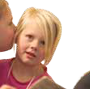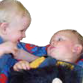

What does a diagnosis of hearing loss mean?

Understanding the ear

Outer ear
Air around us carries sound through sound waves. The outer ear collects these sound waves and sends them along the ear canal.

Middle ear
At the end of the ear canal is the ear drum which bounces or vibrates, just like when you hit a real musical drum. Sound waves pass from the ear drum onto the three tiny ear bones in the middle ear called the hammer, the anvil and the stirrup (because that’s what they look like). They are the smallest bones in your body. When these bones vibrate and move, they transport the sound waves into the inner ear.3

Inner ear
The inner ear contains the cochlea, the hearing organ which is spiral-shaped and looks like a snail’s shell. It is filled with fluid and thousands of tiny sensory hair cells. These sensory hair cells convert all the sound vibrations which are passed from the middle ear into electrical signals which travel up the nerves of the auditory pathway to the brain for processing.

Types of hearing loss

Conductive hearing loss
An interruption to the passage of sound in the outer or middle ear affects the way sound is carried or conducted through to the inner ear and the rest of the auditory system. This can be caused by such things as fluid in the middle ear (‘glue ear’) or a build-up of wax in the outer ear canal. A hearing loss in this part of the system can often be helped medically or surgically. Hearing loss
is usually not severe and usually not permanent.

Sensorineural hearing loss
If the outer and middle ear are working effectively, the cause of the hearing loss is likely to be somewhere in the inner ear. Sensorineural deafness, sometimes called nerve deafness, usually means that the cochlea is not working effectively. The cochlea is the part of the auditory system that creates electrical signals and sends them along the auditory nerve to the brain. This type of hearing loss usually means that a hearing aid (or occasionally a cochlear implant) is required. A sensorineural hearing loss is most likely to be permanent, meaning that the diagnosis is unlikely to change.

Mixed hearing loss
Sometimes children have a sensorineural loss and a conductive loss at the same time. This is called a mixed hearing loss.4

Unilateral hearing loss
This occurs when one ear has normal hearing and the other has a hearing loss, which can create an imbalance in hearing. The child may have difficulty locating sounds and voices and will experience problems distinguishing softly spoken speech from background noise, especially when the speech is
coming from the side with a hearing loss.

A hearing aid is sometimes recommended for unilateral hearing loss. Ongoing audiology monitoring is especially important for the ear with normal hearing, as some children with hearing loss in one ear are at risk of developing a hearing loss in the other ear.

Fluctuating hearing loss
Children who have ear infections (called otitis media) and fluid build-up in their ears may frequently experience varying degrees of hearing loss. Even though the hearing loss is temporary, the child can still develop speech, language
and cognitive problems associated with permanent hearing loss. The child may hear to a degree but miss fragments of spoken information. A child with a sensorineural hearing loss
can also have a fluctuating hearing loss overlaying their permanent hearing loss.5

Auditory Neuropathy Spectrum Disorder
Auditory neuropathy spectrum disorder is a collection of findings suggesting sound enters the inner ear (cochlea) normally but the
transmission of signals from the inner ear to the brain is impaired. People with auditory neuropathy spectrum disorder may have normal hearing,
or hearing loss ranging from mild to severe; the majority have poor speech- perception abilities, meaning they have trouble understanding speech clearly. Often, speech perception is worse than would be predicted by the degree of hearing loss. For example,
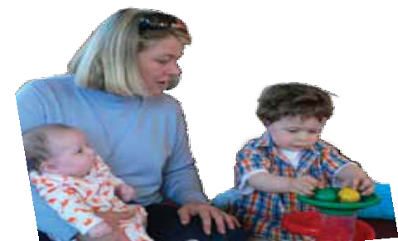a person with auditory neuropathy spectrum disorder may be able to hear sounds, but still have difficulty recognizing spoken words.

What do the different levels of hearing loss mean?
There are different degrees or levels of hearing loss. These are measured in decibels (dB) relating to level or loudness or volume and hertz (Hz)
relating to pitch or frequency of speech sounds.
The different levels of hearing loss are as follows.

Mild hearing loss (20–40dB)
A child with mild hearing loss may hear speech, but only fragments. Short words, word endings, and indistinct word sounds will tend to drop out and not be heard. Background noise in classrooms and other environments will make it even harder to hear. Hearing aids may be recommended.

Moderate hearing loss (41–60dB)
A child with moderate hearing loss may miss over 50 per cent of speech and even more with increased background noise. If the child is not fitted with hearing aids the result often is that vocabulary may be very limited and pronunciation unclear. The child may also have a ‘flat’ voice quality with little inflection because of an inability to monitor his or her own voice.

Severe hearing loss (61–90dB)
A child with this degree of hearing loss will not hear most speech sounds.
In addition speaking skills may not develop without sounds being amplified with hearing aids and the child having speech and language therapy.

Profound hearing loss (91dB and above)
A child with profound hearing loss will almost never hear sounds (especially speech). Speech is unlikely to develop without the use of hearing aids or cochlear implants.

High frequency hearing loss (1500 Hz–8000 Hz)
The child will have hearing loss mainly with high frequency sounds and will be unable to hear consonant sounds consistently. Significant portions of important spoken information may
be lost and high levels of background noise will make it harder to hear.

If the term deaf is used, does that mean my baby cannot hear any sounds?
It is very unlikely that your baby will not be able to hear any sounds at all. The term deaf is used to refer to all types and levels of hearing loss. Other terms used commonly include hearing impaired and hard of hearing.
If you are unsure about your baby’s hearing loss ask your audiologist. He or she can explain the results of your baby’s hearing tests and tell you which sounds your baby can hear and which ones may be difficult to hear.6

Will hearing aids help my baby?
Hearing aids and cochlear implants will help most babies to hear a variety of sounds. Hearing aids do not restore hearing. There are many factors that can affect your baby’s progress. You will be able to discuss your baby’s individual situation with
your audiologist and early intervention worker.
The wearing of two hearing aids is usually recommended in order to give the child balanced hearing and increase the likelihood of hearing more sounds in noisy places.
Children and adolescents up to the age of 21 years who are Australian citizens or permanent residents are eligible for government-funded hearing services from Australian Hearing. Hearing aids are provided free of charge, except for a small annual maintenance fee.
- Australian Hearing, 2005, Choices, Chatswood, NSW.
- Siemens Hearing Instruments, Hearing makes friends: Audiological guide.
- Deaf Education Aotearoa New Zealand and National Audiology Centre, 2004, Getting started: Kei te timata (www.deafed.co.nz/ family book or www.tki.org.nz/specialed/pdf/ familybook.pdf).
- ibid.
- Siemens Hearing Instruments, Hearing makes friends: Audiological guide.
- The National Deaf Children’s Society, 2002, Your baby has a hearing loss, London.
© State of Victoria, 2010
Authorised by the Department of Education and Early Childhood Development

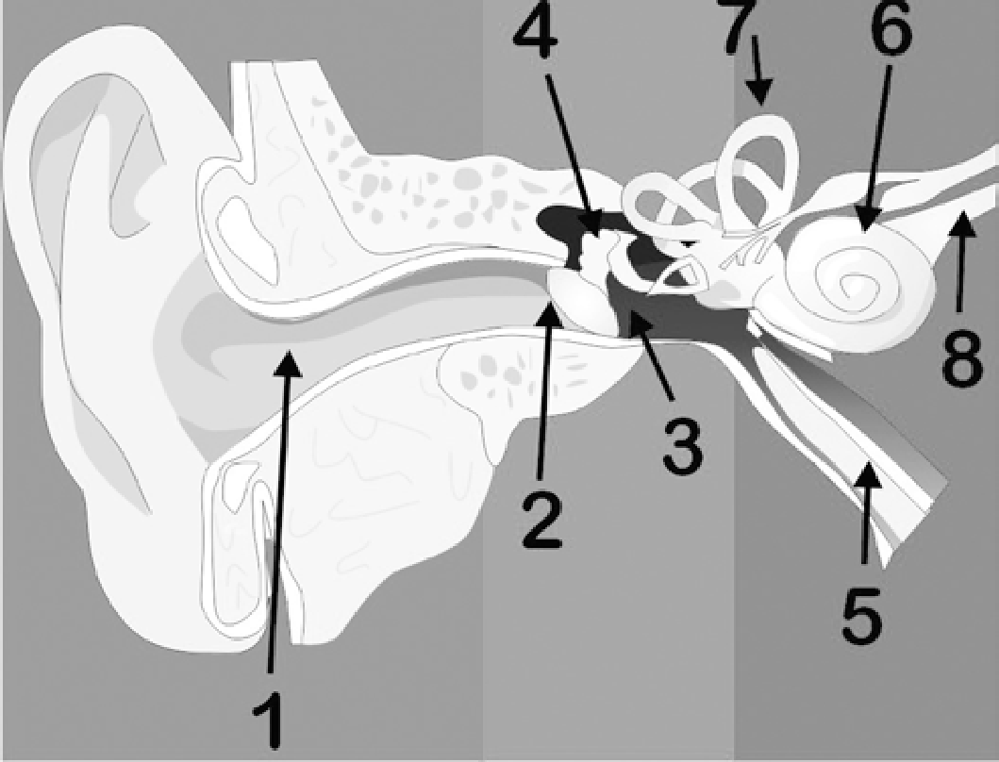1. Ear canal 2: Ear drum 3: Middle ear cavity 4. Middle ear bones 5: Eustachian tube 6: Cochlea 7. Semicircular canals 8: Auditory nerve
Source: Deaf Education Aotearoa New Zealand and the National Audiology Centre, Getting Started: Kei te timata, 2004.

