Early diagnosis of hearing loss – why now and what’s next?

Early diagnosis of hearing loss is important. Current research has shown that babies who are diagnosed early and who start wearing hearing aids and attending early intervention services by six months of age may develop language and communication that is similar to children with normal hearing by the time they start school. The main
goal of early identification of hearing loss is to give your baby access to communication. The advantage of being tested so early is that your baby can get hearing aids, start listening as soon as possible and learn to make
the most of hearing, or your family can begin learning and using AUSLAN (sign language) with your baby.

What does a diagnosis of hearing loss mean?
Most babies with a hearing loss are born into families with no experience or history of it. There are many possible reasons for a baby having a hearing loss. Sensorineural hearing loss (sometimes called nerve deafness)
has a range of causes including genetic factors, complications at birth, premature birth, infections such as rubella during the mother’s pregnancy and childhood illnesses such as mumps, measles or meningitis.
It is not always possible to discover the cause of hearing loss. If you would like further information about causes of hearing loss ask your audiologist, pediatrician or ear nose and throat specialist.1

What difference can I make when I know my child has a hearing loss?
The earlier you know about your baby’s hearing loss, the sooner you can start making a difference. You can make a difference by:
- communicating and playing with your baby. Communicate and play with your baby as you would if her or his hearing was normal. Remember, your baby is able to respond in
many ways to your sounds, eye contact, facial expressions and touch. Cuddling, comforting, rocking, smiling and singing are all forms of communication.
- trying to keep your baby nearby when you can. Your voice will be louder and it will be easier for your baby to hear as well as see you. Even if your baby can’t hear you, being able to see you will be important for your baby’s feelings of security.2 A baby sling can be a great way to keep your baby close and involved, allowing him or her to see your face and see what’s going on.

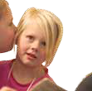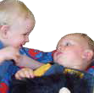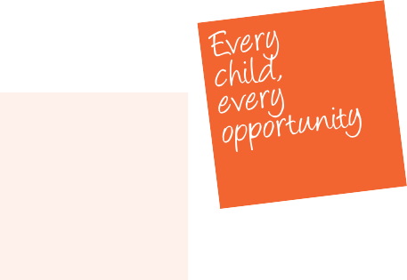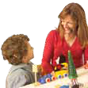

- taking your baby to all appointments.
This will help the professionals you are seeing monitor your baby’s development.
- communicating with your baby through sign language, should you so choose.
- getting information. Get as much information as you can from many different sources. When you get unbiased information and support you are more likely to make good decisions for your baby and your family:
  - Ask questions and make sure you understand the answers.
  - Take the time you need to make decisions. You don’t need to rush, although of course it’s not a good idea to take months.
  - Speak up about your concerns and worries.3
- talking to other parents of children with hearing losses. You can learn a lot from their experiences.
Remember that you are not on your own. A variety of services are available to help you and your baby, including:
- early childhood intervention services
- playgroups
- home visiting services
- parent support staff
- speech pathologists
- parent groups
- maternal and child health centres
- audiologists.

What’s next?
An audiologist (from Australian Hearing) will arrange a number of appointments for you and your baby. Your baby may be fitted with a hearing aid. You will also need to see an
ear, nose and throat (ENT) doctor or paediatrician.
You will also receive information about a range of early intervention supports and services that can help you get the information you need and develop a plan of action for the next few months. The role of early intervention services is to support you, your baby and the rest of the family. Staff will try to answer your questions, discuss communication and offer practical support. They
will also be able to tell you about other services in your local area. It is important to remember that you have a choice in selecting the service with which you feel most comfortable.
It may also help to talk to members of your own family, medical or hearing professionals, other parents and advocacy groups for children with hearing loss or an experienced counsellor.
- The National Deaf Children’s Society, 2002,
Your baby has a hearing loss, London.
- Australian Hearing, 2005, Choices, Chatswood, NSW.
- Aussie deaf kids, Building blocks: A parent guide for families whose baby has been diagnosed with a hearing loss (www.aussiedeafkids.com).

© State of Victoria, 2010
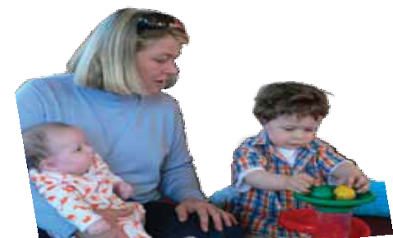Authorised by the Department of Education and Early Childhood Development

