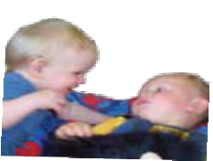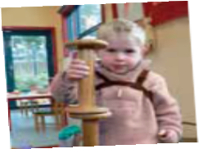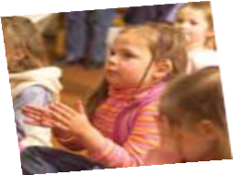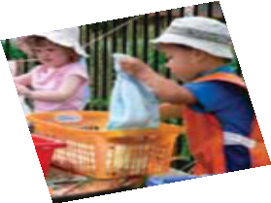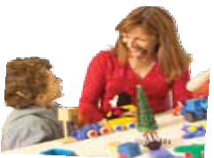Early Childhood Intervention Services for children with a hearing loss

Aurora School
96 Holland Road South Blackburn South 3130
Telephone (03) 8878 9878
TTY (03) 8878 9899
Email: aurora.sch@edumail.vic.gov.au Web: www.auroraschool.vic.edu.au

Early Education Program For Hearing Impaired Children
2 Francis Street
East Brighton 3187
Tlephone 9596 6830 Email: info@eep.org.au Web: www.eep.org.au

Taralye: The Oral Language Centre for Deaf Children
137 Blackburn Road
Blackburn 3130
Telephone:(03) 9877 1300
Email: information@taralye.vic.edu.au Web: www.taralye.vic.edu.au
Royal Institute for Deaf & Blind Children National Remote Early Learning Program Telephone: 1300 131 923
Email: alison.hawkins-bond@ridbc.org.au

Parent Adviser Services
Available in some Department of Education and Early Childhood Development regions. Contact your Specialist Children’s Services intake team (phone numbers overleaf) for further information

Regional Contacts
For further information, please call 1800 783 783 and ask for Specialist Children’s Services intake in your region,
or you can contact your region directly using the contact numbers listed below:

Barwon South Western Region
1800 354 605

Grampians Region
(03) 5330 8608 or (03) 5330-8613

Loddon Mallee Region
1300 363 514

Northern Metropolitan Region
(03) 9304 0775

West Metropolitan Region
(03) 9275 7500

Southern Metropolitan Region
1300 720 151

Eastern Metropolitan Region
1300 662 655

Hume Region
1800 627 391

Gippsland Region
1800 336 010

Or contact the service provider as detailed below

This publication was developed in partnership with the Aurora School, Department of Education and Early Childhood Development, and Taralye: The Oral Language Centre for Deaf Children and Early Education Program for Hearing Impaired Children.
Information for families who have a baby or young child with a hearing loss

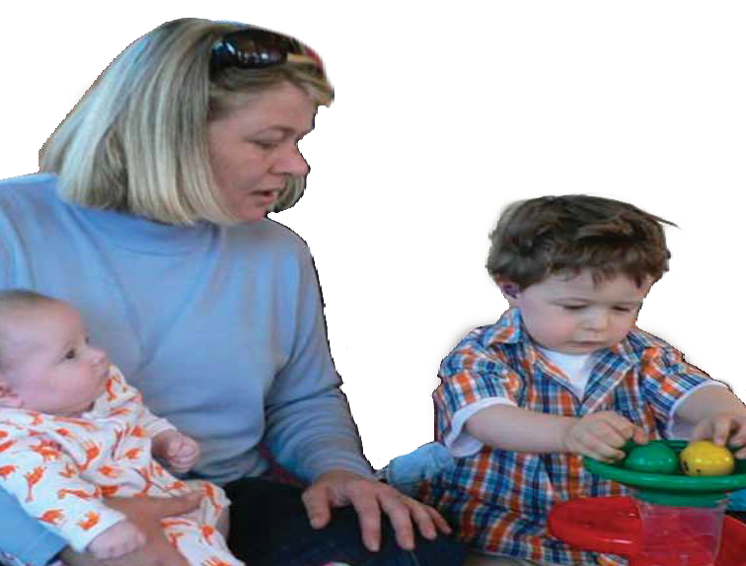
Most parents experience a variety of feelings when their baby or young child is diagnosed with a hearing loss. Each parent reacts differently and copes in unique ways with these feelings and emotions, but it is usual for a diagnosis to create some anxiety.
Whatever your feelings are it is important to share them and remember that there is support to help you.
Your relationship with your baby or young child Remember that the immediate needs of your baby or young child have not been changed by the diagnosis. Regardless of the degree of hearing loss, your early relationship with your child is the foundation for later language and communication
development. This early relationship is based on the emotional security and physical comfort you provide and the time you take to cuddle you child, interact, play together and enjoy each other’s company.
In the future you will learn specific ways to encourage your child’s language development. These will be more effective if you have developed a warm positive relationship with your baby.

Getting Help - Early Childhood Intervention Services (ECIS)
The Department of Education and Early Childhood
Development funds a range of Early Childhood Intervention Services for young children with a hearing loss and their families, including those listed in this brochure.

There are also additional supports available for some children with a hearing loss in kindergarten and child care. Your maternal and child health nurse or audiologist can give you information about Early Childhood Intervention Services .
Early Childhood Intervention Services agencies working with families who have young children with a hearing loss provide different services and approaches to cater for varying needs and
priorities. However, their shared aims and guiding principles focus on helping you gain knowledge and skills to support your child’s development and learning, especially in the areas of language and communication in the early years.

Early Childhood Intervention Services
Aims:
- to support positive relationships between parents and their child with a hearing loss.
- to assist parents to gain the knowledge and skills required to support their child’s development.
- to minimise the impact of a hearing loss on the development of the child.
Guiding Principles:
- Early Childhood Intervention Services should be available to families and children from the time a hearing loss is identified.
- The best outcomes for children are achieved when parents and professionals work together.
- The role of professionals is to support parents to choose the service/s that best meets their needs.

