All about kindergarten

Children go to a kindergarten program in the year before starting school, usually when they are four years old. Some services also offer kindergarten programs for three-year-olds.
Go to page 6 for advice about choosing the best time for your child to start kindergarten.

What is kindergarten?
Kindergarten (also called preschool) is a program for young children delivered by a qualified early childhood teacher.
Why should my child go to kindergarten?
Kindergarten is an important step for young children and is strongly recommended for all children.
Research shows that kindergarten improves children’s health and wellbeing, helps them to develop strong social skills and encourages a love of learning.
Children who go to a kindergarten program are more independent and confident and are more likely to make a smooth transition to primary school (Prep).
What happens at a kindergarten?
A high-quality kindergarten program will offer your child a range of learning experiences and activities that are both stimulating and fun. Your child’s learning and curiosity will be encouraged through experiences and activities, such as exploring the natural world, being exposed to new ideas and solving problems.
Your child will be able to:
• learn to work with others and make friends through group activities and cooperative play
• express their creativity, for example, through dance, movement and art
• build their communication skills by listening to and having conversations with the educators and other children
• develop the skills that they need for reading, writing and mathematics.
Where can I find a kindergarten?
Some kindergartens run as stand-alone services (for example, community kindergartens). Other kindergarten programs are run through long day care centres or schools.
To find a kindergarten program in your local area (or area of choice) visit www.education.vic.gov.au/findaservice or contact your local council, which you can find by visiting www.dpcd.vic.gov.au/localgovernment/find-your-local-council.
Go to page 4 for advice about choosing a kindergarten program that suits your family.
All children can attend kindergarten
Kindergarten is for all children. If your child has a disability or learning difficulty, the educators will talk with you about how the program and environment can support your child.
If you need support to enrol your child in a kindergarten program or to find a program that suits your family contact your local council.

How much does kindergarten cost?
The Victorian Government provides funding to services to contribute to the cost of running a funded kindergarten program, which helps keep fees for four-year-old kindergarten as low as possible.
Look for this certificate, which shows that a kindergarten program receives funding from the Victorian Government and is delivered by a qualified early childhood teacher.

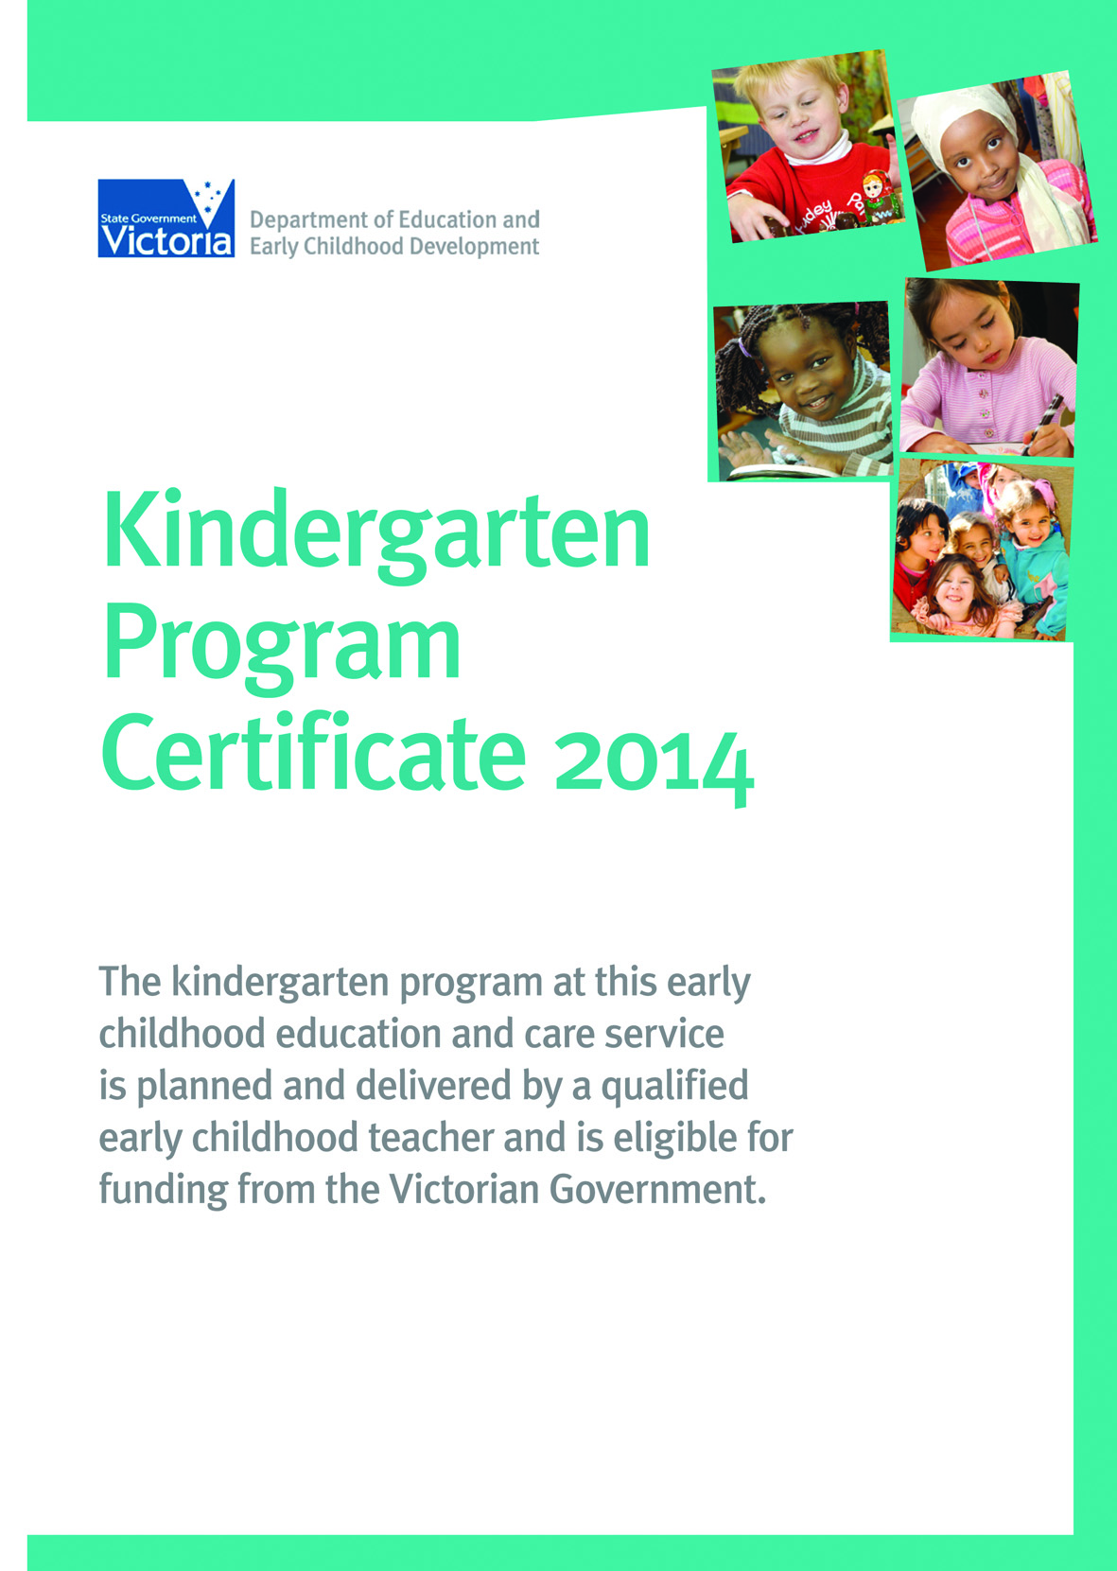

Services that offer kindergarten programs often charge fees to help meet the cost of running the programs. Fees are set
by individual services and can vary depending on how many hours your child attends, group size and extra costs such
as excursions.
How many hours a week can my child go to kindergarten?
Most four-year-old kindergarten programs are offered for 15 hours a week.
Free or low cost kindergarten for children in the year before school
The Victorian Government subsidises fees for some children so they can attend kindergarten for free or at low cost in the year before they start primary school, usually when they are four years old.
Your child is eligible if they:
• are an Aboriginal and/or Torres Strait Islander
• are a triplet or quadruplet
• hold (or have a parent or guardian who holds) an eligible concession card or refugee, humanitarian or asylum seeker visa.
Ask your child’s kindergarten educator or service manager if you think your child may be eligible for a fee subsidy.
Free kindergarten for three-year-olds
The Victorian Government subsidises fees for some children so they can attend kindergarten for free two years before they start primary school, usually when they are three years old.
Your child is eligible to attend free kindergarten if they are at least three years old by 30 April and:
• are an Aboriginal and/or Torres Strait Islander, or
• are known to Child Protection, or referred by Child Protection to Child FIRST.
If your child has had a free program two years before school, they can attend a four-year-old program the next year for free or at low cost.
Ask your child’s kindergarten educator or service manager for more information about free kindergarten programs for three-year-olds.

Choosing a kindergarten program
Every family is different. This means the kindergarten program you choose should be a good fit with your child and family.
It’s a good idea to start looking for a kindergarten program early, as enrolment processes vary across Victoria. Some services accept applications when children turn two.
Once you have a shortlist of kindergarten programs, contact the services to find out if they are holding open days or information sessions, or make an appointment to visit.
This is a great way to get a ‘feel’ for each program, to ask questions and to share information about your child. You can also find out about the days and times the kindergarten program runs, how to enrol your child and any fees charged
and subsidies available.
Visit more than one program if you can. Try not to rely only on what other families say.
What to look for when you visit a service
• Were you made to feel welcome? High-quality kindergarten programs are based on a partnership between families and educators. Did the educators ask questions about your child and your family? Were the educators interested in your questions and concerns?
• If your child was with you, did the educators engage directly with your child (rather than speaking to your child through you)?
• Are there a variety of fun and challenging learning opportunities that celebrate the cultures of the children who use the service?
• Do the indoor and outdoor areas offer the children stimulating learning experiences – for example, the opportunity to explore and discover new things? Is there space for the children to play with others or alone? Are there spaces where children can
go to be quiet?
Have your questions ready
• How will the educators work with you to support your child’s learning?
• How will the educators include your child’s interests?
• What opportunities will there be to discuss your child’s progress?
• If your child has additional needs, how will the service support you and your child?
• How does the program encourage positive behaviour?
• What will happen if your child becomes unwell or upset?
• Does the service have a kindergarten certificate on display? This certificate shows that a kindergarten program receives funding from the Victorian Government and is taught by a qualified early childhood teacher.
• What is the service’s rating against the National Quality Standard (part of an Australia-wide quality system of education and care services)? Can you see the written assessment?
• Is there a waiting list for places?
Do you need to pay a deposit to enrol or to be put on the waiting list? Tell the service if you are not able to pay the deposit.
How old should my child be when they start kindergarten?
It is usual for children to attend a kindergarten program in the year before they start primary school. This is often called ‘four-year-old kindergarten’.
Your child can start school if they turn five years old by 30 April of the year they start school. Your child must be enrolled in school by the age of six, unless they have an exemption. So, if your child’s birthday falls before 30 April in the calendar year, you have a choice about whether to enrol your child in school in the year they turn five or the next year. Children learn at different rates, in different ways, and at different times. In some cases, your child may benefit from starting a kindergarten program later.
Where can I get advice on the best time to start kindergarten?
If you are unsure about the best time for your child to start a kindergarten program, ask a kindergarten educator for advice. Find out how the kindergarten program can support your child.
Meet with the principal or a teacher at the school that your child is likely to attend. Talk about the best time for your child to start Prep. Find out how the Prep program can support your child.
As well, you can talk with your child’s Maternal and Child Health nurse, family doctor and any other professionals your child sees (for example, speech therapist, physiotherapist or paediatrician).
Can my child go to kindergarten for more than one year?
Children who are:
• Aboriginal and/or Torres Strait Islander, or
• known to Child Protection, or referred Child Protection to Child FIRST
can go to kindergarten for free or at low cost for two years before they start primary school, usually starting when they are three years old.
Go to page 4 for more information about free kindergarten for three-year-olds.
Some children with developmental delays who complete four-year-old kindergarten may benefit from completing a second year of funded kindergarten before going on to school.
Talk to a kindergarten educator if you would like to know more about these options.
Do you need an interpreter?
The Victorian Government provides a free interpreter service for families attending funded kindergarten programs. Ask your child’s kindergarten educator or service manager to call the free interpreter service.
Related links
Free or low cost kindergarten – http://www.education.vic.gov.au/childhood/parents/kindergarten/Pages/fees.aspx
Free kindergarten for three-year-old – http://www.education.vic.gov.au/childhood/parents/kindergarten/Pages/earlystart.aspx
Second year of kindergarten for children with developmental delays –
http://www.education.vic.gov.au/childhood/parents/kindergarten/Pages/secondyear.aspx

Prepared by:
Department of Education
and Early Childhood Development
2 Treasury Place, East Melbourne
Melbourne 3002
© State of Victoria January 2014

