NEWSLETTER COPY

Graphic:
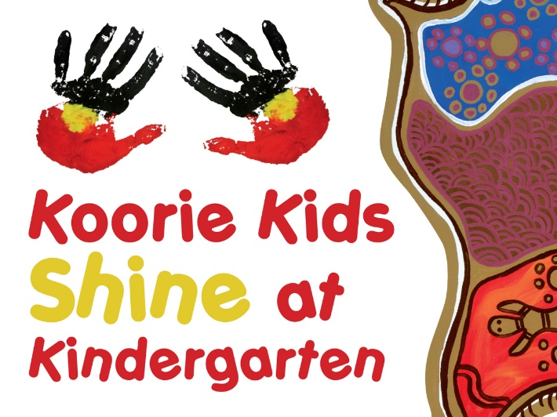

Heading

ENROL YOUR CHILD TODAY, IT’S FREE!

At kindergarten, your child will make new friends, enjoy fun activities and get ready for school.
Your child will:
- learn through play, art, music and dance
- learn to express themselves in a safe, inclusive and caring environment
- build the skills and confidence to prepare them for school

Kindergarten programs have a qualified teacher and run for 15 hours per week.
All Aboriginal and Torres Strait Islander children who turn 3 or 4 years old by 30 April, can attend kindergarten for 15 hours per week for free through the Early Start Kindergarten grant.
For more information visit: www.education.vic.gov.au/kindergarten

