Helping your child to have a strong sense of wellbeing
Issue No.004
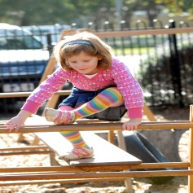
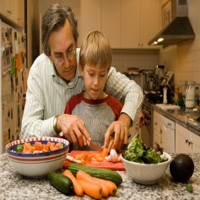
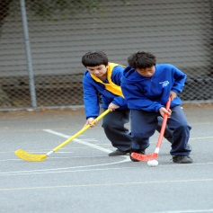
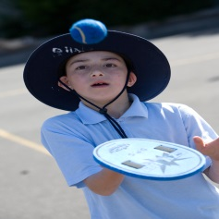
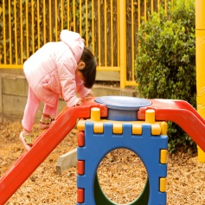
One of the five learning outcomes in the Victorian Early Years Learning and Development Framework and the Early Years Learning Framework for Australia is that children have a strong sense of wellbeing.

A strong sense of wellbeing means much more than feeling happy all the time, or being free of illness. It is a combination of physical, social and emotional factors.
As a baby struggles to roll toward a toy or object of interest they show physical wellbeing (their motor skills are developing). But they also show curiosity (what’s that thing over there?) and perseverance (I’m going to try again!).
Resilience is also a large part of wellbeing – a capacity to persist and to deal with disappointment. When your child tries one more time to finish a puzzle, they are showing resilience.
Being able to control your emotions is also an important part of wellbeing, for example when your child asks for milk and you offer water. At first, their tears well up (I wanted milk!), but as they develop rather than having a tantrum, your child takes a deep breath and takes the water. They are learning to control their emotional response to disappointment and to express emotions appropriately.
Your baby has always been able to communicate when their physical and social needs aren’t being met – crying is a way for them to attract your attention. As your child grows, they will take more responsibility for their own health and wellbeing. They will learn to wash their hands, eat with a knife and fork and drink from a cup without your help.
Children with a strong sense of wellbeing are more likely to be confident and involved learners.

How can I help my child to develop a strong sense of wellbeing?
- Give lots of physical affection! Warm and supportive relationships help your child feel safe and secure. This sense of security means your child will have the confidence to try new things and to express how they are feeling.
- Respond to your baby’s smiles, talk to them while changing nappies, play peek-a-boo, converse about things in a way where you listen to each other, ask a question and pause for a response.
- Encourage your child’s resilience, independence, decision making and ability to get along with others by offering them real choices such as how much food, what to wear etc., and enabling them to take considered risks such as jumping and climbing. As your child grows they are able to identify the qualities of a friend and resolve conflict using suitable language and actions.
- Encourage your child to be active. Give them lots of opportunities to play outside and to develop their motor skills – walking, climbing, running, jumping, skipping, balancing.
- Dance and movement will help your child’s physical coordination and give them confidence in how their bodies move. Use clapping and bouncing games with babies.
- Look for opportunities for your child to be responsible for their own health and wellbeing.
- Dress them in pants with elasticised waists so they can undress or go to the toilet without your help.
- Offer your child a wide range of healthy foods, but give them some choice over which ones they will eat. This can make meal times less stressful by giving your child some responsibility over what and how much they eat.
- Talk to your child about different foods and involve them in choosing food and preparing food. This will build awareness of the importance of healthy eating.
- If you have any concerns about your child’s wellbeing (physical development, mental health or social development) talk to your child’s maternal and child health nurse, doctor or early childhood professional.

Other related newsletters can be found at www.education.vic.gov.au
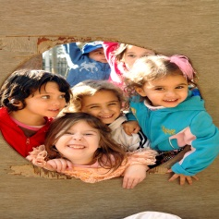

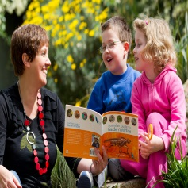
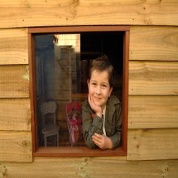
Related links
- Belonging, Being and Becoming: The Early Years Learning Framework for Australia
- Victorian Early Years Learning and Development Framework for all Children from Birth to Eight Years (2009)

You may also like to read
- Early childhood learning
- Helping your child to have a strong sense of identity
- Helping your child to connect and contribute to the world
- Helping your child to be an effective communicator
- Helping your child be a confident and involved learner

