Responding to your baby – how love leads to learning
Issue No. 009

From birth, babies need to form a small number of special, trusting relationships with caring adults.
The first relationships a baby forms is often with a parent but this can also be with a grandparent or other family members.
‘Attachment’ is the word we use to describe this strong and lasting bond that develops between a baby and their caregiver. That bond can be with more than one person.
Within some communities, the way of bringing up children has always involved more than immediate family for example, an integral part of Aboriginal child rearing is that a community of kin raises the child. Responsibility for nurture and care, education and culture are shared responsibilities.
These attachments have a profound effect on how babies learn and connect with their world as they grow and develop other relationships. Children learn about relationships from the relationships they experience.
Warm, loving responses are crucial for your baby’s learning
When a baby is distressed they cry. You hold and comfort your baby until they feel okay again. Once the crying stops, they settle. They are learning that distress is followed by comfort.
Responding to a baby consistently helps them learn to expect that their needs will be met. They learn to trust that the world is a safe place. They feel wanted and important. And they are learning what it means to communicate.
Did you know that by touching and talking to your baby you are also helping to stimulate vital connections in your baby’s brain? The connections that are formed in your child’s brain during their first years are essential for all later learning, including language and social and emotional development.

What does this mean for me?
- Respond to your baby’s cries and other attempts to communicate. This teaches your baby that they can trust you – you are reliable. You can’t spoil a baby by paying attention to them!
- Try to identify what your baby is communicating (hunger, tiredness, discomfort) so you can respond in the best way.
- Be consistent in your responses. (Don’t ignore your baby’s cries on some occasions but not others). Your baby learns that it’s worth communicating their needs and that they live in a safe and predictable world.
- Being held is essential for your baby’s brain development. Hold, cuddle and gently rock your baby. Give skin on skin contact when you can.
- Use routines (for example, nappy changing or feeding) as a time to make physical contact. When your baby is touched their brain produces chemicals that make them feel good.
- Interact with your child – and make it a two-way exchange. When your baby babbles and coos, respond to them with a smile and loving words. Your baby will respond in turn. You are already having conversations.
- Talk, sing and read books to your baby – about anything you like. Your baby will learn to identify your voice and will respond to your tone, expressions and action. They will enjoy the rhythm and pitch of your voice. These are important ways to build your child’s communication and language skills.

Related links
- Growing together in relationships
- Newborn behaviour: in a nutshell

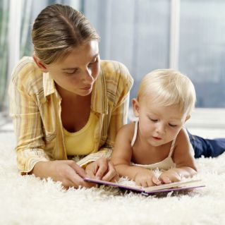
You may also like to read
You may also like to read other titles in this series:
- Having conversations with your child
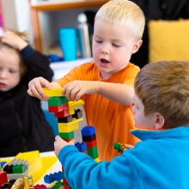
- Helping your child to have a strong sense of identity
- Supporting your child to make decisions
- Everyday learning
Other related newsletters can be found at www.education.vic.gov.au
