How do you see
your child?
Issue No. 007

How you see your child has an impact on your relationship with them. Relationships lay the foundations for children’s identity. Children form a strong sense of self when they build secure relationships with adults, first within the family and then with other caring and attentive adults and children.
Children develop their independence and become aware of their abilities when they seek and accept new challenges, use their bodies and make new discoveries. They begin to cooperate with others and with support; they can feel proud of their achievements.
Think of babies. They are already active learners – not a sponge waiting for your input. They splash in the bath and learn that the harder they splash the more fun it is. They babble at you and, when you respond, babble again. They’ve learned how to get a response.
Think of the toddler who pushes their plate away to show they’ve finished eating. That’s communication. Or the two-year old who says ‘No!’ They’re testing how much control they can have over their world.
Think of the child who puts some tissues aside each week because they’ve learned that the family always runs out by Friday. That’s responsibility. Or the four-year old who tells you to pick up the wrapper that you have dropped. They are being a citizen.
Young children don’t wait for adults to teach them. They look for and create their own experiences. They choose their friends. They make choices and ask questions. They also teach us. They should be seen and heard. Young children are competent, resilient and capable.

Young children have rights as well as needs
Did you know that the United Nations Convention on the Rights of the Child (1989) also recognises that children have rights? Those rights include the right to be active participants in all matters affecting their lives.
That doesn’t mean that we let children do whatever they want. But it does mean we can pay attention to what children say, even when as responsible adults we make decisions they don’t especially like.

What does this mean for me?
- The way we see children affects how we relate to them. If you think of your child as not knowing much, you might talk to your child, but not with your child. Sharing your ideas, and listening to your child’s ideas supports cooperation.
- Seeing your child as a person means showing both empathy and respect. It means that you acknowledge your child’s individuality and that you take seriously their preferences and interests. It means being prepared to give your child a say.
- Children learn through relationships. If some members of your family still believe that ‘children should be seen and not heard’, how might that limit your child’s learning or your interactions with them?
- Some further points to reflect on:
- How do I make it clear to my child that they matter?
- Do I listen to my child’s point of view? Do I respond to my child’s non-verbal cues?
- Do I encourage my child to make choices or to contribute to family life? What opportunities do I provide?
- Do I encourage my child’s independence?
- What decisions do I allow my child to make?
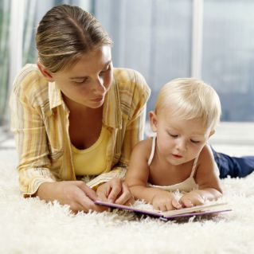

Related links
- Raising Children Network

You may also like to read
You may also like to read other titles in this series:
- Your child is unique
- Your child’s most important teacher
- Supporting your child to make decisions
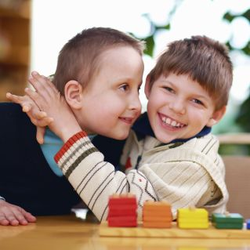
- ‘I can do it myself!’ Encouraging your child to be independent
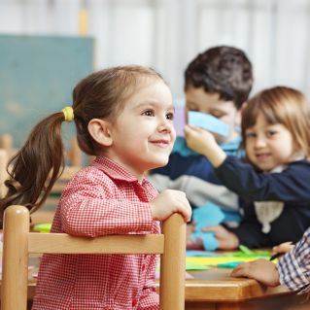
- Having conversations with your child
- Helping your child to have a strong sense of identity

Other related newsletters can be found at www.education.vic.gov.au

