Encouraging children to cope with their feelings
Issue No. 026

Children have so many things to learn!
And one of the most complex things is encouraging them to cope with their feelings and manage their actions and reactions.

Children learn from what you do
If you want your child to be respectful and caring, you will need to model being respectful and caring. If you want your child to clean their teeth without a fuss, it helps if you do the same.
Each family has their own values and ways of doing things. This means your idea of desirable behaviour might not be the same as your friend’s. What is important to your family is the behaviour you would like your child to learn.
As children develop a more knowledgeable sense of self, they reach out and communicate the need for comfort, assistance and companionship. Taking on characters in dramatic play is a great way for children to explore different identities and points of view. All children, with support, can develop a strong sense of self and learn to interact with others with care, empathy and respect. As they show interest in others and being part of a group, children can participate in play with others and begin to develop friendships. This confidence can be transferred to a range of social situations and children can increasingly recognise and accept that there are consequences for their actions.
Over time children establish their own important friendships with other children. They explore their responsibilities and rights and those of others in familiar settings, such as the family, groups, the classroom and the playground. With guidance, they begin to think in terms of other people’s feelings and needs, and respond to diversity with respect. Stories and group discussions assist children in talking through conflicts, supporting development of social skills and tolerance for others.
Children can, over time and with assistance, show concern for others and practice peaceful and inclusive ways of resolving conflicts. This includes using appropriate language and actions. Regulating behaviours and finding positive ways of managing frustrations takes time, effort and assistance.
Self-reliance and confidence are built on a strong sense of identity and belonging. If your child feels secure, important and listened to, they are more likely to express feelings and needs in ways that don’t hurt others.

What does this mean for me?
- Let your child know when you see them doing something you approve of: “I saw you help your sister climb the slide. She looked proud of herself and you looked proud too”.
- Talk about the effect of your child’s action on another person: “Look at Owen’s face! He seems happy that you gave him your train.”
- Be specific. If you only acknowledge behaviour by saying “good girl” or “well done”, your child may not know what you have noticed or what you consider appropriate.
- Choose your battles! Does your child really need to stop playing with their cousins right now and put on their pyjamas? Decide what’s really important and what doesn’t matter so much.
- Keep your requests short and specific. “Please shut the gate”, is better than “Please get your things and shut the gate and then jump in the car after kissing your aunty”!
- Make clear what you want. “Please sit on your chair” tells the child what behaviour you want. “Stop bouncing around” does not.
- Do you need to say it more than once? Trust that your child has heard you and will do what you want. In some cases you will need to give a reminder or to follow through by helping your child. (But try to avoid nagging and criticising.)
- Think ahead and reduce the chance for conflict. If friends are coming to play, put your toddler’s favourite toy away and have a range of play things available. If you don’t want your toddler to play with the TV remote control, move it!
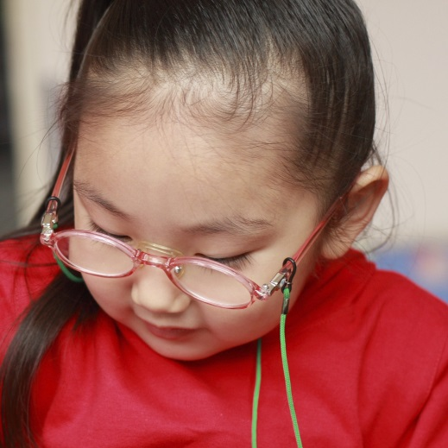
- Give your child choices. Begin with choosing between one to three options; be careful not to overwhelm very young children with too much choice. This gives them some control (which they need) and can minimise conflict.
- If you choose to use reward charts for your older child (between 3 – 8 years), use them with care, the consequences of their actions should mean more than stars on a chart. The Raising Children website has an information sheet on how to use star and reward charts. (See related links.)
If you do have concerns about your child’s behaviour, always ask your child’s maternal and child health nurse, doctor or educator for advice and support.

Related links
- Kids Matter’s: Social and emotional learning: suggestions for families
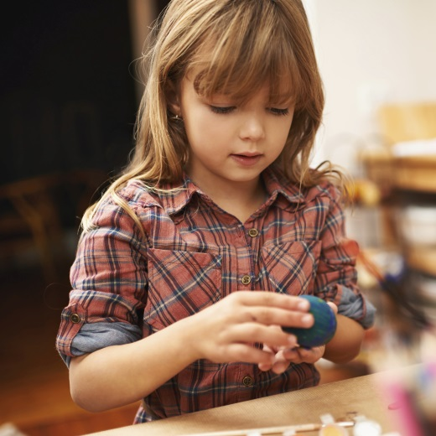
- Raising Children’s: Using reward charts successfully

You may also like to read
You may also like to read other titles in this series:
- Supporting your child to make decisions
- ‘I can do it’: Encouraging your child’s independence
- Building your child’s resilience
Other related newsletters can be found at www.education.vic.gov.au

