Learning to get along
Issue No. 017

Learning to get along with others is essential in life, but also very complex for young children to understand and learn
It involves learning not to deliberately hurt others with words or actions. It involves being able to think from another person’s point of view and to ‘read’ or consider their feelings. It involves learning not to be afraid of, or judgmental about, those who look different or do things differently.
It’s learning that you can’t always get what you want and sometimes you need to compromise. And that the best way to solve a conflict is not to dominate or give up. It’s learning to cooperate and work together when playing.
It’s also about being kind and compassionate – not only to family and friends but to strangers. And it’s about learning to listen.
Your child learns these valuable skills and understandings through their relationships with you and others in the family. They also learn through their involvement and interactions in the wider community.
This learning takes time and continues throughout childhood and into adult life.

What does this mean for me?
- The way you model ‘getting along’ is critical. Your child is learning each time they see you being kind to someone or listening with respect to someone you disagree with. When your child hears you say sorry (and mean it) or acknowledge that you made a mistake, they are learning what it means to get along.
- Remember, getting along doesn’t mean always letting someone else have what they want. Help your child to assert themselves in appropriate ways.
- Model sharing and turn-taking in family life (games are good for this). Let your children see you sharing your own things. When your child is ready, give them the right words to use: Can I have a turn?
- Talk to your child about feelings and appropriate ways to express them. This helps them to express and understand emotions such as anger, frustration and sadness and is an important step in helping them to resolve conflict when they get older:
- Help your child understand what another person feels: See those tears on Mustafa’s face? That’s because you bit him and it hurts.
- Use the situations you see in books, TV or the internet as a good starting point for conversations about feelings and getting along with others.
- Help older children to begin understanding other people’s feelings. If two children are having a fight, ask each child to say how they feel. Have them listen to each other.
- Help older children to solve conflict by asking questions: What’s the problem? What have you done to try to solve it? What else can you do? Support them to work out the best solution.
- Point out the many ways that people are different – how they look; what they choose to believe and what they do.
- Avoid books or games that reinforce racist, biased or stereotyped images. If your child is exposed to such views, explain why they are harmful.
- Find opportunities for your child to interact with other children, for example, by going to a play group or going to the park.

Related links
Kids Matter’s:
- Getting along
- Keeping a balance: managing feelings and behaviour
Raising Children’s:
- Sharing and learning to share
- Handling sibling fights

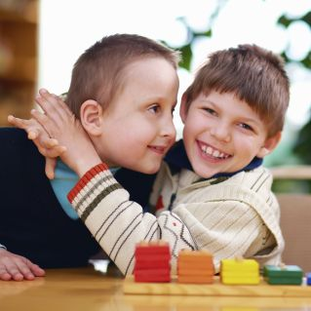
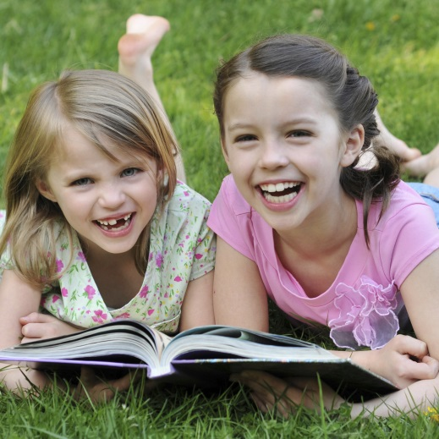
You may also like to read
You may also like to read other titles in this series:
- Encouraging positive behaviour
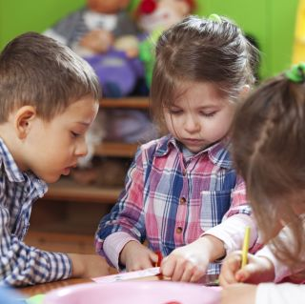
- Having conversations with your child
Other related newsletters can be found at www.education.vic.gov.au

