Helping your child to be an effective communicator
Issue No. 005
One of the five learning outcomes in the Victorian Early Years Learning and Development Framework and the Early Years Learning Framework for Australia is that children are effective communicators.

Children communicate with others from birth.
Effective communication doesn’t always need words. And it’s much more than being able to talk, read and write.
Babies use gestures and sounds to communicate. They smile, cry and touch to tell you they are contented, distressed or curious. They understand much more than they can say in words.
Toddlers and older children might communicate with you through behaviour – hitting and biting are often ways of communicating frustration. Children can also use art, music, dance and dressing up to communicate how they feel, what they think and who they are.
Some young children will be exposed to two languages, either through family or their early childhood education and care setting.
Children can be effective communicators in any language.
Children who don’t use words can also be effective communicators. They might use signing (for example, using a language programme such as Makaton or Auslan), drawing, modelling, painting, a computer program or picture cards to express how they feel and what they want.

How can I help my child to be an effective communicator?
Try hard to understand what your child is trying to communicate, and respond as best you can. How does your child communicate that they are tired or hungry? How do they let you know if they want or don’t want physical contact?
Talk with babies, even before they can understand what you say. Chat to your child about what you are doing and watch them babble back at you!
Sing lullabies and nursery rhymes with your child. Rhyme and rhythm help your child to build language skills.
As children get older they will develop the skills to write simple texts to convey ideas, messages, feelings and information. As they grow they can typically link ideas in a variety of ways and plan art works that communicate ides, concepts, observations, feelings and experiences.
Model effective communication yourself ;especially a willingness to talk with your child and to listen to what they say. Having two-way conversations with your child teaches them the importance of listening and responding. Try to ask questions that don’t require just a yes/no response. Do this often.
Read books with your child and play games with the words and sounds.
If your child is interested in letters and written words, create posters, signs and simple books (using a computer or by hand). Ask your child to tell you what to write in a text message, letter or email. Help them type their name. Play games by finding letters on the keyboard.
Read books, magazines, street signs, advertisements and pictures with your child. Help them identify letters and words and to understand how pictures can tell a story. Talk about what you see and what the words and pictures mean.
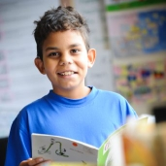
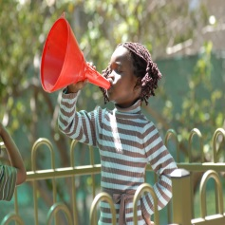
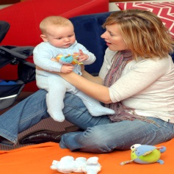
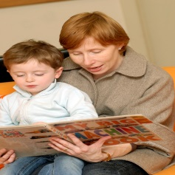
Tell your child stories and encourage them to tell you stories. These can be told in your home language as well as (or in place of) English.
Give your child different opportunities and materials to express their ideas and interests through drawing, painting, building and making music. These are all ways of communicating.
Give your child dress ups to encourage role playing. This encourages talking, listening, imagination and thinking skills as they act out a new role.
If you are concerned about any aspect of your child’s communication, speak to your child’s maternal and child health nurse, early childhood professional or doctor.

Other related newsletters can be found at www.education.vic.gov.au
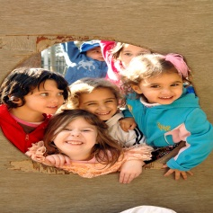

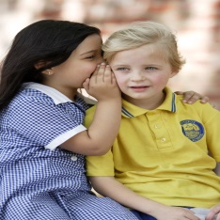
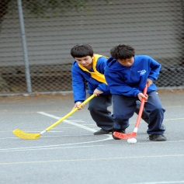
Related links
- Belonging, Being and Becoming: The Early Years Learning Framework for Australia
- Victorian Early Years Learning and Development Framework for all Children from Birth to Eight Years (2009)

You may also like to read
- Early childhood learning
- Helping your child to have a strong sense of identity
- Helping your child to connect and contribute to the world
- Helping your child to have a strong sense of wellbeing
- Helping your child be a confident and involved learner

