




Reading to Young Children: A Head-Start in Life
The research sets out to explore the connections between parents reading to their young children and their child’s later reading and other cognitive skills.
Key Findings
The frequency of reading to children at a young age has a direct causal effect on their schooling outcomes regardless of their family background and home environment.
- Reading to children at age 4-5 every day has a significant positive effect on their reading skills and cognitive skills (i.e., language and literacy, numeracy and cognition) later in life.
  - Reading to children 3-5 days per week (compared to 2 or less) has the same effect on the child’s reading skills at age 4-5 as being six months older.
  - Reading to them 6-7 days per week has the same effect as being almost 12 months older.
- Children read to more frequently at age 4-5 achieve higher scores on the National Assessment Program – Literacy and Numeracy (NAPLAN) tests for both Reading and Numeracy in Year 3 (age 8 to 9).
- These differences in reading and cognitive skills are not related to the child’s family background or home environment but are the direct result of how frequently they have been read to prior to starting school.

This research is a result of a partnership arrangement between the Department of Education and Early Childhood Development and the Melbourne Institute of Applied Economic and Social Research.
1
Introduction
Cognitive skills of young children are an important factor in explaining success later-on in life. Skill attainment at one stage of the life cycle raises skill attainment at later stages of the life cycle (Cunha et al., 2006). Cognitive ability affects the likelihood of acquiring higher education and advanced training, and the economic returns in terms of wages and quality of jobs (Heckman & Masterov, 2007; Cunha et al., 2006).

Cognitive skills are not fixed but can be influenced through investment in preschool training, education in school, and significantly, parental efforts. The most effective period for cognitive skill investment by parents is early on in the life of their children (Cunha et al., 2006). Previous studies have found a positive association of parents reading to their children and the child’s subsequent reading skills, language skills and cognitive development. Children who are read to more frequently at an early age enter school with larger vocabularies and more advanced comprehension skills (Mol & Bus, 2011).

Research has found that reading storybooks to children is one of the most important activities for developing the knowledge required for eventual success in reading. Reading to pre-schoolers has been found to be related to language growth, emergent literacy and reading achievement. (Bus et al., 1995). In addition, reading to children also stimulates them to read books themselves and further develop their cognitive skills (Canoy et al., 2006).

This study examines the effect of parental reading to children early in life on the child’s own reading and other cognitive skills. The research approach and analysis controls for a wide range of child, parent, household and childcare characteristics.

The study focuses on parents’ reading to children at 4 years of age and the subsequent development of very early reading skills (at age 4-5). This focus on early reading skills is relevant since early remedial or stimulating activities may be important for later reading skills/proficiency. In addition to reading skills at age 4-5, reading skills at later ages (up to age 10-11) are also examined. At most ages, more than one reading skill measure is observed, which allows for checking the consistency of results when using different measures.
The literature on the association between reading to children and developmental outcomes is quite extensive. The results all point in the same direction: there is a strong association between reading to children and developmental outcomes. However, there is only scant evidence on whether this can be interpreted as a causal effect. This study undertakes a number of analyses using economic and statistical methodology to investigate this question in detail.
Methods
The analysis in this study used the Longitudinal Study of Australian Children (LSAC) Child Cohort, and followed a group of over 4000 children who were aged 4-5 years in 2004 through to age 10 to 11. LSAC includes a wide range of information relating to the child’s family environment, early childhood and schooling experiences, and physical, socio-emotional and learning outcomes.

This study considered the influence of the frequency of reading to children at age 4-5 in terms of their current and future performance on measures relating to:
- Reading skills – children were rated by their parents, and carers or teachers in terms of their reading skill levels. Different measures are used at different ages: e.g. at age 4 an index ranging from 0 to 3 is used - 0 equates to low skill (cannot read yet) and 3 equates to high skill (can read complex words and simple sentences).
- Language skills – the Peabody Picture Vocabulary Test was used to assess the child’s language skills.
- National Assessment Program – Literacy and Numeracy (NAPLAN) – the child’s scores in Year 3 NAPLAN (age 8-9) were also included.
- Other cognitive measures that support learning – these measures change with age ranging from measures of school readiness at age 4-5 through to teacher ratings of the child’s approach to learning up to the age of 11.
- Non-cognitive measures relating to physical and socio-emotional outcomes.
2
The data analysis was split into two phases:
- descriptive analysis – examining the patterns in the raw data, and
- multivariate analysis – to remove the influence of family and household characteristics, which are correlated with the frequency of reading to children, in order to reveal the causal effect of the frequency of reading to children at age 4-5 on their future abilities in the skills shown above. This estimation of causal effects exploits the existence of factors that influence learning outcomes only through their impact on whether children were read to or not.
Descriptive Analysis
Relationship between reading to children and reading skills of the child
The raw data used in the descriptive analysis indicate a clear association between reading to children more frequently and higher early reading scores. As seen in Figures 1 and 2, children who are read to more frequently have higher reading skills as measured by parents and teachers at age 4-5.

Figure 1: Reading skill by intensity with which children are being read to at age 4-5 (boys and girls) – Parental score
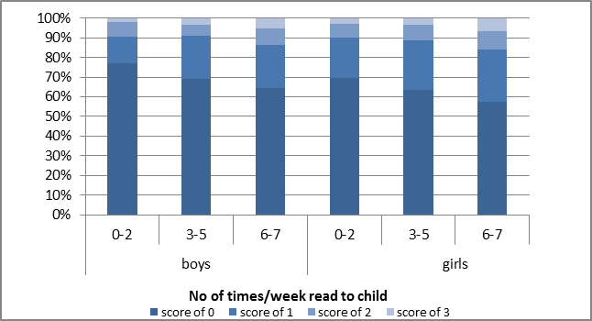
Parents and teachers were asked about the child’s reading ability. Their responses were converted to a scale between 0 and 3 where:
- could not read yet
- could read simple words
- could do two out of the three skills listed under (3)
- could read all of simple words, complex words, simple sentences.
The data also show that girls do slightly better than boys independent of the frequency that they are being read to. This pattern is evident across all measures in the LSAC with girls doing better than boys in all language-related skills.

Figure 2: Reading skill by intensity with which children are being read to at age 4-5 (boys and girls) – Teachers score
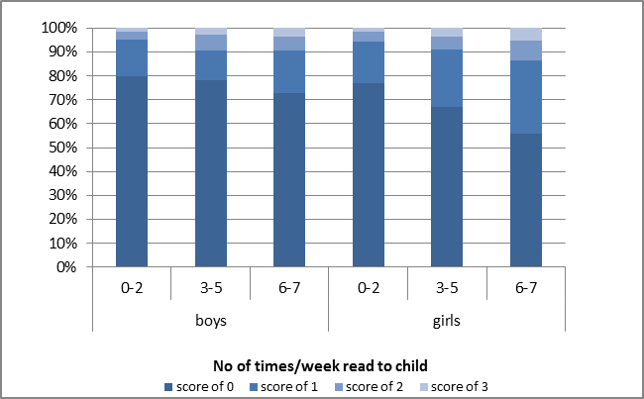
For another example of this association, see the skills of girls and boys at age 8-9, as measured by the NAPLAN reading tests. Figure 3 shows that girls who are read to more frequently are more likely to score high on the NAPLAN reading test (i.e., the curve in the graph shifts to the right). Similarly, Figure 4 shows that boys who are read to more frequently are also more likely to score high on the NAPLAN reading test.

Figure 3: NAPLAN reading skill by intensity with which the child is being read to at age 4-5 – Girls at age 8-9
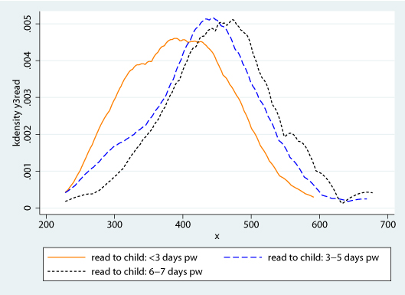

3
Figure 4: NAPLAN reading skill by intensity with which the child is being read to at age 4-5 – Boys at age 8-9
3
The results also show a similar association for numeracy skills. Girls and boys who are read to more frequently are more likely to score high on the NAPLAN numeracy tests, however these effects are smaller compared to the effects on the NAPLAN reading tests.

Relationship between reading to children and cognitive skills of the child
The raw data also show patterns indicating a clear association between reading to children more frequently and higher cognitive skills at age 8-9. Figures 5 and 6, presented below, show a shift to the right of the probability line as the frequency of reading for both girls and boys increases.
Taken together, Figures 1 to 6 show that there is a clear association between reading to children at a young age, and the level of reading and other skills that these children develop over the following years.

Figure 5: Cognitive skills (e.g., language and literacy, numeracy and cognition) by intensity with which boys are being read to at age 4-5 – Skills at age 8-9
Figure 6: Cognitive skills (e.g., language and literacy, numeracy and cognition) by intensity with which girls are being read to at age 4-5 – Skills at age 8-9
Multivariate Analysis
Factors affecting frequency of reading to children
The multivariate data analysis controls for the influence of family and household characteristics (such as the number of TVs in the home, the education level, age and income of the parents, number of siblings, and the primary language spoken) in order to explore the effect of the frequency of reading to children at age 4-5 on their future cognitive skills.

For girls and boys, some similarities in results were found including: that the child is read to less when the child is older, there are more TVs in the home, more TV is watched on weekdays, and there are more siblings. The child is read to more when there are more books in the home and the education of either parent is higher.

Factors influencing reading skills of children
Reading skills of boys are better, for example, when the child is older (within the 4-5 age range) and a non-English language is spoken at home. Broadly similar results are observed for girls.

Although the education of the parent has no effect (or a small effect opposite to what is expected) on reading skill at age 4-5, positive effects of parental education are estimated for later reading and other skills.

Effect of reading to children
The results confirm the strong association between reading to children and their own early reading outcomes. Moreover, the results indicate that, if anything, the causal effects of reading to children are larger than the observed associations in the raw data.
4
To place the size of these effects in context, they can be compared to the effect of age. For boys, reading 3-5 days per week (compared to 2 or less) has a similar effect on reading skills at age 4-5 as being just under six months older, whereas, reading 6-7 days per week (compared to 2 or less) has a similar effect on reading skills at age 4-5 as being just under one year older. The effects for girls are slightly larger relative to age than for boys, comparing to just over six months increase in age and just over one year increase in age respectively.
Conclusion
The study shows that there is an important role for parents in the development and educational performance of their children. Parental reading to children increases the child’s reading and other cognitive skills at least up to the age of 10–11. This is an early-life intervention that seems to be beneficial for the rest of their lives.

The results indicate a direct causal effect from reading to children at a young age and their future schooling outcomes regardless of parental income, education level or cultural background. Although many studies have shown an association between reading and schooling outcomes, actual causality has been much more difficult to prove.
Acknowledgments
This summary paper is based on the 2012 research report, Reading to young children: a head-start in life, authored by: G. Kalb and J.C. van Ours. The research report was developed through the Department’s research partnership arrangements with the Melbourne Institute of Applied Economic and Social Research.

References
- Bus, A. G., van IJzendoorn, M. H., and Pellegrini, A. D. (1995). Joint book reading makes for success in learning to read: A meta-analysis on intergenerational transmission of literacy. Review of Educational Research, 65, 1–21.
- Canoy, M., J.C. van Ours, and F. van der Ploeg (2006). The economics of books, in: Victor A. Ginsburgh and David Throsby (eds.), Handbook of the Economics of Art and Culture, Amsterdam, Elsevier, 721-761.
- Cunha, F., J.J. Heckman, L.J. Lochner and D.V. Masterov (2006). Interpreting the evidence on life cycle skill formation, in: Hanushek, E.A. and F. Welch (eds.) Handbook of the Economics of Education, Amsterdam, Elsevier, 697-812.
- Heckman, J.J. and D.V. Masterov (2007). The productivity argument for investing in young children, Review of Agricultural Economics, 29 (3), 446-493.
- Mol, S.E. and A.G. Bus (2011). To Read or Not to Read: A Meta-Analysis of Print Exposure From Infancy to Early Adulthood, Psychological Bulletin, 137, 267–296.
Resources
- Victorian Premiers’ Reading Challenge http://www.education.vic.gov.au/prc/
- National Year of Reading 2012 http://www.love2read.org.au/
5

