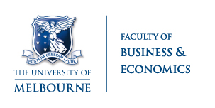
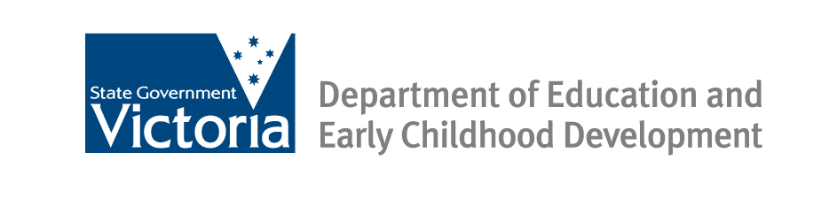

SUMMARY NOTE

Post-compulsory education and training: do young people know what pays?
This research looks at whether young people (aged 20) have an accurate picture of the impact of education and training on their future incomes and occupations.
Key Findings and Conclusions
- In general, young people aged 20 appear overly optimistic about their future outcomes. They expect to work in much more highly skilled occupations and earn higher incomes than realised by actual 30 year olds. This applied irrespective of socioeconomic background or a family history of receiving income support.
- The greatest difference between expectations and realisations in occupation and income is for young people without post-school qualifications.
- Young women seemed to have a more accurate picture of the impact of different levels of education on income, while males often did not. For males, those who are least educated at 20 years of age expected incomes similar to those likely to be most educated at 30 years of age.
- Young people expected to work in much higher skilled occupations than those realised by current 30 year olds. In particular, fewer young women at age 20 anticipated working in clerical jobs compared with those surveyed at 30 years of age (8% and 23% respectively), whilst almost no males aged 20 years anticipated working as labourers or cleaners, however, 13% of males aged 30 years actually did work in these jobs.
- The paper concludes by suggesting that better career information may play a role in assisting young people to make better career and education participation choices.

Project Background
- There is substantial literature that looks at how the expectations of individuals translate into realisations. For example, expectations about: the timing of, and income at, retirement; fertility plans; expected educational attainment; future occupation and income; among many others. However, currently there is no literature in Australia that looks at individuals’ income expectations and compares them to the actual outcomes of similar individuals.
Project Methodology
- The research uses information on the self-reported education plans of young people drawing on two Australian data sets:
  - Youth in Focus (YIF) survey: reports what 20 year olds in 2008 expect to earn when they are 30 years old.
  - Household, Income and Labour Dynamics in Australia (HILDA) survey: reported actual outcomes of individuals age 30 years.
- The analysis focused on the extent to which the expected returns (income and occupation) resulting from education and training were different from the realised returns. It also examined whether these varied for young people from different social backgrounds or characteristics (such as gender, socioeconomic background or income support history).
Acknowledgments
This summary note is based on the 2013 research report, Post-compulsory education and training: do young people know what pays? by Chris Ryan. The research report can be accessed at: http://melbourneinstitute.com/downloads/economic_forums/July_2013/Ryan,%20Chris_16July2013.pdf or
https://www.melbourneinstitute.com/miaesr/publications/working-paper-series/wps2014.html

This research is a result of a partnership arrangement between the Department of Education and Early Childhood Development and the Melbourne Institute of Applied Economic and Social Research.

